DELEGATED HOUSEHOLDER APPLICATION REPORT

Ward: Katesgrove
App Ref: 211639/HOU
Address: 38 Home Farm Close, Reading, RG2 7TD
Proposals: Single storey front extension
Case Officer: Chukwudi Onwudinanti
Applicant: Mr Dinesh Kumar Thapa
Date received (valid from): 4 October 2021
Target Decision date: 29 November 2021

1. INTRODUCTION
The proposed site is a semi-detached dwelling on the Northern side of Home Farm Close, among a mix of semi -detached and terraced dwellings of similar sizes.

2. PROPOSAL AND SUPPORTING INFORMATION
Single storey front extension
Plans considered (Received 4th October 2021)
P1263-01: Location and Block Plans
P1263-02: Plans and Elevations

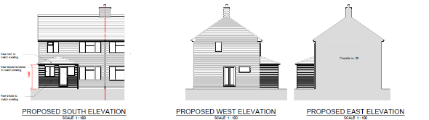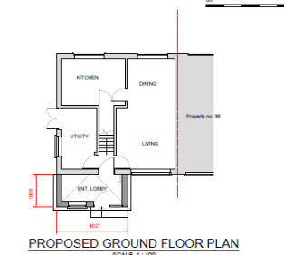

- RELEVANT PLANNING HISTORY
None

4. CONSULTATIONS
4.1 The following addresses were consulted by letter.

40 Home Farm Close, Reading, RG2 7TD
38 Winchester Road, Reading
36 Home Farm Close, Reading, RG2 7TD
25 Home Farm Close, Reading, RG2 7TD
33 Lincoln Road, Reading, RG2 0EX

4.2 No letters of representation have been received.

Equality Act 2010:
In determining this application the Council is required to have regard to its obligations under the Equality Act 2010. However, there is no indication or evidence (including from consultation on the application) that the protected groups identified by the Act have or will have different needs, experiences, issues and priorities in relation to this particular planning application. Therefore in terms of the key equalities protected characteristics it is considered there would be no significant adverse impacts as a result of the development.

- LEGAL AND PLANNING POLICY CONTEXT
Section 38(6) of the Planning and Compulsory Purchase Act 2004 requires that proposals be determined in accordance with the development plan unless material considerations indicate otherwise. Material considerations include relevant policies in the National Planning Policy framework (NPPF) - among them the 'presumption in favour of sustainable development'. The following local and national planning policy and guidance is relevant to this application:

National Policy
National Planning Policy Framework
National Planning Practice Guidance

Reading Borough Local Plan (2019)
CC7 (Design and the Public Realm)
CC8 (Safeguarding Amenity)
H9 (House Extensions and Ancillary Accommodation)

SPD
- Design Guide to House Extensions (2021)

6. APPRAISAL

H9 states: An extension to a house will be acceptable where it:

- Respects the character of the house in terms of scale, location, materials and design;

To assess this, the following has been considered – would the proposal:
- detract from the appearance of the original building through the use of ill-matching materials and by not fitting in with the design, scale and proportions of the original building; NO, the front porch will be finished with red bricks to match existing and will not span the whole length of the principal façade, keeping it to scale with original dwelling.
- reduce the amount of usable amenity space for the property to an unacceptable degree; NO
- require the loss of trees in the garden or put significant trees at risk; NO

- Respects the character and pattern of neighbouring properties and the street as a whole in terms of scale, location, materials and design, and any important existing building line; Respects neighbour’s amenities and does not present a large blank façade to public areas.

To assess this, the following has been considered – would the proposal:
- significantly reduce the amount of daylight and sunlight enjoyed by neighbouring properties; NO
- invade the privacy of neighbouring properties through overlooking from windows or balconies; NO
- detract from the character of neighbouring properties through siting, excessive bulk, ill-matching materials or inconsistent design; NO, while the proposed development is the addition of a front porch, it will still be in keeping with similar extensions at similar dwellings on the street and it is considered that it will be an enhancement of the original design of the porch.
- detract from the appearance of the street or area by using ill-matched materials, glazing and detailing; NO

CC8: Safeguarding Amenity states an extension to a house will be acceptable where it will not cause a significant detrimental impact to the living environment of existing or new residential properties.

To assess this, the following has been considered – would the proposal cause a significant detrimental impact to the living environment of existing or new residential properties in terms of:

- Privacy and overlooking;
- Access to sunlight and daylight;
- Visual dominance and overbearing effects of a development;
- Noise and disturbance;
- Artificial lighting;
- Vibration;
- Dust and fumes;
- Smell;
- Crime and safety.

- CONCLUSION
The proposed development has been assessed and the proposed works are considered to be in accordance with the above relevant policies and planning permission can be granted.

8. RECOMMENDATION
Grant

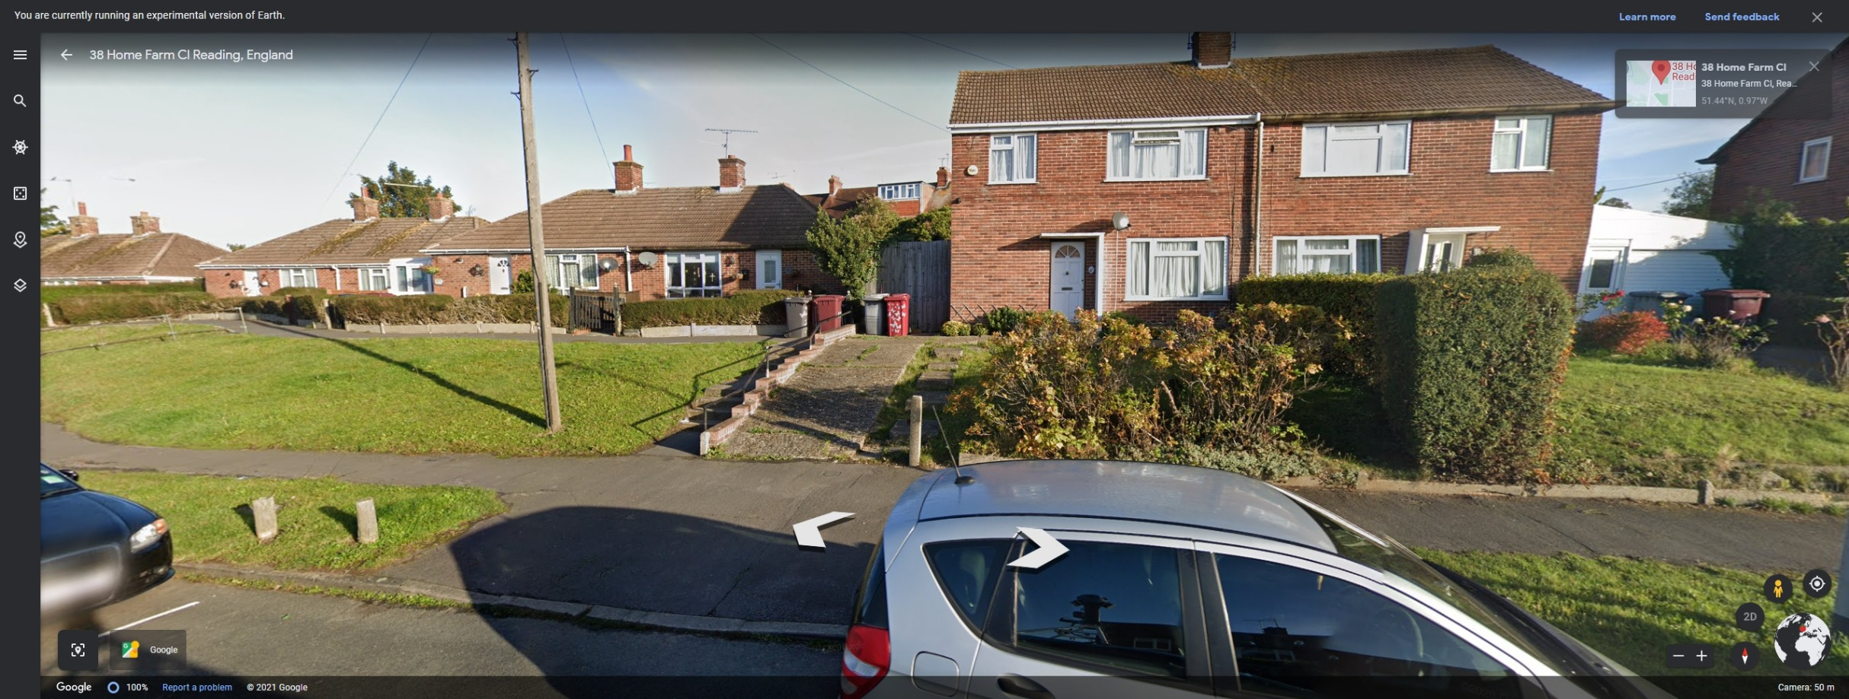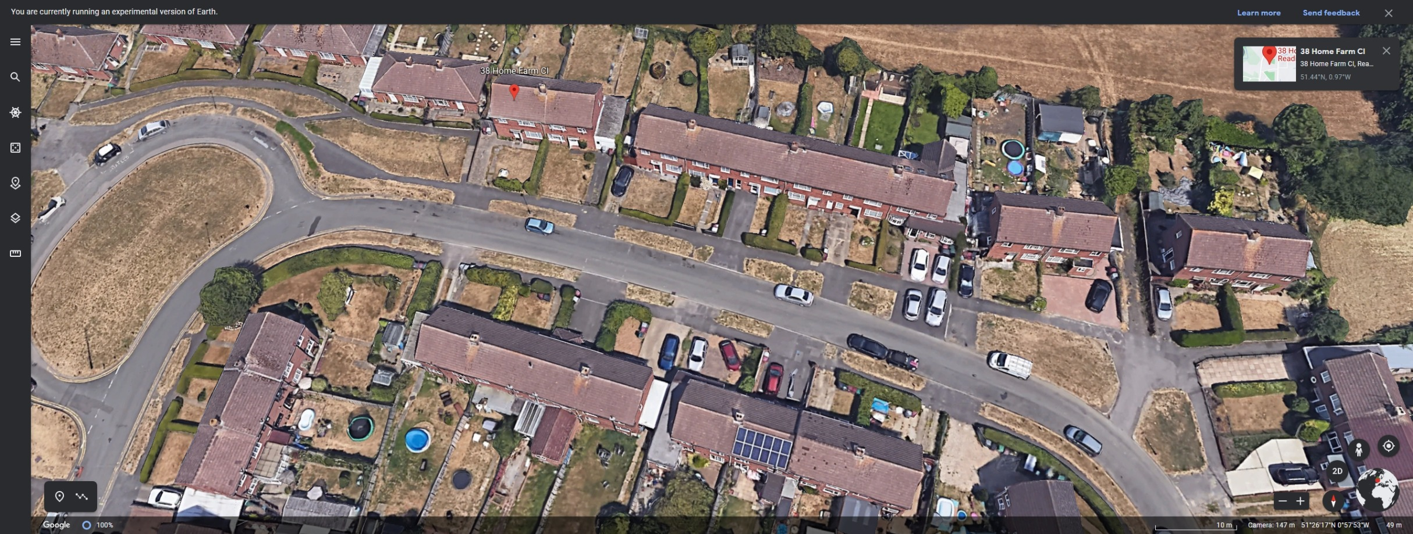

Google Earth Photos.

