DELEGATED HOUSEHOLDER APPLICATION REPORT
Ward: Southcote
App Ref: 210627 / HOU
Address: 206 Southcote Lane, Reading, RG30 3AU
Proposals: Single Storey Front and Rear Extensions
Case Officer: Beatrice Malama
Date received (valid from): 22nd April 2021 Target date: 17th June 2021

SITE DESCRIPTION
The site is a two story mid terrace dwelling located in an area of mixed uses which includes residential, commercial, entertainment and education among others. Residential properties surrounding the site include detached, semi-detached, terraces and flats of varying designs and styles. The property is not listed and does not fall within a conservation area.

PROPOSED DEVELOPMENT
The proposed rear extension measures 3m deep from the existing rear wall, approximately 3.9m wide whereas the front extension measures 1.3m deep from the existing front elevation and approximately 2.6m wide. The proposed front extension would have a pitched roof to match the existing house whereas the rear extension would have a flat roof. Exterior walls would be of rendered blockwork with doors and windows designed to match that on the existing house.
Plans considered;
Drawing No: 01 – Site Location Plan, Block Plan, existing and proposed floor plans, elevations and roof plan.
As received on 22nd April 2021

RELEVANT PLANNING HISTORY
No Planning History

CONSULTATIONS
Confirmation that the site notice was displayed on 28th April 2021 was received. The following neighbours were consulted by letter and no letters of representation were received.
Flats 1, 2, 3 & 4 Bunty Nash Court, Coronation Square, RG30 3QW
No. 204 & 208 Southcote Lane, RG30 3AU

Internal Consultation – Transport
No objection.

Equality Act 2010:
In determining this application the Council is required to have regard to its obligations under the Equality Act 2010. However, there is no indication or evidence (including from consultation on the application) that the protected groups identified by the Act have or will have different needs, experiences, issues and priorities in relation to this particular planning application. Therefore, in terms of the key equalities protected characteristics it is considered there would be no significant adverse impacts as a result of the development.

Relevant Planning Policy and Guidance
Section 38(6) of the Planning and Compulsory Purchase Act 2004 requires that proposals be determined in accordance with policies in the development plan unless material considerations indicate otherwise. Material considerations include relevant policies in the National Planning Policy framework (NPPF) - among them the 'presumption in favour of sustainable development'.

National Planning Policy
National Planning Policy Framework (2019)
National Planning Practice Guidance

Reading Borough Local Plan (2019)
CC7- Design and the Public Realm
CC8 - Safeguarding Amenity
H9 - House Extensions and Ancillary Accommodation

SPG/SPD
A Design Guide to House Extensions SPG (2021)

Assessment
Character and appearance
Policy CC7 (Design and the Public Realm) requires that all developments be of high design quality, whilst Policy H9(House Extensions and Ancillary Accommodation) requires that an extension “respects the character and appearance of the house in terms of scale, location, materials and design, and that it should not harm the character and pattern of neighbouring houses and the appearance of the street scene”.
The scale, design and materials of the proposed front and rear extensions complement that of the original house. In addition, the proposed front extension would not be considered harmful on the character and appearance of the existing house, terrace and the street scene as the proposed front extension would match that on the front porch of the neighbour’s house at No.204 Southcote Lane as shown in the arial photo below. Although the proposed rear extension would have a flat roof which is different from the existing house, the impact on the overall appearance of the existing house and the neighbouring houses would not be considered harmful. There are existing single-story front and rear extensions in the area therefore an extension of this kind is not unconventional nor would it be considered to have a detrimental impact on the character and appearance of neighbouring houses and the street. The proposed development therefore does not harm the character or appearance of the existing house nor have a detrimental impact on the wider area.
Figure 1: Google Arial Photo showing the site and the neighbour’s frontage
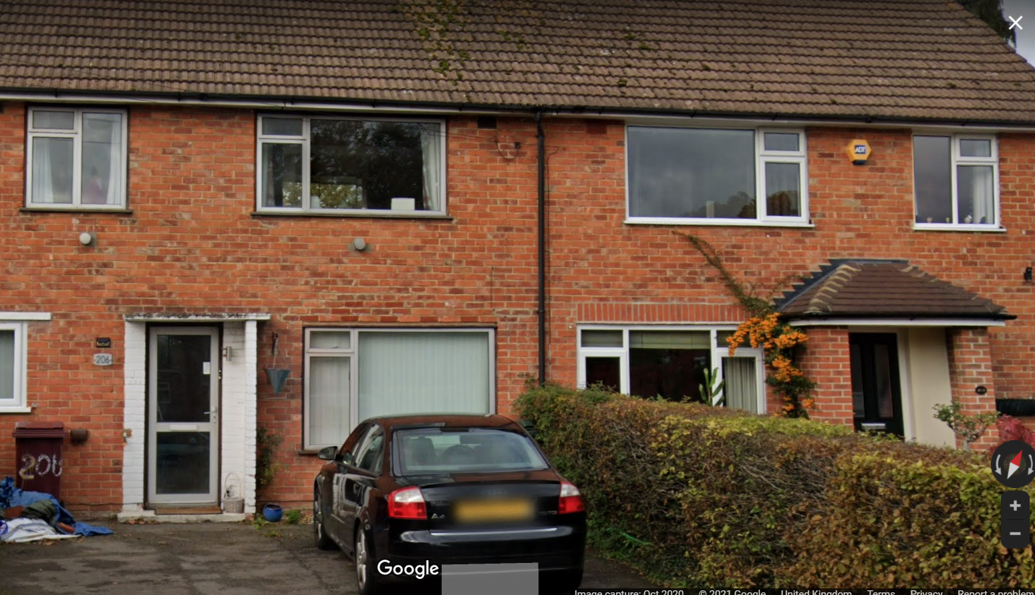

Residential Amenity
CC8 (Safeguarding Amenity) seeks to prevent development causing detrimental impact on the neighbouring properties; policy H9 (House Extensions and Ancillary Accommodation) provides that extensions should not cause an overbearing impact on neighbours”.
As the proposed front and rear extension are single story there would be no overlooking of neighbouring properties and the existing rear boundary fencing between houses would act as a form of screening therefore the extension is unlikely to cause loss of privacy to the neighbours. In addition, the extension is unlikely to cause any loss of sunlight, daylight or overshadowing to the neighbouring house. The proposed development would be considered unlikely to cause an overbearing impact on neighbours.

Conclusion
The proposed extension is considered to be in accordance with the Reading Borough Local Plan (2019) and the Design Guide to House extensions (2021) and therefore the application is recommended for approval subject to conditions.
Recommendation:
Grant
CONDITIONS
- Time Limit (Standard) TL1
- Approved Plans Ap1
- Materials (As Specified) M3

