DELEGATED HOUSEHOLDER APPLICATION REPORT

Address: 49 Oak Tree Road, Reading, RG31 6JU

Application No: 211740/NMA
Proposal: Non-Material Amendment to application 210710 - raise flat roof to rear extension
Case Officer: Chukwudi Onwudinanti

Site Description and Surrounding Area: The application site is a detached on the eastern side of Oak Tree Road.

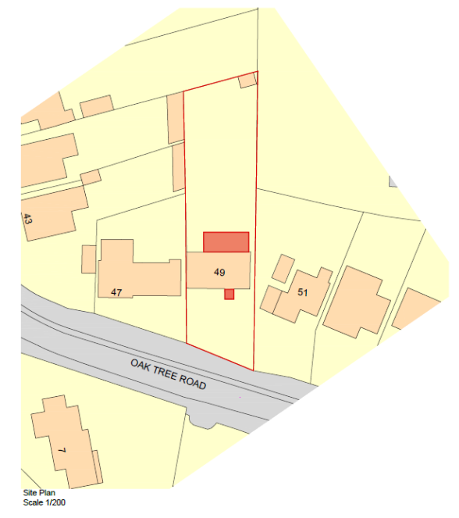

Proposal: Proposal is to raise the flat roof to the rear to a new height of 3.132m. The flat roof needs to be raised to give more headroom to the room and to make the same ceiling height throughout a floor.

Originally Approved under 210710

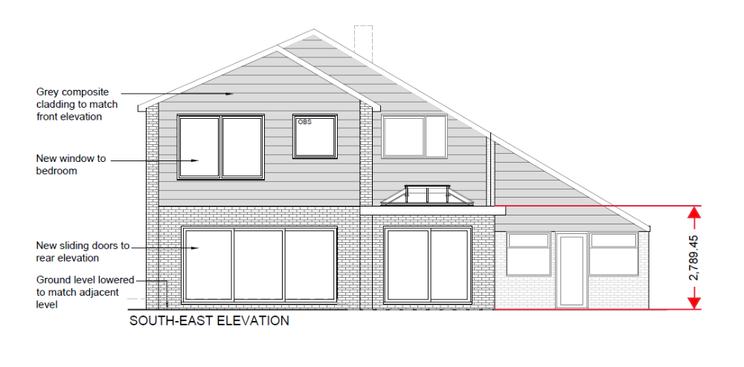

Proposed under 211740

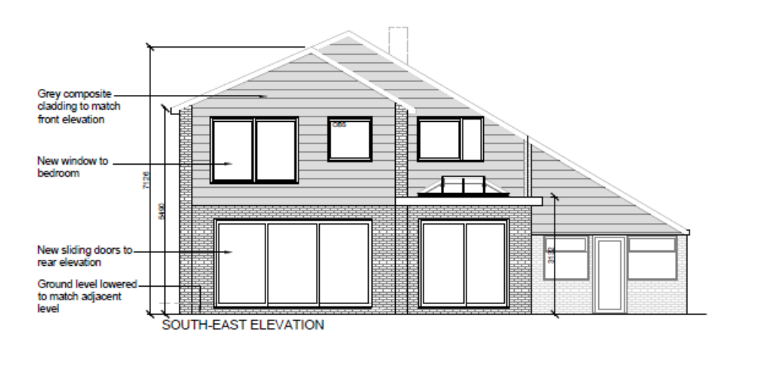
Objections Received (Summary):
Applications under S96A are not applications for planning permission, so are not covered by the publicity requirements as set out in the DMPO.

Relevant Planning History:
Application 210710: Part 1, part 2 storey rear extension with alterations to windows and cladding, reconfiguration of existing porch roof.
Received: 5th May 2021
Approved: 23rd June 2021

Discussions with the Agent:
No discussions were had with the agent.

Plans Considered:
Drawing no: 01 – Site Location Plans Received 25th October 2021
Drawing no: 06C – Proposed Elevations Received 25th October 2021 (originally approved plan under permission 210710)
Drawing no: BR12d – Proposed Elevations Received 25th October 2021

Appraisal:
The proposed change, which will increase the height of the rear extension by 200mm as originally approved under 210710, is not considered to have any significant impact on the character and appearance of the property or the area and no differing effect with regard to amenity matters.

Conclusion:
The changes as proposed are therefore considered to be acceptable non-material alterations to the previously approved application 210710.

Recommendation:
Approve non-material amendment subject to conditions. Although Section 96(A) of the Act does not allow for the original decision to be re-issued, it does allow the modification of, or imposition of, conditions. In this respect it is considered appropriate to impose an additional condition:

Condition
The plans and statements put forward by the agent hereby approved by this Non-Material Amendment (under Section 96A of the Town and Country Planning Act 1990) are as follows:

Drawing no: 01 – Site Location Plans Received 25th October 2021
Drawing no: BR12d – Proposed Elevations Received 25th October 2021

