DELEGATED APPLICATION REPORT - CERTIFICATE OF LAWFULNESS
Application No: 201804/CLE
Site Address: 19 Stanley Grove, Reading
Proposal: Certificate of lawfulness for Change of use of property from single dwelling house into 2no 1 bedroom flats (one on ground floor and one split over the first floor and converted loft space). Original description – Conversion of property into two self contained flats.
Case Officer: Julie Williams
Target Date: 9/2/2021

SITE DESCRIPTION
Property is a two storey end of terrace dwelling with roof extension. The property has a small forecourt front area and a private amenity area which is enclosed to all boundaries.

PROPOSAL
A certificate is sought to confirm that the existing use is as two self-contained 1 bedroom flats. The top floor flat has bedroom in loft area.

The NPPG provides guidance on details that must be included in each type of lawful development certificate (section 191(5) or 192(3) of the Act. Precision in the terms of any certificate is vital, so there is no room for doubt about what was lawful at a particular date, as any subsequent change may be assessed against it.

In particular a certificate for existing use must include a description of the use, operations or other matter for which it is granted regardless of whether the matters fall within a use class. But where it is within a “use class”, a certificate must also specify the relevant “class”. In all cases, the description needs to be more than simply a title or label, if future problems interpreting it are to be avoided. The certificate needs to therefore spell out the characteristics of the matter so as to define it unambiguously and with precision. This is particularly important for uses which do not fall within any “use class” (ie “sui generis” use) and in situations where there are mixed uses.
In accordance with this guidance and in view of how the site has been operated the description for the certificate has been amended, in agreement with the agent and advised by legal section, as shown above.
PLANS SUBMITTED
Block Plan SG19 001
Location Plan SG19 002
Existing floor plans SG19 003
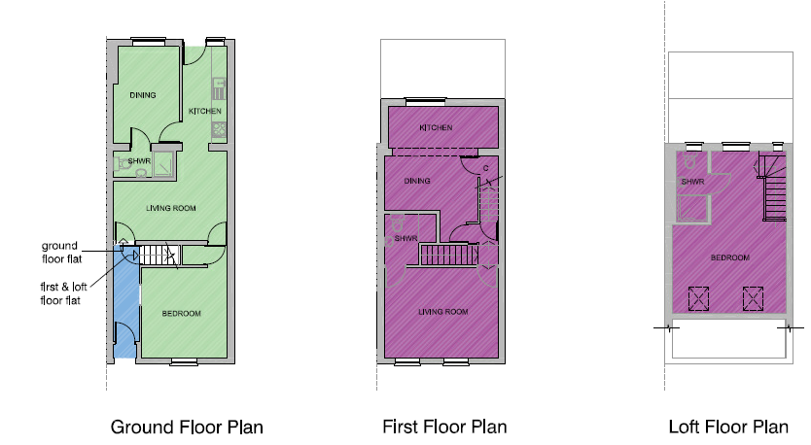
RELEVANT PLANNING HISTORY OF THE SITE
150817 Erection of single storey rear and first floor rear extension. Granted 12 August 2015

RELEVANT PLANNING POLICY AND GUIDANCE
Section 10 of the Planning and Compensation Act 1991 established a procedure that enables anyone who wishes to do so, to apply to the local planning authority to determine whether a proposed use or operation, or an existing operational development or an existing use of land, or any other matter constituting a failure to comply with any condition or limitation subject to which planning permission has been granted, is lawful, and if so, be granted a certificate to that effect.

A Lawful Development Certificate is a legal document stating the lawfulness of past, present or future development. If granted by the local planning authority, the certificate means that enforcement action cannot be carried out to the development referred to in the certificate. However, the certificate will not protect from enforcement action by the planning authority if the specified use or development is then changed 'materially' without a planning application for it.

The certificate is not a planning permission. The planning merits of the use, operation or activity in the application are not relevant. The issue of a certificate depends entirely on factual evidence about the history and planning status of the building or other land and the interpretation of any relevant planning law or judicial authority. The responsibility is on the applicant to provide evidence to support the application.

RESPONSE TO CONSULTATIONS
Legal – Legal have been asked to comment and in discussions confirmed that the conclusions reached and the alterations to the description are correct and logical.
The agent makes reference to a Statutory Declaration in response to my e-mail advice to you.

The Statutory Declaration of the freeholder Amrit Singh Luthra dated 4 December 2020 states
- that the single dwelling house was converted between June 2015 and May 2016 into 2 flats.
- The flats were first occupied as separate dwellings in May 2016.
- Since then the flats have been let

This Statement and the photos support this application.

On balance and without being aware of any information to the contrary, the applicant has provided sufficient evidence to support the claim that the property has been used for 2 separate flats for the requisite 4 year period

Council Tax – 19 Stanley Grove – this was split into two flats (known as gnd & top flr flats), this split was carried out on 01.03.2017. Both flats have been separately let out to tenants since this date.
Enforcement – No records held.
Electoral Services – Data provided – see attached evidence.

EVIDENCE SUBMITTED
The agent supplied the following supporting documents:

Supporting Statement
Affidavits by Satinder Luthra (Owner) dated 9th December 2020 and witnessed by Dexter Montague Solicitors of 105 Oxford Road.
Tenancy Agreements for Ground Floor Flat for 2016 – current day
Tenancy Agreement for First Floor Flat for 2016 – current day
Gas Safety check certificates for both flats
Council tax records for top flat.

ANALYSIS OF EVIDENCE (ASSESSMENT)
For the purposes of establishing the lawful use of the site as claimed by the applicant, the applicant must demonstrate that the two flats have been in place for 4 years leading up to the date the application was made UP subject to no enforcement action having been taken on the property.

The relevant time period is 3rd December 2016 to 2nd December 2020.

The applicant has submitted evidence in the form of tenancy agreements and tenancy associated documents that cover the relevant time period. The LPA has no evidence of its own that disagrees with this evidence and Officers are therefore satisfied that the evidence provided is sufficient to show that the property has been used as claimed by this application.

Therefore it can be confirmed that the property known as 19 Stanley Grove has been in use as two 1 bedroom flats (Use Class C3) for more than 4 years and a Certificate can be issued to this effect.

Recommendation
Grant Certificate

RECOMMENDATION
GRANT Certificate
