DELEGATED HOUSEHOLDER APPLICATION REPORT

Ward: Southcote
App Ref: 211638/HOU
Address: 237 Southcote Lane, Reading, RG30 3AY
Proposals: Two storey side/rear extension and front porch
Case Officer: Chukwudi Onwudinanti
Applicant: Mr Shazad Asghar
Date received (valid from): 4 October 2021
Target Decision date: 29 November 2021

1. INTRODUCTION
The site is an end of terrace dwelling house located on the southern side of Southcote lane, among rows of terraced dwellings of similar style and size.

2. PROPOSAL AND SUPPORTING INFORMATION
The proposal is for the development of a two storey side/rear extension and the introduction of a front porch.

Plans considered (Received 4th October 2021)
P1262-01: LOCATION & BLOCK PLAN
P1262-02: EXISITING PLANS & ELEVATIONS
P1262-03: PROPOSED PLANS AND ELEVATIONS

P1262-01: LOCATION & BLOCK PLAN - A 17 - 11 -2021 (Received 17th November 2021)
P1262-04 (Received 17th November 2021)
P1262-01: PROPOSED PLANS AND ELEVATIONS-A17-11-2021 (Received 17thNovember 2021)
P1262-03: PROPOSED PLANS AND ELEVATIONS: B 25-11 (Received on 26th November 2021)

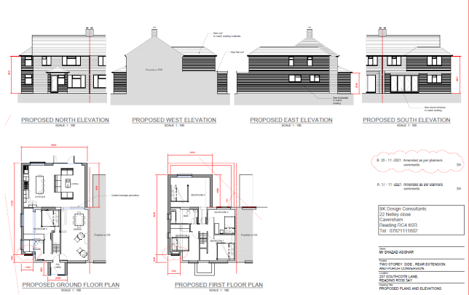

- RELEVANT PLANNING HISTORY

None

4. CONSULTATIONS

4.1 The following addresses were consulted by letter.

235 Southcote Lane, Reading, Berkshire, RG30 3AY
74 Ashampstead Road, Reading, RG30 3LB
239 Southcote Lane, Reading, RG30 3AY
246 Southcote Lane, Reading, RG30 3BA
76 Ashampstead Road, Reading, RG30 3LG
244 Southcote Lane, Reading, RG30 3BA

The planning officer advised the agent to step back the ground floor of the proposed side extension as to make the proposed extension subservient to the original dwelling, as has been done for the first floor extension. The agent took this on board and amended the design accordingly. The blank wall presented initially to the principal elevation has also been re-designed to feature windows in line with CC7.

4.2 No letters of representation have been received.

Equality Act 2010:
In determining this application the Council is required to have regard to its obligations under the Equality Act 2010. However, there is no indication or evidence (including from consultation on the application) that the protected groups identified by the Act have or will have different needs, experiences, issues and priorities in relation to this particular planning application. Therefore in terms of the key equalities protected characteristics it is considered there would be no significant adverse impacts as a result of the development.

- LEGAL AND PLANNING POLICY CONTEXT

Section 38(6) of the Planning and Compulsory Purchase Act 2004 requires that proposals be determined in accordance with the development plan unless material considerations indicate otherwise. Material considerations include relevant policies in the National Planning Policy framework (NPPF) - among them the 'presumption in favour of sustainable development'. The following local and national planning policy and guidance is relevant to this application:

National Policy
National Planning Policy Framework
National Planning Practice Guidance

Reading Borough Local Plan (2019)
CC7 (Design and the Public Realm)
CC8 (Safeguarding Amenity)
H9 (House Extensions and Ancillary Accommodation)

SPD
- A Design Guide to House Extensions SPD

6. APPRAISAL

H9 states: An extension to a house will be acceptable where it:

- Respects the character of the house in terms of scale, location, materials and design;

To assess this, the following has been considered – would the proposal:
- detract from the appearance of the original building through the use of ill-matching materials and by not fitting in with the design, scale and proportions of the original building; NO, the aspect of the proposal that presented a non-subservient character has been remedied by the amendment of the design, to step back the extension from the front façade.
- reduce the amount of usable amenity space for the property to an unacceptable degree; NO
- require the loss of trees in the garden or put significant trees at risk; NO

- Respects the character and pattern of neighbouring properties and the street as a whole in terms of scale, location, materials and design, and any important existing building line; Respects neighbour’s amenities and does not present a large blank façade to public areas.

To assess this, the following has been considered – would the proposal:
- significantly reduce the amount of daylight and sunlight enjoyed by neighbouring properties; NO, the extension does not present any additional impact on the daylight and sunlight already enjoyed by adjoining dwellings, Nos 239 and 235.
- invade the privacy of neighbouring properties through overlooking from windows or balconies; NO, the new window added as a result of this proposal will be an obscure bathroom window, side by side with an existing window of same size and function.
- detract from the character of neighbouring properties through siting, excessive bulk, ill-matching materials or inconsistent design; NO
- detract from the appearance of the street or area by using ill-matched materials, glazing and detailing; NO, the extension wall on the principal elevation is to be finished with materials to match the existing.

CC8: Safeguarding Amenity states an extension to a house will be acceptable where it will not cause a significant detrimental impact to the living environment of existing or new residential properties.

To assess this, the following has been considered – would the proposal cause a significant detrimental impact to the living environment of existing or new residential properties in terms of:

- Privacy and overlooking;
- Access to sunlight and daylight;
- Visual dominance and overbearing effects of a development;
- Noise and disturbance;
- Artificial lighting;
- Vibration;
- Dust and fumes;
- Smell;
- Crime and safety.

- CONCLUSION
The proposed development has been assessed and the proposed works are considered to be in accordance with the above relevant policies and planning permission can be granted.

8. RECOMMENDATION
Grant

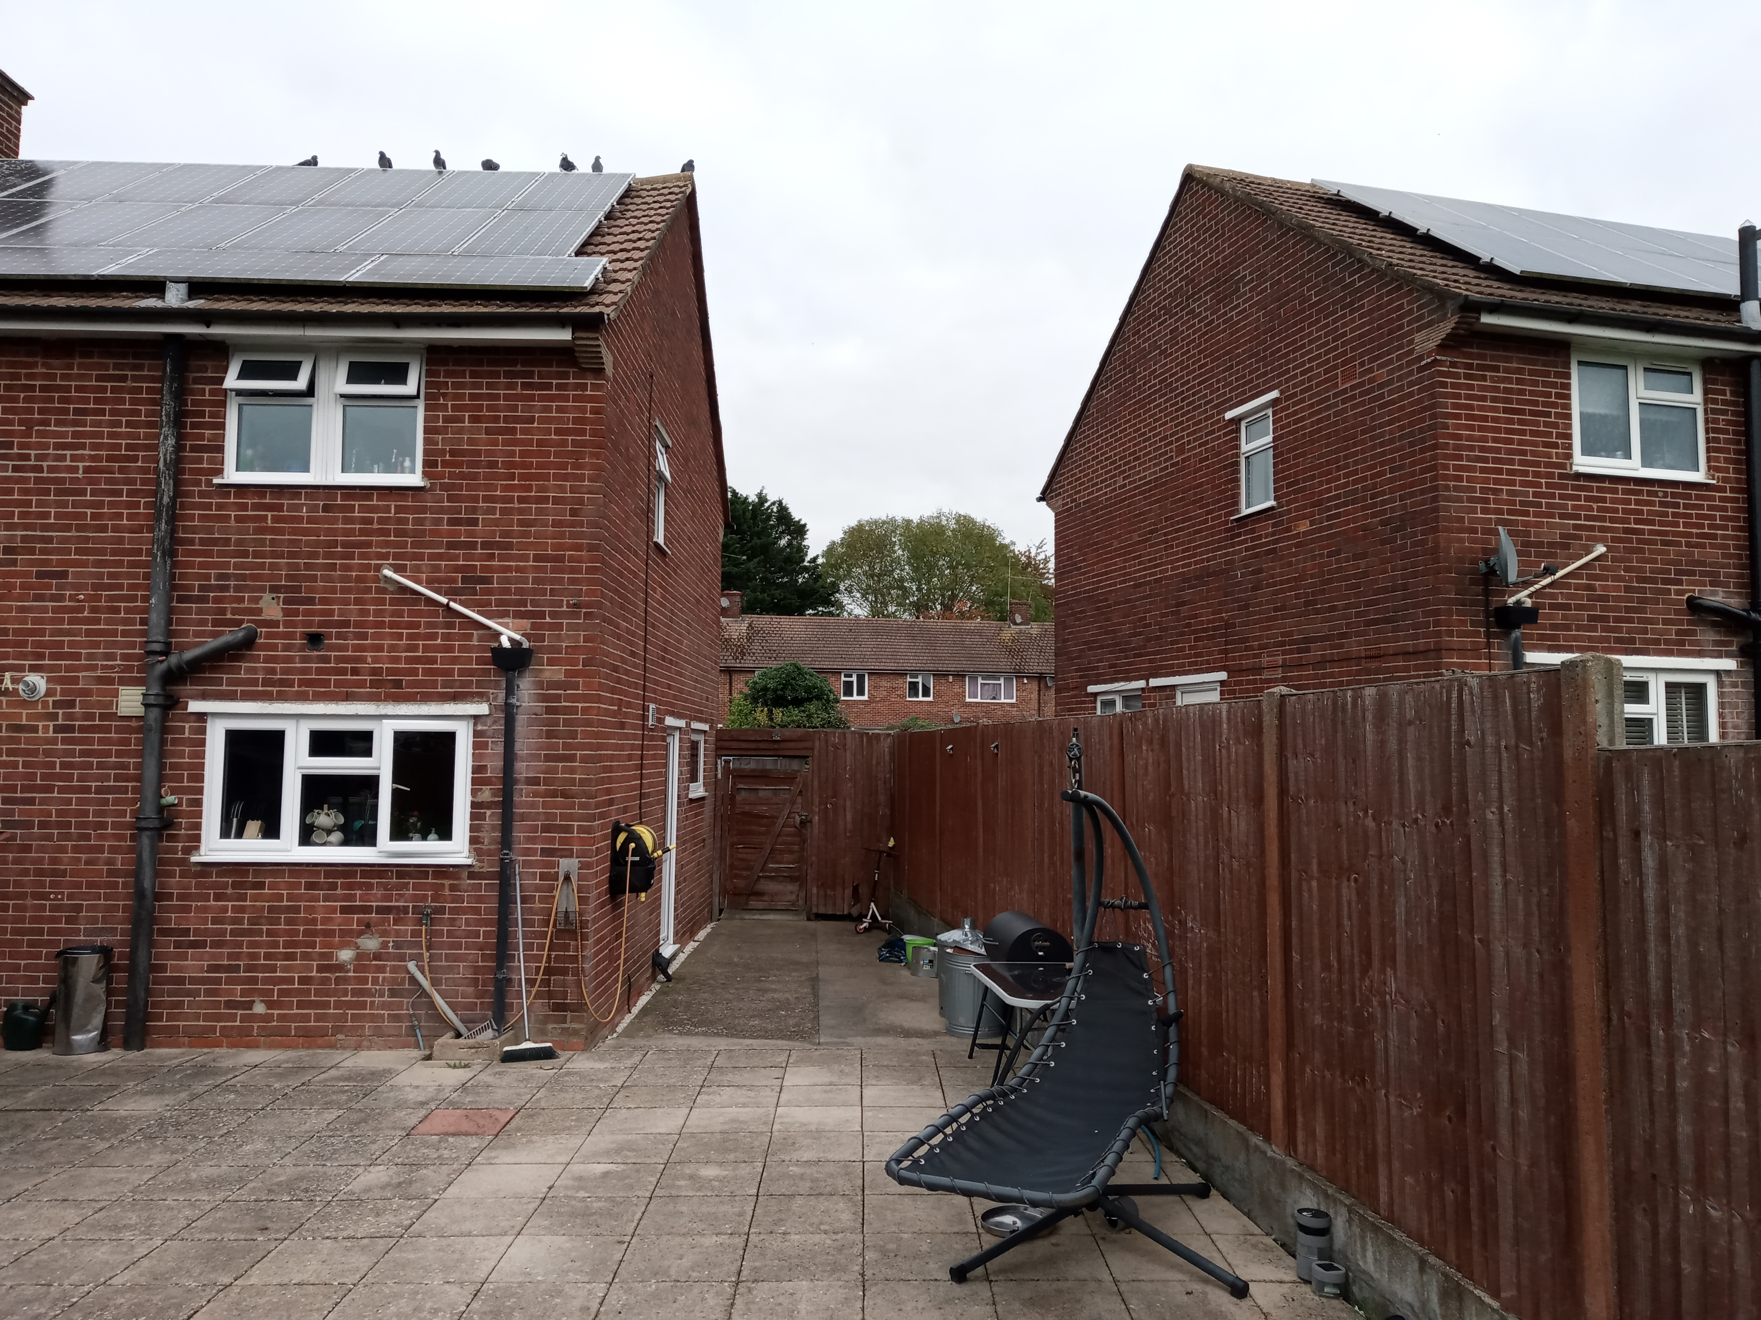
Site photo taken 24th November 2021.

