

Internal and External Repairs at

25 Arbour Close,
Reading, RG1 6EW

For and on behalf of
Sanctuary Group
COMBINED DESIGN, ACCESS AND HERITAGE STATEMENT

Glentworth Court, Lime Kiln Close, Stoke Gifford, Bristol BS34 8SR
T: 0117 931 2062 W: www.kendallkingscott.co.uk

Table of Contents

Section Title Page Ref

1.00 Introduction 3
2.00 Site Overview and History 3
3.00 Listing 4
4.00 Design – Description of the Proposals 5
5.00 Proposals 6
6.00 Summary 6

1.00 INTRODUCTION
1.01 This report has been prepared by Kendall Kingscott Ltd on behalf of Sanctuary Group. The report is to accompany an application for Planning Permission and Listed Building Consent to undertake external repairs on a like for like basis. The external works to comprise replacement all timber sash windows and external rear glazed door.
1.02 The purpose of this report is to provide an assessment of the historic origins of the listed building.
1.03 The report also describes the proposed works and provides strong justification in terms of their impact on the external character and appearance of the building.
1.04 A clear and justified case can made for the proposed repair works, which in our view will not affect the character and appearance of the listed building. The repair and replacement works are intended to maintain the character and significance of the building.
2.00 SITE OVERVIEW AND HISTORY
2.01 25 Arbour Close is situated in the outskirts of Reading in Coley Park, with a bungalow attached to both side elevations. The front elevation looks into the centre of the Arbour Close neighbourhood. The buildings current use is as private residential.
2.02 The building is close to the Holly Brook water course.
2.03 25 Arbour Close is a Grade II Listed structure, the works are proposed only to the external areas of the building.
2.04 The listing identifies several prominent features of the building:
The listing places importance in the red brick walls and occasional blue headers. Windows with light leaded casement. Central 4-panel door with 3 pane overlight.
2.05 The building is a two storey cottage, faced with red brick, with a slate tile roof. in the centre of a modern housing estate.
2.06 The proposed work outlined in this report would have minimal impact on the internal appearance of the building and aims to preserve the significant characteristics of the exterior, while improving safety and longevity of the building fabric.
2.07 The current timber sash windows and rear gazed door set installed in building are not original.

3.00 LISTING
3.01 The listing text is as follows:
- Grade II
- Date of Listing: 14-Dec-1978
- List Entry Number: 1302515
25 ARBOUR CLOSE, READING
WENSLEY ROAD 1. 5128 Kitchen garden walls and gardener's cottage at Coley Park Farm SU 7072 13/605 SU 77 SW 17/605 II 2. Extensive C18 11 foot red brick walls with English and other bonds, and occasional blue headers. Plain soldier course for capping. Plinth. Breached to north-west and south-west. In south wall a gardener's cottage, early C19 front to older building. 2 storeys red brick with band over wound floor, and off set eaves courses. Slate roof with end chimneys. 3 windows on 1st floor, 2 light leaded casements, 2 on ground floor with segmental heads, glazing bar sash to right. Central 4-panel door with 3 pane overlight. Pedimented gable ends. Older brick to rear. Washhouse to west.
Listing NGR: SU7070172011

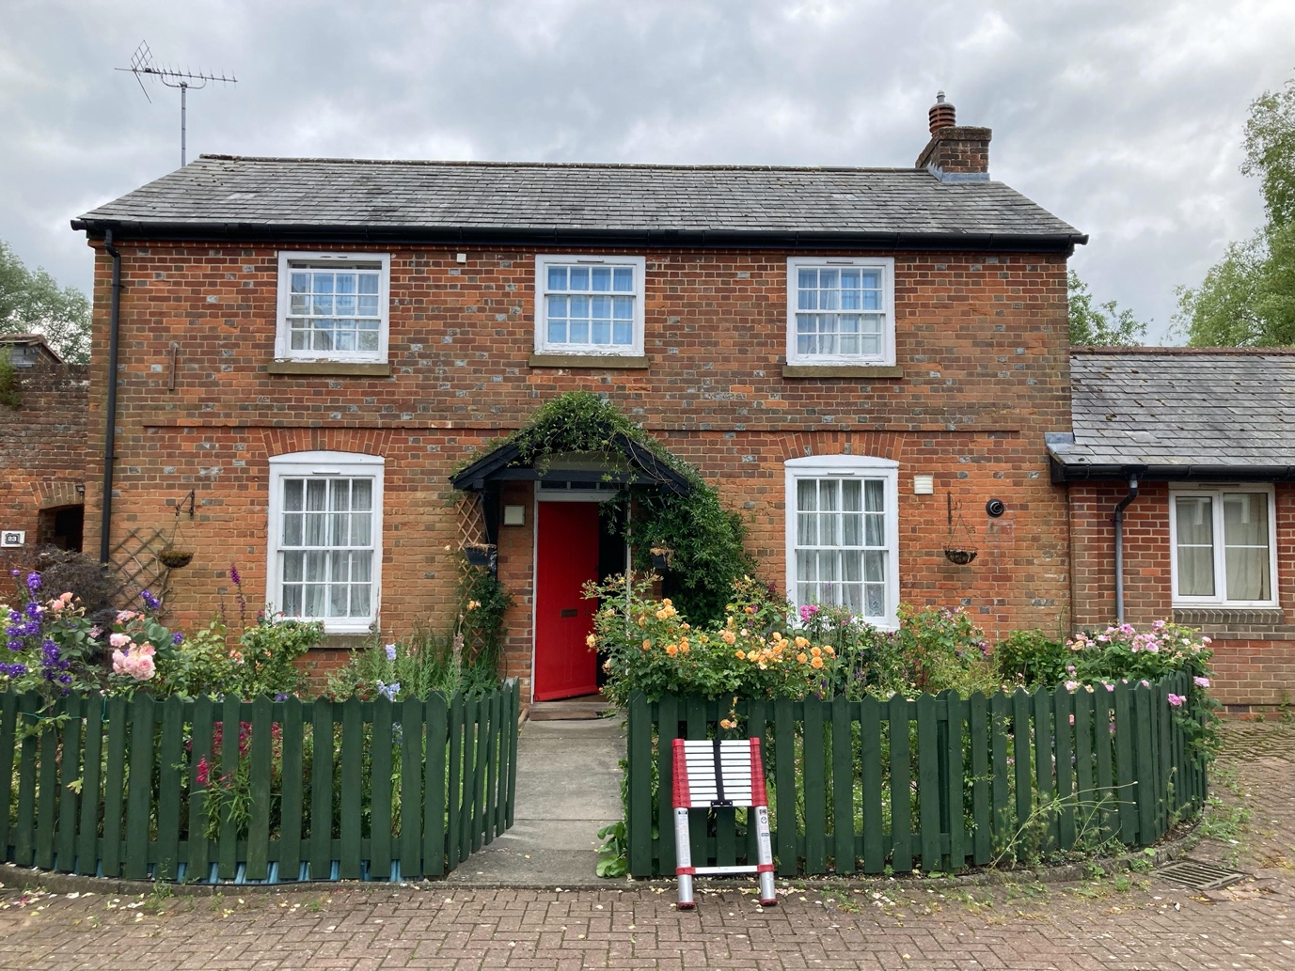

4.00 DESIGN – DESCRIPTION OF THE PROPOSALS
4.01 Overview
The proposal has been designed with the status of the building in mind. The proposed works aim to address issue of areas of black mould growth and damage to existing timber windows and glazed door set.

The existing timber sash and casement windows are largely in a poor condition, with extensive sections of rot and timber decay. Decorations to the windows are flaking and putty cracked or missing typical across both elevations. Spiral sash balances are stiff and dated.

The scope of the works will have a no impact on the existing layout of the building. The proposed works will have no implications on the internal fabric of the building beyond patch repair to damaged / damp-stained plaster walls / ceilings, redecoration to wall finishes.
application proposes to replace all timber sing glazed sash windows and rear door set with similar style timber, double glazed replacements.

The proposals to 25 Arbour Close include the following:

5.00 WINDOW REPLACEMENT
Replace all existing windows with new, white timber sash double glazed windows.
5.01 DOOR REPLACEMENT
Replace rear single glazed door set with similar double glazed door set.
6.00 SUMMARY
25 Arbour Close, Reading is a Grade II Listed building which requires replacement of all timber windows is necessary due to the poor condition of the modern softwood windows frames that have previously been repaired and redecorated. Currently the windows suffer from flaking paint, rot and decay with some water ingress leading to damp within the house.
The door set is in better condition than the windows but are also damaged with cracked paint and timber decay.
The poor condition of existing windows and doors means that redecoration and repair is unfeasible after previous attempts have failed and resulted in more decay. The installation of double glazing will help to prevent further damp inside the house and damage to windows, the windows and doors of the surrounding estate and attached buildings are all double glazed white uPVC.
.

