Design and access statement
Flat 5 Springfield House, 24 Surley Row, Emmer Green, RG4 8LY
Aim
To replace 4 single glazed windows and 1 single glazed French door with double glazing to reduce condensation and mould issues within the property and improve quality of life of the residents.
All windows and doors will remain timber and cottage style but the windows will be vertical sliders to fit with fire regulations that require windows to be bottom-opening. All waste and mess will be removed by the installation company and parking for the installers is available in the forecourt.
Current windows:
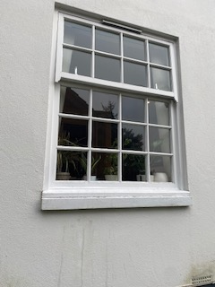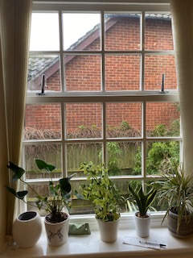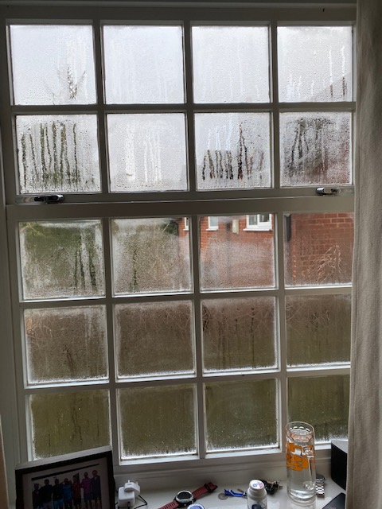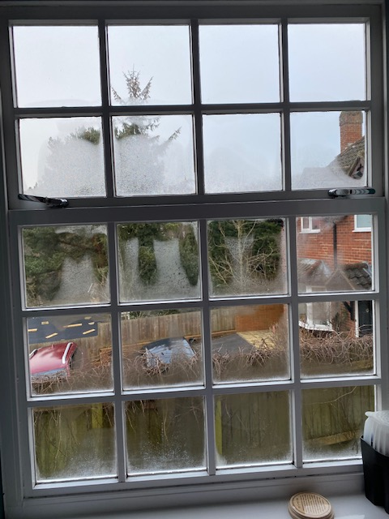

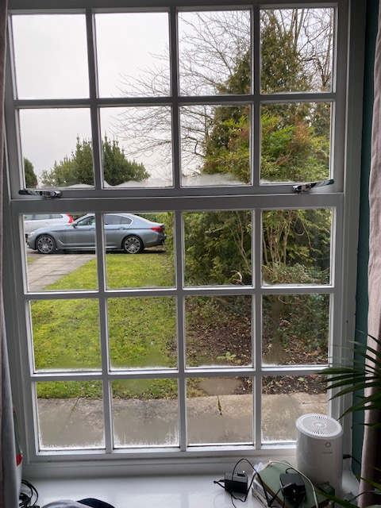

Current French door:
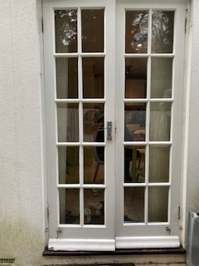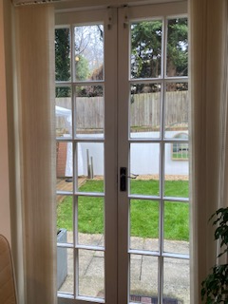

Replacement windows:
