DELEGATED HOUSEHOLDER APPLICATION REPORT

Ward: Church
App Ref: 220314/HOU
Address: 3 Exwick Square, Reading, RG2 8NB
Proposals: Proposed Single storey rear and Side extension.
Case Officer: Chukwudi Onwudinanti
Applicant: SK Design consultants
Date received (valid from): 4 March 2022
Target Decision date: 01 July 2022 (EXT)

1. INTRODUCTION
The proposal site is a semi-detached two storey dwelling on the eastern side of the drive-in into Exwick Square. It is among buildings of similar style and size, in a predominantly residential area.
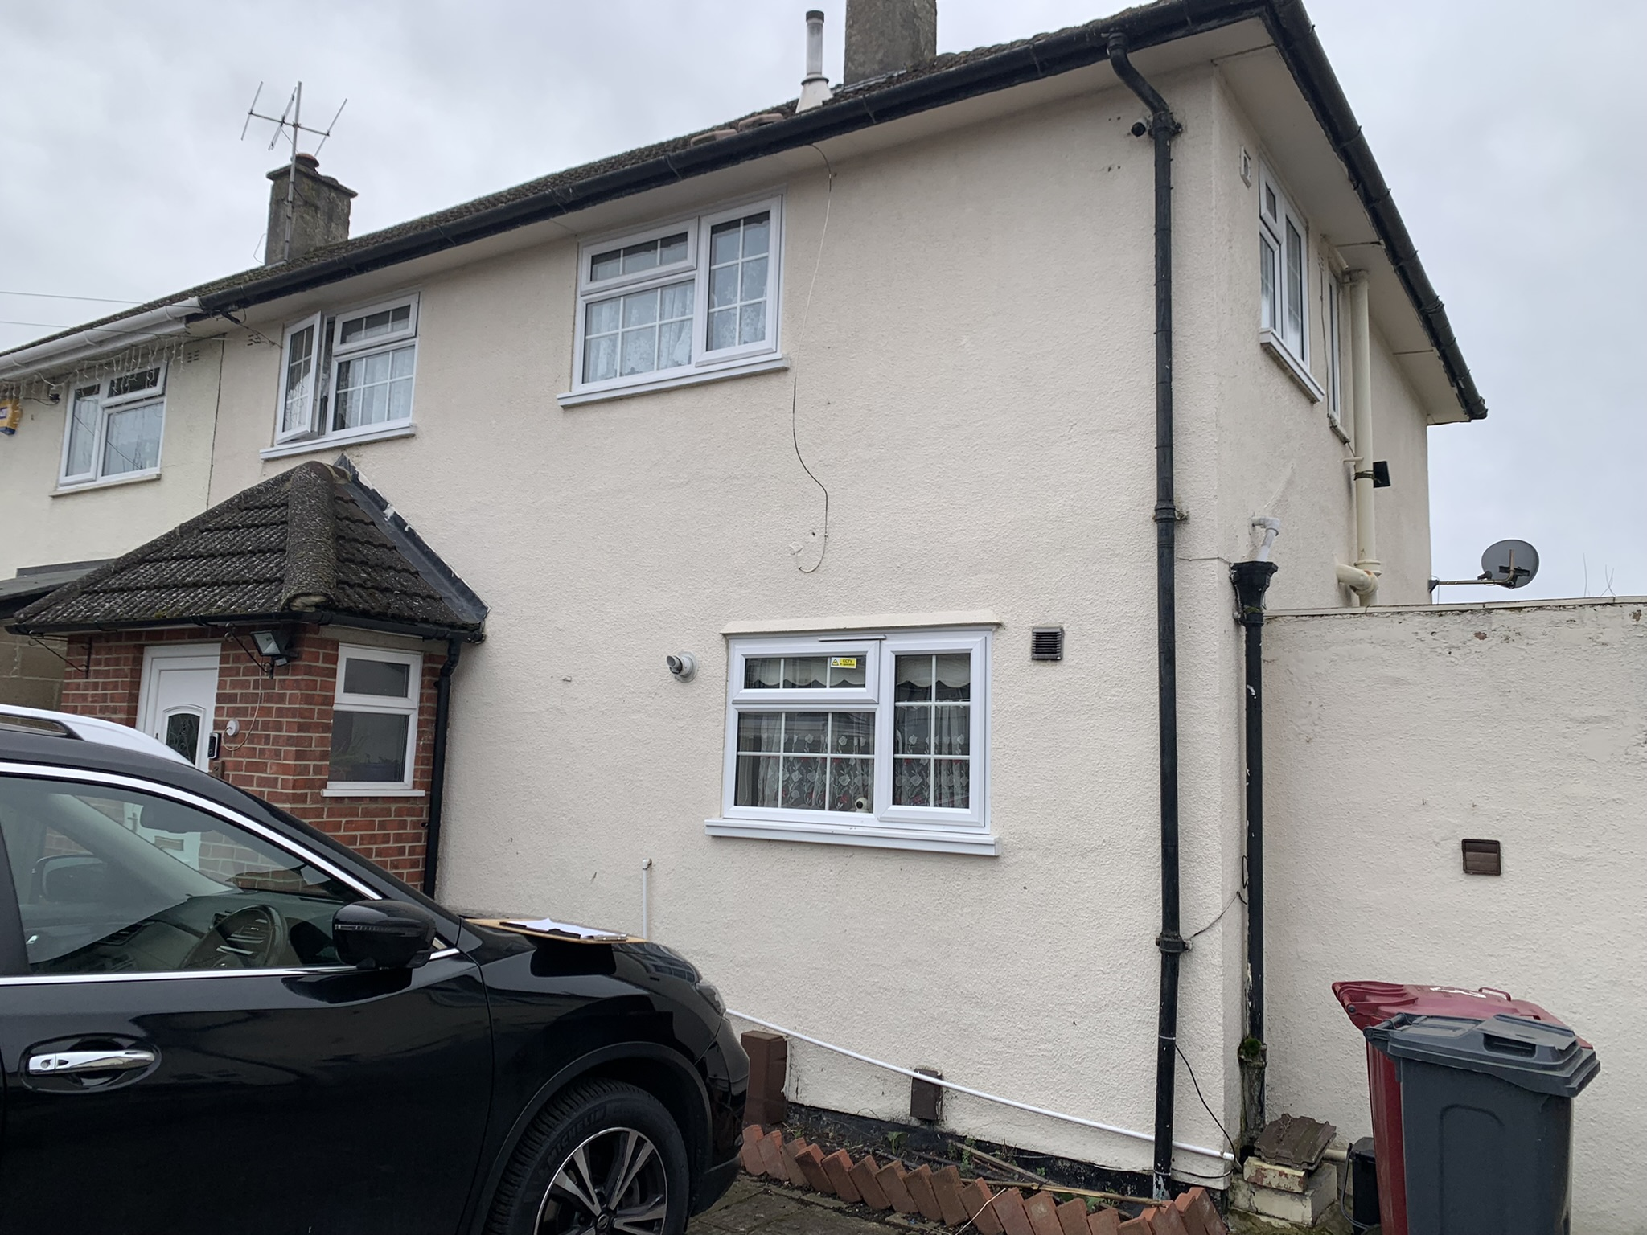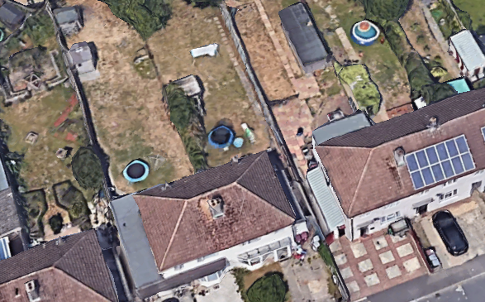

2. PROPOSAL AND SUPPORTING INFORMATION

The application is a proposed Single storey rear and Side extension, extending to the side by the width of an existing wall (approximately 2.3m), running to an overall length of approximately 6m on the side to the rear but with an effective rear extension of approximately 4m.

Plans considered
P1299 01: Location and Block Plan received 8th March 2022
P1299 02: Proposed and Existing Plans and Elevations received 22nd June 2022

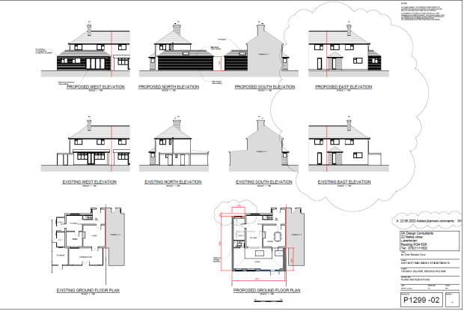
Existing and Proposed Floor Plans and Elevations

- RELEVANT PLANNING HISTORY

None]

4. CONSULTATIONS

4.1 The following addresses were consulted by letter.

459 Northumberland Avenue, Reading, RG2 8LZ
2 Exwick Square, Reading, RG2 8NB
4 Exwick Square, Reading, RG2 8NB
457 Northumberland Avenue, Reading, RG2 8LZ

4.2 No letters of representation have been received.
Agent was advised by Planning Officer to set the side extension aspect back from the frontline of the principal elevation. This advice was taken and the revised drawing sent in to reflect this.

Equality Act 2010:
In determining this application the Council is required to have regard to its obligations under the Equality Act 2010. However, there is no indication or evidence (including from consultation on the application) that the protected groups identified by the Act have or will have different needs, experiences, issues and priorities in relation to this particular planning application. Therefore in terms of the key equalities protected characteristics it is considered there would be no significant adverse impacts as a result of the development.

- LEGAL AND PLANNING POLICY CONTEXT

Section 38(6) of the Planning and Compulsory Purchase Act 2004 requires that proposals be determined in accordance with the development plan unless material considerations indicate otherwise. Material considerations include relevant policies in the National Planning Policy framework (NPPF) - among them the 'presumption in favour of sustainable development'. The following local and national planning policy and guidance is relevant to this application:

National Policy
National Planning Policy Framework
National Planning Practice Guidance

Reading Borough Local Plan (2019)
CC7 (Design and the Public Realm)
CC8 (Safeguarding Amenity)
H9 (House Extensions and Ancillary Accommodation)

SPG/SPD
- A Design Guide to House Extensions SPG

6. APPRAISAL

H9 states: An extension to a house will be acceptable where it:

- Respects the character of the house in terms of scale, location, materials and design;

To assess this, the following has been considered – would the proposal:
- detract from the appearance of the original building through the use of ill-matching materials and by not fitting in with the design, scale and proportions of the original building; NO, while the proposal increases the size of the original dwelling to the side and to the rear, these changes do not detract from the appearance of the dwelling from the street scene.
- reduce the amount of usable amenity space for the property to an unacceptable degree; NO, the increase in footprint does not reduce to an unacceptable degree, the usable amenity space.
- require the loss of trees in the garden or put significant trees at risk; NO

- Respects the character and pattern of neighbouring properties and the street as a whole in terms of scale, location, materials and design, and any important existing building line; Respects neighbour’s amenities and does not present a large blank façade to public areas.

To assess this, the following has been considered – would the proposal:
- significantly reduce the amount of daylight and sunlight enjoyed by neighbouring properties; NO, as the extension is limited to the one storey level.
- invade the privacy of neighbouring properties through overlooking from windows or balconies; NO, there are no windows to the side of the extension.
- detract from the character of neighbouring properties through siting, excessive bulk, ill-matching materials or inconsistent design; NO
- detract from the appearance of the street or area by using ill-matched materials, glazing and detailing; NO

CC8: Safeguarding Amenity states an extension to a house will be acceptable where it will not cause a significant detrimental impact to the living environment of existing or new residential properties.

To assess this, the following has been considered – would the proposal cause a significant detrimental impact to the living environment of existing or new residential properties in terms of:

- Privacy and overlooking;
- Access to sunlight and daylight;
- Visual dominance and overbearing effects of a development;
- Noise and disturbance;
- Artificial lighting;
- Vibration;
- Dust and fumes;
- Smell;
- Crime and safety.

- CONCLUSION
The proposed development has been assessed and the proposed works are considered to be in accordance with the above relevant policies and planning permission can be granted.

8. RECOMMENDATION
Grant

