

Planning Statement – ref 211747 Cranbury College

Currently, Cranbury College Secondary site is heavily restricted on classroom and small workroom space, resulting in a rota of students to access the school. At present, there are an additional 35 students accessing the site that were previously taught at the off-site facility, this facility is no longer available for use, which is putting a huge amount of pressure of the schools resources. This is evidenced following a BB104 analysis recently undertaken. As detailed below, the school has a significant space deficit across all areas expect Staff and Admin.

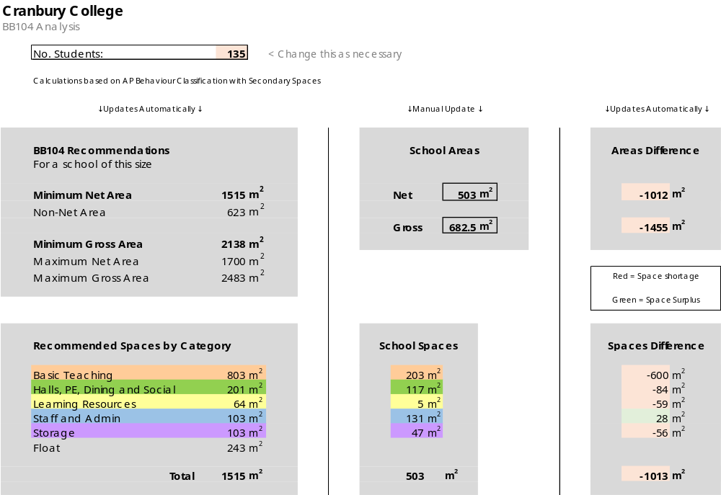

Whilst there are many students in need of a place at the school, there simply isn’t the space to accommodate them without creating a health, safety and behaviour risk. The school currently has a good size car park to the front aspect of Cranbury Road which we could utilise to create the much-needed space. This would consist of 2 modular units consisting of 2 classrooms and 2 group/intervention rooms.

With the additional 2 classrooms, Cranbury College would be in a position to accept the waiting students from the local authority and deliver a stronger onsite curriculum, reducing the need and cost of alternative provision.
The addition of the 2 group/intervention rooms will prove invaluable as smaller spaces to take students that are struggling in the classroom, and targeted small group or 1:1 session’s with visiting outside agency professionals that’s currently a challenge given the available space.

We would propose that temporary units are in place for 3 years initially, this would allow sufficient time to explore a more permanent solution.

We recognised that we are removing a number of parking spaces, but feel that expected benefits would overwhelming outweigh this impact. In a bid to reduce the schools carbon emission, staff are encouraged to travel to work by foot, bicycle, public transport or car share. The school has access to parking permits for the local area which we will made available to relevant staff.

