DELEGATED HOUSEHOLDER APPLICATION REPORT

Ward: Battle
App Ref: 211753/HOU
Address: 36 Prospect Street, Reading, RG1 7YG
Proposals: Demolition of existing garage and store and erection of two storey side/rear extension, single storey rear extension, and an internal refurbishment.
Case Officer: Chukwudi Onwudinanti
Applicant: Mr Mushtaq Ahmed
Date received (valid from): 26 October 2021
Target Decision date: 21 December 2021

1. INTRODUCTION
The proposed site is a semi-detached dwelling unit, on the western side of Prospect Street among dwelling houses of mixed styles and varying sizes.

2. PROPOSAL AND SUPPORTING INFORMATION
Proposed two storey side and rear extension and single storey rear extension.

Plans considered (Received on 26th October 2021)
P1268-01 : Location and Block Plans
P1268-02 : Existing Plans and Elevations
P1268-03 : Proposed Plans and Elevations

Plans considered (Received on 22nd December 2021)
P1268-01A : Location and Block Plans
P1268-03A : Proposed Plans and Elevations

Plans considered (Received on 5th January 2022)
P1268-01A : Location and Block Plans
P1268-03A : Proposed Plans and Elevations

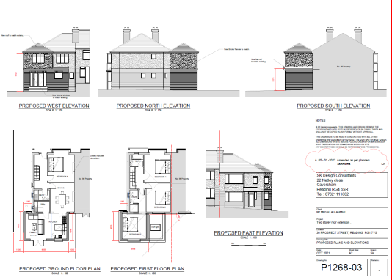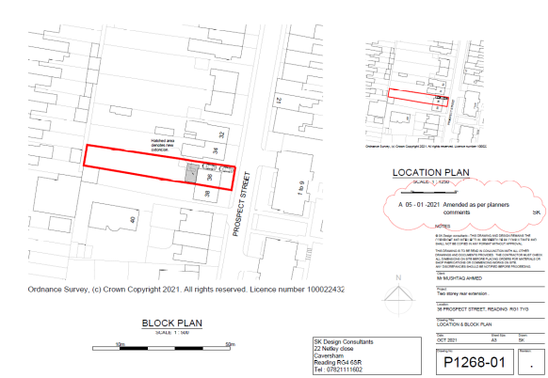

- RELEVANT PLANNING HISTORY
None

4. CONSULTATIONS

4.1 The following addresses were consulted by letter.

38 Prospect Street, Caversham, Reading
45 Lorne Street, Reading, Berkshire, RG1 7YW
47 Lorne Street, Reading, RG1 7YW
Flat 5, 34 Prospect Street, Reading, RG1 7YG
Flat 4, 34 Prospect Street, Reading, RG1 7YG
Flat 3, 34 Prospect Street, Reading, RG1 7YG
Flat 2, 34 Prospect Street, Caversham, Reading, RG4 8JL
Flat 1, 34 Prospect Street, Caversham, Reading, RG4 8JL

4.2 No letters of representation have been received. There have been considerable discussions between the Planning Officer (PO) and the agent regarding the application and the agent has taken the advice of the PO to change different aspects of the design in terms of size and massing.

5. EQUALITY ACT 2010:
In determining this application the Council is required to have regard to its obligations under the Equality Act 2010. However, there is no indication or evidence (including from consultation on the application) that the protected groups identified by the Act have or will have different needs, experiences, issues and priorities in relation to this particular planning application. Therefore in terms of the key equalities protected characteristics it is considered there would be no significant adverse impacts as a result of the development.

6. LEGAL AND PLANNING POLICY CONTEXT
Section 38(6) of the Planning and Compulsory Purchase Act 2004 requires that proposals be determined in accordance with the development plan unless material considerations indicate otherwise. Material considerations include relevant policies in the National Planning Policy framework (NPPF) - among them the 'presumption in favour of sustainable development'. The following local and national planning policy and guidance is relevant to this application:

National Policy
National Planning Policy Framework
National Planning Practice Guidance

Reading Borough Local Plan (2019)
CC7 (Design and the Public Realm)
CC8 (Safeguarding Amenity)
H9 (House Extensions and Ancillary Accommodation)

SPD
- A Design Guide to House Extensions SPG

7. APPRAISAL
H9 states: An extension to a house will be acceptable where it:

- Respects the character of the house in terms of scale, location, materials and design;

To assess this, the following has been considered – would the proposal:
- detract from the appearance of the original building through the use of ill-matching materials and by not fitting in with the design, scale and proportions of the original building; NO, the proposed extension is wholly to the rear and the material finishes are to match existing finishes. The initial size of the proposal has been reduced from 5.8m to 4m to the rear and the side extension has been stepped further away from the boundaries.
- reduce the amount of usable amenity space for the property to an unacceptable degree; NO
- require the loss of trees in the garden or put significant trees at risk; NO

- Respects the character and pattern of neighbouring properties and the street as a whole in terms of scale, location, materials and design, and any important existing building line; Respects neighbour’s amenities and does not present a large blank façade to public areas.

To assess this, the following has been considered – would the proposal:
- significantly reduce the amount of daylight and sunlight enjoyed by neighbouring properties; NO, the second storey aspect of the extension has been stepped back from the point where it would have had a detrimental effect on No 38 neighbours, thereby mitigating any overshadowing. The mass on the side of the boundaries with No 38 has been reduced to 4m, in line with the Design Guide SPD.
- invade the privacy of neighbouring properties through overlooking from windows or balconies; NO, there are no windows on the first floor level of the extension that could cause overlooking.
- detract from the character of neighbouring properties through siting, excessive bulk, ill-matching materials or inconsistent design; NO, the bulk of the extension is to the rear of the original dwelling unit and the aspect visible from the street scene is made subservient to the original dwelling.
- detract from the appearance of the street or area by using ill-matched materials, glazing and detailing; NO

CC8: Safeguarding Amenity states an extension to a house will be acceptable where it will not cause a significant detrimental impact to the living environment of existing or new residential properties.

To assess this, the following has been considered – would the proposal cause a significant detrimental impact to the living environment of existing or new residential properties in terms of:

- Privacy and overlooking;
- Access to sunlight and daylight;
- Visual dominance and overbearing effects of a development;
- Noise and disturbance;
- Artificial lighting;
- Vibration;
- Dust and fumes;
- Smell;
- Crime and safety.

- CONCLUSION
The proposed development has been assessed and the proposed works are considered to be in accordance with the above relevant policies and planning permission can be granted.

8. RECOMMENDATION
Grant
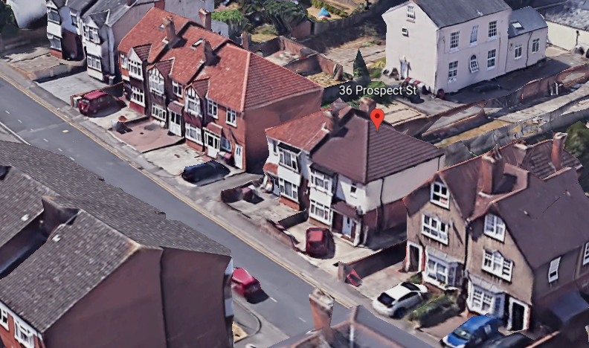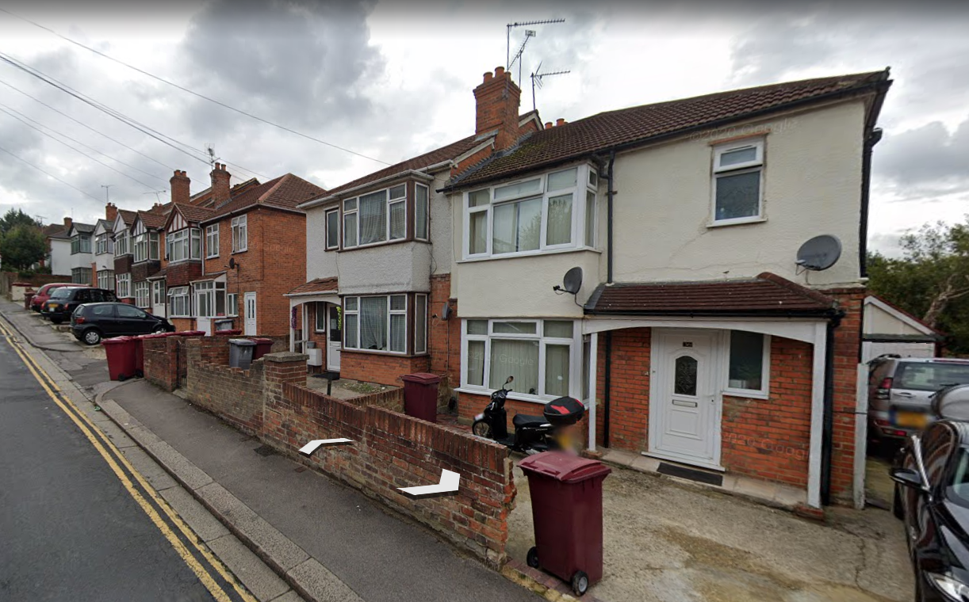

Google Earth Photos (16th December 2021)

