Delegated householder planning report 211106/HOU
32 Ashampstead Road, Reading
2 Storey Side Extension
Site description
The application site is an end-of-terrace house, brick-built, probably 1950s. It has a wide (c4.0 metres) single storey side extension. It lies on the inside of a curve on this suburban road in Southcote. The houses on Ashampstead Road are largely short runs of terraces, although there is a later pair of semis and a recent detached infill house opposite. On this side of the road, the properties are set back from the road behind very deep verges, which are cut into regularly to allow for drop-kerbs. Some end of terrace properties in the area, including No. 30, have been extended to the side (in that case, with a two-storey side extension, a single storey side extension beyond that and a porch canopy extension). The overall impression in the street remains one of spaciousness.
Proposal
The proposal has been amended since it was first submitted, but is described as a 2 storey side extension. The first floor would now be set back by 0.75mm with the front part of the side extension, built on the footprint of the existing side extension, measuring 4 metres wide. The rear of the extension then steps in in line with the boundary to a reduced 3.2 metres in width. The eaves would match the height of the main house but the ridge set down by 0.30mm. Materials indicated to be brick to external walls and tiling to main roof and roof to set back.
From the block plan provided it would appear that the proposed side extension would sit away from the side boundary tapering from about a 1.5 metres gap at the front to about 0.5 metres at the rear.
Relevant planning history
None.
Consultation
Site notice displayed.
Neighbour letters sent to: 28, 30 and 34 Ashampstead Road
Various comments have been received from two addresses, issues raised are:
Considers that the house will no longer be in keeping with other properties
- Too close to neighbouring extension, would look like a row of houses
- Concern for effect on sewerage pipes Officer comment: this is not a planning matter
- Neighbouring properties will become overlooked, there will be an invasion of privacy
- Sunlight will be blocked out
- Loss of light into neighbouring gardens and property
- Loft conversion will block out sunlight
- This property in a short space of time has changed and developed
- It is advised that the roof height has been lowered in accordance with the Building Act 2021 Officer comment: not sure what this refers to or relevance to the proposed development.
No other consultations were undertaken.
Planning Policy
Reading Borough Local Plan (2019) - policies
CS7 (Design and the Public Realm);
H9 (House Extensions);
House Extensions SPD 2021.
APPRAISAL:
This proposal is an amended version of the proposals and this appraisal will discuss this amended version only. The relevant planning issues are considered to be design and amenities impact.
Design
The most relevant view in this planning consideration is as set out below.
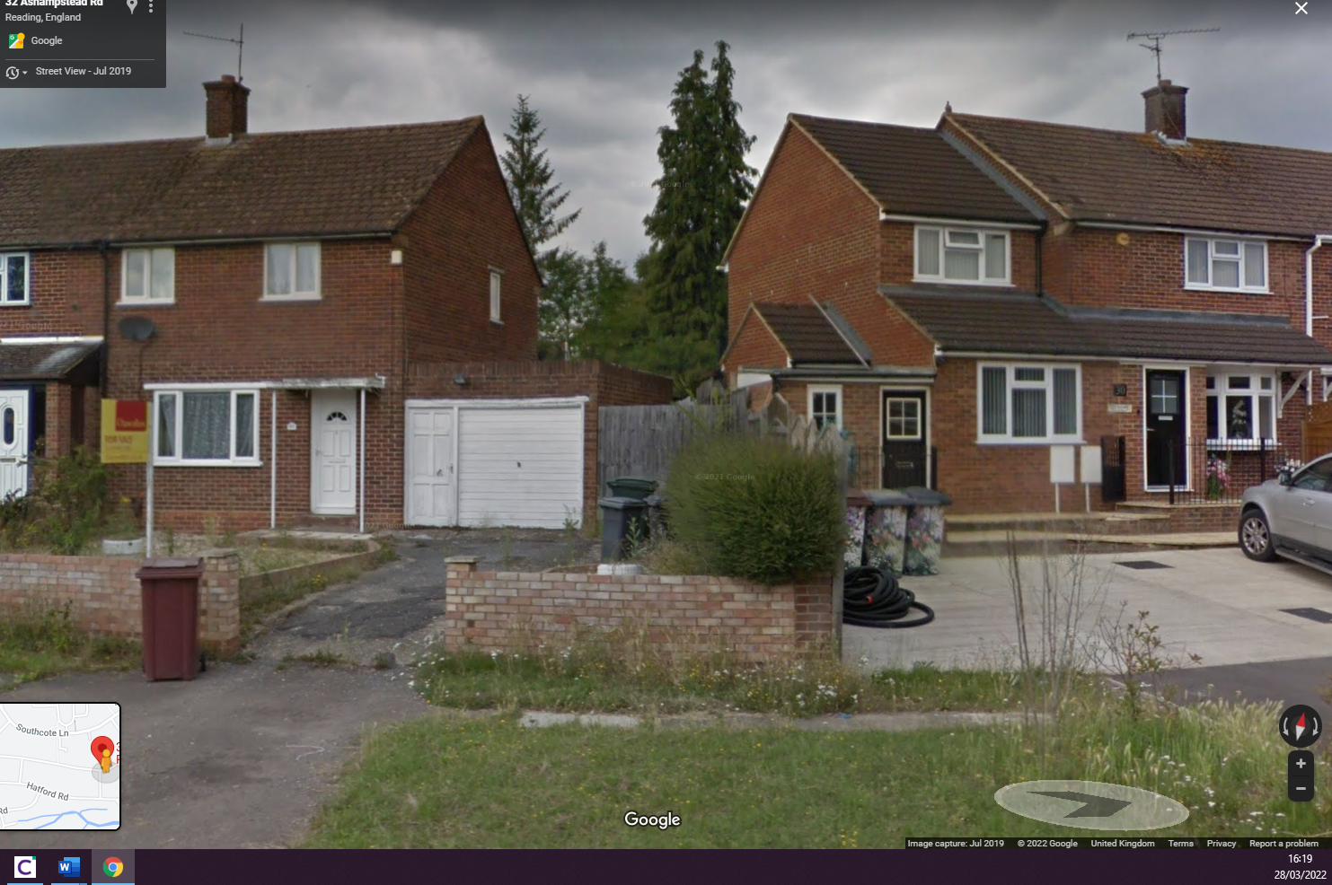
The principal concern with the original plans were that they were contrary to our guidance on side extensions which seek to prevent terracing effects being created – normally achieved by setting the extension (or at least the first floor) back which has the effect of also dropping the ridge height to allow an extension of better proportion. The amended plans are now considered to have overcome this previous concern. The width was also considered but given the width of the existing side garage it was concluded in this case that this was acceptable.
In terms of design detail, the front first floor window in the extension will be very slightly wider than that of the main house, but not so as to be noticeable.
In summary, the proposals will be conditioned to be in matching materials, the design is considered to be suitable and subservient to the host property and is suitable in terms of being sympathetic in massing, design and form to the host property and the streetscene and comply with policies CC7, H9 and the Extensions guidance.
Concerns have been raised with the rear box dormer. This appears to have been built under permitted development and it looks to meet the relevant PD criteria although no certificate to determine this has been requested. An informative can cover this.
Porch – the works underway to construct an enlarged porch are not permitted development, they are too large, neither are they covered by this planning application. No assessment is made of this element, but an informative can state that a separate planning application would be required.
Changes to the former garage (removal of the left-side door, substitution of the garage door for a window, use internally as a habitable room,) are all matters which would be considered to be either de minimis of permitted development.
Amenities impacts
The proposal would involve an additional first floor element, with rear-facing windows. There is the slight curve in the road, so there is a slightly irregular boundary line towards No. 30. However, as is usually the case, the majority of the outlook from the new habitable room window will be down the applicant’s own garden and any lateral overlooking issues to No. 30 would be as would be expected in a residential situation. There are no other overlooking impacts of note.
The proposal involves, in massing terms, an additional first floor side extension over a current ground floor element. Again, this is not an unusual situation. The proposal will case some shadow, mostly over the applicant’s own garden, as it is due north of the location of the proposed extension. It is not clear how or to what extent the proposal would cause demonstrable harm in sunlight or daylight effects to any neighbouring property, but insofar as No. 30 is concerned, there are no side-facing windows (so no light or overlooking concerns) and any impact on light to rear-facing windows in no. 30 or to No. 30’s garden would be mostly affected by their own extensions primarily and not the current proposal; certainly not to any extent such as to lead to the refusal of planning permission on this basis. No other properties would be affected by such concerns.
Other overlooking issues cited are not considered to be relevant to the revised proposals. The proposal complies with Policy CC8.
Other issues
The proposal includes a separate front door. Whilst not an unusual occurrence, it raises the possibility of an internal subdivision being possible, which would not ordinarily be controllable. As a precaution, a condition precluding this is advised.
Equalities Act
With regard to all recognised protected characteristics, it is confirmed that there are no issues.
Recommendation: GRANT permission with conditions.
Tl1-3 years
AP1 Approved plans:
Ground Floor Unaltered received 30/9/21
Proposed First Floor Plan received 10/2/22
Front and Rear Elevations Proposed [Modified Drawing 24/11/21] received on 10/2/22
Existing and Proposed Side Elevations received 10/2/22
Roof Plan, Existing and Proposed received 10/2/22
Enlarged Site Plan to show Boundaries and Next Door Property in detail received on 10/2/22
M1 Materials to match
PD6 No separate use of extension
Std informatives, plus the following:
Separate planning application required for enlarged front porch. Not included on these plans.
Dormer looks to be PD – CLP advised

