Event Safety Management Plan 2021/2022.
Hills Meadow Car Park, George St. Reading RG4 8DH.
Operated by Premier Winter Wonderland Events Limited.

Reading Winter Wonderland.

A FAMILY EVENT GIVING FAMILIES A FANTASTIC WINTER EXPERIENCE.

1. Introduction.
1.1 Intention of Reading Winter Wonderland.
1.2 Aims of Reading Winter Wonderland.

2. Key Personnel.
2.1 Key Personnel numbers.

3. Venue and Site Design.
3. 1 Site Description.
3.2 Venue Capacity.
3.3 Exit Requirements.
3.4 Entrances.
3.5 Excess Visitors.
3.6 No Smoking Regulations.
3.7 Insurance Details.

4. Fire Safety.
4.1 Classifications of Fire.
4.2 Fire Fighting Equipment.
4.3 High Risk Areas.
4.4 Emergency Procedures.
4.5 Special Risks / Vulnerable Persons.
4.6 Designated Muster Area.
4.7 Fire Exit for Marquee.

5. Communications.
5.1 Incident Control Room.
5.2 Off Site Links.
5.3 Radio Communications.
5.4 Radio Operations.
5.5 Public Information and Communications.
5.6 Emergency Public Announcements.

6. Crowd Management.
6.1 Stewards.
6.2 Conduct of Stewards.
6.3 Competency of Stewards.
6.4 Training of Stewards.

7. Transport Management.
7.1 Parking Arrangements – the Operator, Staff, Traders, Stewards/Security and Private Cars
7.2 Parking Arrangements - Coaches.
7.3 Public Transport Arrangements.
7.4 Traffic Management Signs.

8. Structures.
8.1 Site Fencing.
8.2 Entertainment.
8.3 Main Structures.
8.4 VIP / Membership Areas.
8.5 Event Control Unit.
8.6 Temporary Structures.

9. Refreshments.
9.1 Beer Tent.

10. Merchandising.

11. Amusements, Attractions and Promotions.

12. Toilets.

13. Waste Management.

14. Sound, Noise and Vibration Management.

15. Medical and First Aid.

16. General Information and Welfare.
16.1 Information.
16.2 Meeting Points.
16.3 Lost Property.
16.4 Drunkenness / Drug Misuse / Prohibited Items.

17. Children.
17.1 Found Children.
17.2 Lost Children.

18. Performers and Special Guests.

19. TV and Media.
19.1 Pre Event.
19.2 During the Event.

Addendums (Annexes).
1. High Level Site Plan.
2. Ice Rink Plan.
3. Health & Safety Policy.
4. Event Risk Assessments.
5. Roles and Responsibilities.
6. Vehicle and People Traffic Management Details.

1 - Introduction.
  - Intention.
A Premise Licence application is being applied for to enable the operator to play music and serve alcoholic beverages.
It is the intention of the operator to present a fun and family friendly Winter/Christmas Event for local people and tourists alike.
The event will be held at Hills Meadow Car Park from the 12th November – 3rd January excluding Christmas Day and open 11am - 10pm daily.

1.2 Aims of Reading Winter on Ice.
The purpose of this Event Safety Management Plan is to collate information that will be useful to Staff, Stewards, Security and external authorities such as licensing, police and fire services.
With Health, Safety and Welfare of all participants and customers being paramount, we are planning for a successful and safe event.

2 - Key Personnel.
2.1 Key personnel & Contact numbers.
Kelly Williams. Operator. 07899760242/ 07768857857
Hills Meadow will be manned by security from 1st November - 10th January 24 hours a day.

3 - Venue and Site Design.
3.1 Site Description.
Reading Winter Wonderland will be held at Hills Meadow Car Park, Reading. Berkshire.
Hills Meadow Car Park is used throughout the year for Car Parking and Events.
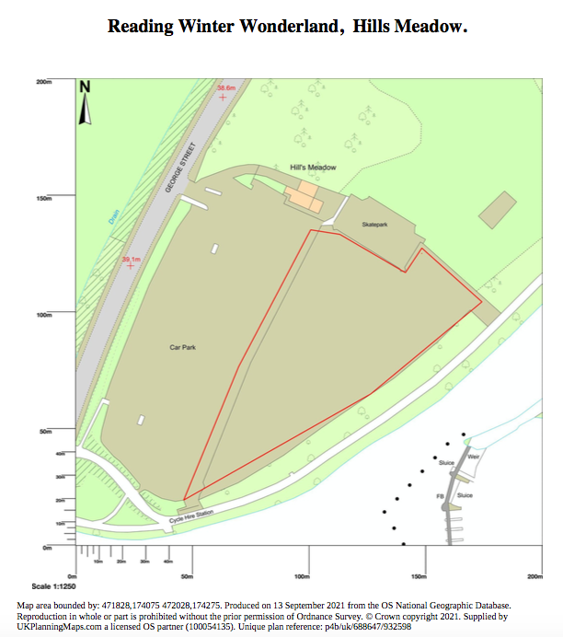

3.2 Venue Capacity.
The Ice Rink has a capacity is 118 skaters per 45 minute session, plus the skaters for the next session who are asked to arrive 20 minutes before their session. The number of customers for the Ice Rink that could be on site at any one time will be 236 people. In addition, other users of the park, friends and family of skaters and customers of other attractions could also be present at any one time and we predict numbers in the park could reach 500 at peak time.
3.3 Exit Requirements.
There are 4 exit/entry points, 2 leading onto The Car Park and 2 leading onto the path that runs behind the event space for Caversham to Reading train station directions ( the latter 2 will be for emergency only ). These will be well sign posted and free from obstruction. The main access for Emergency Vehicles is the entrance facing The Car Park near The Car Wash.
3.4 Entrances.
As above.
3.5 Excess Numbers.
Gate/Security staff will monitor visitor numbers, as we near our max number gate/security staff will go to their positions and limit people in and out keeping in full contact with each other.
3.6 No Smoking Regulation.
All covered tents/marquees will be designated no smoking venues in order to comply with smoke free legislation.
3.7 Insurance Details.
Public and Employees will be insured at £10,000,000. Our current insurance supplier is Park Insurance.
4 - Fire Safety.
4.1 Classification of Fires.
Fires are classified in accordance with BS EN2: 1992 and are defined as below.
Class A Fires Fires involving solid materials, i.e. wood/paper.
Class B Fires Fires involving Liquids.
Class C Fires Fires involving Gases.
Class D Fires Fires involving Metals.
4.2 Fire Fighting Equipment.
Reading Winter on Ice will provide a Fire Point at the Ice Rink Box Office a central point which will house a 9l AFFF Fire Extinguisher and a 2kg CO2 Extinguisher and 1 6l Powder Extinguisher.
4.3 High Risk Areas.
Generator compound. Wooden Stalls. Catering units.
Generator compound, 1x 6KG Powder, 1x 2KG CO2
Wooden Stalls, 1x 6KG Powder.
Catering Units, 1x Fire Blanket (if there is a fryer), 1x 6KG Powder.
Amusement Attractions, Owners of attractions must have a powder and a co2 extinguisher.
4.4 Emergency Procedures.
a) Fire.
If a fire is discovered at any time during the event, it is very important that this procedure is followed.
The fire should only be tackled if it is the early stages and is safe to do so. Time spent fighting a fire in vain is time that could be spent calling the emergency services.
The operator or Security manager should be the nominated person that dials 999 only.
The word "FIRE" is not to be mentioned in any public announcements.
Depending on the fire location the operator/security manager will decide which exits to use and radio his staff immediately on which exits to use so they can help and escort the public to these exits.
If a fire engine is called the operator/security manager will meet the engine at the entrance and direct them to the fire.
b) Suspect device/Bomb threat.
In the event of a bomb warning being received, the security manager shall immediately dial 999 and contact the police and follow their advice and act on their instructions.
A sweep of the site will be made if it is considered safe to do so. Should an evacuation be called for, special attention will be afforded to vulnerable persons and checks will need to be done of the toilets and enclosed areas.
Once evacuated and if a suspect package has been found the area must remain clear and the Police should be informed of its position. Mobile phones must not be used within 10 metres of device.
4.5 Special Risks/Vulnerable Persons.
In the event of an evacuation consideration and help must be given to everyone who needs it especially the young, elderly and the disabled.
4.6 Designated Muster Area.
In the event of a major incident occurring which would require the site being evacuated people will be directed to a designated muster area which will be the square next to the Car Wash. Once every one has left the site announcements will be made every 15 minutes in the muster area to keep the public informed of what is happening.
4.7 Fire Exits.
All fire exits will be signed and any marques will have light up signs.
5 - Communication.
5.1 Incident room.
The incident room/office will be located in the Ice Rink Box Office as it is central to the event.
Key staff will have radios that will be linked to the Box Office.
5.2 Off Site Links.
In the event of an emergency the security manager will dial 999 and request the relevant agency to attend.
5.3. Radio Communication.
All key staff security, Ice Rink manager, catering manager, operator and housekeeping will all have a two way radio's with the base radio being in the Ice Rink Box Office which is positioned central to the event.
5.4. Radio operation.
All radio's must be collected at the beginning of the shift and returned at the end of the shift to the Box Office for security and to make sure they are fully charged, a full charge will last for the full working day.
5.5 Public Information and Communication.
Communication Channels include.
* Publicity material including site brochure.
* Media. (Press, Radio and TV)
* Route - Marketing.
* Signs.
* Notices, information displays.
* Emergency Public announcements.
5.6 Emergency Public Announcements.
When there is known danger, early warning using accurate and timely information is essential. Attendees will respond better if information comes from a source that is recognised as having authority or from someone the attendees respect.
The operator or security manager have the authority to decide that an emergency announcement is necessary, who should make it and under what circumstances.
In the event of a power cut which is unlikely as the event is powered by a generator and there is a back-up which powers up instantly when the power drops, there will be a hand held megaphone that can be used to make an announcement.
6 - Crowd Management.
6.1 Stewards.
The main responsibility of a steward is crowd management. They are also there to assist the police and other emergency services if necessary. The roles of the stewards and security are closely interlinked.
The operator will have approximately 5-10 stewards and 2-4 SIA qualified security staff depending on, off peak or peak times. Stewards and SIA staff will be wearing high visibility jackets to make them easily seen and make them approachable by the public. Also carrying Body Cams.
6.2 Conduct of Stewards.
Stewards need to be fit to carry out their allocated duties, be aged 18 or over and while on duty they should concentrate only on their duties. Stewards should not leave the site without permission and must be calm and courteous to the public who are attending the event.
6.3 Competency of Stewards.
Duties and Competencies of stewards include:
* Understanding their general responsibilities towards the health and safety for all categories of attendees, other stewards, event workers and themselves.
* Carrying out pre-event safety checks.
* Being familiar with the layout of the site and able to assist the attendees by giving information about the available facilities including First Aid, Toilets and also exit points.
* Staffing entrances and exits.
* Controlling or directing the attendees who want to find an attraction or an exit.
* Recognising crowd conditions to ensure the safe dispersal at attendees and the prevention of overcrowding.
* Assisting in the safe operation of the event by keeping gangways and exits clear.
* Responding to emergencies, raising alarms.
6.4 Steward Training.
Stewards and SIA staff will be shown the duties by the operator Kelly Williams who is in charge of the whole event.
The following duties will be explained:
* Access control
* Crowd control
* Queue management and keeping people moving along the paths to ease congestion
* Information delivery
* Assistance in maintaining a safe environment
* Responding to incidents
* Liaising with emergency services and acting as a point of contact during an emergency
* Assisting with the managers of attractions
7 - Transport Management.
The Operator is promoting public transport for general public to access the event. The Reading Mainline Train Station and bus routes run very close by.
7.1 Parking Arrangements, staff, stewards/sia and traders.
The operator Reading Winter on Ice Limited has arranged the use of Hills Meadow for all parking needs and the storage of vehicles needed for the set up and take down of the event. There is also ample parking for public vehicles, staff, stewards/SIA and traders.
7.2 Parking Arrangements - Coach Parking.
As there is a height problem for coaches we are leaving the parking arrangements for coaches to the coach companies but will recommend Napier Road by Kings Meadow.
7.3 Public Transport Arrangements.
The Operator will be promoting the use of public transport.
7.4 Road Traffic Signs.
Road signs will not be needed for this event.

8 - Structures.
8.1 Site Fencing.
The Event will be completely fenced in by a Herris style fence. If the need arises that the Ice Rink or other attractions need a crowd barrier they will be stored on site for that purpose. They will be 1 meter high and can easily be moved in the event of an emergency.
8.2 Main Stage.
The Main Stage for this event is the Ice Rink, as this is the main part and the event feeds from this.
8.3 Reading Winter Wonderland VIP area.
This area will be on the Ice Rink.
8.4 Operation Control Centre.
This is housed in the Box Office which is located by the Ice Rink which is central to the event.
8.5 Temporary Structures.
There will be 1 marquee which will act as the Ice Skate Exchange and First Aid Room. There will be a number wooden Chalets that will be house traders selling festive gifts, gloves, hats etc and also food outlets.
9 - Refreshments.
Reading Winter on Ice Limited will provide the Local Authority Environmental Health Officers with a list of caterers who will be attending and operating from the event.
All caterers will be required to provide all relevant food licencing, safety and environmental health certification. Copies of all relevant documentation shall be available for inspection on the day prior to set up.
9.1 Bar Area.
The Premise Licence will be issued under the name Premier Winter Wonderland Events Ltd and there will be a minimum of 2 Personal licence holders on site with the main one being Billy Williams. If glass ware is used in the bar, when exiting the bar drinks will be transferred into plastic glasses but alcoholic drinks will not be allowed off site, we envisage only using Plastic Glasses. Proposed bar opening times will be 11am until 10pm. A challenge 25 Policy will be used.
10 - Merchandising.
The operator is providing a number of Wooden Chalets for traders to sell festive offerings. All electrical equipment bought on site must have an up to date PAT Test. Traders can enter the site from 8.30am and must leave by 9.15 am to ensure the site is ready for opening to the public at 10am. No vehicle must enter the site without permission from Billy Williams and must be supervised by Billy Williams or a nominated person by Billy Williams.
11 - Amusements, Attractions and Displays.
The Operator will have amusements, attractions and displays. Kelly / Billy Williams will specifically choose the amusements, attractions and displays. Kelly is in overall control of the event and having vast experience in the leisure sector all over the world the attraction operators will be answerable to them only.
12 - Sanitary Facilities.
The Operator will ensure that adequate provision is made for the number of people attending the event and cleaned regularly through the day. They will be split 50/50 male/female. The Operator will monitor the queues throughout the event as the weather gets colder if more units are needed they will be in place the next morning.
13 - Waste Management.
The Operator are very proactive regarding recycling of waste and where possible waste will be recycled. Waste will be picked up through the day and will be taken to the designated waste site for collection.
14 - Sound and Noise.
As any music that is played will be for background purpose we do not consider this will be a problem, but will be monitored to make sure it stays below 60-70Db. Also on exit from the event the attendees will be asked by security to respect any nearby residents and make their way home quietly. The Operator is also applying for a Premise Licence for music on site.
15 - Medical - First Aid.
As the main purpose of this event is Ice Skating we will contract out the First Aid cover, so there will be qualified First Aiders on site for the full operation hours. Treatment room and First Aid station will be located in the Skate Exchange Marquee at the Ice Rink.
16 - Information and Welfare.
16.1 Information.
The Operator will provide advance information about the layout and the facilities on the web site and other forms of media. The main point of information will be the Ice Rink Box Office which has a central location at the event.
16.2 Meeting Point.
There is no designated meeting point for attendees but it is the Box Office for staff.
16.3 Lost Property.
Lost property will be held at the skate exchange marquee at the Ice Rink and the Box Office.
16.4 Drunkenness.
As this is a family event drunkenness will not be tolerated, if a person is under the influence of alcohol the person will be escorted off site and provided with a bottle of water to help them sober up, also if someone is wanting to come on site and is visibly under the influence of alcohol they will not be permitted access to the site.
17 - Children.
The Box Office will be the focal point for lost children and P.A announcements will be directed that way.
17.1 Found Children.
If a child is found to be lost by a steward the steward will radio through to all other stewards informing them of the situation and then take the child to the Box Office. PA announcements will be made to let the child’s parents know where their child is.
When a child is being collected and the child is reluctant to go with the parent or guardian the Security Manager will ask for proof of identification and if in any doubt a second opinion will be sought from the Police. Child welfare is paramount.
Once the child is reunited all staff and stewards must be notified.
17.2 Lost Children.
Any stewards being advised of a lost child by a parent or guardian must report directly to the Security Manager with a relevant description, name and last known location of the child to see if the child has been found.
A radio communication will be broadcast to all staff with relevant details of the lost child.
While the child is lost all entrance/exit points will be supervised by a steward to make sure the child does not leave the site.
If the child has not been located after five minutes, with the parents or guardians consent, a request will be communicated back to the Security Manager to contact the Police and on arrival all help will be given to them.
As above when a child is reunited with parent or guardian if there are any reasons for suspecting the collecting person is not the correct person, identification should be asked for. Once the child is collected all stewards/security will be notified.
18 - Performers
From time to time the Operator may have special performers or celebrity appearances to help with promotion and advertising.
On arrival the performers will be dropped off at the entrance close to The Car Wash where they will be met by 2 security/stewards and escorted quickly to the position that they are required to go. Once they have performed they will be escorted back to the entrance for collection with the least fuss from the public as possible.
19 - TV and Media.
19.1 Pre event.
For the build up to the event there will be numerous press releases to help gain awareness to make it a success. As new attractions are booked they will also be released the same way so when the attendees arrive on site they should already be familiar with the site.
The Operator will also be selling online the Ice Skate tickets in advance of the event, this helps with the waiting times on the day.
19.2 During the Event.
There will be ongoing press/promotions for the event and also online sales will continue to the end of the event.

A FAMILY EVENT GIVING FAMILIES A FANTASTIC WINTER EXPERIENCE.

Annexes
Reading Winter Wonderland.
2020/2021.

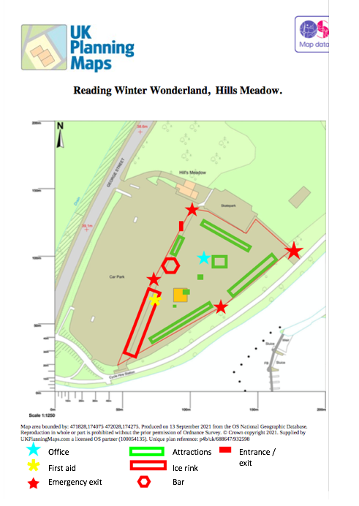

2. Measurements of Structures.
Ice Rink 30m x 15m
Skate Exchange Marquee combined with Ice Rink Marquee 18m x 50m x 9.15m
Christmas Wooden Chalets 3m x 2.5m x 2.7m
3. Health and Safety.
The Operator takes Health and Safety extremely seriously and all possible steps will be taken to ensure that the Health and Safety of its employees, business partners and the general public are equal to that of any other function performed be the Company.
4. Event Risk Assessments.
Hazard Severity Potential.
1 = Minor non-disabling injury or illness.
2 = Serious injury or illness/Temporary disability.
3 = Loss of life/Permanent disability/Major injury/RIDDOR reportable
Risk Ranking (R) = Hazard Severity Potential (S) x Likelihood of Occurrence (L)
Likelihood of Occurrence.
1 = Low - once or a few times per year/or over a lifetime of project
2 = Medium - once or several times per month/or per activity.
3 = High - once or several times per day/or per activity.
The definitions can be as follows.
1. Low Likelihood: Improbable or just feasible likelihood of occurrence e.g. loss or harm occurring. This might be as little as once or twice per year or several times over the lifetime of the activity/project.
2. Medium Likelihood: Occasional occurrence which for continuous, or semi-continuous, activity means loss or harm may occur, once or several times a month while for intermittent, or infrequent , activity means loss or harm may occur once or a few/several times when activity takes place.
3. High Likelihood: A common, regular or frequent occurrence i.e. daily, several times per day, or once/several times each time activity takes place.

Risk Ranking.
Risk Ranking = Hazard Severity Potential x Likelihood of Occurrence.

3 3. Medium. 6. High. 9. High 1 and 2 = Low Risk
Hazard 3 and 4 = Medium Risk
Severity 2 2. Low 4. Medium. 6. High. 6 and 9 = High Risk
Score
1 1. Low 2. Low 3. Medium

1 2 3
Likelihood of Occurrence Score.

Hazard. Who might be Harmed. How. S. L. R. Control Measure.
Fire. Public, Contractors, Traders. Burns, 3. 2. 6. Clear escape routes.
Staff. Smoke. Well disrupted extinguishers
Fire retardant materials.

Trips/slips Public, Contractors, Traders. Cuts/Breaks 2. 2. 4. Signage, all cables covered.
Falls. Staff. Bruises. Steps marked.

Electricity. Public, Contractors, Traders. Elec shock. 3. 1. 3. All equipment tested,
Staff. Burns. Cables secured and away
from standing water.

Crowd. Public, Staff, Traders. Crushing, 3. 1. 3. Do not exceed max numbers.
Fainting. Keep passage ways moving
or keep people moving by
Stewards/Security.

Vehicle Public, Staff, Traders, Crushing/Breaks 3. 1. 3. No vehicle movement without
Movement. Contractors. Bruises Supervision by Steward.

Set up/ Staff/Contractors. Crushing/Breaks 3. 1. 3. Only qualified staff to be on site
Break Down. Cuts stall holders to be supervised
whilst moving vehicles.
First Aid to be on site.

Suspect Staff/Contractors. Crushing/Fainting. 3. 1. 3. Regular sweeps in all areas.
Device. Public.

Food Staff/Contractors. Food Poisoning. 2. 1. 2. Caterers to comply with Food
Contamination. Public. Safety Regulations.

Sanitation. Staff/Contractors. Disease. 2. 1. 2. Toilets to be regularly cleaned.
Public

Noise. Staff/Contractors Hearing 1. 1. 1. Sounds to be monitored at all
Public/Residents Disturbance. times.

Site Access. Staff/Contractors Bruising. 1. 2. 1. Access only while supervised
Ground Damage. by steward.

5. Responsibilities.
It is the responsibility of the Operator to make sure all the contractors have the relevant paperwork and know their responsibilities before coming onto the site and know who to contact if a situation arises where help will be needed, if they are not sure they must stop work and wait.
It is the responsibility of the Operator to train all staff and stewards what is expected from them and to show them round the site so they will be familiar with the day to day running of the event.
It is the responsibility of the Operator to report any Health and Safety Issues or incidents to the Health and Safety Executive.
It is the responsibility of the Operator to make judgement on extreme weather, whether it is safe to have the public on site. If deemed not safe the site will be closed until condition are better, customers will be notified be email, website and social networking sites.
It is the responsibility of the Operator, staff, stewards and traders to give customers a Magical Winter Experience.

