201853 – Brunel Retail Park

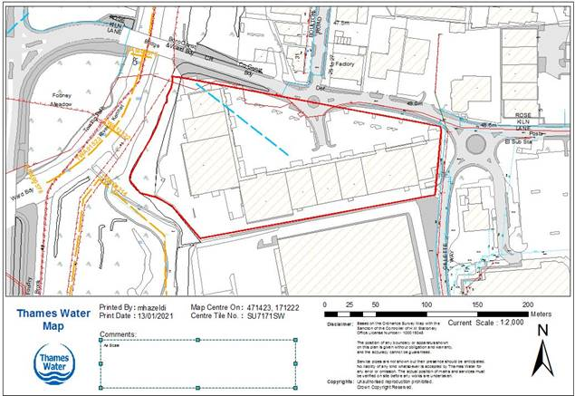
Key: Blue line - a letting easement – TWA02397

