DELEGATED HOUSEHOLDER APPLICATION REPORT
Ward: Minster
App Ref: 211042 / HOU
Address: 3 Kimberley Close, Reading, RG1 6LA
Proposals: Proposed single storey rear and front extension and part double part single storey side extension with garage conversion, following demolition of the existing conservatory. Proposed loft conversion with two rear dormer windows and two velux windows in the front roof slope.
Case Officer: Beatrice Malama
Date received (valid from): 23rd June 2021 Target date: 18th August 2021
Agreed Extension: 9th September 2021

Site description
The application site is a semi-detached house located at the end of Kimberley Close. The area is predominantly residential characterised by a mixture of detached, semi-detached and terraced properties of varying styles and designs. The property is not listed, nor located within a conservation area.
Proposal
The proposal comprises a single story rear and front extensions and part double part single story side extension and conversion of the attached garage to study room. The proposed development also involves loft conversion to create an additional ensuite bedroom with two rear dormer windows and two velux windows in the front roof slope. The proposed rear extension would replace the existing conservatory. The proposed single story rear extension measures 3.3m deep from the existing rear wall and approximately 6.3m wide. The proposed ground floor side extension measures 3m deep from the existing side wall and 10.3m wide whereas the first floor side extension would measure 3m deep and 5.8m wide. The proposed front extension measures 3m deep from the existing front wall and approximately 3.5m wide. The proposed first floor side extension is set back and down resulting in a lower ridgeline than that of the existing house. The proposed front and rear extensions would have a flat roof whereas the proposed two story side extension would have a pitched roof. The converted garage would retain its flat roof. The windows and doors on the extension would be designed to complement that on the existing house with rear dormer windows proposed to have obscured glazed glass. Whilst the proposed extension would extend very close to the northern boundary fencing, a gap of at least 1.2m would be retained between the extension and the southern side boundary fencing.

Plans considered;
Drawing No: KC-02 – Existing Plans
Drawing No: KC-03 – Existing Elevations
Received on 23rd June 2021

Drawing No: KC-01R – Location and Block Plan
Drawing No: KC-04R – Proposed Plans
Drawing No: KC-06R – Proposed Elevations
Received on 18th August 2021

Relevant Planning History
No relevant planning history

Consultations
A site notice was sent to the Agent on 30th June 2021 and the following addresses were consulted by letter.
4 Barrington Way, Reading, RG1 6EG
1 Kimberley Close, Reading, RG1 6LA
Two objection letters were received from the occupants of 4 Barrington Way and 1 Kimberley Close.
Summary of objections raised by the occupants:
- Overlooking and loss of privacy due to the 3 additional rear facing windows
- Impact on character and appearance
- Potential damage to existing boundary fencing, hedges and/or trees
- Increasing number of bedrooms and car-parking spaces could increase the occupants, increasing noise and services required from additional tenants

Planning Officer Comment: Please refer to Character and Appearance and Residential amenity sections of the report to see assessment of the proposed development in relation to the above concerns.
Equality Act 2010:
In determining this application the Council is required to have regard to its obligations under the Equality Act 2010. However, there is no indication or evidence (including from consultation on the application) that the protected groups identified by the Act have or will have different needs, experiences, issues and priorities in relation to this particular planning application. Therefore, in terms of the key equalities protected characteristics it is considered there would be no significant adverse impacts as a result of the development.
Relevant Planning Policy and Guidance
Section 38(6) of the Planning and Compulsory Purchase Act 2004 requires that proposals be determined in accordance with policies in the development plan unless material considerations indicate otherwise. Material considerations include relevant policies in the National Planning Policy framework (NPPF) - among them the 'presumption in favour of sustainable development'.

National Planning Policy
National Planning Policy Framework (2021)
National Planning Practice Guidance

Reading Borough Local Plan (2019)
CC7 (Design and the Public Realm)
CC8 (Safeguarding Amenity)
H9 (House Extensions and Ancillary Accommodation)
TR5: Car and cycle parking and electric vehicle charging
SPG/SPD
Design Guide to House Extensions (2021)
Revised Parking Standards and Design (2011)

Assessment
Character and appearance
Policy CC7 (Design and the Public Realm) requires that all developments be of high design quality.
Policy H9 House extensions and ancillary accommodation in Reading Borough Local Plan 2019 states that “Extensions respect the character and appearance of the house in terms of scale, location, materials and design and should not harm the character and pattern of neighbouring houses and the appearance of the street scene. Extensions should reflect the building line, or, preferably, be set back from the building line”.
The Council’s Supplementary Planning Guidance - Design Guide to House Extensions states that “two storey side extensions should normally be designed to be smaller in scale than the main house. To achieve this the proposed front elevation should be set further back than the front elevation of the original house and a gap between neighbouring buildings be maintained by bringing the upper floor away from the side boundary”.

The area comprises of dwelling houses of various designs and styles. There are a number of properties in the area with front and rear extensions of various types, designs and scales and thus no established street character. Whilst the proposed development would result in a notable increase in the size of the existing house, the proposed first floor side extension would be set back and down resulting in a lower ridgeline than that of the existing house and thus the extension would be more subservient to the existing house. Proposed exterior wall finishes would be of brick to match the existing house and the neighbouring houses.
Notwithstanding that the proposed design includes a flat roof and would be read as a distinctly separate addition to the main house, this is not considered to have a detrimental impact on the appearance of the original house and neighbouring houses. In addition, the introduction of dormer windows to the rear elevation roof for a loft floor would not harm the character and appearance of the existing house. Although the proposed development would be visible from the public realm, it is considered not to have a detrimental impact on the character and appearance of the house and street scene as the design and exterior finishes would match that on the existing house and the setting back and down of the side elevation would allow the existing house to retain its primary character. Furthermore, the property is located at the end of Kimberley Close as such it is considered unlikely to have a detrimental impact on the appearance of the wider area. Any potential harm on the street scene would be limited and therefore would not a warranty a refusal.
In light of the above, the proposed changes to the existing house are considered to be acceptable in terms of design quality, scale and materials and thus would not conflict with Policies CC7 and H9 of the Reading Borough Local Plan 2019.
Residential Amenity
Policy CC7 in Reading Borough Local Plan 2019 states that “All development must be of high design quality that maintains and enhances the character and appearance of the area of Reading in which it is located”.
Policy CC8 (Safeguarding Amenity) of the Reading Local Plan states that “development will only be acceptable where it will not cause a significant detrimental impact to the living environment of neighbouring residents in terms of privacy and overlooking, access to sunlight and daylight and visual dominance and overbearing effects of a development”. Policy H9 House extensions and ancillary accommodation in Reading Borough Local Plan 2019 states that an extension should “not present an overbearing impact on neighbours”.
The main elements to be considered when assessing the impact of development on residential amenity are:
Privacy and overlooking: The property has two existing bedroom windows to the first floor rear elevation and one toilet window to the side elevation. These bedroom windows afford clear views out and across both the rear garden and that of the neighbour at 4 Barrington Way. An approximately 3m high hedge exists between both neighbouring properties along the shared boundary.
The proposal sees the introduction of a new rear facing bedroom window in the side extension. One of the existing bedrooms will be converted to a bathroom with an obscure glazed window (which can be conditioned). The loft conversion would introduce two new dormer windows to the rear roof slope which are also detailed to be obscure glazed.

The total number of upper floor rear openings would increase from two to five. However, of these, the bathroom window and loft dormers would be obscure glazed and would not be openable up to 1.7m above ground level. Therefore, there would remain two unobscured bedroom windows facing westwards into the rear garden, identical to what exists at present.
The proposed side extension would be set approximately 1.2m from the boundary. The new bedroom window would face west across the neighbours garden as the existing bedroom windows do at present, but be set slightly further back from the rear elevation.
Whilst the existing hedge between neighbouring properties would continue to provide some level of screening to the users of the adjoining garden, the side extension and reorganisation of internal space would not create any harmful new views, or significantly greater levels overlooking to the neighbours rear garden.
Therefore in light of the above and subject to relevant obscure glazing condition to those windows specified, it is not considered that the proposed extension would significantly harm the living conditions of adjoining neighbours through loss of privacy.
Access to sunlight and daylight: Due to the orientation of the existing house and adjoining neighbours and the existing generous garden space available to adjoining neighbours, the proposal is unlikely to cause any significant loss of sunlight, daylight or create an unacceptable level of overshadowing to the neighbouring occupants.
Visual dominance and overbearing effects of a development: Although the proposed rear extension would have a notable footprint, the proposed rear extension and part of the proposed front extension would be single story thus making the proposed first floor extension more subservient to the original house. In addition, the design and exterior finishing materials of the extension would match the original house and thus allowing the character of the original house to be retained. The proposal therefore would be considered unlikely to present an overbearing impact on the neighbouring properties and the street scene.
Noise and disturbance and impact on services: As extended, the property will continue to be used as a single unit residential dwelling and therefore would unlikely result in undue noise nuisance for the neighbours and increased pressure on existing services.
Potential damage to existing boundary fencing, hedges and/or trees: As this is a civil matter, it can be dealt with between landowners accordingly.
Impact on existing garden space: Although the proposed rear extension would result in a reduction in the amount of garden space available to the present and future occupants of 3 Kimberley Close, it is considered that the impact on the enjoyment of the garden space by the occupants would not be detrimental.
In view of the above, it is considered that proposed development would not conflict with the requirements of Policies CC8 and H9 of the Reading Borough Local Plan 2019.

Transport
Although the proposed development would result in the loss of the existing garage and thus the loss of a parking space, provisions have been made for three off road car parking spaces as illustrated on drawing No. KC-01R - location and Block Plan. The proposal therefore complies with the requirements within the Council’s adopted Parking Standards and Design SPD that requires that 2 off road parking spaces be provided for a 3+ bedroom dwelling in Zone 2.

Conclusion
The proposed extension is considered to be in accordance with the Reading Borough Local Plan (2019) and the Design Guide to House extensions (2021) and therefore the application is recommended for approval subject to conditions.
Recommendation:
Grant
CONDITIONS
- Time Limit (Standard) TL1
- Approved Plans Ap1
- Materials (As Specified) M3
- No new windows should be introduced to the side elevation of the upper floors
- Obscure glazing (bathroom and roof level)

Site Photos:
1: Side View of the site (Arial photo 11/10/21)
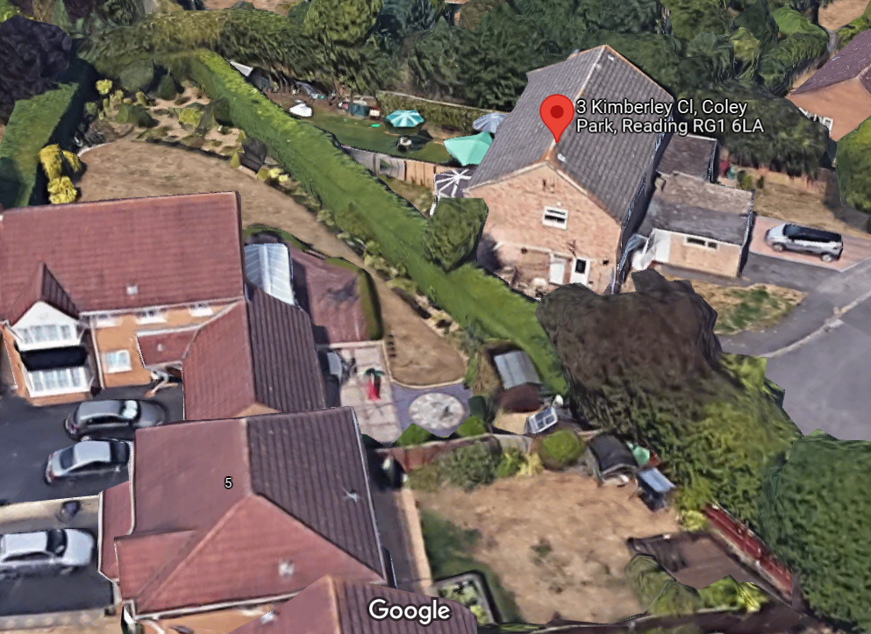
2: Rear View of the side and adjoining neighbours (Arial photo 11/10/21)
