DELEGATED HOUSEHOLDER APPLICATION REPORT

Ward: Redlands
App Ref: 211509/FUL
Address: Granby Tavern Ph, 120 London Road, Reading, RG1 5AY
Proposals: New entrance door (replacement of window).
Case Officer: Chukwudi Onwudinanti
Applicant: Swiss Bubble Ltd
Date received (valid from): 28 October 2021
Target Decision date: 23 December 2021

1. INTRODUCTION
The proposal site is a locally listed building on the southern side of London Road. It has been on the Council’s list of locally listed buildings since 20th November 2013.
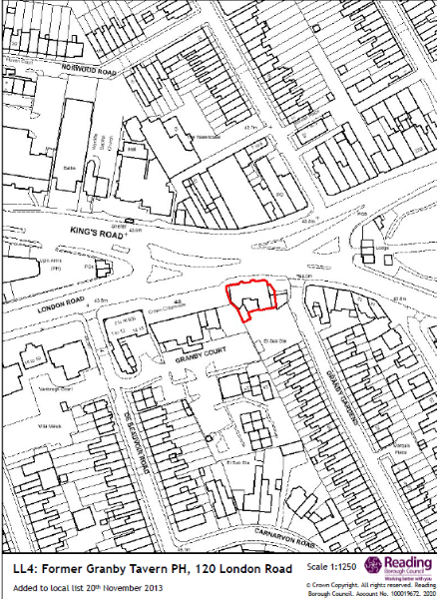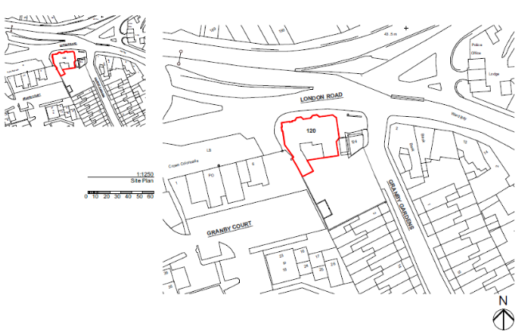

2. PROPOSAL AND SUPPORTING INFORMATION
New entrance door (replacement of window).

Plans considered (Received 10th September 2021)

Drawing no: 171.02/A.1.21.1 : Site Location Plan
Drawing no: 171.02/A.1.21.4: Existing External Elevations
Drawing no: 171.02/A.1.21.2: Existing Ground Floor Plans
Drawing no: 171.02/A.1.21.3: Existing First Floor Plan
Drawing no: 171.02/A.1.21.7: Proposed External Elevation
Drawing no: 171.02/A.1.21.5: Proposed Ground Floor Plan
Drawing no: 171.02/A.1.21.6: Proposed First Floor Plan

- RELEVANT PLANNING HISTORY
211277 : 2 No. No fascia sign on rails, 4 No. Internally illuminated no fascia, 1 No. LED internally illuminated, 2 No. Internally hung sign, 1 No. Vinyl sign externally illuminated on the totem (Undetermined)

4. CONSULTATIONS
4.1 The following addresses were consulted by letter.

124 London Road, Reading, Berkshire, RG1 5AY
108-112 London Road, Reading, RG1 5AY
Tesco Reading, 1 - 4 London Road, Reading, RG1 5BA
Flat 2, 1a London Road, Reading, RG1 5BJ
Flat 1, 1a London Road, Reading, RG1 5BJ
Flat 4, 1a London Road, Reading, RG1 5BJ
Flat 3, 1a London Road, Reading, RG1 5BJ
1a London Road, Reading

4.2 No letters of representation have been received.

Equality Act 2010:
In determining this application the Council is required to have regard to its obligations under the Equality Act 2010. However, there is no indication or evidence (including from consultation on the application) that the protected groups identified by the Act have or will have different needs, experiences, issues and priorities in relation to this particular planning application. Therefore in terms of the key equalities protected characteristics it is considered there would be no significant adverse impacts as a result of the development.

- LEGAL AND PLANNING POLICY CONTEXT
Section 38(6) of the Planning and Compulsory Purchase Act 2004 requires that proposals be determined in accordance with the development plan unless material considerations indicate otherwise. Material considerations include relevant policies in the National Planning Policy framework (NPPF) - among them the 'presumption in favour of sustainable development'. The following local and national planning policy and guidance is relevant to this application:

National Policy
National Planning Policy Framework
National Planning Practice Guidance

Reading Borough Local Plan (2019)
CC7 (Design and the Public Realm)
CC8 (Safeguarding Amenity)
EN1: Protection and Enhancement Of The Historic Environment
EN4: Locally Important Heritage Assets

- APPRAISAL
While Reading Borough Local Plan (RBLP) Policies CC7 and CC8 have been taken into consideration in determining this application, there is no significant detrimental impact the development could have on the Public Realm and Amenity, as the development is limited to only the change from a window into a door, using original matching materials.

Policy EN1 states: All proposals will be expected to protect and where possible enhance the significance of heritage assets and their settings, the historic character and local distinctiveness of the area in which they are located. Proposals should seek to avoid harm in the first instance. Any harm to or loss of a heritage asset should require clear and convincing justification, usually in the form of public benefits.

Applications which affect Listed Buildings will not have an adverse impact on those elements which contribute to their special architectural or historic interest including, where appropriate, their settings.

Policy EN4 states: Development proposals that affect locally important heritage assets will demonstrate that development conserves architectural, archaeological or historical significance which may include the appearance, character and setting of the asset.

Planning permission may be granted in cases where a proposal could result in harm to or loss of a locally important heritage asset only where it can be demonstrated that the benefits of the development significantly outweigh the asset’s significance. Where it is accepted by the Local Planning Authority that retention is not important, recording of the heritage asset should be undertaken and submitted alongside development proposals.

In determining this application, the Planning Officer advised the Agent to provide the LPA with a heritage statement and a statement to justify the reason for the application to alter the appearance of this locally listed building. The agent provided this statement, stating that their reason for this application is to provide Disabled Access to the building. This provision has been viewed by the Planning Officer to satisfy EN1 and EN4 requirements. This development therefore provides a wider door, put in place to give greater disabled access and set in between the two bay windows in a fashion that enhances the appearance of the principal façade.
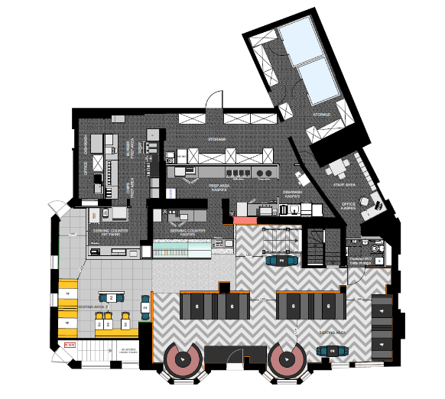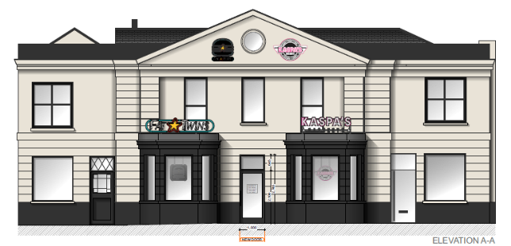

Proposed Ground Floor Plan and Elevation showing proposed door.

- CONCLUSION
The proposed development has been assessed and the proposed works are considered to be in accordance with the above relevant policies and planning permission can be granted.

- RECOMMENDATION
Grant
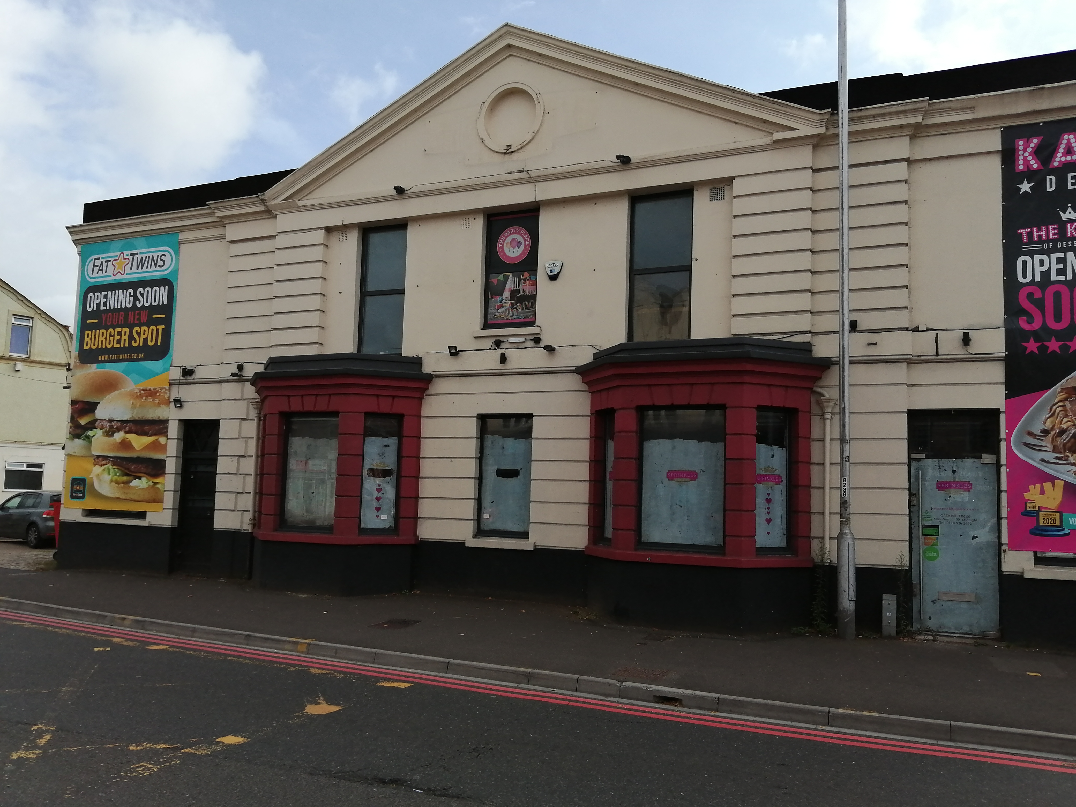

Site Photo taken on 23rd September 2021

