DELEGATED HOUSEHOLDER APPLICATION REPORT

Ward: Thames
App Ref: 211840/HOU
Address: 2 The Ridgeway, Caversham, Reading, RG4 8NX
Proposals: A single storey side extension with internal alterations.
Case Officer: Chukwudi Onwudinanti
Applicant: Mr & Mrs Troth
Date received (valid from): 12 November 2021
Target Decision date: 3 February 2022

1. INTRODUCTION
The proposal site is a semi-detached dwelling house on the intersection of Ridgeway and Berrylands Roads. The dwelling is of a different style from all the other houses around the same street scene. As a result of its position, the proposed site has two street facing facades - the front façade facing Berrylands Road and the proposed extension side, facing Ridgeway Road.

2. PROPOSAL AND SUPPORTING INFORMATION

This proposal is for single storey side extension measuring 7m deep and 4m wide, with internal alterations to the kitchen and utility room areas. The agent has stated that this application is a revision of a previous application which was granted for a two storey extension (ref: 210668). In contrast to the previous approval, which had a pitched roof, replicating the existing roof style, this application features a mono pitch roof.

Plans considered
21005 - SU – 001: Existing Site Plan (block plan)
21005 - LO – 001 : Location Plan
21005 - DD – 001 : Proposed Site Plan (block plan)
21005 - SU – 002 : Existing Floor Plans
21005 - DD – 002 : Proposed Floor Plans
21005 - SU – 003- : Existing Elevation & Typical Section
21005 - DD – 003 : Proposed Elevation & Typical Section
21005 - SU – 004: Existing Elevations
21005 - DD – 004 : Proposed Elevations

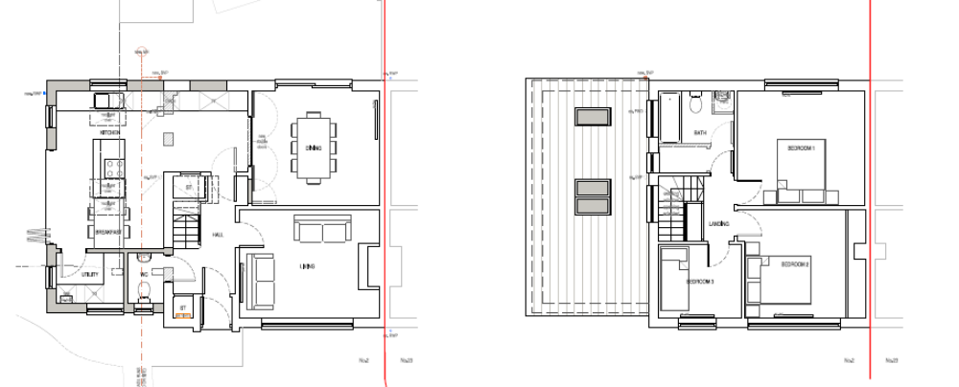

- RELEVANT PLANNING HISTORY

Application Ref: 210668
Application Date: 29th April 2021
Description: A proposed two storey side extension with internal alterations
Status: Granted 13th August 2021

4. CONSULTATIONS

4.1 The following addresses were consulted by letter.

24 Berrylands Road, Caversham, Reading, RG4 8NU
23 Berrylands Road, Caversham, Reading

4.2 No letters of representation were received.

Discussion with the agent:
The Planning Officer discussed the potential for the proposal to have a pitched roof to replicate the existing roof of the original dwelling. However, amended plans were not forthcoming and on further review the Officer considered that the mono pitch, which falls to the height of 2.1m at the eaves facing the street scene, would not be prominent within the street scene, and would not, therefore, have a significant overall negative impact on the public realm.

Equality Act 2010:
In determining this application the Council is required to have regard to its obligations under the Equality Act 2010. However, there is no indication or evidence (including from consultation on the application) that the protected groups identified by the Act have or will have different needs, experiences, issues and priorities in relation to this particular planning application. Therefore in terms of the key equalities protected characteristics it is considered there would be no significant adverse impacts as a result of the development.

- LEGAL AND PLANNING POLICY CONTEXT

Section 38(6) of the Planning and Compulsory Purchase Act 2004 requires that proposals be determined in accordance with the development plan unless material considerations indicate otherwise. Material considerations include relevant policies in the National Planning Policy framework (NPPF) - among them the 'presumption in favour of sustainable development'. The following local and national planning policy and guidance is relevant to this application:

National Policy
National Planning Policy Framework
National Planning Practice Guidance

Reading Borough Local Plan (2019)
CC7 (Design and the Public Realm)
CC8 (Safeguarding Amenity)
H9 (House Extensions and Ancillary Accommodation)

SPG/SPD
- A Design Guide to House Extensions SPG

6. APPRAISAL

H9 states: An extension to a house will be acceptable where it:

- Respects the character of the house in terms of scale, location, materials and design;

To assess this, the following has been considered – would the proposal:
- detract from the appearance of the original building through the use of ill-matching materials and by not fitting in with the design, scale and proportions of the original building; NO, the design of the mono pitch roof has been stepped down as to remove any negative impact on the original building.
- reduce the amount of usable amenity space for the property to an unacceptable degree; NO
- require the loss of trees in the garden or put significant trees at risk; NO

- Respects the character and pattern of neighbouring properties and the street as a whole in terms of scale, location, materials and design, and any important existing building line; Respects neighbour’s amenities and does not present a large blank façade to public areas.

To assess this, the following has been considered – would the proposal:
- significantly reduce the amount of daylight and sunlight enjoyed by neighbouring properties; NO
- invade the privacy of neighbouring properties through overlooking from windows or balconies; NO
- detract from the character of neighbouring properties through siting, excessive bulk, ill-matching materials or inconsistent design; NO.
- detract from the appearance of the street or area by using ill-matched materials, glazing and detailing; NO

CC8: Safeguarding Amenity states an extension to a house will be acceptable where it will not cause a significant detrimental impact to the living environment of existing or new residential properties.

To assess this, the following has been considered – would the proposal cause a significant detrimental impact to the living environment of existing or new residential properties in terms of:

- Privacy and overlooking;
- Access to sunlight and daylight;
- Visual dominance and overbearing effects of a development;
- Noise and disturbance;
- Artificial lighting;
- Vibration;
- Dust and fumes;
- Smell;
- Crime and safety.

- CONCLUSION
The proposed development has been assessed and the proposed works are considered to be in accordance with the above relevant policies and planning permission can be granted.

8.0 RECOMMENDATION
Grant
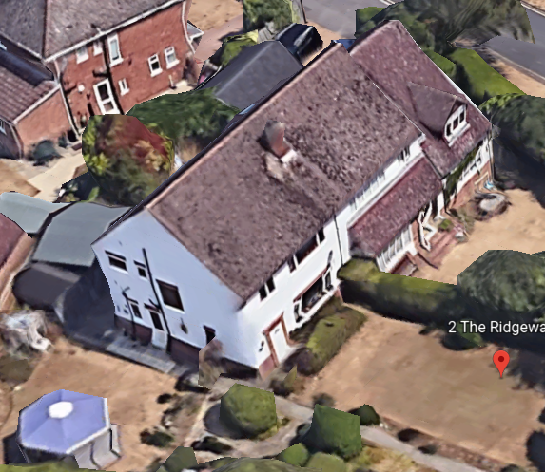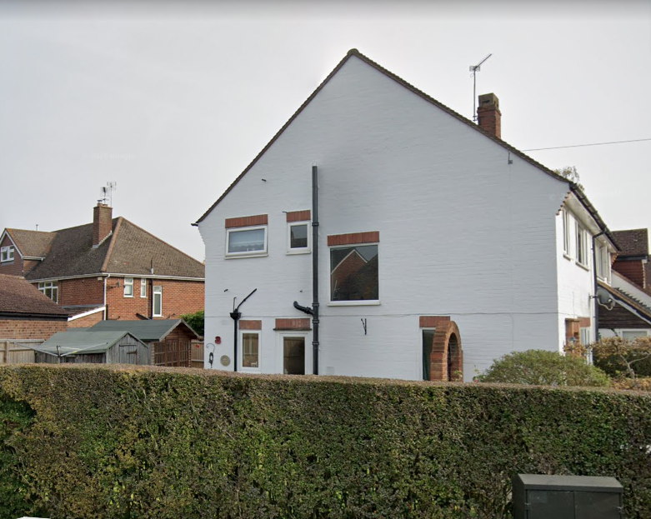

Google Earth Photos

