DELEGATED HOUSEHOLDER APPLICATION REPORT

Ward: Southcote
App Ref: 220266/ADV
Address: 108 Bath Road, Reading, RG30 2EU
Proposals: 6.3m illuminated pylon sign
Case Officer: Chukwudi Onwudinanti
Applicant: Esso Petroleum Company
Date received (valid from): 8 March 2022
Target Decision date: 1st July 2022 (Ext)

1. INTRODUCTION
The site is on a forecourt on the northern side of Bath Road, close to the intersection with Burghfield Road. It is adjoined by commercial buildings and facilities on two sides and the rear, while separated from residential buildings to the front by the wide Bath Road and setbacks of wide green verges.
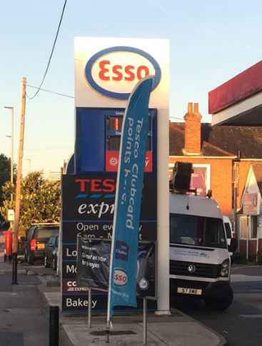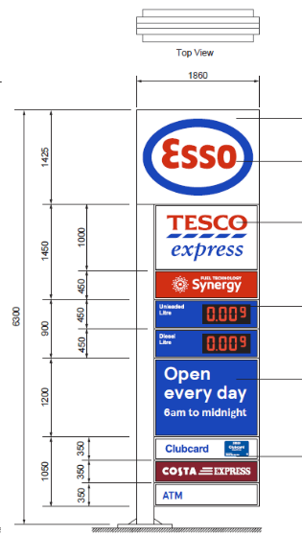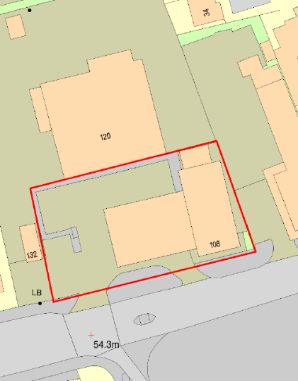

2. PROPOSAL AND SUPPORTING INFORMATION
6.3m illuminated pylon sign

Plans considered received 24th February 2022
Location Plan
ES-STP-A: Site Plan
ES-MID –A: Pylon Details

- RELEVANT PLANNING HISTORY
Application Ref:151856
Description: New advertisement signs to be erected on the forecourt
Decision: Permitted
Decision Date: 10th December 2015

4. CONSULTATIONS
Transport has been consulted and have no objections but have advised to include condition AD1 in the Decision Notice.

Equality Act 2010:
In determining this application the Council is required to have regard to its obligations under the Equality Act 2010. However, there is no indication or evidence (including from consultation on the application) that the protected groups identified by the Act have or will have different needs, experiences, issues and priorities in relation to this particular planning application. Therefore in terms of the key equalities protected characteristics it is considered there would be no significant adverse impacts as a result of the development.

- LEGAL AND PLANNING POLICY CONTEXT

Section 38(6) of the Planning and Compulsory Purchase Act 2004 requires that proposals be determined in accordance with the development plan unless material considerations indicate otherwise. Material considerations include relevant policies in the National Planning Policy framework (NPPF) - among them the 'presumption in favour of sustainable development'. The following local and national planning policy and guidance is relevant to this application:

National Policy
National Planning Policy Framework
National Planning Practice Guidance

Reading Borough Local Plan (2019)
CC7 (Design and the Public Realm)
OU4 (Advertisements)

6. APPRAISAL
CC7 (Design and the Public Realm)
The existing advertisement on this site stands at approximately 5m. There is an added 1m to the overall length of the advertisement as this proposal stands at 6m. However, this increment in height has not been judged to be significantly impactful on the overall effect on the street scene and public realm.

OU4: ADVERTISEMENTS
Advertisements will respect the building or structure on which they are located and/or
their surroundings and setting in terms of size, location, design, materials, colour, noise,
lettering, amount and type of text, illumination and luminance, and will not have a
detrimental effect on public safety. The cumulative impact of adverts will be taken into
account, and a proliferation of advertisements that detrimentally affects visual or aural
amenity or public safety will not be acceptable. All adverts shall comply with the
following criteria:

a) Advertisements will not obstruct windows, any other sign already located on the
building, or cut across significant architectural features such as historic fascias,
windows, pilasters, cornices or scrolls; Complies
b) Where a shop or business occupies more than one adjacent unit, the advertisement will not run between the shopfronts; N/A
c) Advertisements on listed buildings or in Conservation Areas will respect or enhance the
building or area, and will respect the key features of the special historic interest; N/A
d) Advertisements will not reduce visibility for users of the highway or accesses onto the
highway; Complies ( As advised by Transport)
e) Illumination should not detract from the amenity of the area or pose a safety hazard
to users of the highway; Complies ( As advised by Transport) and
f) Advertisements should not obscure the sight lines of cameras installed for public
safety. Complies ( Advertisement is replacing an existing advertisement)

- CONCLUSION
The proposed development has been assessed and the proposed works are considered to be in accordance with the above relevant policies and planning permission can be granted.

8. RECOMMENDATION
Grant

