DELEGATED APPLICATION REPORT Target Date: 19/08/2021
Address: St Barnabas Church Hall, Elm Road, Reading, RG6 5TS
Application No: 211039 / ADV
Proposal: Advertisement Consent Replace the existing wooden notice board with two new fixed notice boards in a v format which will be used to display church events and seasonal services and times
Case Officer: Beatrice Malama

Site Description
The application site is a piece of land within St Barnabas Church located along Elm Road. Located south west of the site is Whiteknights retail centre and to the north across the road is the Sportsman (PH). The area is predominantly residential. The property is not Listed and it does not fall within a Conservation Area.

Proposal
The proposal is to replace three existing wooden notice boards with two new fixed notice boards in a V format which will be used to display church events and seasonal services and times. The proposed notice boards would each measure a maximum of 2m high from the ground level and approximately 1.4m wide (as shown in figure 1 below) and would be located 1.5m from the site boundary to the front.
Figure 1: Proposed Notice Boards
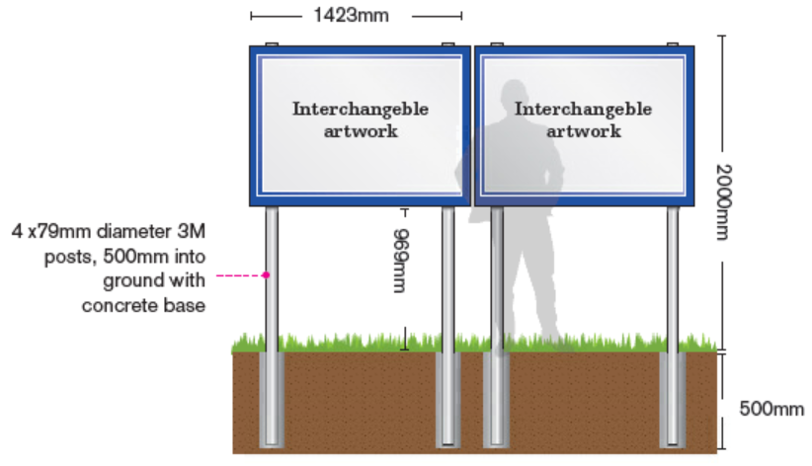

Plans Submitted
The following plans were received on 23rd June 2021:
Drawing No: TQRQM21175124858721 – Site Plan
Drawing No: TQRQM21175131208034 – Site Plan (Proposed Notice Boards site)
Drawing No: Unnumbered - Proposed Signage Mockup
Drawing No: Unnumbered - Proposed Elevation (Mockup)

Relevant Planning History
No Planning History

Consultations
Internal Consultation
Transport: Transport have no objections to the proposal.

External Consultation
Confirmation that the site notice was displayed on 8th July 2021 was received and the following addresses were consulted by letter.
Unit A Whiteknights Retail Park, 203-205 Shinfield Road, Reading, RG2 8HA
9 Elm Road, Reading, RG6 5TS
No responses have been received.

Equality Act 2010:
In determining this application the Council is required to have regard to its obligations under the Equality Act 2010. However, there is no indication or evidence (including from consultation on the application) that the protected groups identified by the Act have or will have different needs, experiences, issues and priorities in relation to this particular planning application. Therefore in terms of the key equalities protected characteristics it is considered there would be no significant adverse impacts as a result of the development.

Relevant Planning Policy and Guidance and Legal Context
Section 38(6) of the Planning and Compulsory Purchase Act 2004 requires that proposals be determined in accordance with the development plan unless material considerations indicate otherwise. The Development Plan for Reading relevant to the application site comprises the Reading Local Plan (2019)

The ‘National Planning Policy framework’ (‘’NPPF’’) 2021 states clearly that its content is to be a material consideration in the determination of applications. The ‘NPPF’ states that due weight should be given to the adopted policies of the Local Development Framework (LDF) according to their degree of consistency with the ‘NPPF’ (the closer the policies in the plan to the policies in the ‘NPPF’, the greater the weight that may be given). Accordingly, the ‘NPPF’ and the following development plan policies and supplementary planning guidance are relevant.

Regulation 3 of the Town and Country Planning (Control of Advertisements) (England) Regulations 2007 requires the Local Planning Authority to exercise its powers under these regulations in the interests of amenity and public safety taking into account the provisions of the development plan, so far as they are material; and any other relevant factors. Regulation 3 states that factors relevant to amenity include the general characteristics of the locality, including the presence of any feature of historic, architectural, cultural, or similar interest.

Reading Borough Local Plan (2019):
CC7: Design and the Public Realm
TR3: Access, Traffic and Highway-Related Matters
OU4: Advertisements

Appraisal
The main issues to be considered are:
i) Amenity
ii) Public safety

i) Amenity
Policy OU4 states that Advertisements will respect the building or structure on which they are located and/or their surroundings and setting in terms of size, location, design, materials, colour, noise, lettering, amount and type of text, illumination and luminance, and will not have a detrimental effect on public safety. The cumulative impact of adverts will be taken into account, and a proliferation of advertisements that detrimentally affects visual or aural amenity or public safety will not be acceptable. All adverts shall comply with the following criteria:

a) Advertisements will not obstruct windows, any other sign already located on the
building, or cut across significant architectural features such as historic fascias,
windows, pilasters, cornices or scrolls; Complies

b) Where a shop or business occupies more than one adjacent unit, the advertisement will not run between the shopfronts; n/a

c) Advertisements on listed buildings or in Conservation Areas will respect or enhance the building or area, and will respect the key features of the special historic interest; N/a

d) Advertisements will not reduce visibility for users of the highway or accesses onto the highway; Complies,

e) Illumination should not detract from the amenity of the area or pose a safety hazard to users of the highway; n/a

f) Advertisements should not obscure the sight lines of cameras installed for public safety. Complies

ii) Public Safety
The NPPG (in particular in this instance Paragraph: 068 Reference ID: 18b-068-20140306 & Paragraph: 078 Reference ID: 18b-078-20140306) provides guidance as to the considerations affecting public safety. These are detailed below (in italics), together with officer responses in relation to the proposal (in bold):

The main types of advertisement which may cause danger to road users are:
(a) those which obstruct or impair sight-lines at corners, bends or at a junction, or at any point of access to a highway; No
(b) those which, because of their size or siting, would obstruct or confuse a road-user’s view, or reduce the clarity or effectiveness of a traffic sign or signal, or would be likely to distract road-users because of their unusual nature; No
(c) those which effectively leave insufficient clearance above any part of a highway, or insufficient lateral clearance for vehicles on the carriageway (due allowance being made for the camber of the road-surface); No
(d) those externally or internally illuminated signs (incorporating either flashing or static lights) including those utilising light emitting diode technology:
i. where the means of illumination is directly visible from any part of the road; n/a.
ii. which, because of their colour, could be mistaken for, or confused with, traffic lights or any other authorised signals; N/a
iii. which, because of their size or brightness, could result in glare and dazzle, or distract road-users, particularly in misty or wet weather; N/a
iv. which are subject to frequent changes of the display; N/a
(e) those which incorporate moving or apparently moving elements in their display, or successive individual advertisements which do not display the whole message; No
(f) those requiring close study (such as Public Information Panels), which are situated so that people looking at them would be insufficiently protected from passing vehicles; or those advertisements sited on narrow footpaths where they may interfere with safe passage by causing pedestrians to step into the road; No
(g) those which resemble traffic signs, as defined in section 64 of the Road Traffic Regulation Act 1984, and may therefore be subject to removal by the traffic authority under section 69 of that Act, for example:
i. those embodying red circles, crosses or triangles, or any traffic sign symbol; or those in combinations of colours which might otherwise be mistaken for traffic signs; No or
ii. those incorporating large arrows or chevrons with only the arrow or chevron made of retroflective material or illuminated, causing confusion with similar signs in use at, or approaching roundabouts. No
(h) those which embody directional or other traffic elements and which need special scrutiny because of possible resemblance to, or confusion with, traffic signs, for example, advertisements which:
i. contain a large arrow or chevron (or have a pointed end and have only a few words of message); No
ii. invite drivers to turn right on a main road, or where there is fast moving traffic; No
iii. invite drivers to turn, but are sited so close to the turning that there is not enough time to signal and turn safely; No or
iv. are so close to similar advertisements, or official traffic signs, that road-users might be confused in the vicinity of a road junction or other traffic hazard. No
The prevention of crime is a public safety consideration and local planning authorities should consider whether granting express consent could block the view of CCTV cameras, or whether illumination from an advertisement would cause glare on such cameras. No.

Conclusion
The proposal has been assessed and the works are considered to be in line with the above policies and therefore Advertisement Consent can be granted subject to conditions.
Recommendation
Grant
Conditions
- A1: Standard Advert Requirements
- AD2: Approved Plans (Adverts)

Informative
- Your attention is drawn to the terms and conditions of this consent. Any development which is carried out but which differs materially from the approved plans and details, or does not comply with any condition(s) or planning obligation(s) attached to the consent may result in the Council taking action to remedy the breach of planning control. If you are in any doubt please contact the Council.

