DELEGATED HOUSEHOLDER APPLICATION REPORT

Ward: Tilehurst
App Ref: 220896/HOU
Address: 43 Gratwicke Road, Tilehurst, Reading, RG30 4TU
Proposals: Existing outbuilding to be demolished. Single storey rear extension. Ground floor refurbishment.
Case Officer: Chukwudi Onwudinanti
Applicant: Mr Clark Darrall
Date received (valid from): 17 June 2022
Target Decision date: 23 September 2022 (EXT)

1. SITE DESCRIPTION
The site is a semi-detached dwelling on the northern side of Gratwicke Road. It is one of two rows of buildings on both sides of the road, of identical styles and size. The building stands on the stretch of Gratwicke Road between Bramble Crescent and Blundells Road. The road is characterised by adjacent buildings linked by side garages. Some of these garages have been converted into side extensions. It is not in a conservation area or article 4 land.

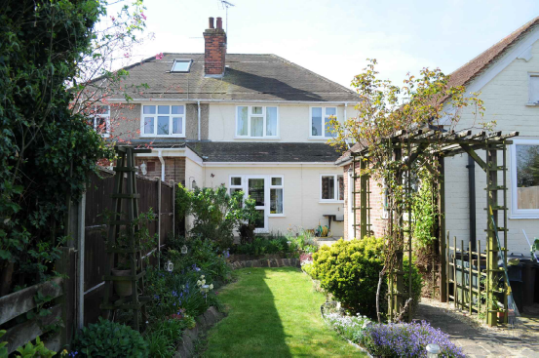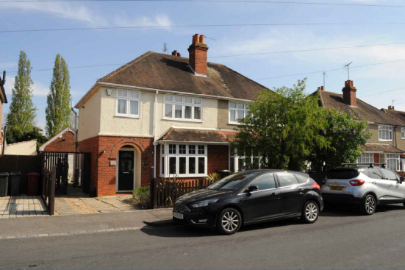
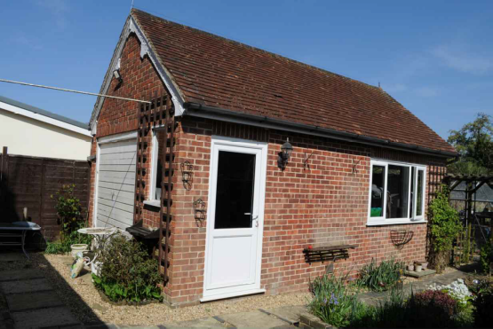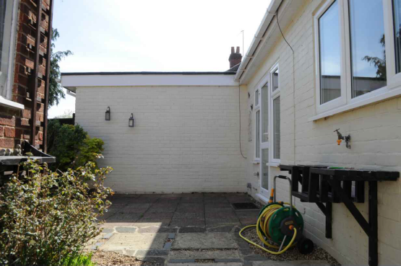

2. PROPOSAL AND SUPPORTING INFORMATION
The proposal is to demolish the existing outbuilding and build an extension measuring approximately 3.5m by 6.5m to the rear of the property. The extension stands floor to wall plate height of 2.5m, with an overall ground to roof covering of approximately 4m, with part glazing to the side at sill of 2.2m. There is also an aspect of internal floor refurbishments.

Plans considered received 20th June 2022
PL01: Location Plans
PL02: Existing and Proposed Site Plans with Roof Plans Rev A received 10th October 2022
PL03: Existing and Proposed Ground Floor Plans Rev B received 10th October 2022
PL04: Existing Elevations Sheet 01
PL05: Existing Elevations Sheet 02
PL06 Proposed Elevations Sheet 01 Rev B received 10th October 2022
PL07 : Proposed Elevations Sheet 02 Rev A received 10th October 2022
PL08: Proposed 3D Illustrations received 10th October 2022

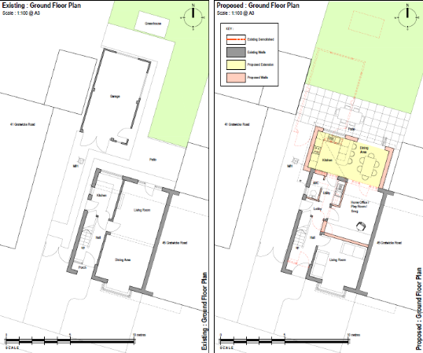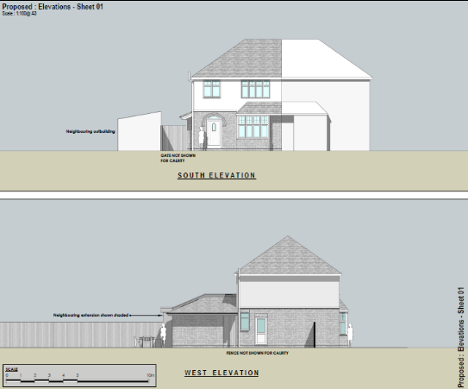
Existing and Proposed Ground Floor Plans Proposed Side Elevation

- RELEVANT PLANNING HISTORY

None

4. CONSULTATIONS

The following addresses were consulted by letter.

52 Recreation Road, Tilehurst, Reading, Berkshire, RG30 4UA
45 Gratwicke Road, Tilehurst, Reading, RG30 4TU
50 Recreation Road, Tilehurst, Reading, RG30 4UA
41 Gratwicke Road, Tilehurst, RG30 4TU

No letters of representation have been.

Equality Act 2010:
In determining this application the Council is required to have regard to its obligations under the Equality Act 2010. However, there is no indication or evidence (including from consultation on the application) that the protected groups identified by the Act have or will have different needs, experiences, issues and priorities in relation to this particular planning application. Therefore in terms of the key equalities protected characteristics it is considered there would be no significant adverse impacts as a result of the development.

- LEGAL AND PLANNING POLICY CONTEXT

Section 38(6) of the Planning and Compulsory Purchase Act 2004 requires that proposals be determined in accordance with the development plan unless material considerations indicate otherwise. Material considerations include relevant policies in the National Planning Policy framework (NPPF) - among them the 'presumption in favour of sustainable development'. The following local and national planning policy and guidance is relevant to this application:

National Policy
National Planning Policy Framework
National Planning Practice Guidance

Reading Borough Local Plan (2019)
CC7 (Design and the Public Realm)
CC8 (Safeguarding Amenity)
H9 (House Extensions and Ancillary Accommodation)

SPD
Design Guide to House Extensions (2021)

6. APPRAISAL

Character and Appearance

Policy H9 states that an extension to a house will be acceptable where it respects the character of the house in terms of scale, location, materials and design and respects the character and pattern of neighbouring properties and the street as a whole in terms of scale, location, materials and design, and any important existing building line. Policy CC7 also sets out relevant considerations for design.

All aspects of this proposal are to the rear of the existing dwelling and of a proportionate scale to the existing dwelling. The development is limited to the ground floor storey level and materials to be used are mostly to match the existing materials.

Therefore, it is considered that this proposal will not cause any harm to the character of the building and the neighbourhood scene.

Residential Amenity

Policy H9 states that an extension will be acceptable where it does not result in an overbearing impact on neighbours. Policy H10 seeks to ensure that the amenity of gardens and other outdoor areas are not compromised. Policy CC8 states an extension to a house will be acceptable where it will not cause a significant detrimental impact to the living environment of existing or new residential properties.

- Privacy and overlooking: As stated above in this report, all aspects of this proposal is on the ground floor level. While the glazing to the side faces the neighbouring property and the proposal presents a flat roof to the rear, it is considered that the glazing with a sill height of 2.1m does not present a risk of overlooking and the restricted use of the flat roof will be secured by way of conditions.
- Overbearing effects: The scale of the development is proportionate and presents no overbearing effects.
- Sunlight and daylight: There are no aspects of this proposal that is of a height or of position that will impact on the sunlight and daylight available to the adjoining properties.

- CONCLUSION
The proposed development has been assessed as set out above and is considered to be acceptable on that basis, subject to the following conditions.

8. RECOMMENDATION
Grant
Recommended Conditions:
AP1: Approved Plans
ML3: Materials as Specified
TL1: Time Limits
PD5: Restricted Use of Roof

