DELEGATED HOUSEHOLDER APPLICATION REPORT
Ward: Norcot
App Ref: 211283 / HOU
Address: 33 Usk Road, Tilehurst, Reading, RG30 4HP
Proposal: Proposed single storey rear and side extension
Case Officer: Beatrice Malama
Date received (valid from): 4th August 2021 Target date: 29th September 2021

SITE DESCRIPTION
The application site is a two story semi-detached dwelling house located at 33 Usk Road in a predominantly residential area comprising of semidetached and terraced houses of similar style and design. The area comprises of houses built of brick and exterior walls finished with redbrick and/or render. Many properties have been extended with rear and side extensions of various sizes and designs. The property has a combination of redbrick and rendered exterior finish. The roof is pitched. The property is not listed and does not fall within a conservation area.

PROPOSED DEVELOPMENT
The proposed development is a single story rear and side extension to create additional space for kitchen, dining, utility and study rooms. In order to allow for the construction of the proposed rear extension, the existing detached garage located along the side boundary in the rear garden of the site would be demolished. The proposed rear extension would measure a maximum of 4m deep from the existing rear wall and 9.5m wide whereas the proposed side extension would measure 2m deep from the existing side wall and 3.74m wide. The extension would have a pitched tiled roof with two rooflights to the rear and one rooflight to the side. A mall part of the roof to the proposed rear extension would be flat. The overall height of the extension would be approximately 3.6m with the height up to eaves level measuring 2.6m.
Plans considered;
Drawing No: SD33/PL 01 REV A – Existing and Proposed Floor and Roof Plans
Drawing No: SD33/PL 02 – Existing and Proposed Elevations
Drawing No: SD33/PL 03 – Existing and Proposed Elevations
Drawing No: SD33/PL 04 – Location Plan, Existing and Proposed Block Plans
Received on 4th August 2021

RELEVANT PLANNING HISTORY
No relevant planning history

CONSULTATIONS
Internal Consultation
Transport – Requested revised plans illustrating 2 x off road parking spaces and access were submitted by the applicant on 01/09/21.

External Consultation
A site notice was sent to the Agent on 11th August 2021 and the following addresses were consulted by letter.
Churchend Primary School, Usk Road, Tilehurst, Reading, RG30 4HP
31 and 35 Usk Road, Tilehurst, Reading, RG30 4HP
No letters of representation have been received.

Equality Act 2010:
In determining this application the Council is required to have regard to its obligations under the Equality Act 2010. However, there is no indication or evidence (including from consultation on the application) that the protected groups identified by the Act have or will have different needs, experiences, issues and priorities in relation to this particular planning application. Therefore, in terms of the key equalities protected characteristics it is considered there would be no significant adverse impacts as a result of the development.

Relevant Planning Policy and Guidance
Section 38(6) of the Planning and Compulsory Purchase Act 2004 requires that proposals be determined in accordance with policies in the development plan unless material considerations indicate otherwise. Material considerations include relevant policies in the National Planning Policy framework (NPPF) - among them the 'presumption in favour of sustainable development'.

National Planning Policy
National Planning Policy Framework (2021)
National Planning Practice Guidance

Reading Borough Local Plan (2019)
CC7 (Design and the Public Realm)
CC8 (Safeguarding Amenity)
H9 (House Extensions and Ancillary Accommodation)

SPG/SPD
Design Guide to House Extensions SPG (2021)

Assessment
Character and appearance
Policy CC7 (Design and the Public Realm) requires that all developments be of high design quality, whilst Policy H9 (House Extensions and Ancillary Accommodation) requires that an extension “respects the character and appearance of the house in terms of scale, location, materials and design and should not harm the character and pattern of neighbouring houses and the appearance of the street scene”.
The Proposed extension would be single story with a pitched tiled roof to match the original house. A small part of the roof to the rear extension would be flat. Exterior wall finishes would be of brick and the windows and doors would be of upvc and double glazed to match the existing house. The proposed extension therefore would be considered unlikely to harm the character and appearance of the existing house. In addition, although the extension would be visible to the public realm, the side extension would be setback from the existing building line to the front and the exterior appearance would match that of the existing house and thus the character of the original house would be retained. In this regard therefore it is considered that the impact of the proposed extension on the character and appearance of the neighbouring houses and the street would not be harmful.
Residential Amenity
Policy CC8 (Safeguarding Amenity) seeks to prevent development causing detrimental impact on the neighbouring properties; policy H9 (House Extensions and Ancillary Accommodation) provides that extensions should not cause an overbearing impact on neighbours”.
The proposed extension would be single story with an overall height of 3.6m. The proposed side extension would result in the removal of an existing side widow and a side door. This means the number of openings to the proposed south western side elevation would be reduced from three to one and as such any potential loss of privacy to the neighbour would be reduced. There is an existing boundary fencing between adjoining properties and therefore this would further reduce any potential harmful overlooking of neighbouring properties.
With regard to the impact on the amount of sunlight, daylight and overshadowing to the neighbouring properties, although much of the proposed extension would stretch along the boundary fencing on both sides of the site, it would be considered unlikely to cause any harmful loss of sunlight, daylight and overshadowing to the neighbouring properties as the rooms of adjoining neighbours that would be closest to the proposed extension are non-habitable and do not have side windows. In view of this, it is considered that the proposed extension would unlikely have an overbearing impact on the living conditions of the present or future occupants of neighbouring houses.

Conclusion
The proposed extension is considered to be in accordance with the Reading Borough Local Plan (2019) and the Design Guide to House extensions (2021) and therefore the application is recommended for approval subject to conditions.

Recommendation:
Grant

Conditions
- Time Limit (Standard) TL1
- Approved Plans Ap1
- Materials (To Match) M1
Appendix 1: Site Photos.
Photo 1: Existing Rear Elevation
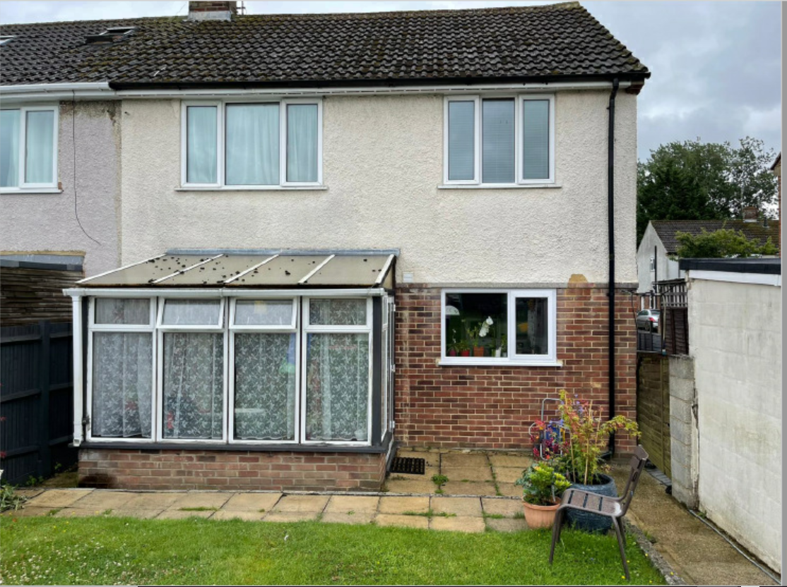
Photo 2: Existing Front Elevation
