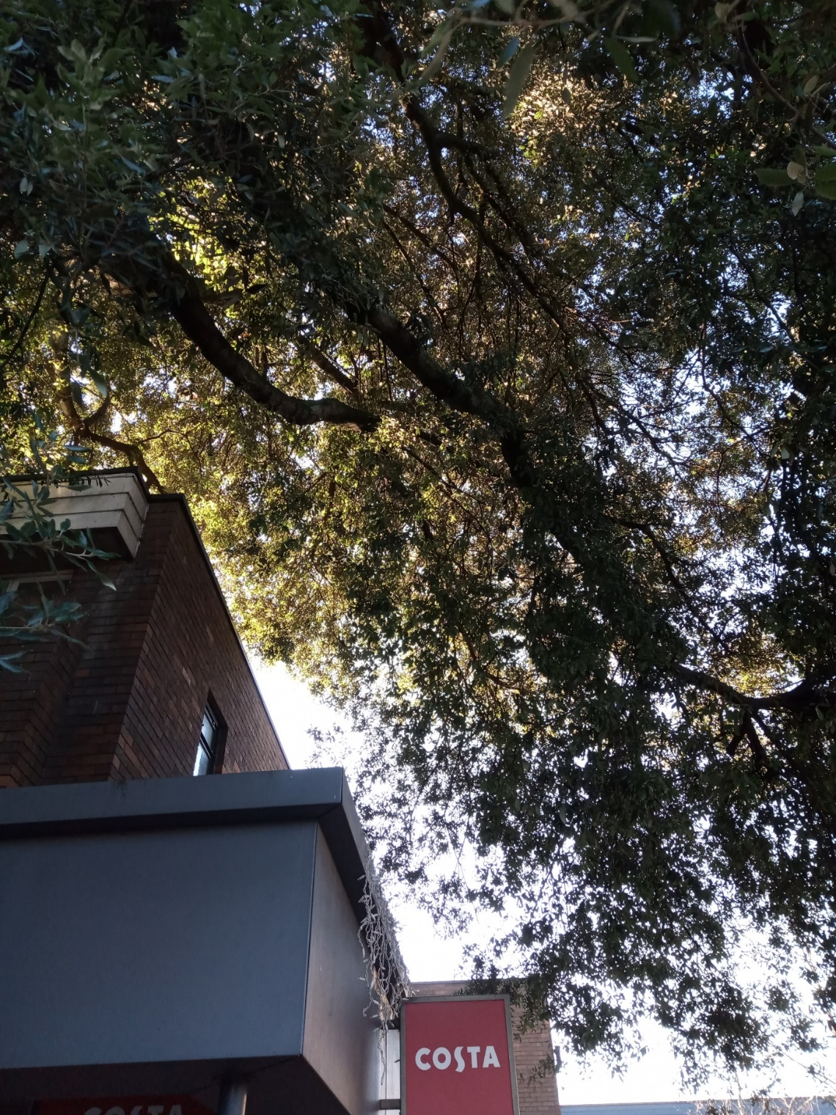
Southwest canopy area – Lower section crown lifted to 1m above building canopy (indicated in blue); upper tree crown pruned to give 2m clearance from the building (red)

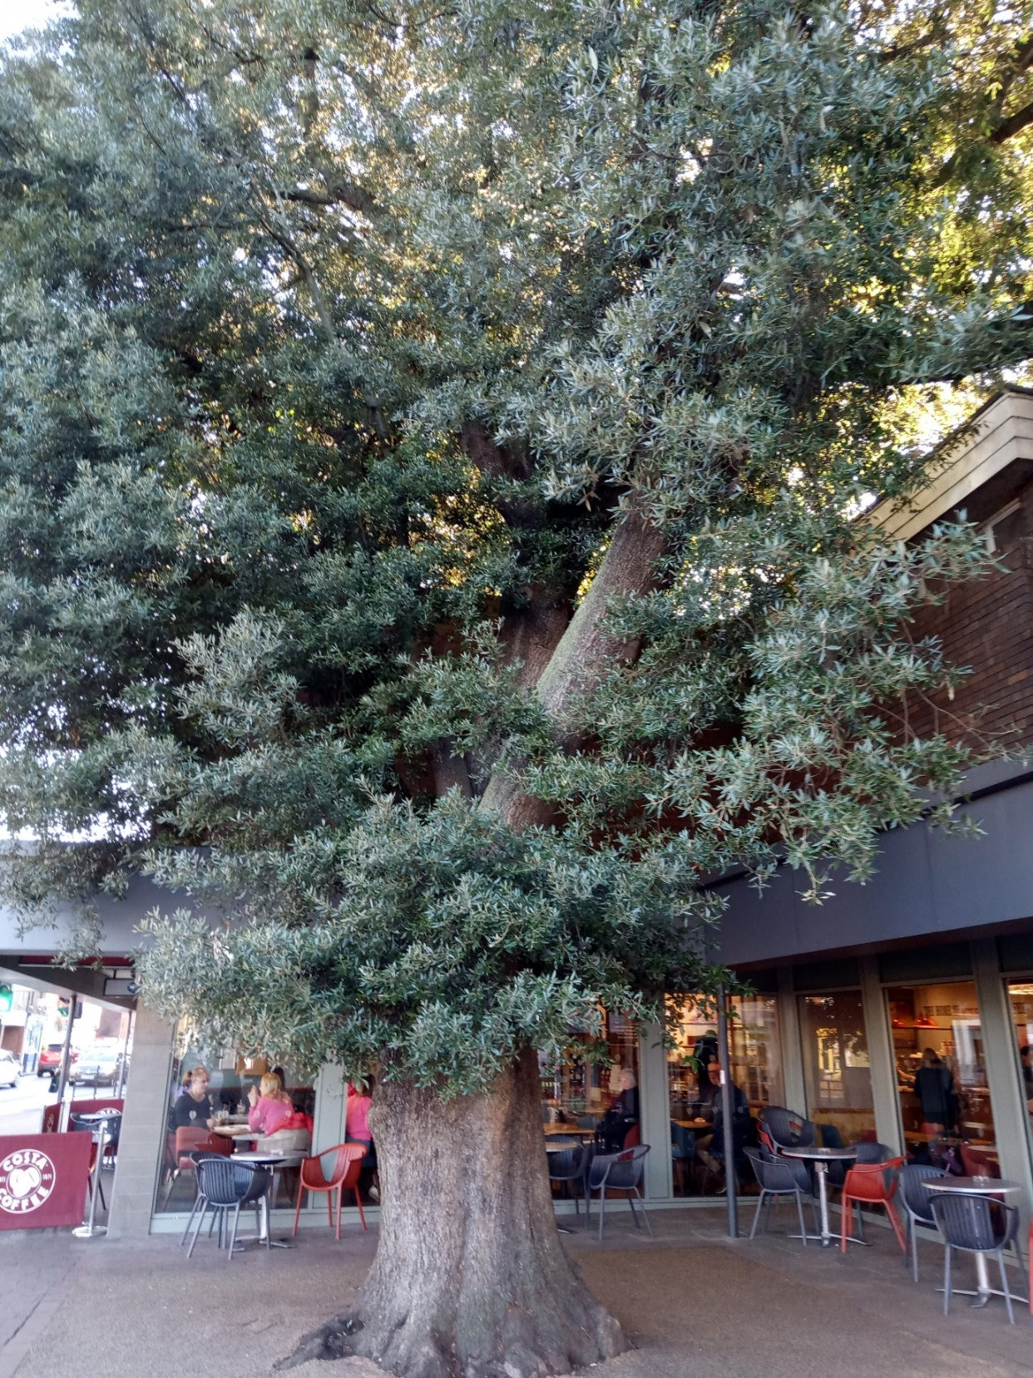
Crown lift to 3m by removing epicormic growth

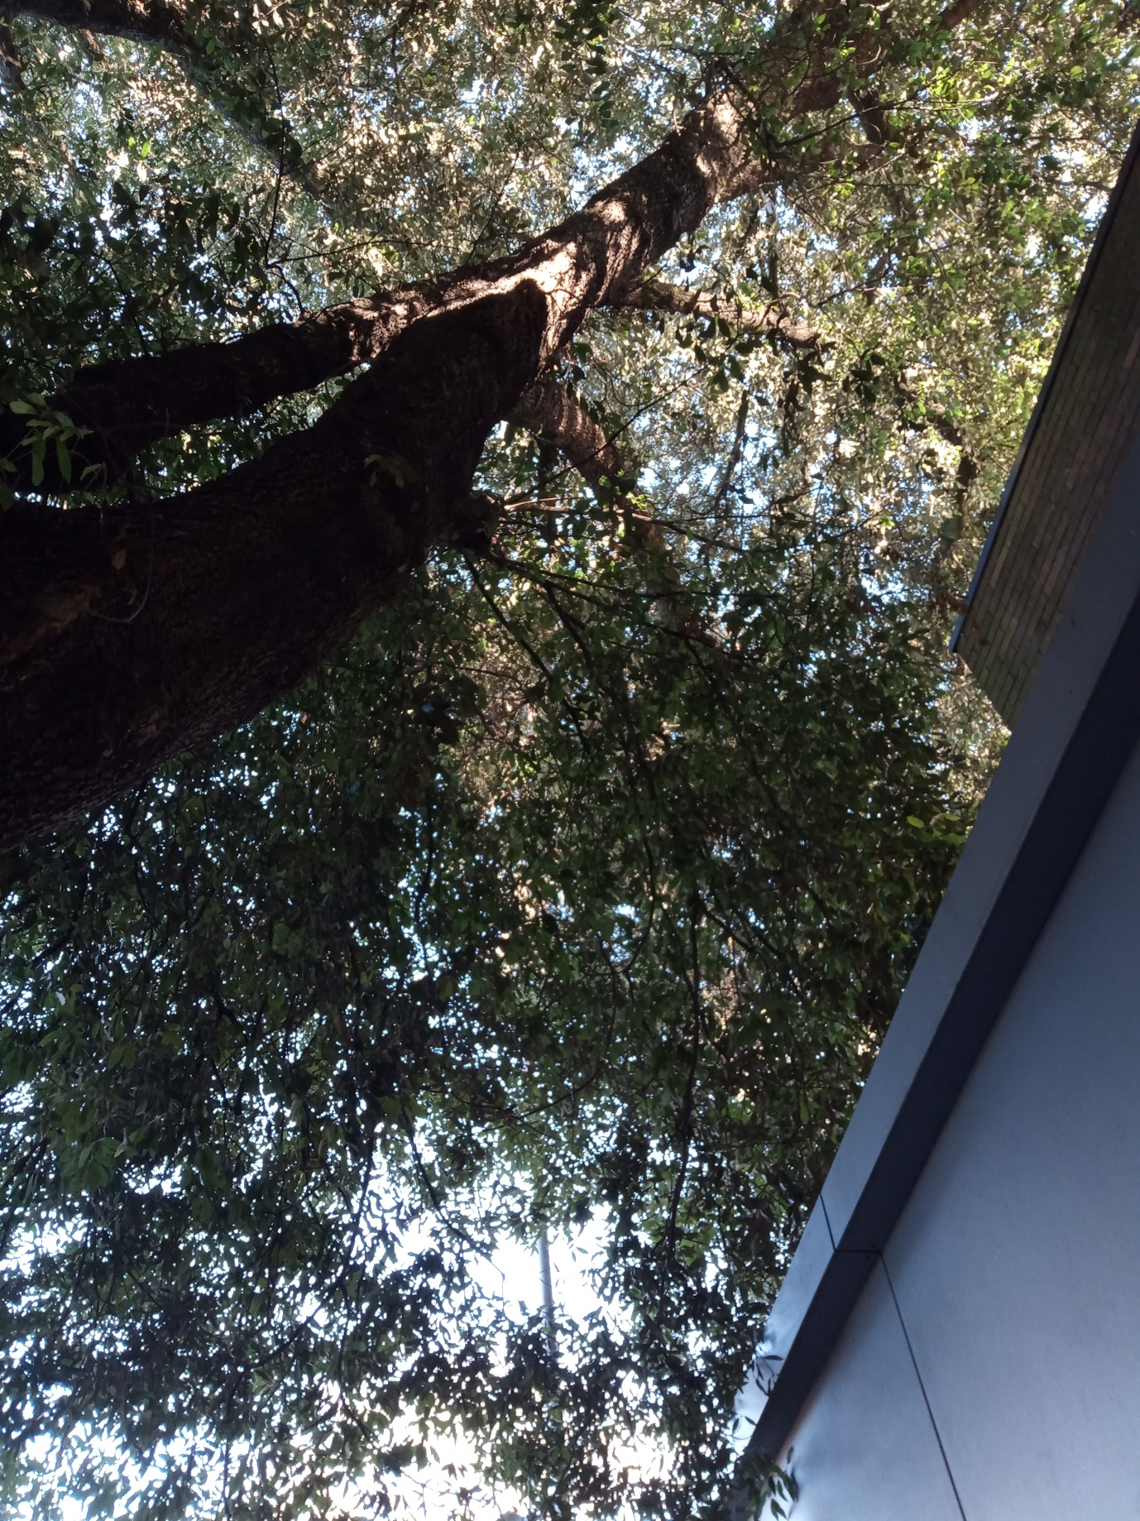
Removal of re-growth on east/northeast side

