DELEGATED HOUSEHOLDER APPLICATION REPORT

Ward: Southcote
App Ref: 220570/HOU
Address: 49 Southcote Lane, Reading, RG30 3AG
Proposals: Proposed single storey Garden Room.
Case Officer: Chukwudi Onwudinanti
Applicant: Mr & Mrs Simpson
Date received (valid from): 15 April 2022
Target Decision date: 2 September 2022 (EXT)

1. INTRODUCTION
The proposal site is a semi-detached two storey dwelling unit on the eastern side of Southcote Lane, among buildings of similar size and style on the same side of the road and buildings of varied styles on the opposite side of the road. It has a large garden at the rear of the property, approximately three times the size of the building.

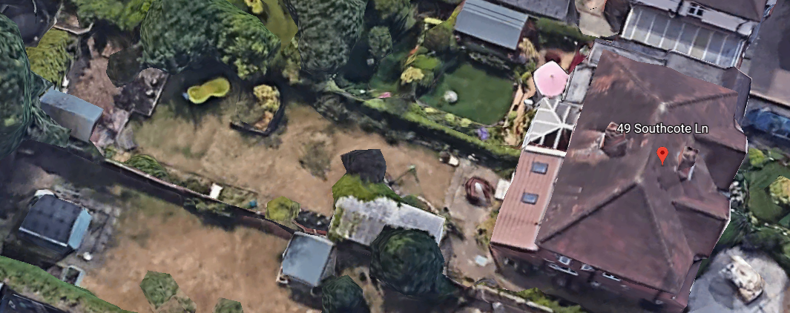

2. PROPOSAL AND SUPPORTING INFORMATION

The application is a proposal to build a back garden room, measuring approximately 5m by 6m, with the shorter width facing the existing building. It has a height of 2.4m to the eaves and a roof thickness of 0.3m, creating an overall height of 2.7m.

Plans considered (received 19th April 2022)
Drawing No: 099 – Site Location Plan
Drawing No: 098 – Block Plan
Drawing No: 100 – Existing and Proposed Plans and Elevations
Arboricultural Assessment and Tree Protection Report dated 30th August 2022

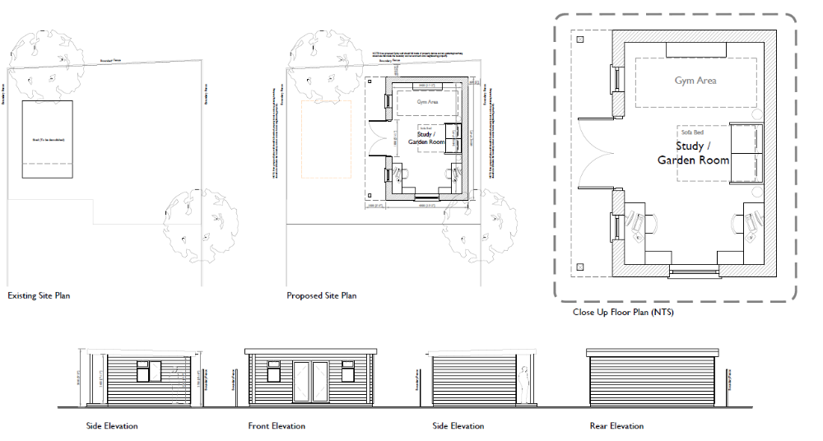

- RELEVANT PLANNING HISTORY

Application Ref:150013
Description: Certificate of Lawfulness for Proposed mono pitched tiled roof and demolition of attached store and in-fill extension to existing single storey rear extension
Decision : Permitted
Decision Date: 6th February 2018

4. CONSULTATIONS

4.1 The following addresses were consulted by letter.

51 Southcote Lane, Reading, RG3 3AG
47 Southcote Lane, Reading, RG30 3AG
42 Kenilworth Avenue, Reading, RG30 3DN

4.2 No letters of representation have been received.

Trees/Natural Environment.
Natural Environment were consulted on this application. An arboricultrural statement/ Tree Protection plan was requested. Arboricultural Report and Method Statement / Tree Protection Plan prepared by Steve Wood for SMW (Tree) Consultancy Ltd dated 31st August 2022 was submitted by the agent and confirmed to be appropriate by NE.

Equality Act 2010:
In determining this application the Council is required to have regard to its obligations under the Equality Act 2010. However, there is no indication or evidence (including from consultation on the application) that the protected groups identified by the Act have or will have different needs, experiences, issues and priorities in relation to this particular planning application. Therefore in terms of the key equalities protected characteristics it is considered there would be no significant adverse impacts as a result of the development.

- LEGAL AND PLANNING POLICY CONTEXT

Section 38(6) of the Planning and Compulsory Purchase Act 2004 requires that proposals be determined in accordance with the development plan unless material considerations indicate otherwise. Material considerations include relevant policies in the National Planning Policy framework (NPPF) - among them the 'presumption in favour of sustainable development'. The following local and national planning policy and guidance is relevant to this application:

National Policy
National Planning Policy Framework
National Planning Practice Guidance

Reading Borough Local Plan (2019)
CC7 (Design and the Public Realm)
CC8 (Safeguarding Amenity)
H9 (House Extensions and Ancillary Accommodation)

SPD
- Design Guide to House Extensions (2021)

6. APPRAISAL

H9 states: An extension to a house will be acceptable where it:

- Respects the character of the house in terms of scale, location, materials and design;

To assess this, the following has been considered – would the proposal:
- detract from the appearance of the original building through the use of ill-matching materials and by not fitting in with the design, scale and proportions of the original building; NO, all aspects of the proposal are to the rear of the existing dwelling and within a height of 2.7m, so is considered to be within an acceptable scale.
- reduce the amount of usable amenity space for the property to an unacceptable degree; NO, the rear outbuilding does not occupy so much space within the rear garden, as to reduce the amount of amenity space to an unacceptable level.
- require the loss of trees in the garden or put significant trees at risk; NO, as advised by Natural Environment, the applicant has submitted a Tree Protection Plan that the Natural Environment accepts as appropriate to mitigate any risks to any of the trees within close proximity.

- Respects the character and pattern of neighbouring properties and the street as a whole in terms of scale, location, materials and design, and any important existing building line; Respects neighbour’s amenities and does not present a large blank façade to public areas.

To assess this, the following has been considered – would the proposal:
- significantly reduce the amount of daylight and sunlight enjoyed by neighbouring properties; NO, the outbuilding is one storey and will present no impact on the neighbouring buildings.
- invade the privacy of neighbouring properties through overlooking from windows or balconies; NO, there are no windows set at heights that will overlook the adjoining properties.
- detract from the character of neighbouring properties through siting, excessive bulk, ill-matching materials or inconsistent design; NO, all aspects of the proposal will be to the rear, so not visible from the street scene.
- detract from the appearance of the street or area by using ill-matched materials, glazing and detailing; NO, as already cited above, the proposed outbuilding will be to the rear of the property and not visible from the street.

CC8: Safeguarding Amenity states an extension to a house will be acceptable where it will not cause a significant detrimental impact to the living environment of existing or new residential properties.

To assess this, the following has been considered – would the proposal cause a significant detrimental impact to the living environment of existing or new residential properties in terms of:

- Privacy and overlooking; No
- Access to sunlight and daylight; No
- Visual dominance and overbearing effects of a development; No

- CONCLUSION
The proposed development has been assessed and the proposed works are considered to be in accordance with the above relevant policies and planning permission can be granted.

8. RECOMMENDATION
Grant

