DELEGATED HOUSEHOLDER APPLICATION REPORT

Ward: Thames
App Ref: 220442/CLP
Address: 4 Cwmcarn, Reading, RG4 8LE
Proposals: Construction of a single storey rear extension with doors, windows and a tiled pitched roof.
Case Officer: Chukwudi Onwudinanti
Applicant: Mr & Mrs Richard Harding
Date received (valid from): 28 March 2022
Target Decision date: 17 June 2022 (Ext)

INTRODUCTION
The application site is a two-storey semi-detached dwelling located on the northern side of Cwmcam. The surrounding area is predominantly residential, comprising dwellings of a similar style and design.

The LPA has no clear evidence that permitted development rights have been removed from the property.

PROPOSAL AND SUPPORTING INFORMATION

The proposal is for a single storey rear extension. It would have a mono-pitch roof with a maximum height of 3.7m, depth of 2.9m, have a width of 3.68m. The proposed development would not be within 2m of the boundary of the site.

Materials are proposed to be of similar appearance to the main dwelling.

Plans Submitted Received 28th March 2022:

The agent supplied the following drawings:
HARDING-0322-01 – Proposed Ground Floor Plan
HARDING-0322-02 – Proposed Elevations
HARDING-0322-03 - Existing Plan and Elevations
HARDING-0322-04 – Section A-A
HARDING-0322-05 - Location Plan
HARDING-0322-06 - Block Plan

RELEVANT PLANNING HISTORY
None

CONSULTATIONS
No consultations were undertaken as it is not required for an application of this type.

Equality Act 2010:

In determining this application the Council is required to have regard to its obligations under the Equality Act 2010. However, there is no indication or evidence (including from consultation on the application) that the protected groups identified by the Act have or will have different needs, experiences, issues and priorities in relation to this particular planning application. Therefore in terms of the key equalities protected characteristics it is considered there would be no significant adverse impacts as a result of the development.

RELEVANT PLANNING POLICY & GUIDANCE:
National Planning Practice Guidance
The Town and Country Planning (General Permitted Development) (England) Order 2015 (GPDO)
Permitted development rights for householders – Technical Guidance September 2019

ASSESSMENT (Class A)
A Certificate of Lawfulness for a Proposed Development has been submitted as the applicant considers the proposal falls within the permitted development rights of the property.

The proposal must be assessed to ensure that it complies with the conditions Class A, Part 1, Schedule 2 of the Town and Country Planning (General Permitted Development) (England) Order 2015 (as amended), which relates to ‘The enlargement, improvement or other alteration of a dwellinghouse’.

A.1 Development is not permitted by Class A if:

A.1 (a) permission to use the dwellinghouse as a dwellinghouse has been granted only by virtue of Class M, N, P or Q of Part 3 of this Schedule (changes of use); COMPLIES
A.1 (b) as a result of the works, the total area of ground covered by buildings within the curtilage of the dwellinghouse (other than the original dwellinghouse) would exceed 50% of the total area of the curtilage (excluding the ground area of the original dwellinghouse); COMPLIES
A.1 (c) the height of the part of the dwellinghouse enlarged, improved or altered would exceed the height of the highest part of the roof of the existing dwellinghouse; COMPLIES
A.1 (d) the height of the eaves of the part of the dwellinghouse enlarged, improved or altered would exceed the height of the eaves of the existing dwellinghouse; COMPLIES
A.1 (e) the enlarged part of the dwellinghouse would extend beyond a wall which (i) forms the principal elevation of the original dwellinghouse; or (ii) fronts a highway and forms a side elevation of the original dwellinghouse; COMPLIES
A.1 (f) subject to paragraph (g), the enlarged part of the dwellinghouse would have a single storey and – (i) extend beyond the rear wall of the original dwellinghouse by more than 4 metres in the case of a detached dwellinghouse, or 3 metres in the case of any other dwellinghouse, (ii) exceed 4 metres in height; COMPLIES
A.1 (g) for a dwellinghouse not on article 2(3) land nor on a site of special scientific interest, the enlarged part of the dwellinghouse would have a single storey and – (i) extend beyond the rear wall of the original dwellinghouse by more than 8 metres in the case of a detached dwellinghouse, or 6 metres in the case of any other dwellinghouse, or (ii) exceed 4 metres in height COMPLIES
A.1 (h) the enlarged part of the dwellinghouse would have more than a single storey and – (i) extend beyond the rear wall of the original dwellinghouse by more than 3 metres, or (ii) be within 7 metres of any boundary of the curtilage of the dwellinghouse opposite the rear wall of the dwellinghouse; COMPLIES
A.1 (i) the enlarged part of the dwellinghouse would be within 2 metres of the boundary of the curtilage of the dwellinghouse, and the height of the eaves of the enlarged part would exceed 3 metres; COMPLIES
A.1 (j) the enlarged part of the dwellinghouse would extend beyond a wall forming a side elevation of the original dwellinghouse, and would – (i) exceed 4 metres in height, (ii) have more than a single storey, or (iii) have a width greater than half the width of the original dwellinghouse; COMPLIES
A.1 (k) it would consist of or include – (i) the construction or provision of a verandah, balcony or raised platform (ii) the installation, alteration or replacement of a microwave antenna, (iii) the installation, alteration or replacement of a chimney, flue or soil and vent pipe, or (iv) an alteration to any part of the roof of the dwellinghouse COMPLIES
A.2 In the case of a dwellinghouse on article 2(3) land, development is not permitted by Class A if:
A.2 (a) it would consist of or include the cladding of any part of the exterior of the dwellinghouse with stone, artificial stone, pebble dash, render, timber, plastic or tiles; N/A
A.2 (b) the enlarged part of the dwellinghouse would extend beyond a wall forming a side elevation of the original dwellinghouse; N/A or
A.2 (c) the enlarged part of the dwellinghouse would have more than a single storey and extend beyond the rear wall of the original dwellinghouse. N/A
Conditions
Development is permitted by Class A subject to the following conditions:
A.3 (a) the materials used in any exterior work (other than materials used in the construction of a conservatory) must be of a similar appearance to those used in the construction of the exterior of the dwellinghouse; COMPLIES
A.3 (b) any upper-floor window located in a wall or roof slope forming a side elevation of the dwellinghouse must be (i) obscure-glazed, and (ii) non-opening unless the parts of the window which can be opened are more than 1.7 metres above the floor of the room in which the window is installed; COMPLIES
A.3 (c) where the enlarged part of the dwellinghouse has more than a single storey, or forms an upper storey on an existing enlargement of the original dwellinghouse, the roof pitch of the enlarged part must, so far as practicable, be the same as the roof pitch of the original dwellinghouse. N/A
Recommendation
Sufficient evidence has been provided to demonstrate that a Certificate of Lawfulness should be granted for the proposed single storey side extension.
The proposal has been assessed against the Town and Country Planning Act 1990 (as amended) and Class A, Part 1, Schedule 2 of the Town and Country Planning (General Permitted Development) (England) Order 2015 (as amended) and it has been confirmed that the proposal would be lawful for planning purposes on the basis of the following drawings and information:
HARDING-0322-01 – Proposed Ground Floor Plan
HARDING-0322-02 – Proposed Elevations
HARDING-0322-04 – Section A-A
HARDING-0322-06 - Block Plan

Therefore, the Local Planning Authority will, on this occasion, issue the applicant with a Certificate of Lawfulness for the proposed development.
Informatives
Building Regulations
Encroachment and Party Wall
Construction and Demolition
Positive and Proactive working

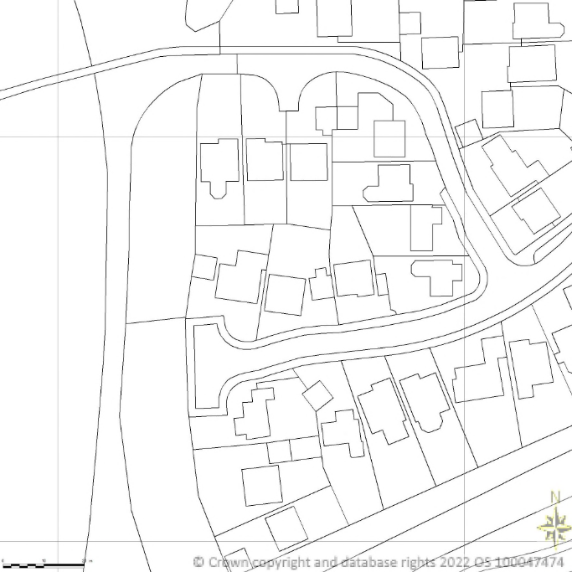

Location Plan: Not to Scale

