Planning Design and Access Statement

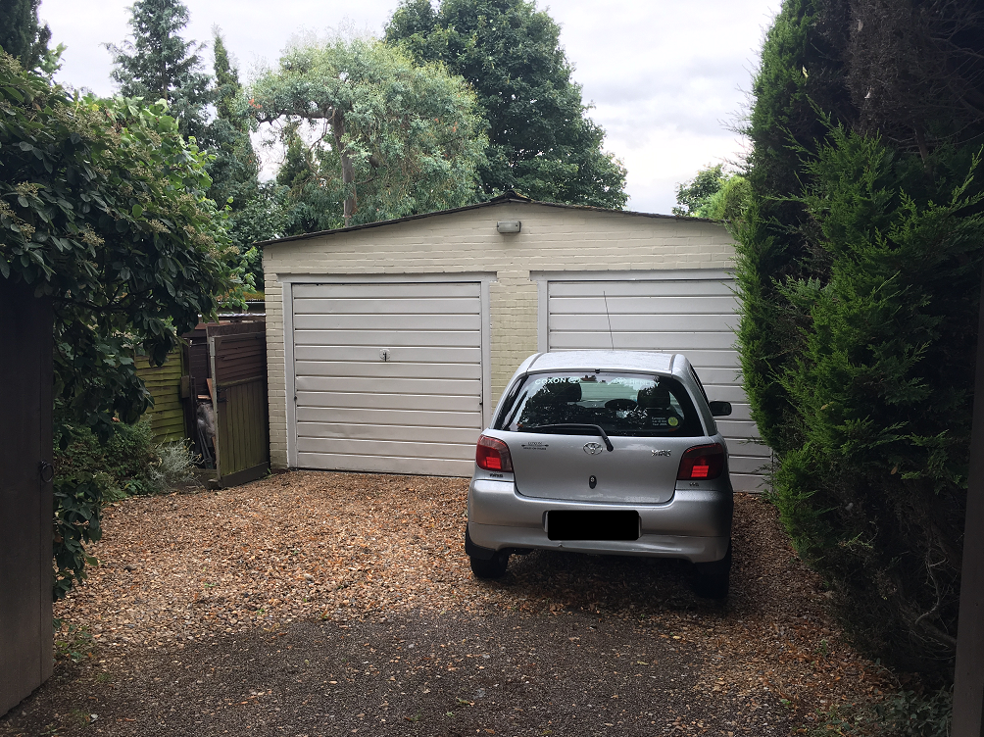
Erection of a new single dwelling

190 Henley Road
Caversham
Reading
RG4 5LN

Revision A (17-02-2022)
1.0 INTRODUCTION
This statement accompanies a detailed planning application for a new dwelling at land to the rear of 190 Henley Road following it’s granting (reference: 181305. The proposal resulted in a number of conditions which are proposed to be addressed by this new application. Changes relating to the application include a rear single storey extension and alterations to the design externally and internally.
The planning conditions this application seeks to address are as follows:
- Condition 3: Schedule of materials
- Condition 5: Soft and hard landscaping
- Condition 9: Construction noise and dust mitigation
- Condition 10: Construction method statement

2.0 PLANNING HISTORY

- 181305 - Demolition of existing garage and replacement with detached dwelling
- 060621 - Retrospective application for replacement of front wall and gates
- 930712 - Single Storey Rear Extension To Kitchen

3.0 THE SITE

The site is located to the southern end of All Hallows Road close to the junction with the A4155 Henley Road and within the defined settlement boundary. The site is generally level and is accessed via a dropped curb to All Hallows Road. It contains a double garage associated with 190 Henley Road, with hedge and shrub planting and close board fencing to the front and sides. There is also a dropped curb to the front of the host property along Henley Road and space for car parking to the front of that house.

The site is within Zone 3, Secondary Core Area, of the Councils Revised Parking Standards and Design SPG 2011 which characterises this area as containing a variety of land uses, within 400m walk of high frequency bus services. The immediate area is generally residential in nature, though there is a mini supermarket and petrol filling station to the west along Henley Road, as well as a pub just to the west of that.

Development in the area tends to be of two storey scale of generally post-war construction and with later developments including immediately to the north of the site around Marlow Court which appears to have been constructed in the early 2000’s.
The building the subject of this application has been the subject of an Initial Bat Assessment undertaken by Eaves Ecology and which concluded that there was no evidence of bats using the building and that the condition of the building reduces its suitability as a roost. As a consequence, the potential for roosting bats is assessed as negligible and no further surveys are required.

4.0 PROPOSAL
The proposal seeks to make minor amendments to the external and internal design of the dwelling with the inclusion of a small rear single storey extension and additional roof light. The following plan extracts are not to scale but seek to demonstrate the minimal changes proposed for ease of assessment.
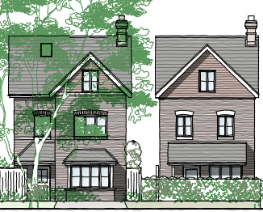
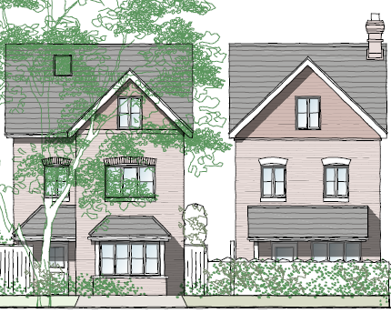

Approved rear elevation
Proposed rear elevation
Proposed street scene
Approved street scene

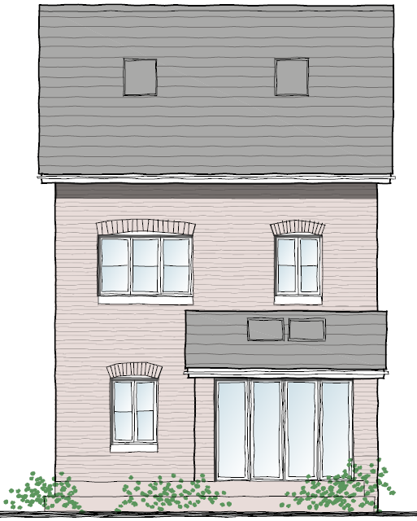
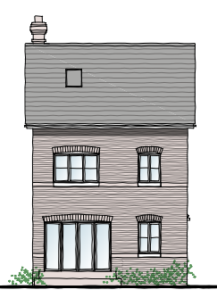

Proposed second floor
Approved second floor by 181305
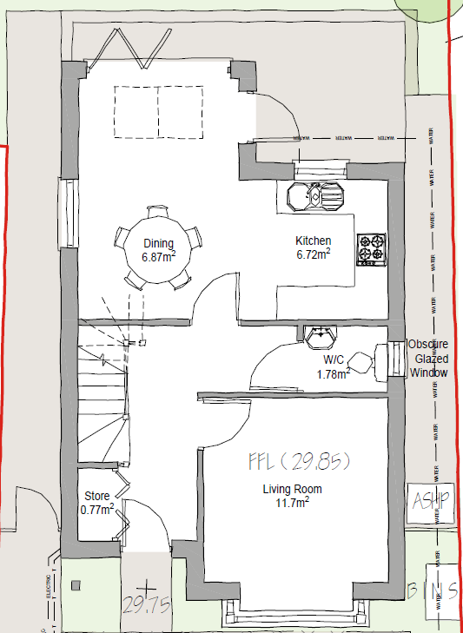
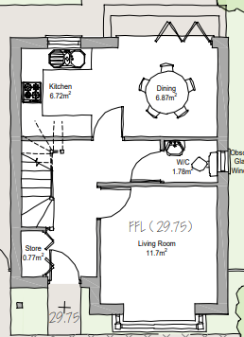

Approved ground floor
Proposed ground floor

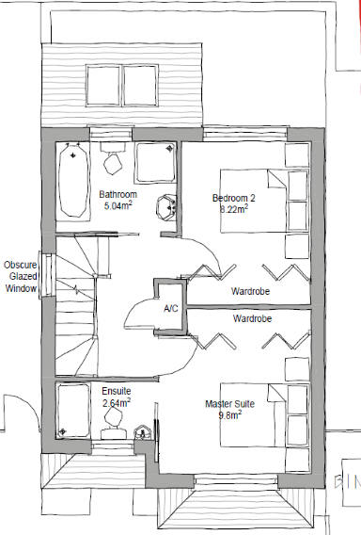
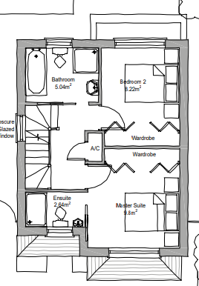

Approved first floor
Proposed first floor
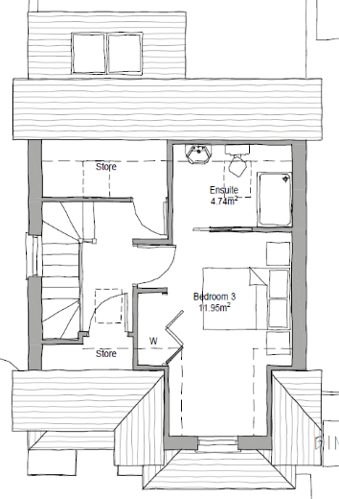
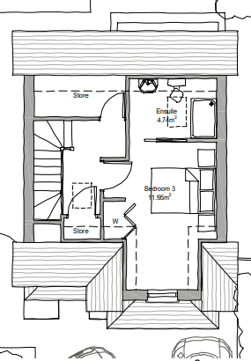

Approved second floor
Proposed second floor

5.0 PLANNING POLICY
The principle of a three bedroom dwelling is considered accepted by virtue of application ref: 181305. This application is considered to be in accordance with Reading Boroughs new Local Plan, adopted November 2019.
- CC1: Presumption in Favour of Sustainable Development.
- CC2: Sustainable Design and Construction.
- CC3: Adaption to Climate Change.
- CC5: Waste Minimisation and Storage.
- CC7: Design and Public Realm.
- CC8: Safeguarding Amenity.
- EN14: Trees, Hedges and Woodland.
- EN15: Air Quality.
- EN16: Pollution and Water Resources.
- EN18: Flooding and Drainage.
- H1: Provision on Housing.
- H3: Affordable Housing.
- H5: Standards for New Housing.
- H11: Development of Private Residential Gardens.
- TR3: Access, Traffic, and Highways-Related Matters.
- TR5: Car and Cycle Parking and Electric Vehicle Charging.
6.0 IMPACT ON CHARACTER
The proposal reflects the existing design of the previously approved dwelling which was considered to be appropriate in design terms. There are therefore no material changes to the impact on the street scene from the previous granted permission. There is now a small rear extension included which is not considered to be harmful to the character of the approved dwelling or street scene setting.
7.0 IMPACT ON HIGHWAYS
The proposal does not alter the approved access arrangement or approved parking provision - As such it is considered there will be no harm to the adjacent highway networks. An electric vehicle charging point is also included on the proposed drawings to ensure the continued promotion of electric vehicle use.
8.0 IMPACT ON NEIGHBOURS
The changes to the internal layout does not alter the relationship with neighbours. There are no habitable side windows proposed and the scale remains unchanged. As such there are no material differences in terms of overlooking, overbearing or dominating effects on neighbouring residential amenity.
9.0 IMPACT ON TREES
There is a TPO Lime Tree with an RPA extending into the site and across the existing access and driveway. As such a number of protection solutions are proposed to include root barriers on both sides of incoming services, as well as hand excavation to remove the existing driveway hard standing and a cellular confinement system for the full extent of the driveway.
In addition, new border planting is proposed along the flanking shared boundary with 1 Marlow Court, with 3 new trees proposed to be planted in the rear garden following the loss of an existing Ash and Sycamore tree, resulting in a net gain of tree planting.
10.0 IMPACT ON CLIMATE CHANGE
The proposal seeks to include solar panels, an air source heat pump and an electric boiler to meet the policy expectations of a minimum improvement in the dwelling emission rate over the target emission rate, as defined the 2013 Building Regulations (Policy H5: Standards for New Housing).
The application site is also located in Reading’s Air Quality Management Area, albeit on the periphery of this designation. As such the proposal sets back the development from the road (Henley Road) by some 45 metre ensuring a reduction for the occupants of the dwelling. For completeness the applicant currently lives 190 Henley Road and as such there will be no additional vehicle movements from the site than which currently exists.
The application is supported with a construction management plan which ensures the minimisation of dust by utilising bark chippings, no fines mixed aggregates and boarded walks for contractor use. Owing to the scale of the development and the constraint of the TPO Lime Tree there will not be any large HGVs delivering material to the site and as such vans proportionate to the scale of the development will be used.
11.0 CONCLUSION
This statement has sought to demonstrate the proposed development is acceptable in principle. Material planning considerations have been assessed and it is concluded the site can be developed as proposed without adverse impacts to the character of the area, amenity of neighbouring land uses, highway safety and ecology. Overall, the proposal is compliant with the relevant local and national policy and guidance and has sought to respond positively to policy and planning context.

