Oxford Road Community School – Roof Replacement

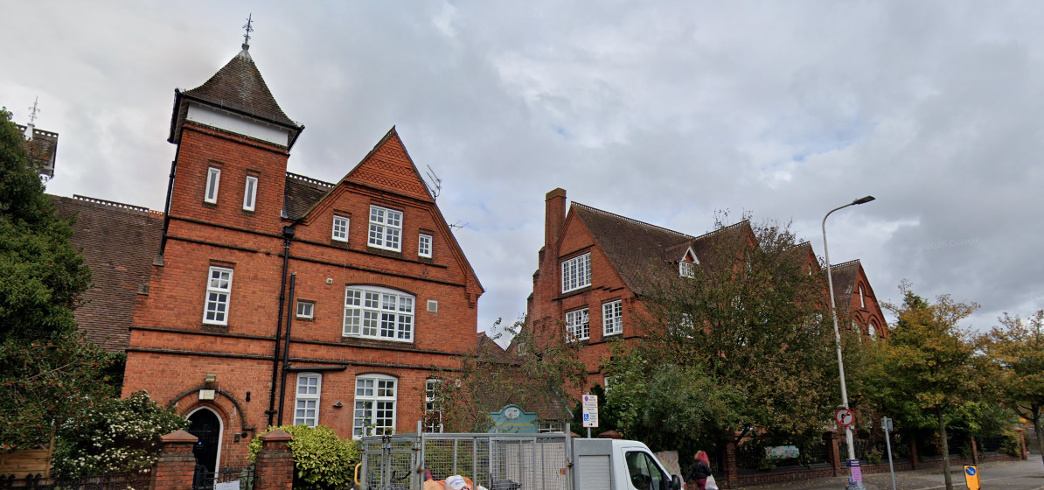
Design, Access & Heritage Statement

Oxford Road Community School, 146 Oxford Road, Reading, RG1 7PJ.

Project ITMS Code E04948 Reading Fabrics Programme – Pitched Roofing
Contents
Background 3
Existing Roofs 3
Existing Roof Condition 4
Proposal 4
Scale & Appearance 5
Access 6
Layout 6
Ecology 6
Appendix A: Roofs Photo Schedule 7
Appendix B: Tile Matching 17
Appendix C: Ecology Survey Report 21

Background
Oxford Road Community School is a primary school for ages 3 to 11 years. The main building is two storey. Construction is of solid masonry walls, cut timber pitched roof with clay tile covering. The roof has several features such as chimneys, dormer windows and decorative vents, cupola, tile hung gables and a small spire. There is also a modular building in the playground, however this does not form part of the works. The roof is experiencing a number of leaks and defects. Some patch repair has taken place, but to maintain the watertightness of the building, prevent further decay reroofing is proposed as the most economical option and best to maintain the condition of the structure below.
The building is grade II listed (List Entry Number is: 1392867) and is also mentioned in Berkshire volume of the Pevsner Buildings of England (2010). The building being originally a Board School Board school, 1880-83 by Morris and Stallwood, extended 1894 by Stallwood. Roof features described in the previous paragraph are mentioned in the listing.

Existing Roofs
The existing roof consists of a number of pitched roofs at various levels, with clay tile covering and decorative ridge tiles. Valleys between the pitched roofs are lined with lead. The ridge of the roof has a number of decorative metal vent cowl’s which ventilate the rooms below. One of these Cowl’s is enclosed in a timber frame (Cupola) with pitched roof and gives the appearance of a bell tower. Some of the gables have tile hung tympana. The principal elevation facing Oxford Road has a spire type structure above an internal staircase giving access to all floors.

Internally the building has vaulted ceilings with lath & plaster finish, however the majority have had suspended mineral tile ceilings installed below. Bagged mineral wool insulation is present above the suspended ceilings and lath & plaster has been covered in wire mesh, presumably due to concerns over plaster key to the lath failing. Only a small number of roofs covering administrative areas have not had a mineral tile ceiling installed.

Rainwater goods have had some modern alterations. At some point in the past a number of gutters have been replaced with UPVC half round gutter laid within original cast iron brackets, still present. Some half round cast iron gutter remains in areas and most rainwater downpipes are cast iron (Gutter & DP Photos Appendix A Photos 12-14). There is no facia or soffit present with a masonry overhang provided at roof eaves and the cast iron gutter brackets appear to be built into the masonry. Some exposed timberwork is present around dormer windows and appears in good condition from ground level.

There are a number of small flat roofs to the main school building. These consist of:- a modern extension with a felt flat roof at the rear (North Elevation) of the property, a boiler room on the front elevation (south) facing Oxford Road and a single storey attached toilets on the West Elevation. All are presumed later additions to the building in the last century.

Existing Roof Condition

The pitched roofs currently has a large number of slipped or missing tiles, indicating nail sickness. Patch repair of the roof in various locations has already taken place (Appendix A Photo 1-5). Some machine pressed clay tiles were noted present on the roof during investigations, from possible previous repairs or previous re-roofing. The decorative ridge tiles are damaged in a number of locations and some replacement with modern (non-matching) tiles has already taken place (Ridge Tiles Appendix A Photos 6 &7). The tile hung tympana to the gables appear in relevantly good condition, compared to the rest of the roof. Where the loft space is accessible there is remains of a previous underlay below tiles in very poor condition, possibly a straw and plaster torching (Appendix A Photos 8-10). Continuation of emergency patch repairs would be uneconomical and risk water damage to the structure below.

The felt flat roof above the boiler room and toilets on west elevation has reached the end of their expected life. The boiler room roof also has significant vegetation, evidence of cracking to the felt and damage to lead flashings, possibly by vandals attempting to steel the material.

Proposal
The proposed is to remove the existing roof covering and re-instate it using as much of the original material as possible and where unable to do so with sympathetic replacement.
Proposed work for the pitched roofs:
- Exiting tile covering will be carefully removed including ridge tiles and hip tiles along with mortar from ridges / verges. The removed tiles will be sorted, and any re-usable tiles stored for re-use.
- Existing lead work to valleys and flashings will be removed and sent for recycling.
- Vegetation growth present will be cut back and cleared way from roofs and walls.
- Features such as cupolas and vent stacks will be retained in place and protected.
- While access is available any repairs required to masonry chimneys or timber work will be completed. This will be accessed once access obtained.
- Plastic rainwater goods will be removed.
- Tile hung tympana to the gables will be inspected and if there are signs of nail sickness then the tiles will be numbered and removed for re-use.
- A breathable sarking felt, and new timber battens will be installed to all pitched roofs
- Where insulation has already been added above suspended ceilings no new insulation will be added.
- In portions of the building where vaulted ceilings remain insulation will be added followig the guidance of Historic England guide (HEAG070 Insulating Pitched Roofs at Rafter Level). Mineral wool insulation will be placed between the rafters and above ceilings. A breathable vapour control barrier will be placed over the rafters and a counter batten added above the vapour control layer to ensure adequate ventilation space.
- Existing cast gutter and downpipes if sound will be cleaned and painted.
- UPVC rainwater goods and any defective cast will be replaced with new matching cast iron. Wherever possible existing gutter brackets will be re-used if sound.
- A new tile covering will be installed with a mixture of retained and replacement tiles. Replacement tiles being mixed in. Ridge tiles will be fixed with lime mortar.
- If necessary to remove tile hung tympana to replace fixings they will be reinstated using the number system on removal to maintain original appearance.
- New lead will be installed to valleys, flashings and other detailing.(Code 6 to valley gutters, Code 5 for Chimney flashings & Code 4 for step flashings & soakers)
Proposed work for the flat roofing:
- Strip up and remove existing felt covering and lead.
- Install new insulation to current building regulations. Forming gutters in roof surface where features e.g., windows prevent 150mm upstand.
- Install new reinforced bitumen membrane
- Install Ublifex Lead Alternative Flashing, due to ease of access to low level flat roofs, there is a high probability of lead theft from this area.

Scale & Appearance
Roof height & features. No alteration to roof height will take place and all features such as vent cowls and cupulas and weathervanes will be retained.
Tiles existing tiles will be re-used and where not possible new tiles of similar appearance will be used on the rear elevations (See Appendix B Photos 20 to 22)
Ridge Tiles. The original ridge tiles are no longer commercially available. Due to the significant number of damaged, it is proposed to commission the production of a batch of replacement ridge tiles to be mixed in with the existing. This would return the ridges to what is believed to be their original appearance.
Rainwater Goods. Cast iron rainwater goods where present will be retained and any UPVC from previous repairs will be replaced with new cast Iron, returning the building to a more original appearance. Gutter brackets will be retained where in sound condition and sympathetic new brackets used where they cannot.
Flashings & leadwork. New leadwork will be reinstated to all pitched roofs. The flat roofs due to their lower level and easier access will
Flat Roofing. The flat roofs will be re-instated with similar reinforced bitumen felt coverings maintaining the current appearance.

Justification & Mitigation
Justification: To prevent further damage to the building structure and historic ceilings, and to improve the environmental conditions within the building. Will improve the environmental performance of the building, and make it weather tight and fit for occupation for the next 60+ years.
Mitigation: The provision of new matching roof and ridge tiles will improve the detrimental visual impact of previous piecemeal alterations. Rainwater goods will be changed back to cast from uPVC which will improve the appearance of the building.

Access
The replacement of the roof covering will not affect the existing access arrangements for the site.
Oxford Road Community School is located in a semi residential area. The main pedestrian entrance is on the South Boundary off Oxford Road. There is no onsite parking. Most children and staff arrive by foot, bicycle or local public transport.

Layout
No change to the present layout of the site or layout of the roofs is planned as part of these works.
The site is dominated by the main listed building, which runs across the site East to West and sits close to the boundary with Oxford Road. The boundary to Oxford Road has a number of trees and shrubs, which partially obscure the front elevation of the main building. The oxford road boundary has iron railings between masonry pillars. The Rear (North) side of the site has a surfaced playground with a modular building. All other site boundaries are masonry walls. There is a pedestrian access on Oxford Road and George Street.

Ecology
A bat survey has been completed and found no evidence of bat activity in or around the roof. The survey is included in appendix D.
No other disturbance of local wildlife or ecosystems is expected.

Appendix A: Roofs Photo Schedule

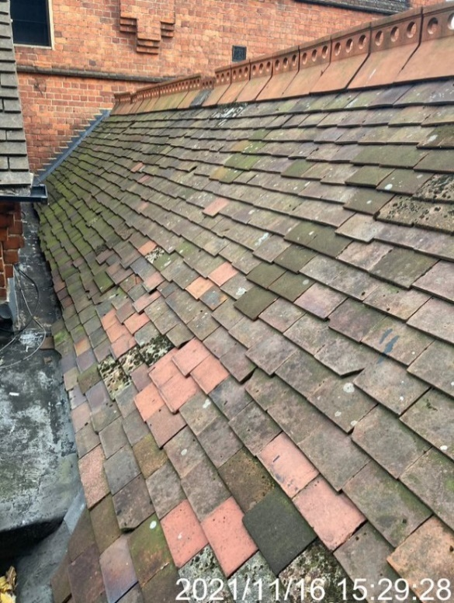
Photo 1 – Existing roof section showing slipped/missing tiles & recent replacements
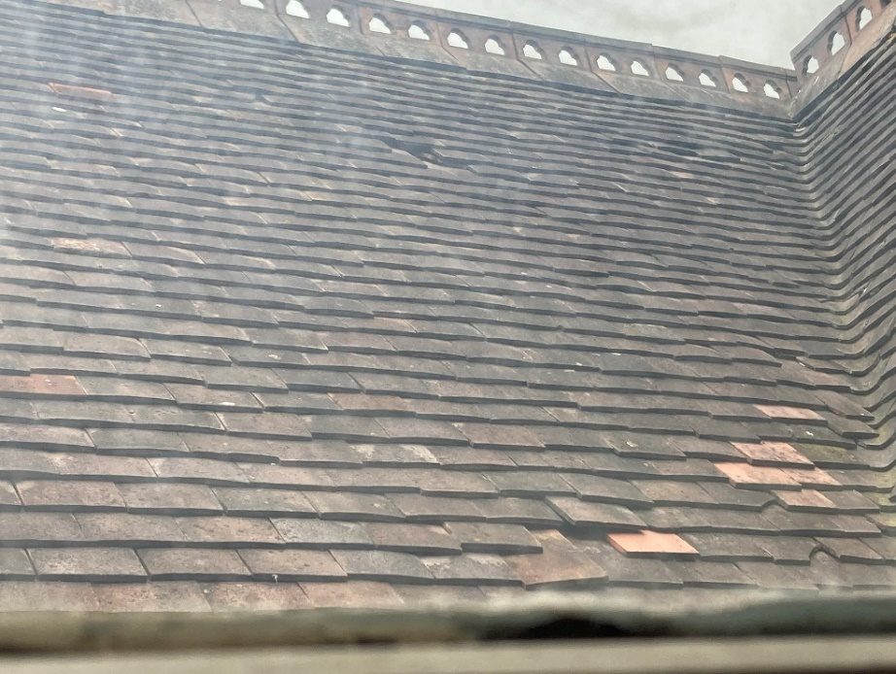
Photo 2 – Existing roof section showing slipped/missing tiles & recent replacements
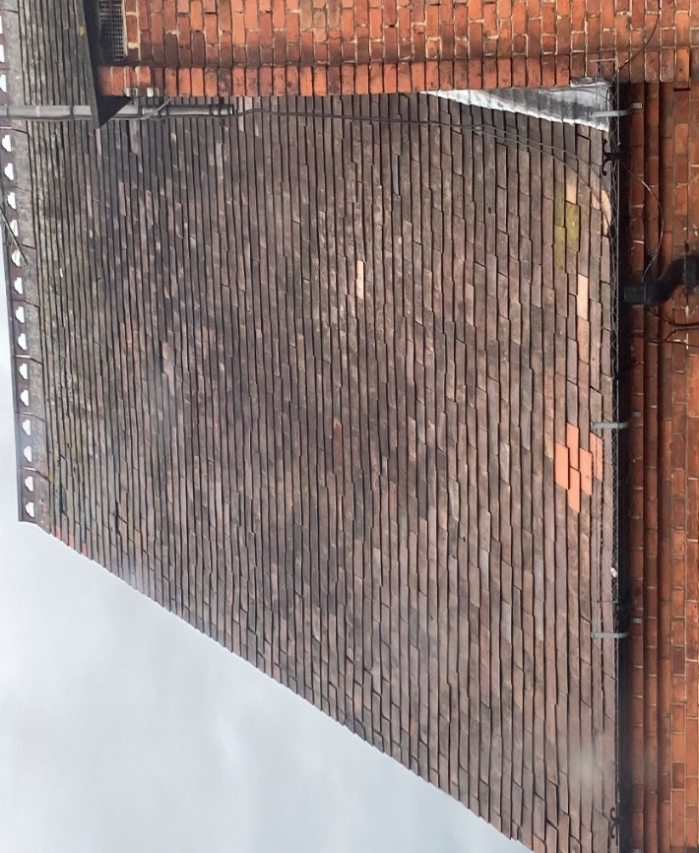
Photo 3 – Existing roof section showing slipped tiles & recent replacements
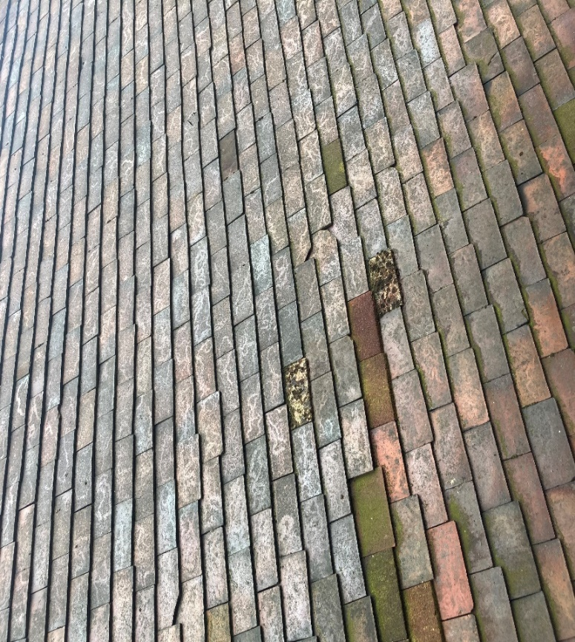
Photo 4 – Existing roof showing slipped& recent replacements
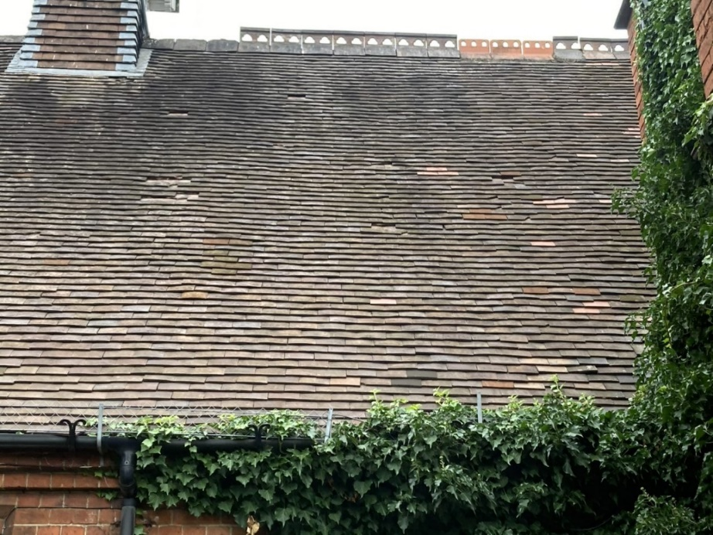
Photo 5 Ridges tiles are broken or have been replaced with a poor match. (Original ridge tiles centre)
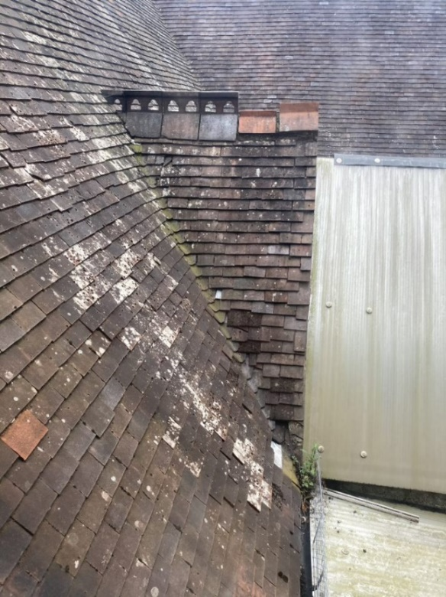
Photo 6 Previous ridge tile repairs have been with non-matching stock. (Original ridge tiles left)
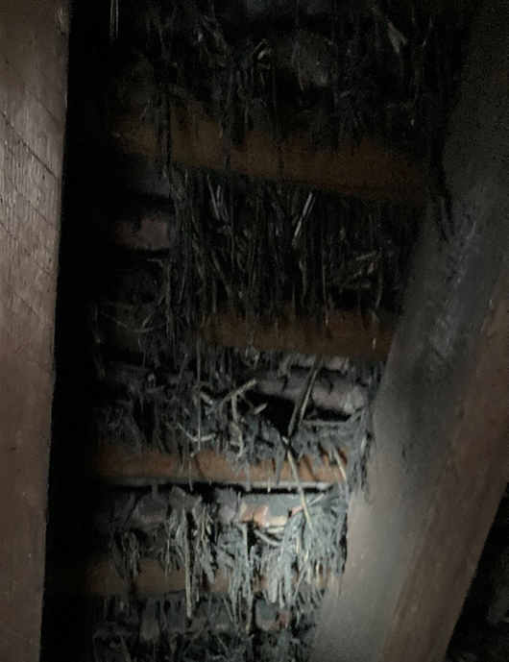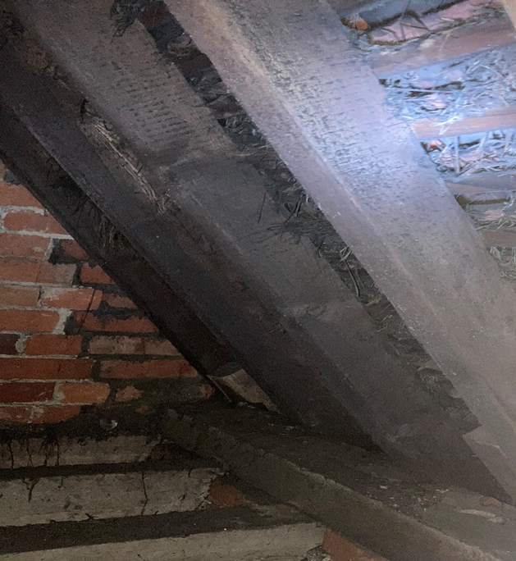
Photo 8 Remains of possible straw and plaster torching below tiles where roof voids accessible.
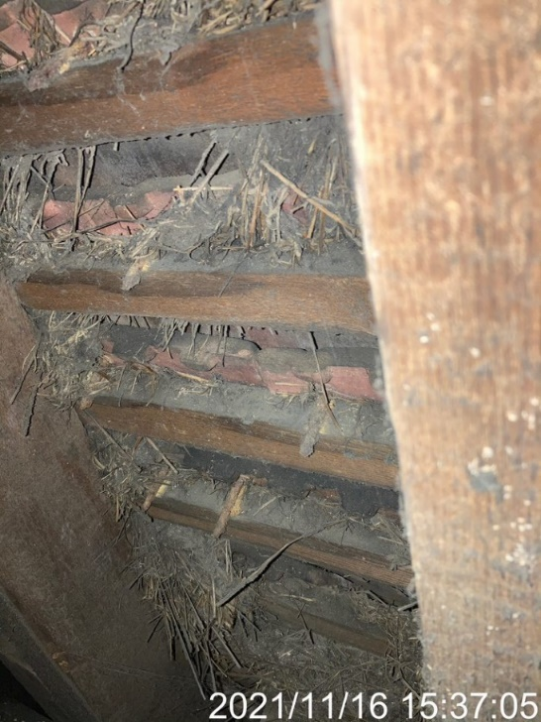
Photo 9 Rust to tile nails where roof voids accessible
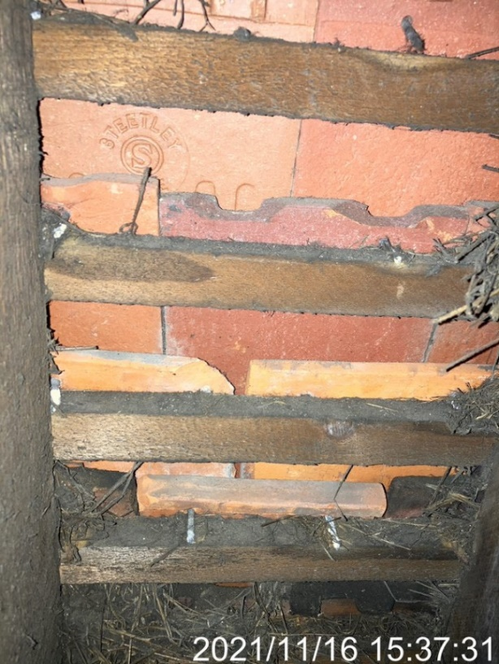
Photo 10 Range of tile types and ages visible from underside of roof where roof voids accessible
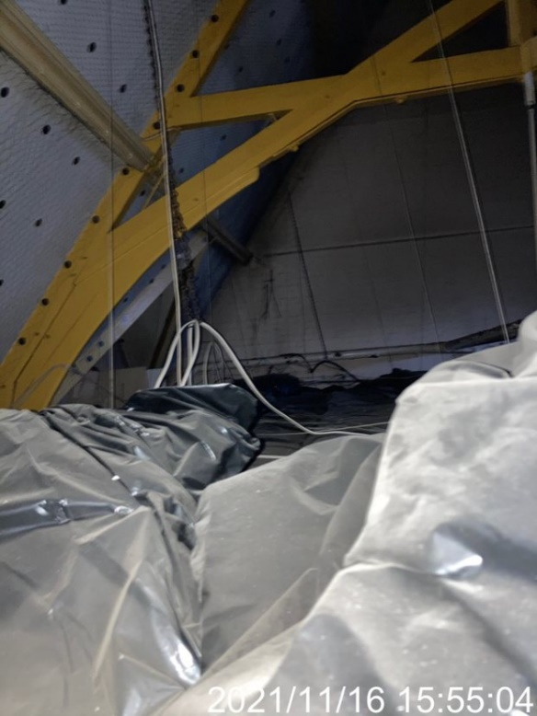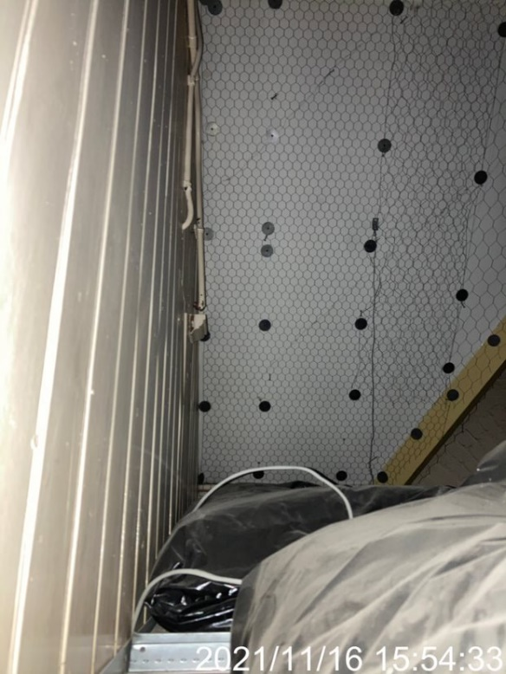
Photo 11 Above suspended ceilings, showing existing wire covering to plaster
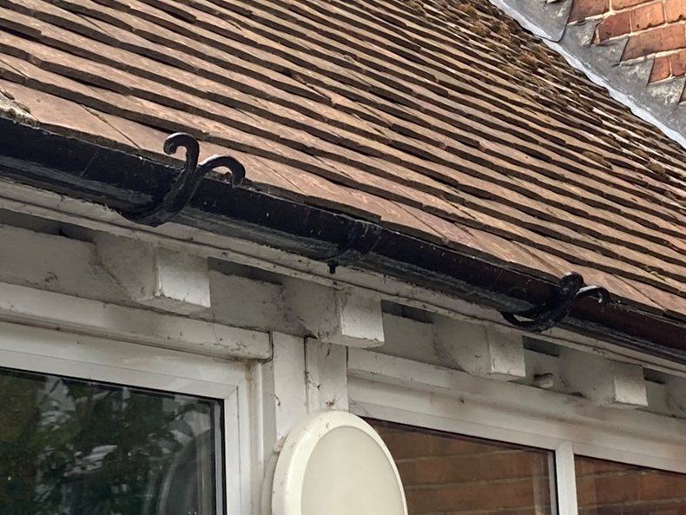
Picture 12 Existing Cast Round Gutters
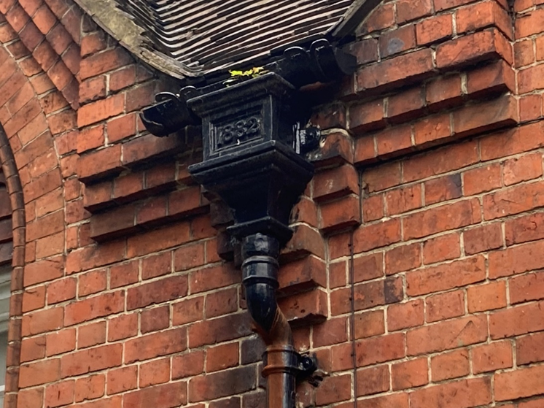
Picture 13 Existing Cast Downpipes and Hoppers
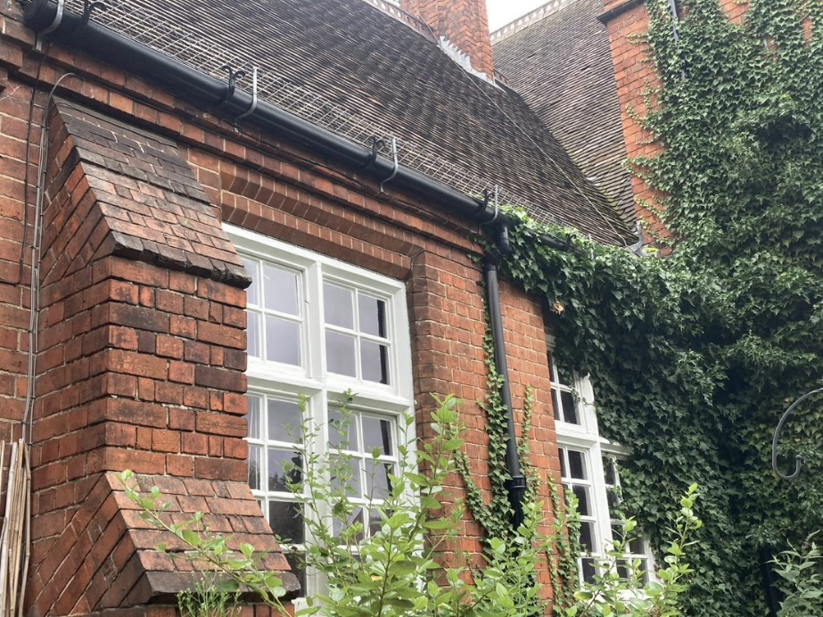
Photo 14 Gutters replaced with UPVC using existing cast brackets and downpipe partially replaced.
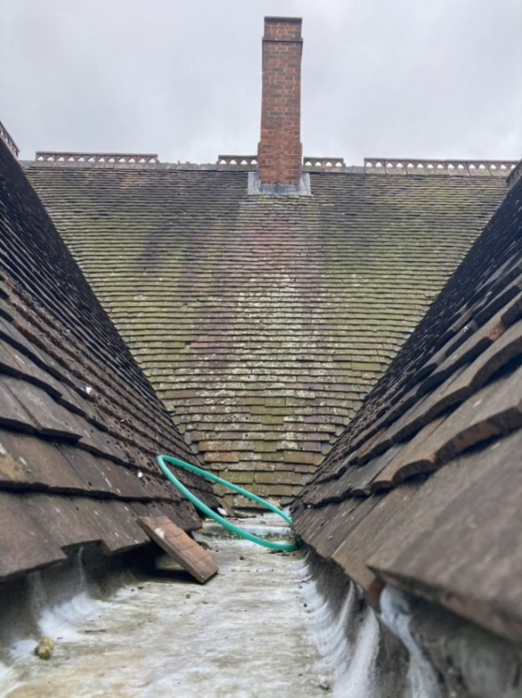
Photo 15 Typical lead gutter between roofs (Also show further tile & ridge damage)
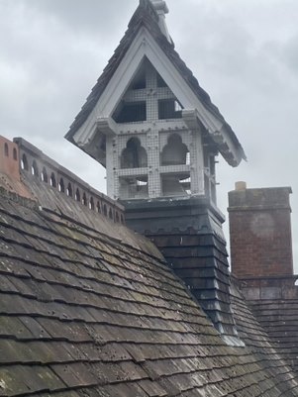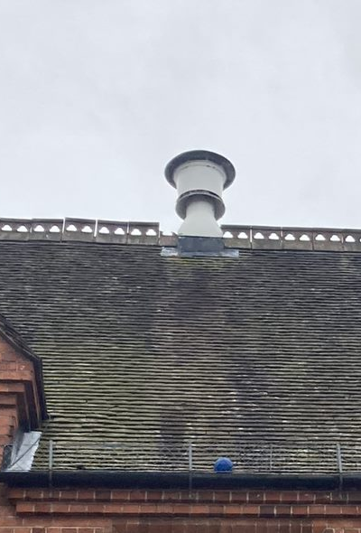
Photo 16 Decorative Copula around building vent and typical roof vent
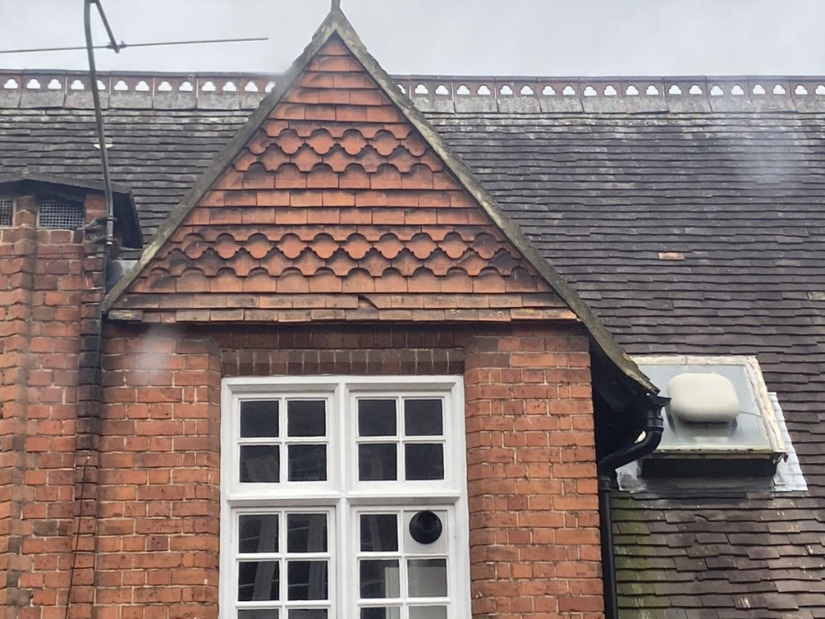
Photo 17 Existing tile hung tympana to some areas.
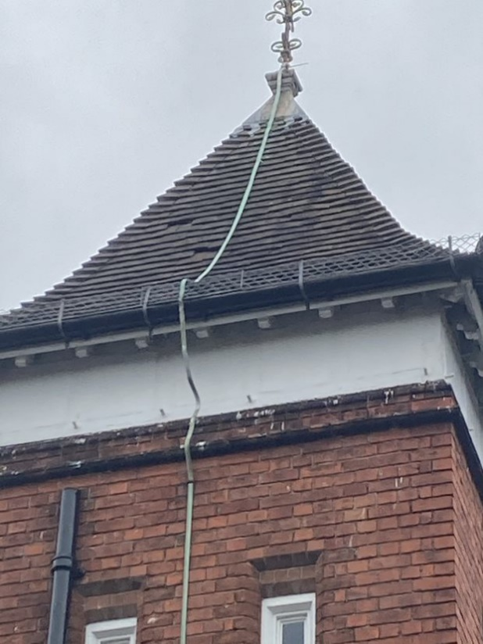
Photo 18 Spire at front of building with further missing tiles visible.
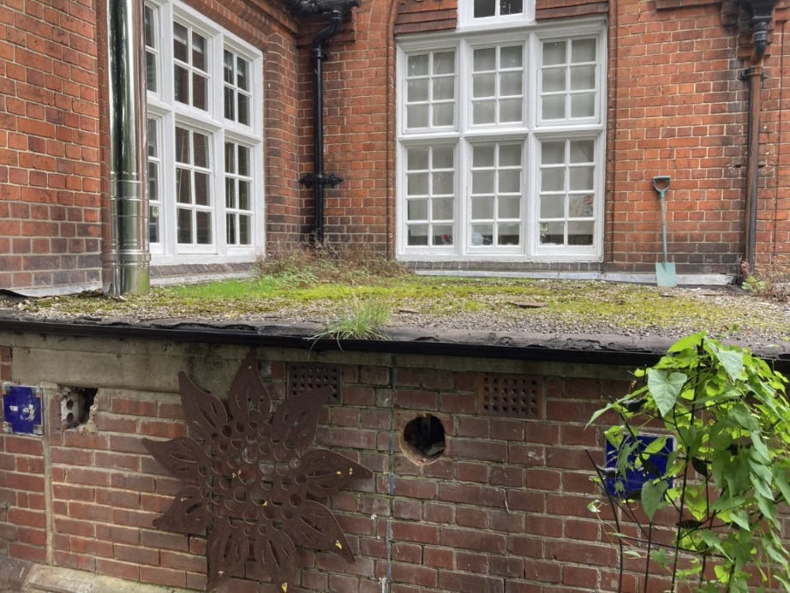
Photo 19 Flat roof condition over boiler room.

Appendix B: Tile Matching

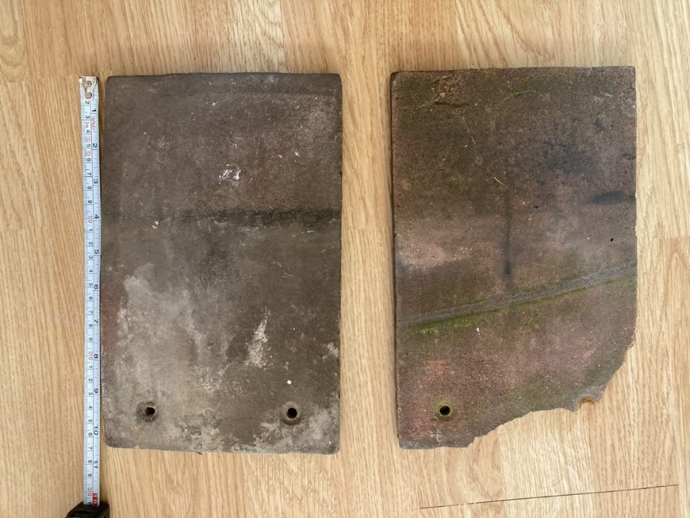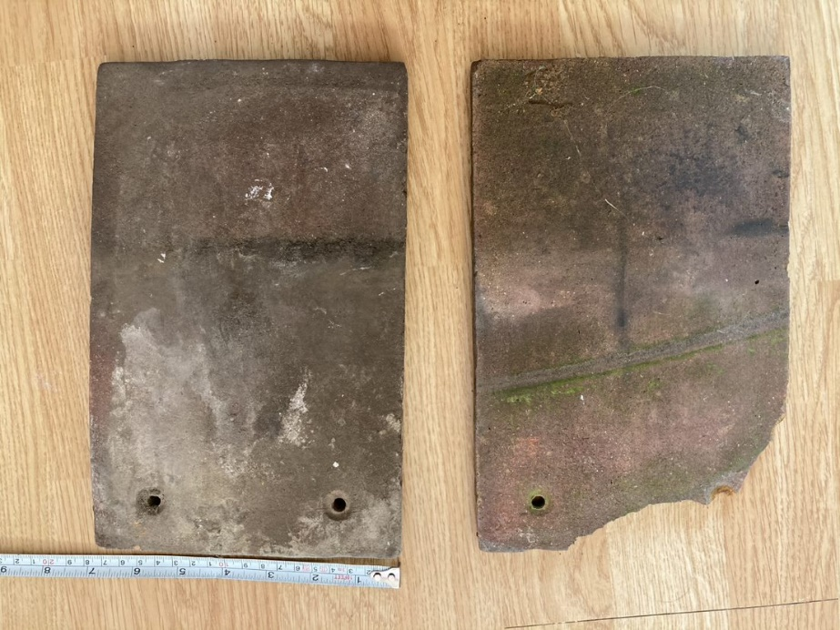
Photo 20 Tiles Recovered from Oxford Road Community School
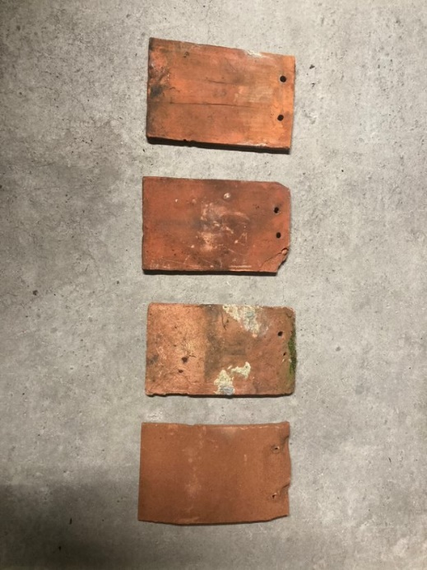
Photo 21 – Matching tiles from Hampshire County Council Historic Tile Store


Photo 22 –Oxford Road Tiles & Hampshire County Council Historic Tile Store

Appendix C: Ecology Survey Report



Oxford Road Community School,
146 Oxford Road, Reading, Berkshire RG1 7PJ

Bat Survey Report

September 2021

on behalf of Reading Borough Council

Windrush Ecology Limited – Howbery Park – Benson Lane – Wallingford OX10 8BA
Tel 01491 822681 – Web www.windrushecology.com – Email enquiry@windrushecology.com
Company Registration No: 7068178 – Place of Registration – 4 Witan Way, Witney, Oxfordshire, OX28 6FF

Disclaimer

This report is issued to the client for their sole use and for the intended purpose as stated in the agreement between the client and Windrush Ecology Ltd. This report may not be relied upon by any other party without the express written consent of Windrush Ecology Ltd.

Windrush Ecology has exercised due care in preparing this report. It has not independently verified information provided by others, and no warranty is made in relation to the content of this report and Windrush Ecology Ltd assumes no liability for any loss resulting from errors, omissions or misinterpretation made by others.

Any recommendation, opinion or finding stated in this report is based on the circumstances and facts as they existed at the time that Windrush Ecology Ltd performed the work. The content of this report has been provided in accordance with the provisions of the CIEEM Code of Conduct.

Nothing in this report constitutes legal opinion.

Client | Reading Borough Council
Job name | Oxford Road Community School, 146 Oxford Road, Reading, Berkshire RG1 7PJ
Survey date | 10th February 2021, 22nd July 2021 & 19th August 2021
Report date | 6th September 2021
Report title | Bat Survey Report
Reference | W4153_rep_Oxford Road Community School_06-09-21

 | Signed | Name | Position | Date
Prepared by | 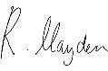 | Reuben Hayden MSc QCIEEM | Ecologist | 25/02/2021
Reviewed by | 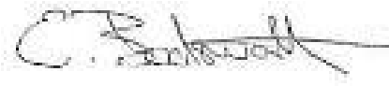 | Edward Bodsworth MA (Cantab) PhD MCIEEM | Director | 06/03/2021
Updated by |  | Reuben Hayden MSc QCIEEM | Ecologist | 06/09/2021
Reviewed by |  | Edward Bodsworth MA (Cantab) PhD MCIEEM | Director | 06/09/2021

Windrush Ecology Limited – Howbery Park – Benson Lane – Wallingford OX10 8BA
Tel 01491 822681 – Web www.windrushecology.com – Email enquiry@windrushecology.com
Company Registration No: 7068178 – Place of Registration – 4 Witan Way, Witney, Oxfordshire, OX28 6FF


Oxford Road Community School, Reading

Contents

1 Executive Summary 0
2 Introduction 1
2.1 Site Description 1
2.2 Proposed Works 1
2.3 Aims of Study 1
2.4 Bat Ecology 1
3 Methodology 3
3.1 Limitations on Survey Data 3
3.2 Field Surveys 3
3.2.1 Preliminary Roost Assessment (PRA) 3
3.2.2 Bat Activity Surveys 5
4 Results 7
4.1 Description of Buildings 7
4.1.1 Building 1 - Main School Building 8
4.1.2 Building 2 - Western Outbuilding 11
4.1.3 Building 3 - Western Outbuilding 12
4.1.4 Building 4 – Wooden Shed 12
4.1.5 Building 5 – Covered Outbuilding 12
4.2 Evidence of Bats 12
4.2.1 Bat Activity 13
4.3 Evidence of Birds 14
5 Discussion 14
5.1 Assessment of Results 14
5.1.1 Bats 14
5.1.2 Birds 14
5.2 Legislative Guidance 14
5.2.1 Bats 14
5.2.2 Nesting Birds 15
5.3 Potential Impacts 16
5.3.1 Bats 16
5.3.2 Birds 16
6 Recommendations 16
6.1 Further Surveys 16
6.2 Bats 16
6.2.1 Timing 16
6.2.2 Careful Work Practices 16
6.2.3 Enhancement 17
6.3 Birds 17
6.3.1 Enhancement 17
7 References 17
8 Appendix 1. Photographs 19

9 Appendix 2. Site Location Plans ............................................................................. 18
W4153_rep_Oxford Road Community School_06-09-21 i

Executive Summary

Site Details | Oxford Road Community School is located to the north side of Oxford Road, to the western side of the town of Reading in Berkshire RG1 7PJ. The approximate Ordnance Survey grid reference for the site is SU 705 734.
Proposals | There is a proposal to undertake roofing repairs/works to the roof of the main school building (Building 1).
Methodology | An initial bat survey and preliminary roost assessment was undertaken on the 10th February 2021 by Reuben Hayden MSc QCIEEM.  Bat activity (emergence) surveys, focused on Building 1 at Oxford Road Community School were conducted at dusk on 22nd July and 19th August 2021, in accordance with best practice (Collins, 2016).
Evaluation | - No bats or evidence of bats was found in association with the buildings.  - Building 1 is assessed as having ‘moderate’ potential to offer shelter to roosting (Collins, 2016).  - Buildings 2, 3, 4 and 5 are assessed as having ‘negligible’ potential to offer shelter to roosting (Collins, 2016).  - No evidence of nesting birds was noted in association with the buildings.  - No bats were observed emerging from Building 1 during the bat activity surveys.
Impact Assessment | There is no evidence to suggest that Building 1 of Oxford Road Community School is being used as a place of shelter/protection by roosting bats. As a result of this conclusion, roofing works to the building are unlikely to result in any significant impacts on bats or the places that they use for breeding, shelter and/or protection (roosts) and no specific compensation measures are considered necessary (Mitchell-Jones, 2004).
Recommendations | The erection of bat and bird boxes are also recommended to maximise the sites value to wildlife.
1

Introduction

Site Description
Oxford Road Community School, hereafter referred to as the ‘site’, is located to the north side of Oxford Road, within the suburbs to the western side of the town of Reading in Berkshire RG1 7PJ. The approximate Ordnance Survey grid reference for the site is SU 705 734.

The site comprises an active school, with a number of school buildings set within grounds of hard-standing. Whilst all of the school buildings were surveyed within this study, the focus of this report is the main school building which is of brick construction with a pitched roof of clay tiles. The building dates from 1882, and was built within the Victoria era.

The site is located to the western side of Reading town centre, within the suburbs of the town, with built development surrounding the site in all directions; characterised by terraced dwellings, roads and gardens. Habitats are limited to areas of open green space, amenity grassland and amenity parkland.

The River Thames is located approximately 1.3km to the north of the site, providing potential foraging and commuting habitats for bats within the local area. However, there are no strong habitat connections between the site and the habitats associated with the river, nor are there any other strong habitat connections to other habitats that may support bat species.

Proposed Works
There is a proposal to undertake roofing repairs/works to the roof of the main school building (Building 1); details are currently unknown.

Aims of Study
The aims of this study are to survey the buildings for bats and/or evidence of bats, and other protected species including nesting birds. The study assesses the overall potential of the building to support roosting bats and other protected species. The report discusses the potential impacts of the proposed works on bats, protected species and their habitats.

The report assesses the potential impacts in accordance with the legal protection afforded to bats under The Conservation of Habitats & Species Regulations 2017, and recommendations are made with regard to further bat surveys, where considered necessary. European Protected Species (Bat) licenses are also discussed in light of the impact assessment.

Bat Ecology
Bats are the only mammals to have developed the ability of true flight. At present, over 1,100 species of bat are recognized worldwide, making bats the second largest mammal group after rodents. As well as flight, bats have evolved a system of navigation and orientation using echolocation which has allowed many species to become nocturnal. There are 18 species of bat that occur within the British Isles, of which 17 are known to breed here. More species occur in the south and west of the country, with species numbers declining towards the north and into Scotland.

All bat species in the UK are nocturnal and feed exclusively on insects (they are insectivorous) which they catch in flight during their night-time activity, using echolocation to locate and home-in on their prey. Bats will roost during the daytime and seek out dark, enclosed and undisturbed places in which to do so, often using a variety of roosting sites within their home range. Different roost sites are used for different purposes (such as mating, giving birth and hibernation) and at different periods of a bat’s life cycle.

During the summer, female bats will gather together in a maternity or breeding roost. In the UK, this starts to occur towards the end of May and the females will seek out a warm and undisturbed site in which to give birth. Because maternity roosts require a particular set of environmental attributes (such as location, temperature, orientation and size), breeding bats tend to return to roost and breed in the same locations year after year. Given that bats live a relatively long time (anywhere from 10-20 years), and only give birth to one pup a year, maternity colonies are crucial to the reproduction and survival of the local population and can be very sensitive to environmental change.

Relatively little is known about hibernation roosts, as tracking and locating hibernating bats is very difficult. However, many species (particularly those within the genera Myotis and Rhinolophus) have been found within underground sites such as caves, mines and cellars, where the temperature remains constant and low throughout the winter allowing the bats to remain in a state of torpor. The spring and autumn are periods of transition and bats can use a number of different locations on a temporary basis, often moving between roosts as environmental conditions change and temperatures fluctuate. In the autumn, bats will mate, and it has been shown that male and female bats will gather at particular locations (such as a building, cave or tree) to meet, socialise and copulate.

Bats choose to roost in a number of different locations, depending on the species, their activity pattern and the period of their lifecycle. Certain species, such as the pipistrelles, favour crevices and small cavities for roosting and will use features such as cracks, crevices and small rot holes in the boughs and trunks of trees and within certain features of buildings such as boxed eaves, gaps under roof tiles, hanging tiles and soffit boards. Other species favour large, uncluttered roof spaces and lofts within buildings where they can hang up on the underside of the roof and use the interior space for flying prior to emergence. Hollow trees, cellars, caves, barns, churches and cavity walls can also all be used for roosting, given suitable access. Certain species, such as the noctule, favour roosting sites within trees whilst others tend to favour buildings. Roost sites may be used by only a very small number of bats, such as solitary males, or may offer shelter to tens or hundreds of bats within maternity and hibernation roost sites.

The suitability of roosting sites is also highly influenced by the location or context of a tree, building or cave. Roost sites are most often favoured when they are within close proximity to foraging habitats and where those habitats are connected to one another within the landscape by features such as hedgerows, woodlands, rivers or sunken lanes along which bats disperse and ‘commute’ from place to place. Suitable foraging habitats are any places where insect prey is diverse and abundant such as woodlands, ponds, lakes, rivers, scrub, hedgerows and unimproved grassland or pasture. Thus, the ecological context of a site is very important for determining if bats may be present within a roost and the potential for a roost to be present tends to be much higher within rural or village locations.

Methodology

Limitations on Survey Data
As with any survey undertaken on a certain date, the data presented within this report provide information at a particular point in time and present a ‘snap-shot’ of the ecological status of the site. Ecosystems and species behaviour/activity are dynamic and can change over time. Whilst this report presents a characterisation and evaluation of habitat and species status at the time of the study, it should not be taken as an exhaustive representation of the ecological status of the site either at present or into the future.

The eastern loft void (loft void 3) within Building 1 was not accessible at the time of the survey due to health and safety concerns. It is considered that loft void 3 is similar in dimensions and structure as loft void 1, and this has been taken into account when assessing Building 1 for its bat roost potential.

Field Surveys

Preliminary Roost Assessment (PRA)
A Preliminary Bat Roost Assessment was undertaken on the 10th February 2021 by professional ecologist Reuben Hayden MSc QCIEEM. Mr Hayden acts as a ‘duly accredited agent’ to survey for bats in accordance with the personal bat licences of Edward Bodsworth MA (Cantab) PhD MCIEEM (Natural England Licence no. 2015-12114-CLS-CLS, 202045379-CLS-CLS & 2020-45382-CLS-CLS).

A detailed internal and external survey of the buildings within the site (where access allowed) was undertaken using a 1 million candle-power torch and close-focusing binoculars in order to look for bats and/or evidence of bats and to assess the potential of the buildings to support roosting bats.

The buildings were inspected for evidence of bats including, bat droppings, urine stains, feeding remains (such as moth wings) and characteristic fur staining around access points.

Notes were made on the relative freshness, shape and size of bat droppings and the location and quantity of any feeding remains. ‘Clean’ gaps and crevices within the structure of the buildings were looked for as this can indicate where bats may have gained access to the interior spaces and the fabric of the walls.

The bat survey was undertaken according to best practice guidelines published by the Bat Conservation Trust (Collins, 2016).

The study also takes into account the structure and ecological context of the buildings, including the following factors which may increase the likelihood of roosting bats being present:

- Age of the building (pre-20th Century or early 20th Century construction)
- Nature of construction; traditional brick, stone or timber construction
- Large and complicated roof void with unobstructed flying spaces
- Large (>20 cm) roof timbers with mortice/tenon joints, cracks and holes
- Entrances and gaps for bats to fly and crawl through
- Poorly maintained fabric providing ready access points for bats into roofs, walls; but at the same time not being too draughty and cool.
- Roof warmed by the sun, south-facing roofs in particular
- Weatherboarding and/or hanging tiles with gaps
- Undisturbed roof voids
- Buildings and built structures in proximity to each other providing a variety of roosting opportunities throughout the year
- Buildings or built structures close to good foraging habitat, in particular mature trees, parkland, woodland or wetland, especially in a rural setting.

The following criteria are used for as guidelines for assessing the potential suitability of buildings for bats (Collins, 2016):

Suitability | Description of Roosting Habitats
Negligible | Negligible habitat features on site likely to be used by roosting bats.
Low | A structure with one or more potential roost sites that could be used by individual bats opportunistically. However, these potential roost sites do not provide enough space, shelter, protection, appropriate conditions and/or suitable surrounding habitat to be used on a regular basis or by larger numbers of bats (i.e. unlikely to be suitable for maternity or hibernation).
Moderate | A structure with one or more potential roost sites that could be used by bats due to their size, shelter, protection, conditions and surrounding habitat but unlikely to support a roost of high conservation status (with respect to roost type only – the assessments in this table are made irrespective of species conservation status, which is established after the presence is confirmed).
High | A structure with one or more potential roost sites that are obviously suitable for use by larger numbers of bats on a more regular basis and potentially for longer periods of time due to their size, shelter, protection, conditions and surrounding habitats.

Confirmed presence of roosting bats is where evidence indicates that a building or other structure is used by bats, this includes:

- bats seen roosting or observed flying from a roost or freely in the habitat;
- droppings, carcasses, feeding remains etc. found and/or
- bats heard ‘chattering’ inside a roost on a warm day or at dusk.

Where the possibility that bats are present cannot be eliminated or evidence of bats is found during the building inspection survey, then further surveys (such as winter hibernation, presence/absence and/or roost characterisation) are likely to be necessary if impacts on the roosting habitat (or the bats using it) are predicted.

In addition to the bat survey, the buildings were checked for evidence of nesting birds including old birds’ nests, bird droppings, feathers and eggs. Specific observations were made with regard to species such as the barn owl, swallow and house martin; species that are often associated with buildings.
3.2.1.1 Weather Conditions
The weather on the day was cold and dry (3°C), with moderate amounts of loose cloud (40% cloud cover) and a light breeze (Beaufort scale 2).

Bat Activity Surveys
Bat activity (emergence) surveys of Building 1 at Oxford Road Community School were conducted at dusk on the 22nd July 2021 and 19th August 2021, in accordance with best practice (Collins, 2016).

No emerging bats were recorded during both of the activity surveys. For details of the surveyors employed during each of the surveys please see Table 1 below.

Table 1. Bat activity survey schedule.

Date | Surveyors
 | Robbie Birkett (Bat Survey Licence 2019-39934-CLS-CLS)
Date | Surveyors
22.07.2021 | Oliver Bevan (Bat Survey Licence 2021-53108-CLS-CLS)  Mateusz Lewis  Samuel Prior
19.08.2021 | Reuben Hayden (Bat Survey Licence 2021-54302-CLS-CLS)  Robbie Birkett (Bat Survey Licence 2019-39934-CLS-CLS)  Samuel Prior  Infrared Camera

Please refer to Table 2 for timing and weather conditions during the bat activity surveys and Figure 1 for the location of surveyors during each survey. Surveyors watched for bats emerging from the building at dusk and were equipped with Echometer Touch bat detectors to record and analyse bat calls in real time.

Table 2. Timings and weather conditions during the bat activity surveys at Oxford Road Community School.

Date | Timing | Sunset | Temp  (Start) | Temp  (Finish) | Weather (at start of survey)
22.07.2021 | 20:53-22:37 | 21:07 | 22°C | 21°C | Dry, clear skies (0% cloud cover) with light air (Beaufort Scale 1).
19.08.2021 | 20:04-21:49 | 20:19 | 17°C | 17°C | Intermittent light drizzle throughout, overcast (100% cloud cover) with light air breeze (Beaufort Scale 1).

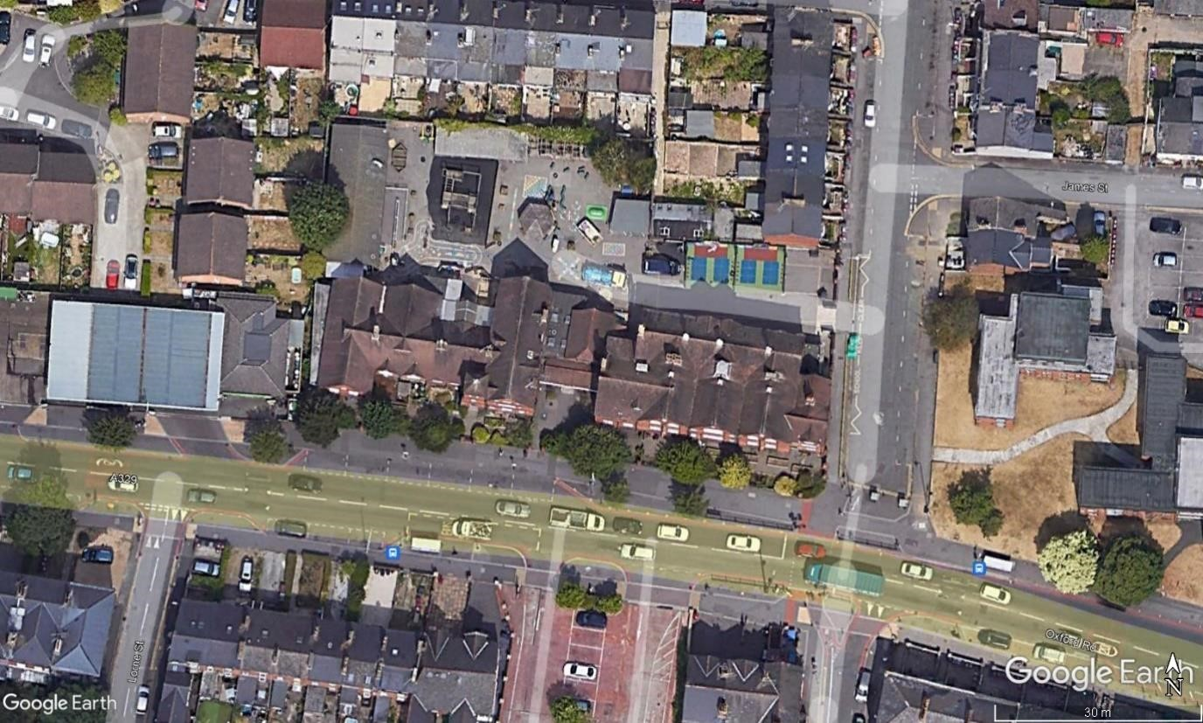

Figure 1. Aerial photograph showing the position of the surveyors during the bat activity surveys in 2021. Red circles indicate the positions of the surveyors on the 22nd July and 19th August 2021 and the yellow circle indicates the position of the infrared camera on the 19th August 2021. The study building is shown by the red outline.

Results

Description of Buildings
Please refer to Appendix 1 for photographs of the buildings. Location plans can be found within Appendix 2. The locations of the buildings within the site can be seen in Figure 2.

Bats will choose to roost within different locations within the summer and winter periods (see Figure 3), favouring dark, enclosed, humid and cool locations for hibernation such as caves and cellars. These locations must maintain a constant low temperature (2-8°C), but temperatures must also not go below freezing.

In addition, bats favour places that are undisturbed and retain relatively high humidity during the winter period. The buildings within the site are considered to be unsuitable for bat hibernation and the interior and exterior features of the buildings will most likely be affected by fluctuating temperatures that could reach freezing throughout the winter months.

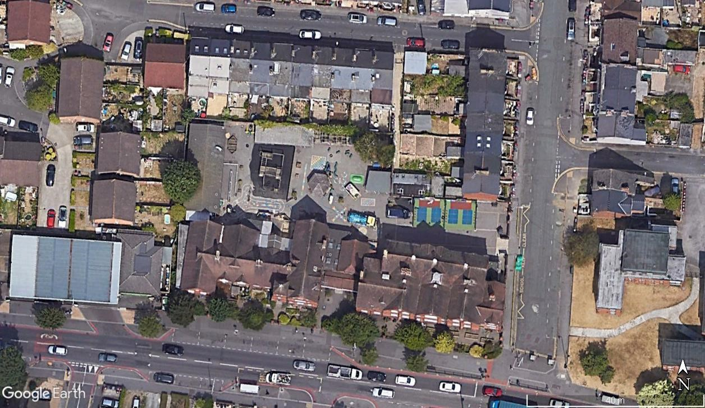

1

3

2

4
5
1

2

3

Figure 2. Buildings within the site, outlined in white. Loft voids are outlined and labelled in blue.

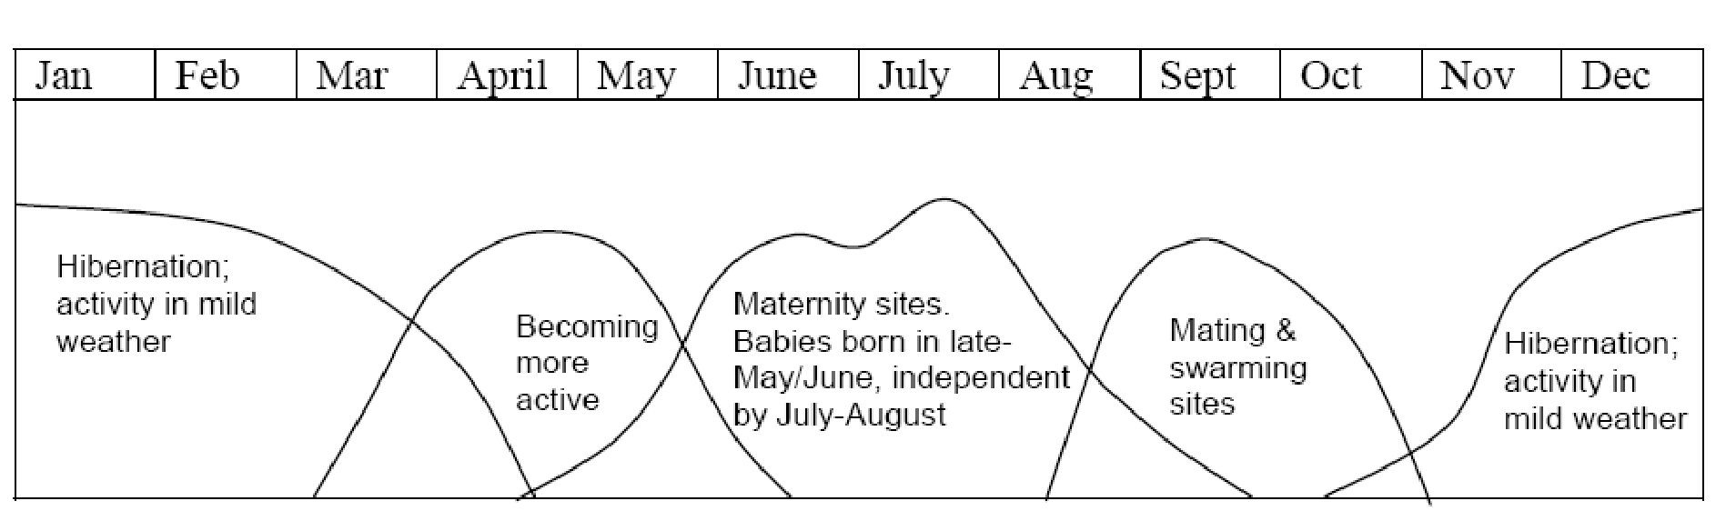
Figure 3. Diagram showing the yearly life cycle of a bat. Taken from the Bat Mitigation Guidelines by Mitchell-Jones (2004).

Building 1 - Main School Building
The main school building is of brick construction with a pitched roof of clay tiles, dating from 1882, and being built within the Victoria era. The roof has multiple ridges with eaves that extend out from the brick walls and connect to the mortaring along the roof.

The building has three loft voids:

- Loft void one is found on the western side of the building and covers a section of roof pitching. It has a window on the northern elevation that brings light into the space. The loft void has a floor to ridge height of approximately 2.5m and the roof is supported by a wooden king post frame with common rafters and has no underlay.

- Loft two is found on the western side of the building and is situated above a restroom. The loft is approximately 3m wide and has a floor to ridge height of approximately
1.5m. The void is completely devoid of light without artificial lighting and the roof underlay is plastered over, with no access points into the space.

- Loft three is found on the eastern side of the building and covers the section of the northern pitch. This loft void was inaccessible at the time of the survey due to safety reasoning, but is considered to be similar to loft void one in design.

The interior spaces within the building are well illuminated by windows on multiple elevations, being made of corridors, classrooms and halls that are used for school purposes regularly.

The external solid brick walls are in an excellent state of repair with no gaps or crevices present. The pitched roof sections with clay tiles are in a relatively poor state of repair with a number of missing/slipped tiles being noted. These features can be seen in Figure 4.

The building is assessed as having ‘moderate’ potential (Collins, 2016) to offer shelter to roosting bats. This is due to the crevice features noted in the external fabric of the building (lifted/missing tiles, gaps under metal flashing) and loft spaces 1 and 3; as shown below.

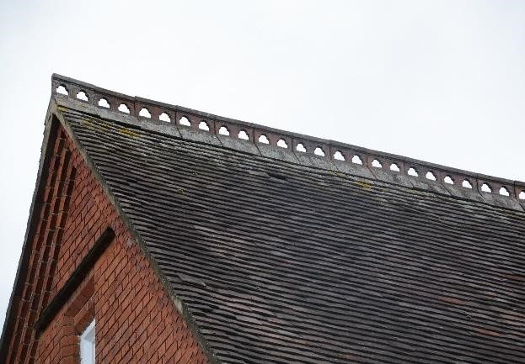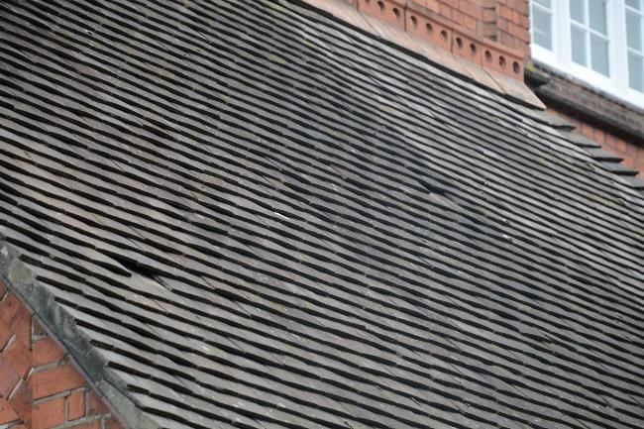

Missing tile on north western elevation. Missing tiles on northern elevation.

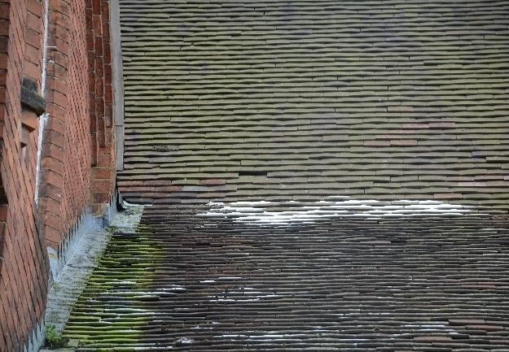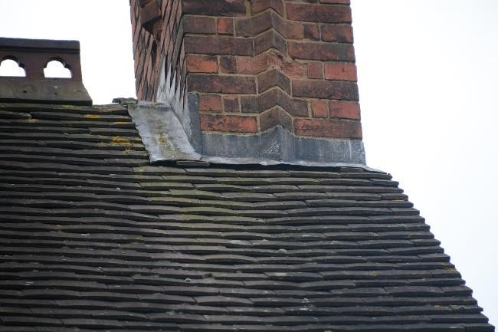

Missing tile on northern elevation. Gap under lead flashing on northern elevation.

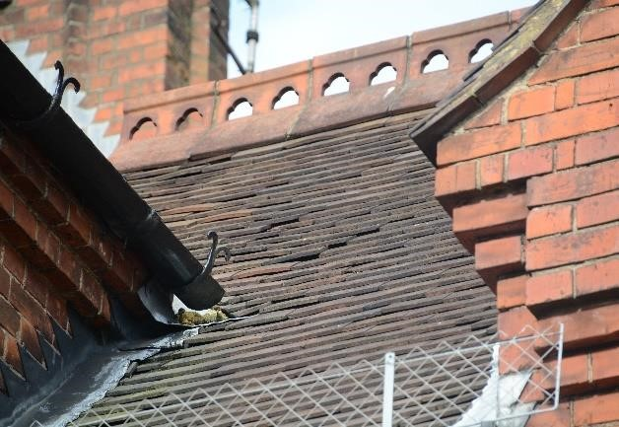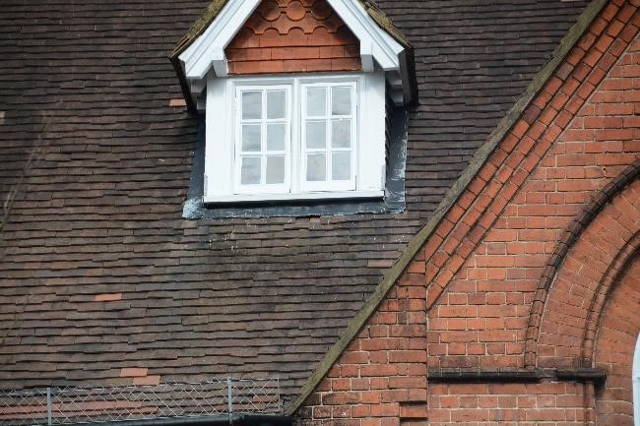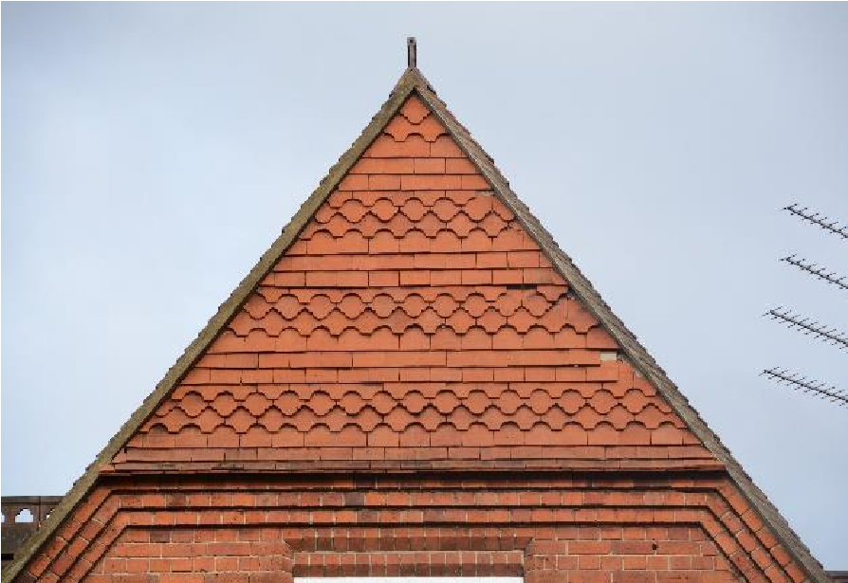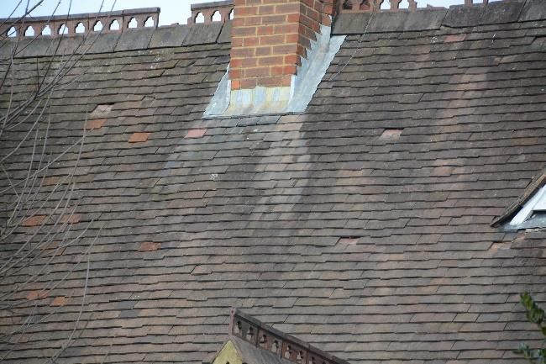

Dislodged tiles on southern elevation.

Gap under metal flashing on southern elevation.

Missing hanging tile on southern elevation. Missing tiles on southern elevation.

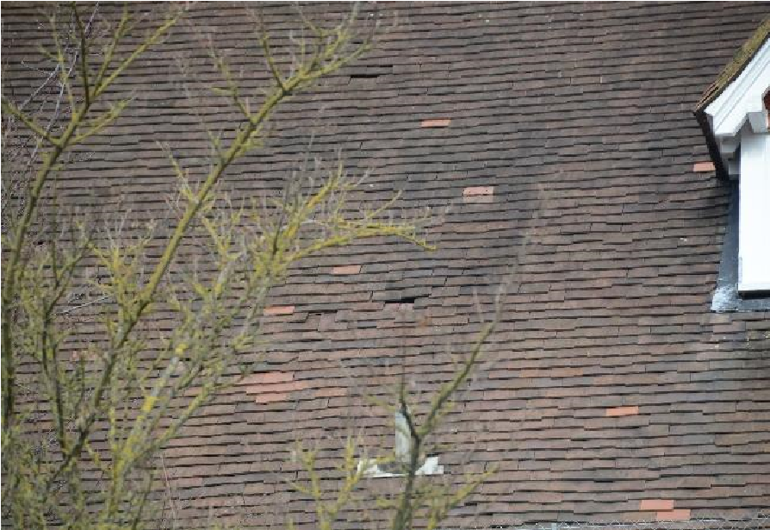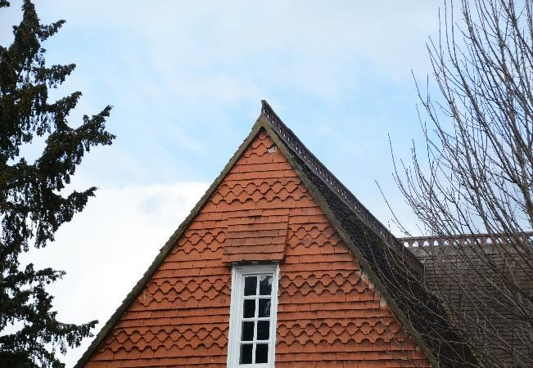
Missing tiles on southern elevation. Missing hanging tile on southern elevation.

Figure 4. Identified potential bat roost features of the main school building.

Building 2 - Western Outbuilding
The western outbuilding is of render construction with a pitched roof of concrete tiles. The building has wooden soffited eaves and wooden barge boarding on the northern and southern elevations.

The interior spaces within the building are well illuminated by windows on multiple elevations. The external solid render walls are in an excellent state of repair with no gaps or crevices present. The concrete tiled roof is also in a good state of repair with no notable gaps or crevices.

The building is assessed as having ‘negligible’ potential (Collins, 2016) to offer shelter to roosting bats. This is due to the lack of external features and the lack of a loft void.

Building 3 - Western Outbuilding
The western outbuilding is of brick construction with a sloped roof of corrugated cement-fibre. The building has wooden barge boarding on the southern and eastern elevations. The western elevation is constructed from overlapping wooden panels and has no barge boarding.

There are no windows that illuminate the interior space, and it is currently used for storage purposes. The external brick walls/wooden panelling are in an excellent state of repair with no gaps or crevices present. The cement-fibre roof is also in a good state of repair with no notable gaps or crevices.

The building is assessed as having ‘negligible’ potential (Collins, 2016) to offer shelter to roosting bats. This is due to the lack of external features and the lack of a loft void.

Building 4 – Wooden Shed
The wooden shed is found within the north eastern corner of the site and is of wooden panel construction with a pitched roof of bitumen felt. The building is of very simple construction.

There are no windows that illuminate the interior space, and it is currently used for storage purposes. The wooden panelled walls are in an excellent state of repair with no gaps or crevices present. The bitumen felt roof is also in an excellent state of repair with no notable gaps or crevices.

The building is assessed as having ‘negligible’ potential (Collins, 2016) to offer shelter to roosting bats. This is due to the lack of external features and the lack of a loft void.

Building 5 – Covered Outbuilding
The covered outbuilding is found within the northern area of the site and is a covered structure with a wooden frame and an overlapping wooden panel roof.

The roof has no underlay, and the external structure is in excellent repair with no notable gaps or crevices.

The building is assessed as having ‘negligible’ potential (Collins, 2016) to offer shelter to roosting bats. This is due to the lack of external features and the lack of a loft void.

Evidence of Bats
No bats or evidence of bats was found during the initial bat survey and preliminary roost assessment. In particular, no bat droppings were found inside any of the buildings (including loft space 1 and 2) or associated with accessible external features.

Bat Activity
4.2.1.1 22nd July 2021
No bats were seen to emerge from Building 1 during the survey on the 22nd July 2021. Full results of the dusk emergence survey undertaken on 22nd July 2021 are presented in Table 3.

Table 3. Results of the dusk emergence survey of Building 1 at Oxford Road Community School, undertaken on 22nd July 2021.

Time | Species | Emergence  (Y/N) | Observation
21:23 | Noctule | N | Commuting overhead.
21:30 | Noctule | N | Heard not seen.
21:50 | Common pipistrelle | N | Heard not seen.
21:44 | Common pipistrelle | N | Commuting overhead from S towards N.
21:57 | Common pipistrelle | N | Low pass above playground towards N.
4.2.1.2 19th August 2021
No bats were seen to emerge from Building 1 during the survey on the 19th August 2021. Full results of the dusk emergence survey undertaken on 19th August 2021 are presented in Table 4.

Table 4. Results of the dusk emergence survey of Building 1 at Oxford Road Community School, undertaken on 19th August 2021.

Time | Species | Emergence  (Y/N) | Observation
20:33 | Common pipistrelle | N | Heard not seen.
20:36 | Common pipistrelle | N | Flew round E side towards W.
20:38 | Common pipistrelle | N | Commuting from S to N overhead.
21:02 | Common pipistrelle | N | Heard not seen.
21:03 | Soprano pipistrelle | N | Heard not seen.

Evidence of Birds
No evidence of nesting birds was noted in the interior or on the exterior of the buildings. In particular, there is no evidence of swallows or house martins, and the buildings are unsuitable for barn owls.

Discussion

Assessment of Results

Bats
The combined results of the initial building inspection and subsequent bat activity surveys have confirmed the likely absence of roosting bats within Building 1 at Oxford Road Community School.

There is no evidence to suggest the presence of a roost of higher conservation significance, such as a maternity roost; the buildings are not considered to be suitable for hibernation.

Two bat activity surveys are considered adequate in this instance, as there is no indication that bats are using the internal space of Building 1, and the potential for roosting bats was always considered to be within the loft spaces and the external fabric of the roof.

Birds
Nesting birds are considered absent in association with the buildings at Oxford Road Community School.

Legislative Guidance

Bats
As with many animal species within the UK, declines in the abundance and distribution of many bat species have been documented through recent decades. The reasons for these declines are various and complex but it is considered that the major factors are changes in land use and agriculture, the loss of woodlands and hedgerows and the loss of suitable roosting sites.

Bats are particularly sensitive to human activity due to the fact that they roost within buildings, trees and underground structures such as mines, and the availability of suitable roost sites is considered to be a key factor in the conservation of bats within the UK. As a consequence, all species of bat and their roost sites are protected under the Wildlife and Countryside Act 1981 (as amended by the Countryside and Rights of Way Act 2000) and under The Conservation of Habitats and Species Regulations 2017. Taken together, these make it an offence to:

- Deliberately capture or intentionally take a bat
- Deliberately or intentionally kill or injure a bat
- To be in possession or control of any live or dead wild bat or any part of, or anything derived from a wild bat
- Damage or destroy a breeding site or resting place of such an animal or intentionally or recklessly damage, destroy or obstruct access to any place that a wild bat uses for shelter or protection
- Intentionally or recklessly disturb any wild bat while it is occupying a structure or place that it uses for shelter or protection
- Deliberately disturb any bat, in particular any disturbance which is likely
- to impair their ability;
  - to survive, breed, reproduce or to rear or nurture their young; or
  - in the case of hibernating or migratory species, to hibernate or migrate; or - to affect significantly the local distribution or abundance of the species to which they belong

A bat roost may be any structure a bat uses for breeding, resting, shelter or protection. It is important to note that since bats tend to re-use the same roost sites, current legal opinion is that a bat roost is protected whether or not the bats are present at the time.

Although the law provides strict protection to bats, it also allows this protection to be set aside (derogation) under The Conservation of Habitats and Species Regulations 2017 through the issuing of licences. Where a lawful operation is required to be carried out, but which is likely to result in one of the above offences, a licence may be obtained from Natural England (the statutory body in England with responsibility for nature conservation) to allow the operation to proceed. However, in accordance with the requirements of The Conservation of Habitats and Species Regulations 2017, a licence can only be issued where the following requirements are satisfied:

- The proposal is necessary ‘to preserve public health or public safety or other imperative reasons of overriding public interest including those of a social or economic nature and beneficial consequences of primary importance for the environment’;
- ‘There is no satisfactory alternative’;
- The proposals ‘will not be detrimental to the maintenance of the population of the species concerned at a favourable conservation status in their natural range’.

Nesting Birds
Nesting birds are protected under the Wildlife and Countryside Act 1981 (as amended), which makes it an offence to intentionally kill, injure or take any wild bird or take, damage or destroy its nest whilst in use or being built, or take or destroy its eggs. The nesting season for most species is between March and August inclusive.

Potential Impacts

Bats
There is no evidence to suggest that Building 1 of Oxford Road Community School is being used as a place of shelter/protection by roosting bats.

As a result of this conclusion, roofing works to Building 1 are unlikely to result in any significant impacts on bats or the places that they use for breeding, shelter and/or protection (roosts) and no specific compensation measures are considered necessary (Mitchell-Jones, 2004).

Since no significant impacts on bats are predicted under The Conservation of Habitats and Species Regulations 2017, a European Protected Species (bat) licence will not be required for the proposed works to proceed. Since there are no predicted impacts on bats or their habitats, it is not necessary to consider the ‘three tests’ of The Conservation of Habitats and Species Regulations 2017 in this instance.

Birds
There is no evidence to indicate that nesting birds are using the buildings and the proposed works to the building will not to result in any foreseeable impacts on nesting birds.

Recommendations

Further Surveys
No further surveys are considered necessary.

Bats

Timing
There are no constraints with regard to the timing of works and bats.

Careful Work Practices
Works should proceed in a careful and controlled manner. Contractors should be briefed with regard to the fact that individual bats can often exploit very small crevices as roost sites and that bats can move between roost sites on a regular basis.

In the very unlikely event that bats or significant evidence of bats (for example large accumulations of fresh bat droppings) are encountered, works should stop immediately, and advice sought from a qualified ecologist.

Enhancement
Although it is not necessary from a legal perspective, it is recommended that a bat box is erected on the southern elevation of one of the buildings at Oxford Road Community School.

This could be a traditional wooden bat box, or longer-lasting woodcrete boxes (Schwegler box) specifically designed for buildings and houses (e.g. the Schwegler 1FQ or 1WQ bat boxes) or a solid oak-built, double-chambered box.

If a bat box is adopted, it is recommended that it be installed as high as possible on the exterior wall of the southern elevation. The erection of a bat box would be seen as an enhancement to the existing situation.

Birds

Enhancement
The erection of bird nesting boxes is recommended in order to provide suitable nest sites for species within the local area, as nest boxes can be excellent substitutes for the nesting potential of trees. Over 60 species are known to adopt nest boxes including blue tits, great tits, starlings, robins and sparrows.

The location and nature of the nest box depends on the species it is designed for; boxes for tits, sparrows or starlings should be fixed two to four metres up a tree or a wall; open-fronted boxes for robins and wrens need to be low down, below 2m, and well-hidden in vegetation. Unless there are trees or buildings which shade the box during the day, boxes should be faced between north and east, thus avoiding strong sunlight and the wettest winds. Boxes can either be integrated into new buildings or erected on the exterior of buildings and trees.

References
Altringham, J., 2003. British Bats. Harper Collins.

Bat Conservation Trust, 2018. Bats and artificial lighting in the UK: Bats and the Built Environment series. The Bat Conservation Trust, London.

Collins, J. 2016. Bat Surveys for Professional Ecologists: Good Practice Guidelines (3rd edition). The Bat Conservation Trust, London.

Emery, M., 2008. Effect of Street Lighting on Bats. Urbis Lighting Ltd., Anglia.

Joint Nature Conservation Committee, 2012. Bat Worker’s Manual. Joint Nature Conservation Committee, Peterborough, UK.

Mitchell-Jones, A., 2004. Bat Mitigation Guidelines. English Nature.

Neuweiler, G., 2000. The Biology of Bats. Oxford University Press, Oxford, UK.

Appendix 1. Photographs

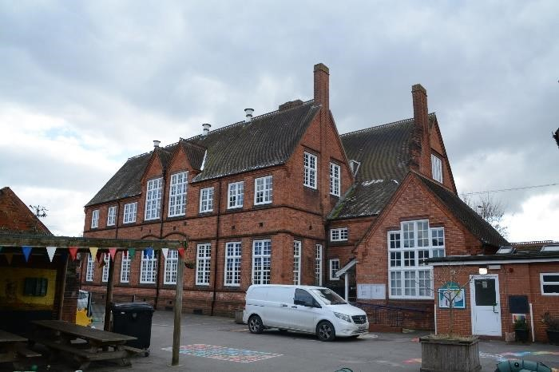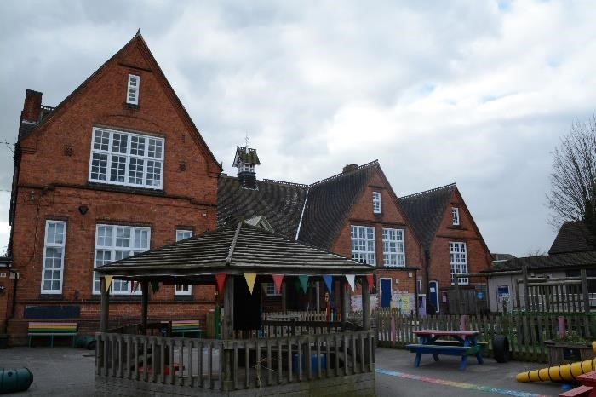

Photograph 1. The eastern side of the northern Photograph 2. The western side of the northern elevation of Building 1. elevation of Building 1.

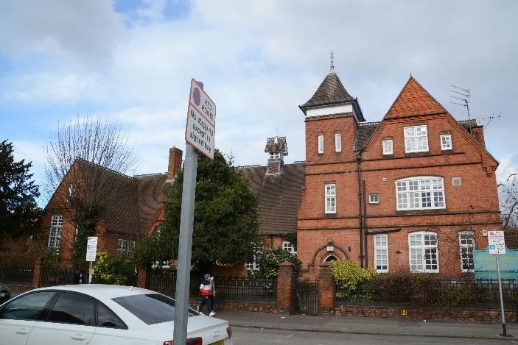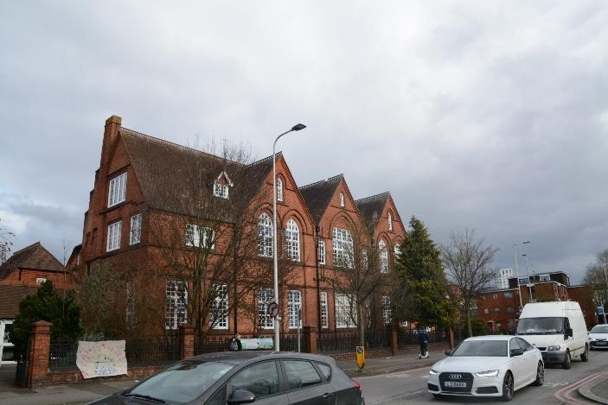 Photograph 3. The western side of the southern Photograph 4. The eastern side of the southern elevation of Building 1. elevation of Building 1.

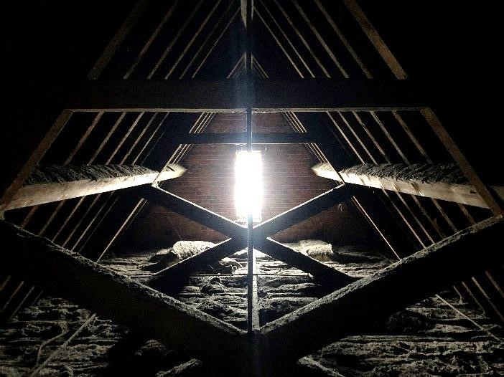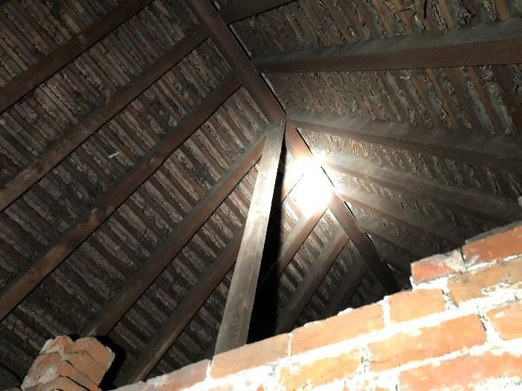

Photograph 5. Loft void 1 of Building 1. Photograph 6. Loft void 1 of Building 1.

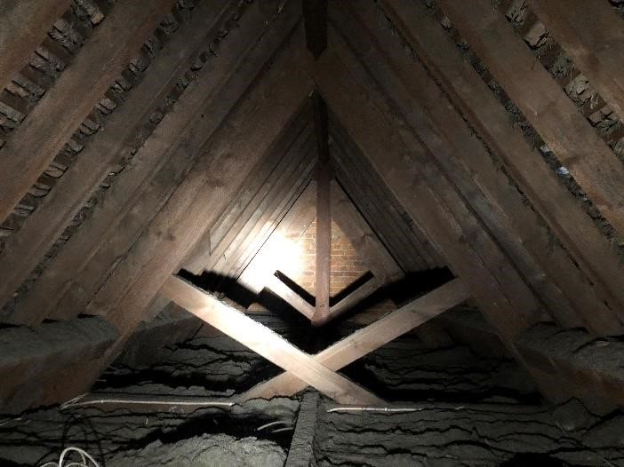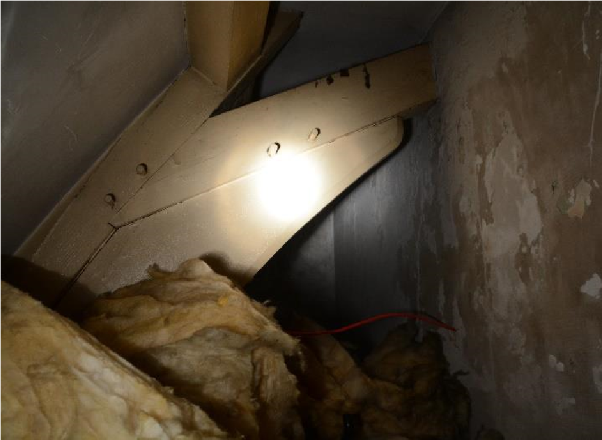

Photograph 7. Loft void 1 of Building 1. Photograph 8. Loft void 2 of Building 1.

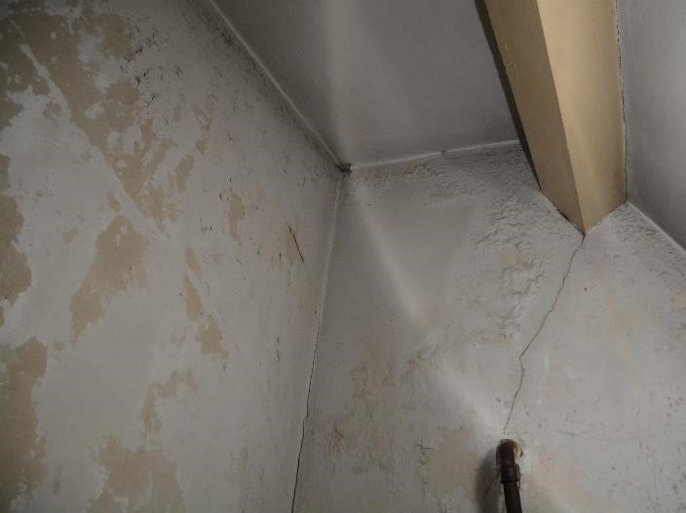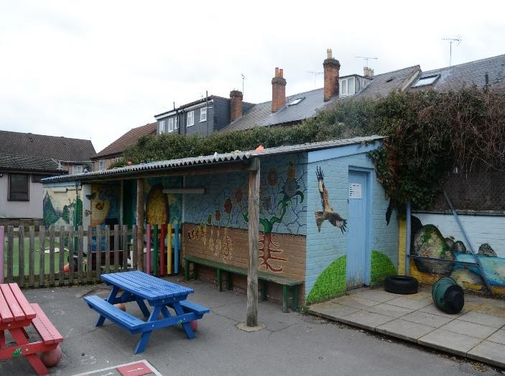

Photograph 7. Loft void 2 of Building 1. Photograph 8. The southern elevation of Building 3.

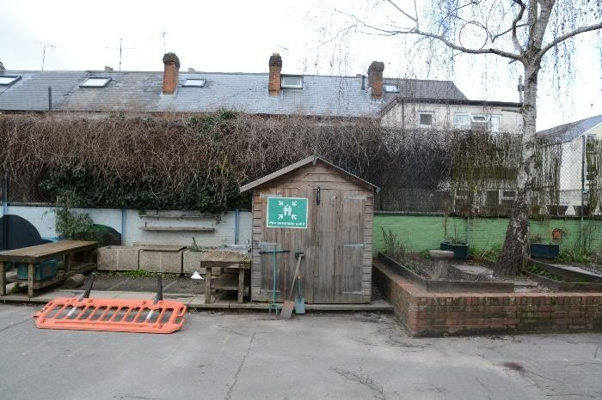

Photograph 9. The southern elevation of Building 4. Photograph 10. The northern elevation of Building 5.

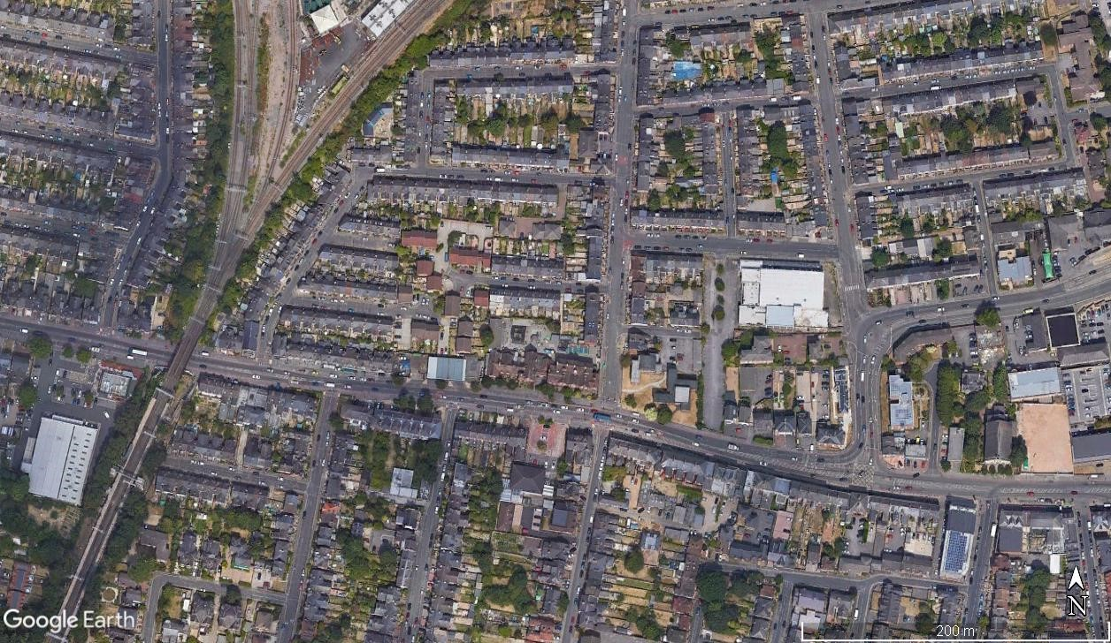
9

Appendix 2. Site Location Plans

An aerial photograph showing the location of Oxford Road Community School (outlined in red). Source: Google Earth Pro
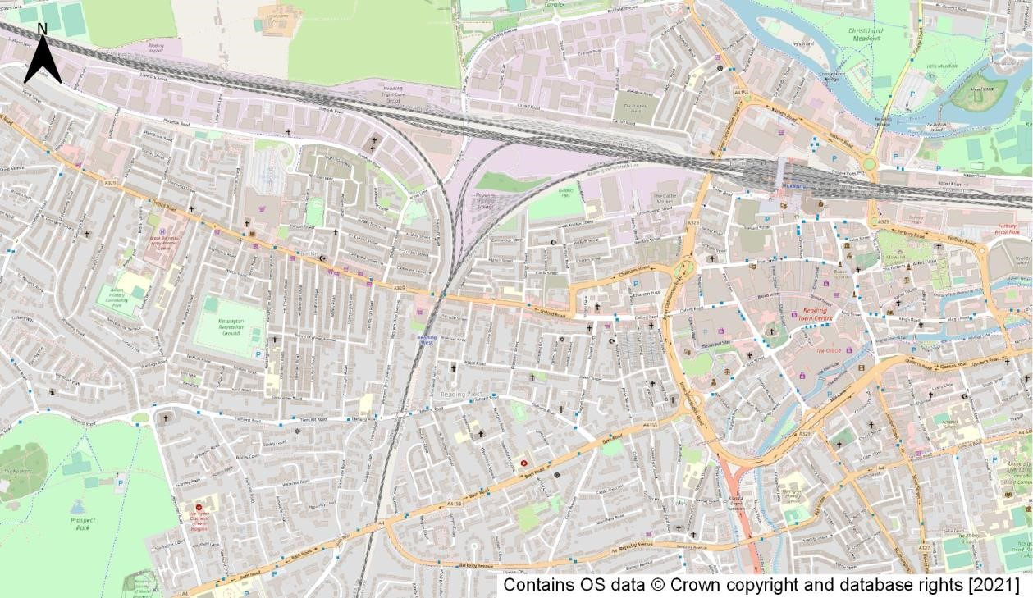

An Ordnance Survey map showing the approximate location of the site (indicated by the red dot) within the wider local area. Source: OSM Standard

