DELEGATED HOUSEHOLDER APPLICATION REPORT

Ward: Southcote
App Ref: 220619/HOU
Address: 6 Southcote Farm Lane, Reading, RG30 3DS
Proposals: Demolition of an existing rear facing single storey build. Householder planning application for a single storey rear extension Inc. feature roof light and part garage conversion
Case Officer: Chukwudi Onwudinanti
Applicant: Holtham Newman Architects
Date received (valid from): 27 April 2022
Target Decision date: 1 July 2022 (EXT)

1. INTRODUCTION
The proposal site is a semi-detached dwelling on the western side of Southcote Lane, among dwellings of similar style and size, as well as other residential dwellings of varied styles and sizes. The area is predominantly residential with close proximity to Southcote Primary School.

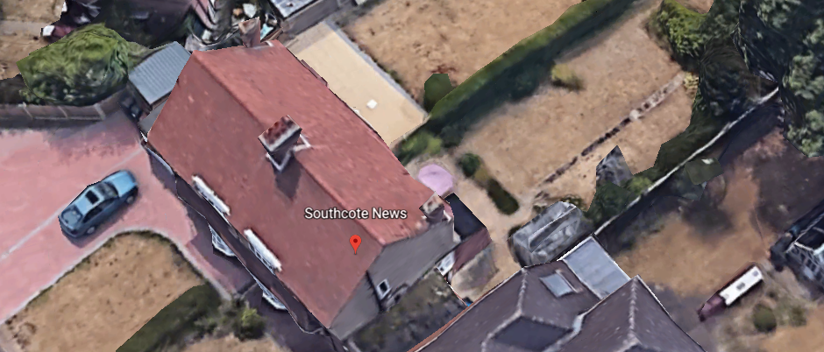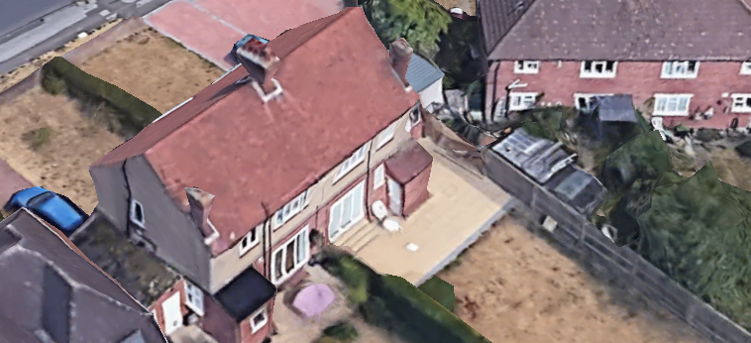

2. PROPOSAL AND SUPPORTING INFORMATION

The application proposes to demolish an existing rear facing single storey build, adding a feature roof light and part garage conversion
Plans considered received 27th April 2022
2207-P103 : Site Plan
2207-P102 : Block Plans as Existing and Proposed
2207-P104 : Car Park Plans As Existing and Proposed
2207-P100 Rev A : Ground Floor Plans as Proposed and existing
2207-P101 Rev A :External Elevations as Existing and Proposed

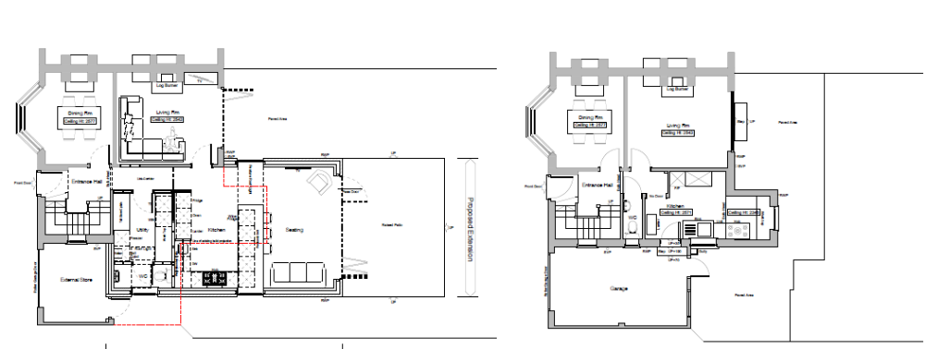

Proposed Ground Floor Plan Existing Ground Floor Plan
- RELEVANT PLANNING HISTORY

None

4. CONSULTATIONS

4.1 The following addresses were consulted by letter.

4 Southcote Farm Lane, Reading, RG3 3DS
8 Southcote Farm Lane, Reading, RG30 3DS
93 Silchester Road, Reading, RG30 3EJ
89 Silchester Road, Reading, RG30 3EJ
91 Silchester Road, Reading, RG30 3EJ

4.2 No letters of representation have been received.

Equality Act 2010:
In determining this application the Council is required to have regard to its obligations under the Equality Act 2010. However, there is no indication or evidence (including from consultation on the application) that the protected groups identified by the Act have or will have different needs, experiences, issues and priorities in relation to this particular planning application. Therefore in terms of the key equalities protected characteristics it is considered there would be no significant adverse impacts as a result of the development.

- LEGAL AND PLANNING POLICY CONTEXT

Section 38(6) of the Planning and Compulsory Purchase Act 2004 requires that proposals be determined in accordance with the development plan unless material considerations indicate otherwise. Material considerations include relevant policies in the National Planning Policy framework (NPPF) - among them the 'presumption in favour of sustainable development'. The following local and national planning policy and guidance is relevant to this application:

National Policy
National Planning Policy Framework
National Planning Practice Guidance

Reading Borough Local Plan (2019)
CC7 (Design and the Public Realm)
CC8 (Safeguarding Amenity)
H9 (House Extensions and Ancillary Accommodation)

SPD
- Design Guide to House Extensions (2021)

6. APPRAISAL

H9 states: An extension to a house will be acceptable where it:

- Respects the character of the house in terms of scale, location, materials and design;

To assess this, the following has been considered – would the proposal:
- detract from the appearance of the original building through the use of ill-matching materials and by not fitting in with the design, scale and proportions of the original building; NO, the extension to the side is within the footprint of the existing garage and the rear aspect does not add anything visually significant from the street scene.
- reduce the amount of usable amenity space for the property to an unacceptable degree; NO, the increased footprint of the building overall is not deemed to be to an unacceptable degree.
- require the loss of trees in the garden or put significant trees at risk; NO

- Respects the character and pattern of neighbouring properties and the street as a whole in terms of scale, location, materials and design, and any important existing building line; Respects neighbour’s amenities and does not present a large blank façade to public areas.

To assess this, the following has been considered – would the proposal:
- significantly reduce the amount of daylight and sunlight enjoyed by neighbouring properties; NO, the extension is at one storey level and does not impact on the adjoining properties.
- invade the privacy of neighbouring properties through overlooking from windows or balconies; NO
- detract from the character of neighbouring properties through siting, excessive bulk, ill-matching materials or inconsistent design; NO
- detract from the appearance of the street or area by using ill-matched materials, glazing and detailing; NO

CC8: Safeguarding Amenity states an extension to a house will be acceptable where it will not cause a significant detrimental impact to the living environment of existing or new residential properties.

To assess this, the following has been considered – would the proposal cause a significant detrimental impact to the living environment of existing or new residential properties in terms of:

- Privacy and overlooking;
- Access to sunlight and daylight;
- Visual dominance and overbearing effects of a development;
- Noise and disturbance;
- Artificial lighting;
- Vibration;
- Dust and fumes;
- Smell;
- Crime and safety.

- CONCLUSION
The proposed development has been assessed and the proposed works are considered to be in accordance with the above relevant policies and planning permission can be granted.

8. RECOMMENDATION
Grant

