DELEGATED HOUSEHOLDER APPLICATION REPORT

Ward: Thames
App Ref: 211826/HOU
Address: 18 Albert Road, Caversham, Reading, RG4 7PE
Proposals: Single storey side and front extension to dwelling
Case Officer: Chukwudi Onwudinanti
Applicant: Mrs G Fountoulaki
Date received (valid from): 11 November 2021
Target Decision date: 21 February 2022

1. INTRODUCTION
The site is a detached building on the eastern side of Albert Road, within a residential area comprising of dwellings of different sizes and styles.

2. PROPOSAL AND SUPPORTING INFORMATION
The proposal is for a single storey side and front extension to dwelling, measuring 7.6m in depth and 3.6m and 1.5m wide to the front and back respectively. It has a mono pitch roof with eave height of 2.5m. The highest ridge of the roof is 3.5m.

Plans considered
Received on 11th November 2021
D1334-01 : Site and Location Plans
D1334-02 : Existing Floor Plans
D1334-03 : Existing Elevations
D1334-04 : Block and Location Plans
D1334-05a : Site and Location Plans
D1334-06a : Proposed Floor Plans
D1334-07a : Proposed Elevations

Received on 2nd February 2022
D1334-05b : Revised Site and Location Plans
D1334-06b : Revised Proposed Floor Plans
D1334-07b : Revised Proposed Elevations

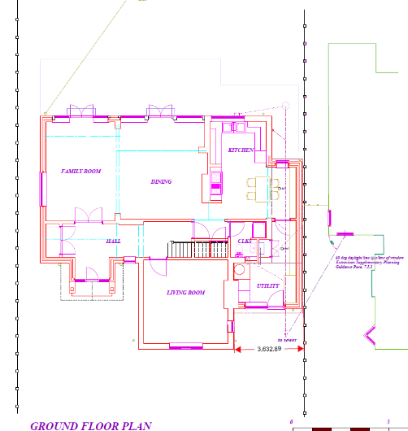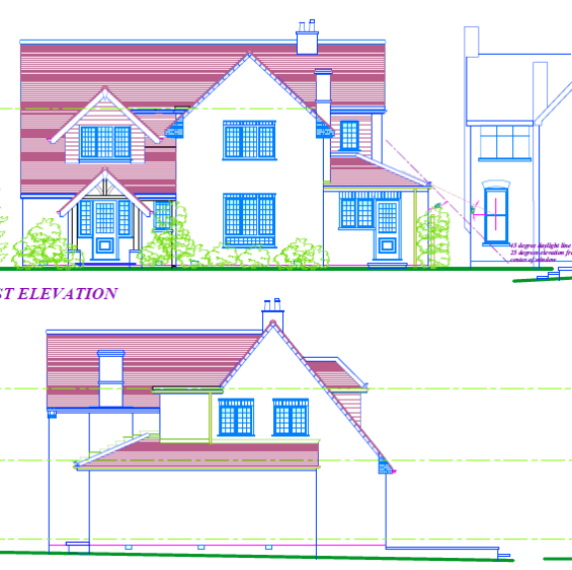
Proposed Extension Side of extension seen from No.16
- RELEVANT PLANNING HISTORY

None

4. CONSULTATIONS

4.1 The following addresses were consulted by letter.

16 Albert Road, Caversham, Reading, Berkshire, RG4 7PE
1 Malvern Way, Twyford, Reading, RG10 9PY
20 Albert Road, Caversham, Reading, Berks
15 Kidmore Road, Caversham, Reading, RG4 7LR

4.2 Letters of objections were sent in by the neighbour at No 16 Albert Road. The conclusion in the objections raised stated thus:

This proposal involves an overbearing blank brick wall, 3m high at minimum and rising to 4.4m, along 7.7m of our boundary, contrary to published guidelines. It would block daylight from four windows in our ground floor
rooms contrary to planning rules. A substantial section of wall would be so close to our house that a tall person could touch both buildings simultaneously with their hands, rendering the gap between our house a lightless tunnel. Our front door would open to directly face a 4.4m-high wall on our boundary. The apex of the pitched roof would be so high that it would even intrude on the sightline of upstairs windows. A new kitchen window would be sited 2m from our large continually-used kitchen window (omitted from plans), looking straight into our kitchen/main living area. The effect of this proposal on the treasured amenity of the house where we live and work would be profound and contrary to planning rules and guidelines in terms of overbearing, overshadowing and overlooking, building along boundaries and closing the gap.

In response to these concerns raised by the neighbour, and after discussions with the Planning Officer, the applicant has reduced the overall height of the extension to 2.5m and the roof design has been revised into a mono pitch roof, such that no part of this extension rises above 2.5m or presents a significant additional impact on the daylight presently enjoyed by the neighbour.

Equality Act 2010:
In determining this application the Council is required to have regard to its obligations under the Equality Act 2010. However, there is no indication or evidence (including from consultation on the application) that the protected groups identified by the Act have or will have different needs, experiences, issues and priorities in relation to this particular planning application. Therefore in terms of the key equalities protected characteristics it is considered there would be no significant adverse impacts as a result of the development.

- LEGAL AND PLANNING POLICY CONTEXT
Section 38(6) of the Planning and Compulsory Purchase Act 2004 requires that proposals be determined in accordance with the development plan unless material considerations indicate otherwise. Material considerations include relevant policies in the National Planning Policy framework (NPPF) - among them the 'presumption in favour of sustainable development'. The following local and national planning policy and guidance is relevant to this application:

National Policy
National Planning Policy Framework
National Planning Practice Guidance

Reading Borough Local Plan (2019)
CC7 (Design and the Public Realm)
CC8 (Safeguarding Amenity)
H9 (House Extensions and Ancillary Accommodation)

SPG/SPD
- A Design Guide to House Extensions SPG

6. APPRAISAL
H9 states: An extension to a house will be acceptable where it:

- Respects the character of the house in terms of scale, location, materials and design;

To assess this, the following has been considered – would the proposal:
- detract from the appearance of the original building through the use of ill-matching materials and by not fitting in with the design, scale and proportions of the original building; NO
- reduce the amount of usable amenity space for the property to an unacceptable degree; NO
- require the loss of trees in the garden or put significant trees at risk; NO

- Respects the character and pattern of neighbouring properties and the street as a whole in terms of scale, location, materials and design, and any important existing building line; Respects neighbour’s amenities and does not present a large blank façade to public areas.

To assess this, the following has been considered – would the proposal:
- significantly reduce the amount of daylight and sunlight enjoyed by neighbouring properties; NO, the original design for the application has been revised such that the height (2.5m max) presented to the neighbouring property at No.16 is not of significant additional impact and the roof design has been made into a mon pitch roof with same level eave height through the extents of the extension.
- invade the privacy of neighbouring properties through overlooking from windows or balconies; NO
- detract from the character of neighbouring properties through siting, excessive bulk, ill-matching materials or inconsistent design; NO
- detract from the appearance of the street or area by using ill-matched materials, glazing and detailing; NO

CC8: Safeguarding Amenity states an extension to a house will be acceptable where it will not cause a significant detrimental impact to the living environment of existing or new residential properties.
To assess this, the following has been considered – would the proposal cause a significant detrimental impact to the living environment of existing or new residential properties in terms of:
- Privacy and overlooking;
- Access to sunlight and daylight;
- Visual dominance and overbearing effects of a development;
- Noise and disturbance;
- Artificial lighting;
- Vibration;
- Dust and fumes;
- Smell;
- Crime and safety.

- CONCLUSION
The proposed development has been assessed and the proposed works are considered to be in accordance with the above relevant policies and planning permission can be granted.

- RECOMMENDATION
Grant
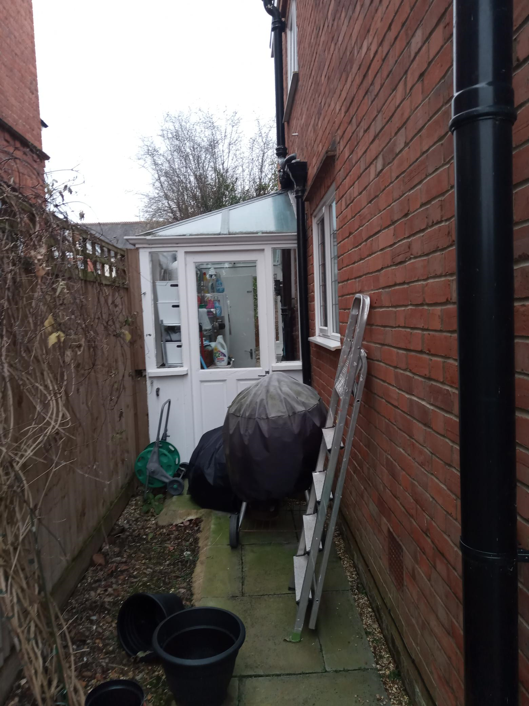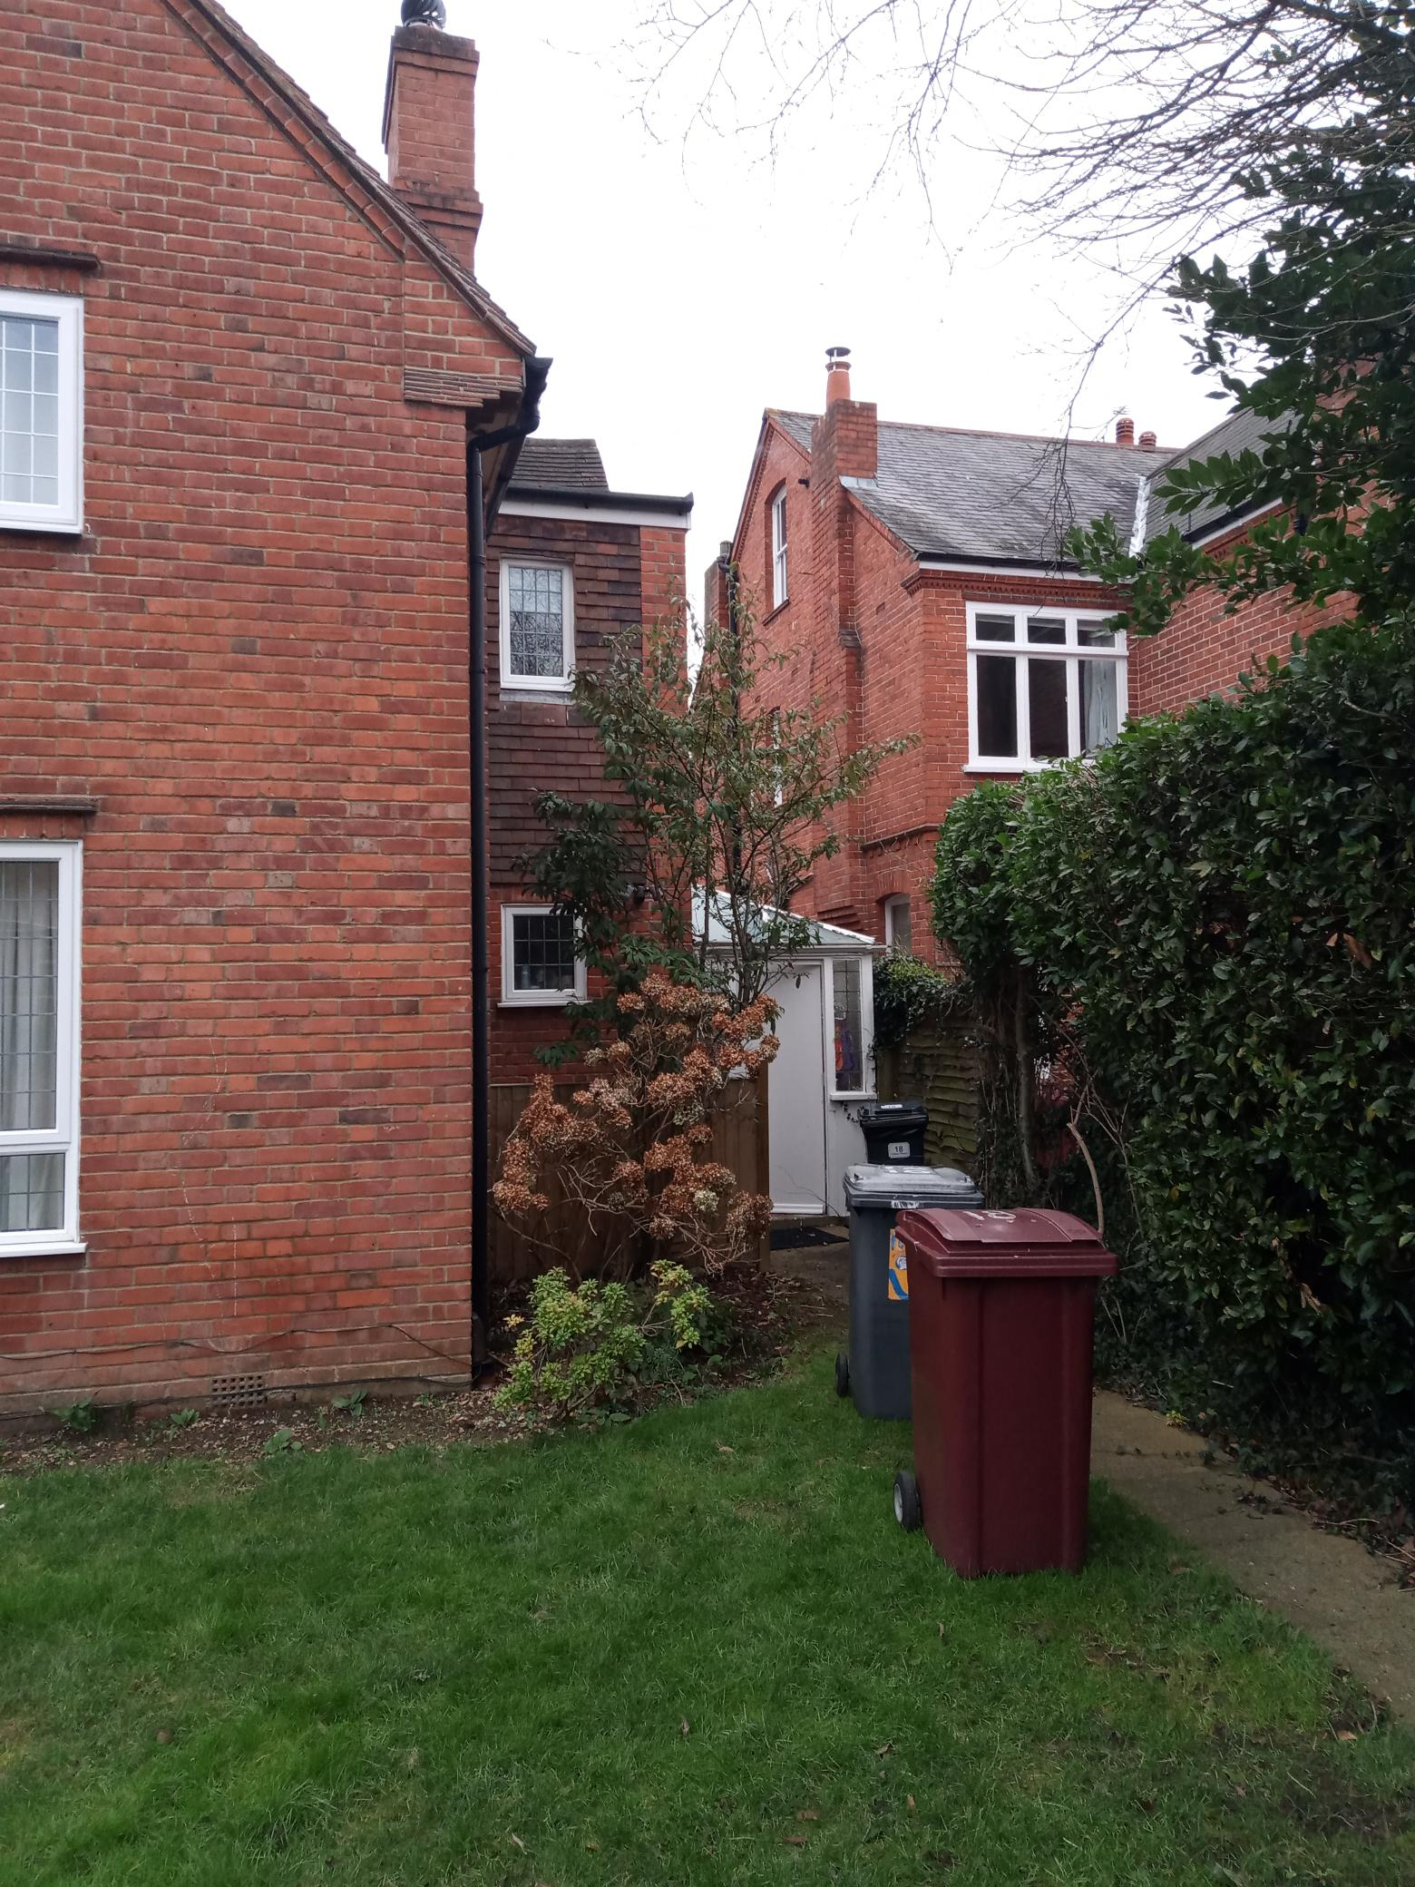

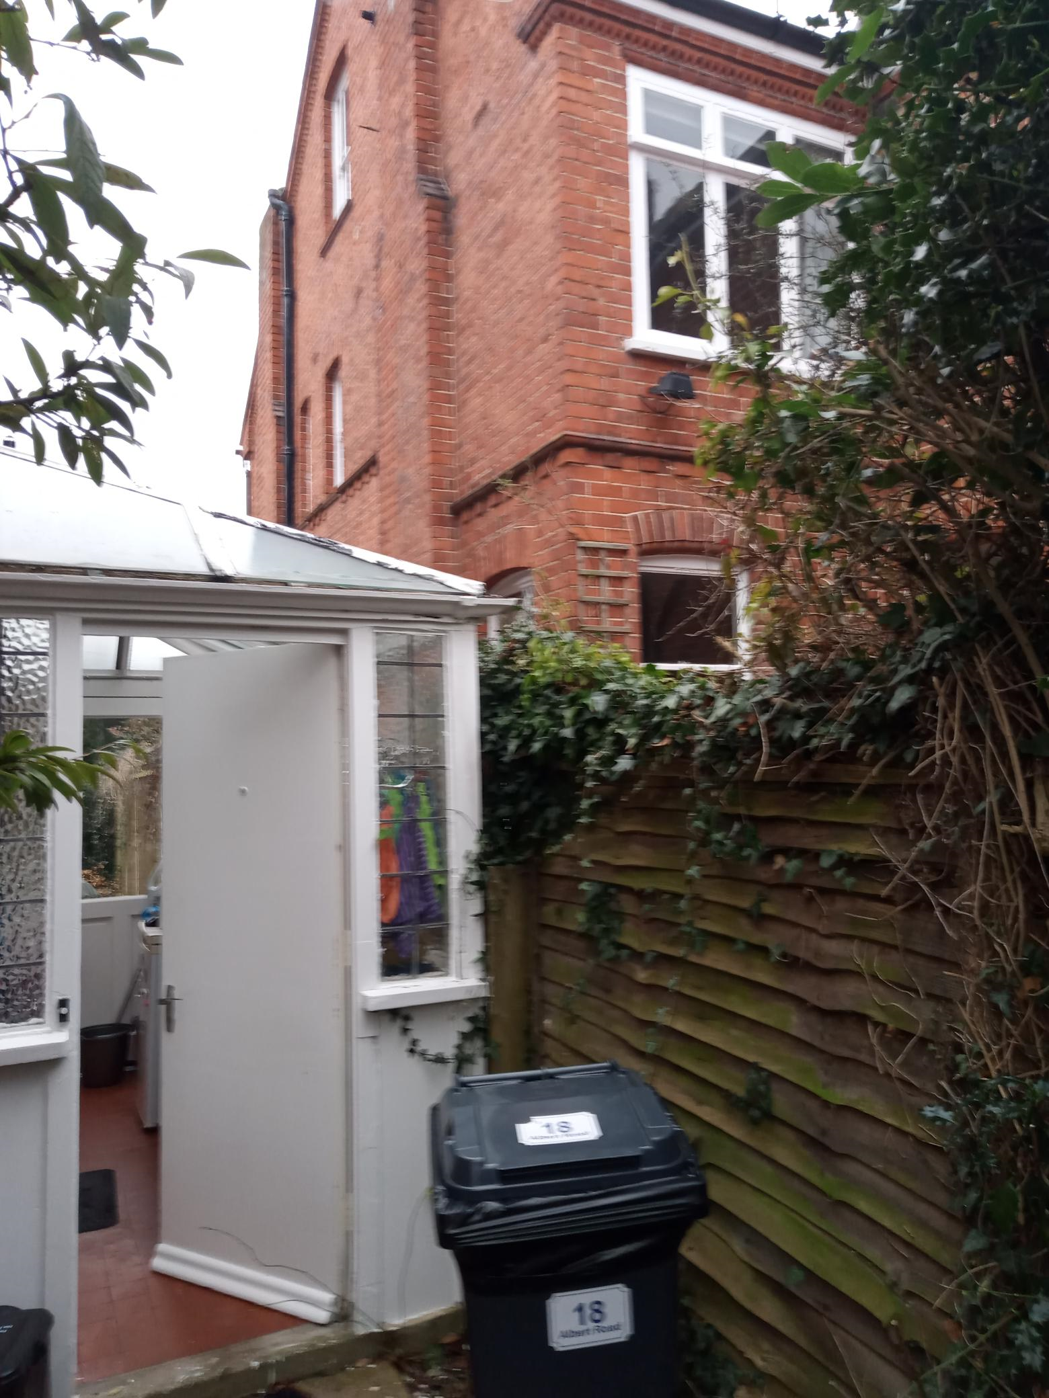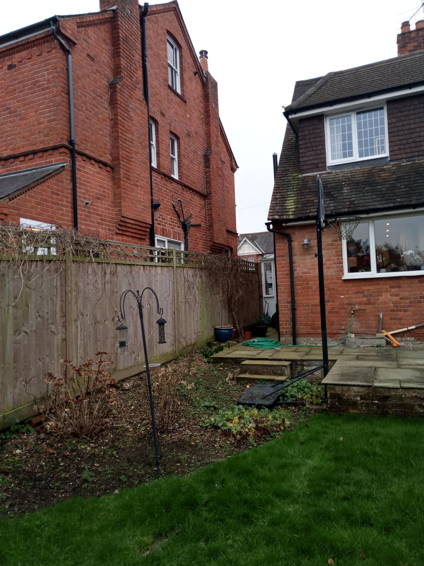

Site photos taken on 27th January 2022

