DELEGATED APPLICATION REPORT

Ward: Thames
App Ref: 220636/ADV
Address: 65 Caversham Road, Reading, RG1 8AD
Proposals: External Canopies to front and rear Facades with internally lit Individual letters. High level banner signs. Fascia Signage Internally Illuminated.
Case Officer: Chukwudi Onwudinanti
Applicant: Stevco Limited
Date received (valid from): 29 April 2022
Target Decision date: 5 August 2022 (Ext)

1. INTRODUCTION
The proposal site is a commercial building on the eastern side of Caversham Road, the former ‘Dawsons’ music shop, adjacent to the fire station with the car park to the rear accessed from Northfield Road to the north.
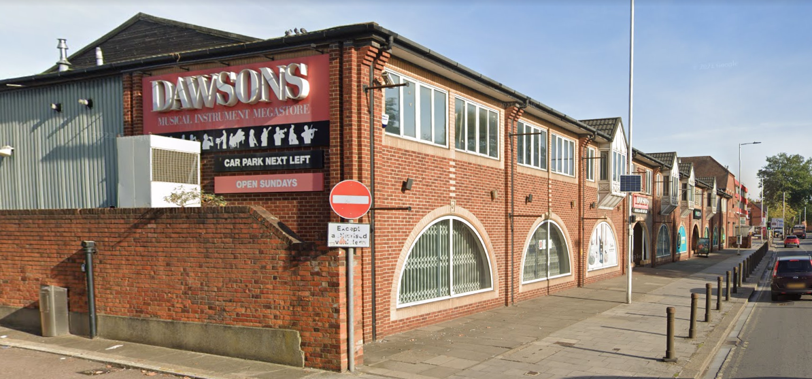

2. PROPOSAL AND SUPPORTING INFORMATION

The proposal includes the following:

Front Elevation

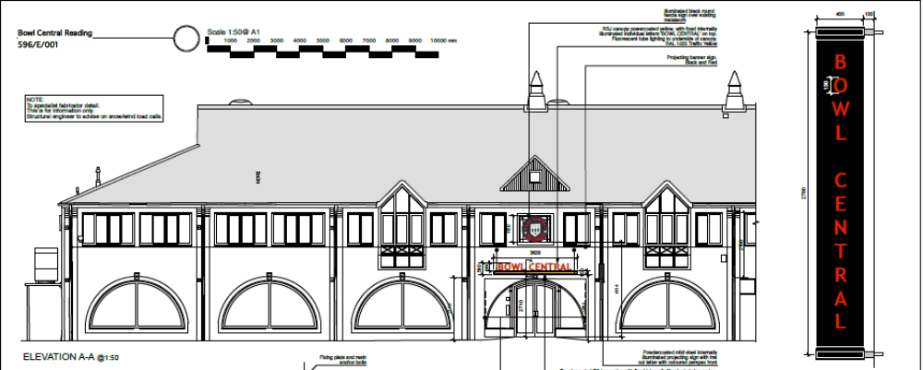

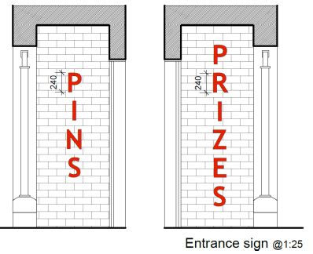
- 1 x Black and red fascia circular sign above the door 1.15m high (over the existing metal street number). Internally illuminated.
- 1 x internally illuminated powder coated sign with individual letters ‘Bowl Central’ attached to projecting canopy with neon tube lighting to underside above main entrance. 3.63m wide, 2.86m from ground level to underside and 0.36m high individual letters.
- 6 x fabric banners ‘Bowl Central’ black and red, of 2.8m high and 0.5 m deep (including fixing) and 2.7m from ground level to underside.
- 2 x entrance signs backlit letters on the entrance flank walls.

Rear Elevation
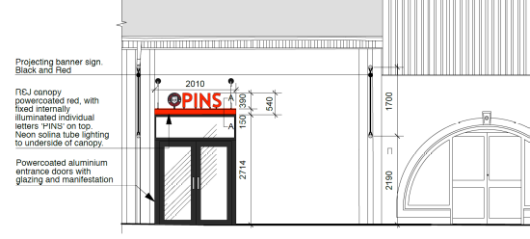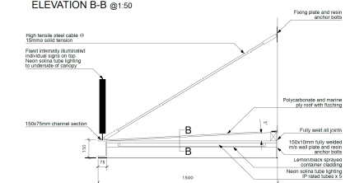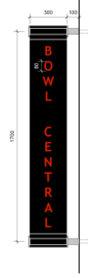

- 1 x External canopy with internally lit Individual letters ‘PINS’ and logo. Note that the new door way is not under consideration as part of this advertisement application.
2 x Fabric banner sign, red and black with words ‘Bowl Central’ 1.7m high, 0.4m deep (including fixing) and 2.4m to underside.

- 1 x internally illuminated powder coated sign, fret cut with words ‘Bowl Central’ – red and black. 1.15m high, 5.05m wide, with 0.4m high letters and 4.29m from ground to underside.
- 1 x internally illuminated, fret cut with word ‘Car Park Next Left’ 3.2m wide, 0.38m high and 3.71m from ground to underside

Plans considered received 29th April 2022
Drawing No: 596/P/017 – Location Plan
Existing Elevations
Drawing No: 596/E/001- Elevation A-A
Drawing No: 596/E/002 - Elevation B-B and Elevation C-C received 5th August 2022

- RELEVANT PLANNING HISTORY

Application Ref: 220661
Description: Infill of Loading bay screen to rear facade and installation of new entrance screen and doors, canopy over. Not yet determined.

4. CONSULTATIONS

4.1 The following addresses were consulted by letter.

69 Caversham Road, Reading, Berkshire, RG1 8AD
Premier House, 60 Caversham Road, Reading, Berkshire, RG1 7EB
80 Caversham Road, Reading, RG1 1AA
71-73 Caversham Road, Reading, RG1 8JA

4.2 No letters of representation have been received. Transport and Environmental Health were consulted and comments are as follows:

Transport - no objection to the proposed advertisements subject to a condition regarding luminance and that the underside of the banner signs are a minimum of 2.4m above the public highway.

Height of banner has been addressed as requested to be a minimum of 2.4m from the ground floor to the underside of the proposed banner and therefore deemed acceptable

Environmental Health – no objection, and request of limiting the hours of luminance if necessary. The PO does not deem that it is necessary to limit the hours of luminance due to the location of the site being predominantly commercial with other advertisements and the limit of 350cd/m2 attached as a condition.

Equality Act 2010:
In determining this application the Council is required to have regard to its obligations under the Equality Act 2010. However, there is no indication or evidence (including from consultation on the application) that the protected groups identified by the Act have or will have different needs, experiences, issues and priorities in relation to this particular planning application. Therefore in terms of the key equalities protected characteristics it is considered there would be no significant adverse impacts as a result of the development.

- RELEVANT PLANNING POLICY, GUIDANCE AND LEGAL CONTEXT
Regulation 3 of the Town and Country Planning (Control of Advertisements) (England) Regulations 2007 requires the Local Planning Authority to exercise its powers under these regulations in the interests of amenity and public safety taking into account the provisions of the development plan, so far as they are material; and any other relevant factors.

Regulation 3 states that factors relevant to amenity include the general characteristics of the locality, including the presence of any feature of historic, architectural, cultural, or similar interest.

Factors relevant to public safety include highway safety and whether the advert would hinder security or surveillance devices, including speed cameras.

Section 38(6) of the Planning and Compulsory Purchase Act 2004 requires that proposals be determined in accordance with the development plan unless material considerations indicate otherwise. Material considerations include relevant policies in the National Planning Policy framework (NPPF) - among them the 'presumption in favour of sustainable development'. The following local and national planning policy and guidance is relevant to this application:

National Policy
National Planning Policy Framework
National Planning Practice Guidance

Reading Borough Local Plan (2019)
CC7 (Design and the Public Realm)
CC8 (Safeguarding Amenity)
TR3 (Access, Traffic and Highway-Related Matters
OU4 (Advertisements)

6. APPRAISAL

The main issues are considered to be:
- Amenity
- Safety

Policy OU4 states:
“Advertisements will respect the building or structure on which they are located and/or
their surroundings and setting in terms of size, location, design, materials, colour, noise, lettering, amount and type of text, illumination and luminance, and will not have a detrimental effect on public safety. The cumulative impact of adverts will be taken into account, and a proliferation of advertisements that detrimentally affects visual or aural amenity or public safety will not be acceptable….”.

a) Amenity
The proposed signage is considered to be wholly appropriate within central Reading and would largely replace signage of a similar nature. It is considered that the size, material, colour and luminance would not be harmful to the wider area and would not have significant detrimental effects on visual amenity. APART FROM THE BANNER SIGNS – A condition is included which restricts the level of lux to max of 350cd/m2.

On the above basis, the proposed sign is considered to comply with Adopted Reading Borough Local Plan Policies CC7, CC8, TR3 and OU4.

b) Safety
The NPPG (in particular in this instance Paragraph: 068 Reference ID: 18b-068-20140306 & Paragraph: 078 Reference ID: 18b-078-20140306) provides guidance as to the considerations affecting public safety. The proposed canopies with attached letters would overhang where pedestrians could walk, but would be 2.19m to the underside (rear) and 2.86m (front), therefore not posing any hazard to pedestrians. The signs above the canopies would be illuminated, but within acceptable levels, to be controlled via condition and which would not distract drivers so as to have an effect on safety. They would not obscure any existing road signs, or sight lines of CCTV cameras. Therefore, it is concluded that there would be no detrimental effect with regard to highway safety and the signage is therefore, considered to accord with Adopted Reading Borough Local Plan Policies TR3 and OU4.

- CONCLUSION
The proposed development has been assessed and the proposed works are considered to be in accordance with the above relevant policies and planning permission can be granted.

8. RECOMMENDATION
Grant

