DELEGATED HOUSEHOLDER APPLICATION REPORT

Ward: Peppard
App Ref: 220402/HPA
Address: 95 Grove Road, Emmer Green, Reading, RG4 8LW
Proposals: Rear extension measuring 6.0m in depth, with a maximum height of 3.6m, and 2.7m in height to eaves level. Notification of the construction of an extension under class A Part 1 of Schedule 2 of the Town and Country Planning (General Permitted Development) (England) Order 2015.
Case Officer: Chukwudi Onwudinanti
Applicant: Mr Niththiyanathan Jeyaratnarajah
Date received (valid from): 22 March 2022
Target Decision date: 17 June 2022 (Ext)

INTRODUCTION

The proposal site is an end of terrace dwelling unit on the southern side of Grove Road, one of the two terraced buildings of similar style and size adjacent to each other.

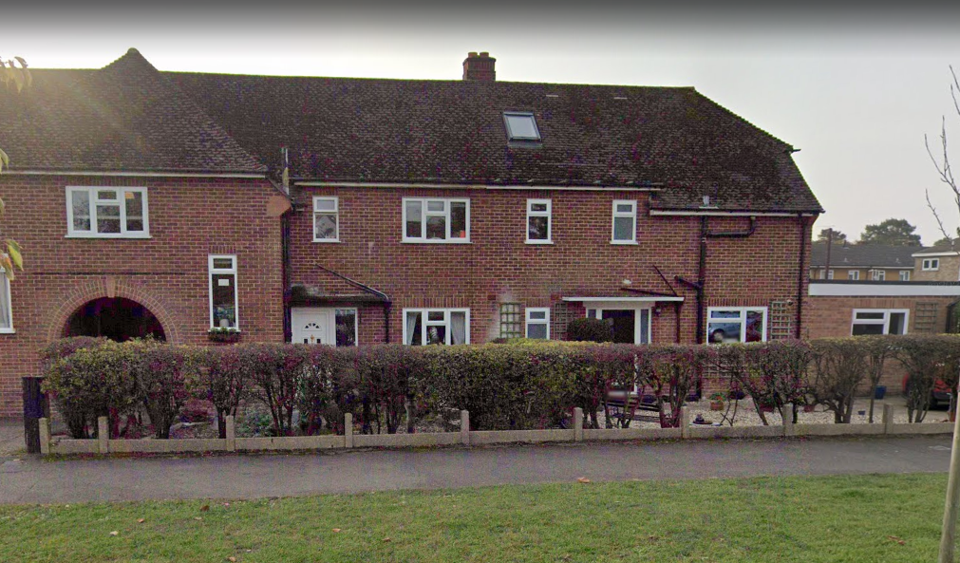

PROPOSAL
The applicant has provided information on the proposed rear extension. The extension proposed would:
- Extend beyond the rear wall of the original dwelling by 6m
- Have a maximum height of 3.6m
- Have an eaves height of 2.7m

As such it is determined under Class A, Part 1 (g), of Schedule 2 to the Town and Country Planning (General Permitted Development) (England) Order 2015 (“the 2015 Order”) (as amended). This allows the following (as long as the dwellinghouse is not on article 2 (3) land nor on a site of special scientific interest):

A single storey extension, beyond the rear wall of a semi-detached house, between 3m and 6m in depth, and up to 4m in height

[n.b. max 3m in height to the eaves (part A1. (i) within 2m of a boundary]

And provided the development is not excluded by virtue of the criteria in the remainder of Paragraph A.1 of the 2015 Order and in compliance with the following relevant conditions.

Conditions
A.3 Development is permitted by Class A subject to the following conditions- (a) the materials used in any exterior work (other than materials used in the construction of a conservatory) shall be of a similar appearance to those used in the construction of the exterior of the existing dwellinghouse

b) any upper-floor window located in a wall or roof slope forming a side elevation of the dwellinghouse shall be -
(i) obscure-glazed, and
(ii) non-opening unless the parts of the window which can be opened are more than 1.7 metres above the floor of the room in which the window is installed

As the proposal would be within 2 metres of the boundary of the curtilage Paragraph A.1 (i) would also apply, which restricts the eaves to a maximum of 3m.

The application site is not within a Conservation Area nor have PD rights been withdrawn or restricted by way of a direction made under Article 4 or condition attached to an express planning permission.
As such it is determined under Class A, Part 1 (g), of Schedule 2 to the Town and Country Planning (General Permitted Development) (England) Order 2015 (“the 2015 Order”) (as amended). This allows the following (as long as the dwellinghouse is not on article 2 (3) land nor on a site of special scientific interest):

A single storey extension, beyond the rear wall of a semi-detached house, between 3m and 6m in depth, and up to 4m in height

[n.b. max 3m in height to the eaves (part A1. (i) within 2m of a boundary]

And provided the development is not excluded by virtue of the criteria in the remainder of Paragraph A.1 of the 2015 Order and in compliance with the following relevant conditions.

Conditions
A.3 Development is permitted by Class A subject to the following conditions- (a) the materials used in any exterior work (other than materials used in the construction of a conservatory) shall be of a similar appearance to those used in the construction of the exterior of the existing dwellinghouse

b) any upper-floor window located in a wall or roof slope forming a side elevation of the dwellinghouse shall be -
(i) obscure-glazed, and
(ii) non-opening unless the parts of the window which can be opened are more than 1.7 metres above the floor of the room in which the window is installed

As the proposal would be within 2 metres of the boundary of the curtilage Paragraph A.1 (i) would also apply, which restricts the eaves to a maximum of 3m.

The application site is not within a Conservation Area nor have PD rights been withdrawn or restricted by way of a direction made under Article 4 or condition attached to an express planning permission.

PLANS SUBMITTED
The applicant submitted the following drawings. Received on 22nd March 2022:
PA-01: Site Location Plan and Photos
PA-02: Existing and Proposed Ground Floor Plans
PA-03: Existing & Proposed Rear & Flank wall Elevations
PA-04: Existing and Proposed Roof Plan
PA-05: Proposed Block Plan

PLANNING HISTORY
None.

NOTIFICATION
In accordance with the relevant provision of the GPDO 2015 Order, as amended, the LPA notified on 29th March 2022 the adjoining owners and occupiers at 97 Grove Road, Flats 1 and 2 of 93 Grove Road of the proposed extension providing a period of 21-days for representations to be made. The 21-day consultation period expired on 19th April 2022.
No letters of representation have been received.

As such, because there have been no objections, the proposed extension is Permitted Development under the 2015 Order, as amended.

Notification is provided that Prior Approval is not required.

The extension must be carried out in accordance with the information provided to the LPA (depth 6m, max height 3.6m, eaves 2.7m).

EQUALITIES IMPACT
In determining this application, the Local Planning Authority has had regard to its obligations under the Equality Act 2010. The key equalities protected characteristics include age, disability, gender reassignment, marriage and civil partnership, pregnancy and maternity, race, religion or belief, gender, and sexual orientation.

In terms of the key equalities protected characteristics it is considered there would be no significant adverse impacts as a result of the development.

DECISION
Notification is given that Prior Approval is not required for the extension proposed under proposed under Class A, Part 1, of Schedule 2 to the Town and Country Planning (General Permitted Development) (England) Order 2015, as amended (Prior Approval).
