DELEGATED HOUSEHOLDER APPLICATION REPORT

Ward: Park
App Ref: 220166/HOU
Address: 38 Freshwater Road, Reading, RG1 3NA
Proposals: Demolition of existing single storey rear extension and erection of a replacement single storey rear extension
Case Officer: Chukwudi Onwudinanti
Applicant: Reynolds Associates
Date received (valid from): 7 February 2022
Target Decision date: 4 April 2022

1. INTRODUCTION
The site is a mid-terrace dwelling unit on the southern side of Freshwater Road, among two lines of terraces on both sides of the road. The area is characterised by long lines of terraces forming a wide predominantly residential area.
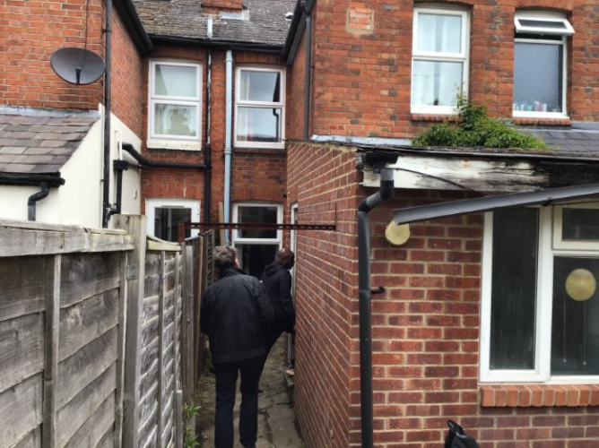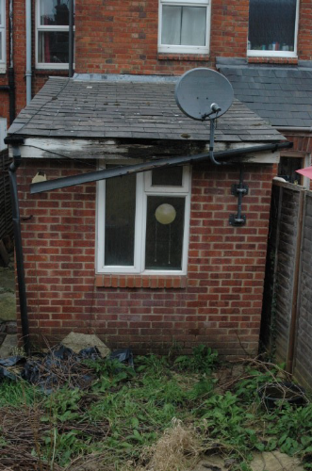

2. PROPOSAL AND SUPPORTING INFORMATION
The proposal is to demolish the existing single storey rear extension and erect a replacement single storey rear extension in order that repairs on the drainage running under the existing extension can be repaired.

Plans considered (received 7th February 2022)
DR 2203/1 Site Location Plan
DR 2203/2 Block Plan/Site Plan
DR 2203/3 Plans and Elevations As Existing
DR 2203/4 Plans and Elevations As Proposed
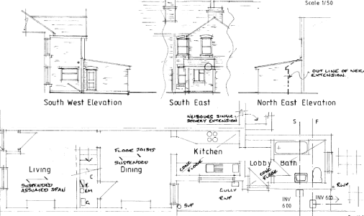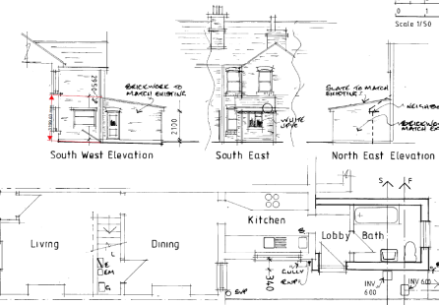
Plans and Elevations As Existing Plans and Elevations As Proposed

- RELEVANT PLANNING HISTORY

None

4. CONSULTATIONS

4.1 The following addresses were consulted by letter.

35 Coventry Road, Reading, RG1 3ND
40 Freshwater Road, Reading, RG1 3NA
33 Coventry Road, Reading, RG1 3ND
42 Freshwater Road, Reading, RG1 3NA

4.2 No letters of representation have been received.

Equality Act 2010:
In determining this application the Council is required to have regard to its obligations under the Equality Act 2010. However, there is no indication or evidence (including from consultation on the application) that the protected groups identified by the Act have or will have different needs, experiences, issues and priorities in relation to this particular planning application. Therefore in terms of the key equalities protected characteristics it is considered there would be no significant adverse impacts as a result of the development.

- LEGAL AND PLANNING POLICY CONTEXT

Section 38(6) of the Planning and Compulsory Purchase Act 2004 requires that proposals be determined in accordance with the development plan unless material considerations indicate otherwise. Material considerations include relevant policies in the National Planning Policy framework (NPPF) - among them the 'presumption in favour of sustainable development'. The following local and national planning policy and guidance is relevant to this application:

National Policy
National Planning Policy Framework
National Planning Practice Guidance

Reading Borough Local Plan (2019)
CC7 (Design and the Public Realm)
CC8 (Safeguarding Amenity)
H9 (House Extensions and Ancillary Accommodation)

SPD
- Design Guide to House Extensions (2021)

6. APPRAISAL

H9 states: An extension to a house will be acceptable where it:

- Respects the character of the house in terms of scale, location, materials and design;

To assess this, the following has been considered – would the proposal:
- detract from the appearance of the original building through the use of ill-matching materials and by not fitting in with the design, scale and proportions of the original building; NO, it is a like for like replacement.
- reduce the amount of usable amenity space for the property to an unacceptable degree; NO, the footprint is not increased.
- require the loss of trees in the garden or put significant trees at risk; NO

- Respects the character and pattern of neighbouring properties and the street as a whole in terms of scale, location, materials and design, and any important existing building line; Respects neighbour’s amenities and does not present a large blank façade to public areas.

To assess this, the following has been considered – would the proposal:
- significantly reduce the amount of daylight and sunlight enjoyed by neighbouring properties; NO, it is a single storey extension at the same level as the existing and only 2.1m at the eaves.
- invade the privacy of neighbouring properties through overlooking from windows or balconies; NO
- detract from the character of neighbouring properties through siting, excessive bulk, ill-matching materials or inconsistent design; NO
- detract from the appearance of the street or area by using ill-matched materials, glazing and detailing; NO

CC8: Safeguarding Amenity states an extension to a house will be acceptable where it will not cause a significant detrimental impact to the living environment of existing or new residential properties.

To assess this, the following has been considered – would the proposal cause a significant detrimental impact to the living environment of existing or new residential properties in terms of:

- Privacy and overlooking; NO
- Access to sunlight and daylight; NO
- Visual dominance and overbearing effects of a development; NO
- Noise and disturbance; NO
- Artificial lighting; NO
- Vibration; NO
- Dust and fumes; NO
- Smell; NO
- Crime and safety. NO

- CONCLUSION
The proposed development has been assessed and the proposed works are considered to be in accordance with the above relevant policies and planning permission can be granted.

8.0 RECOMMENDATION
Grant

