Proposed Material Schedule

Highridge,
Upper Warren Avenue,
Caversham,
Reading,
RG4 7ED

External Walls

Facing brick (Light grey with matching mortar) -
Wienerberger: Terca Clay Brick



Wooden Wall –
Benchmark Timber : Western Red Cedar Timber

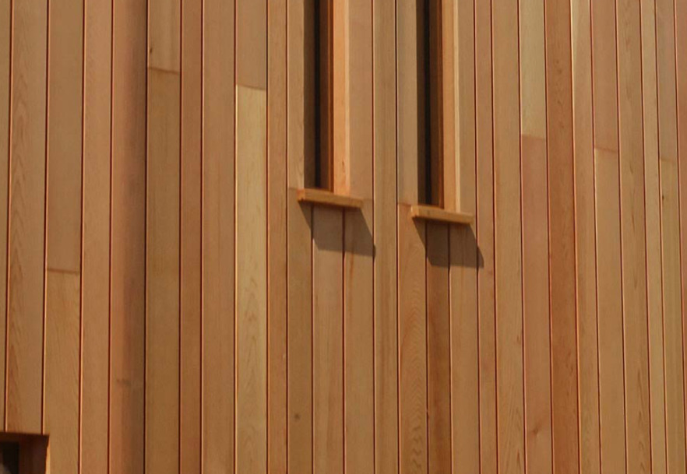

Dark Colour Timber Cladding –
Harleston Supplies: Feather Edge 4.8m Black Timber Cladding

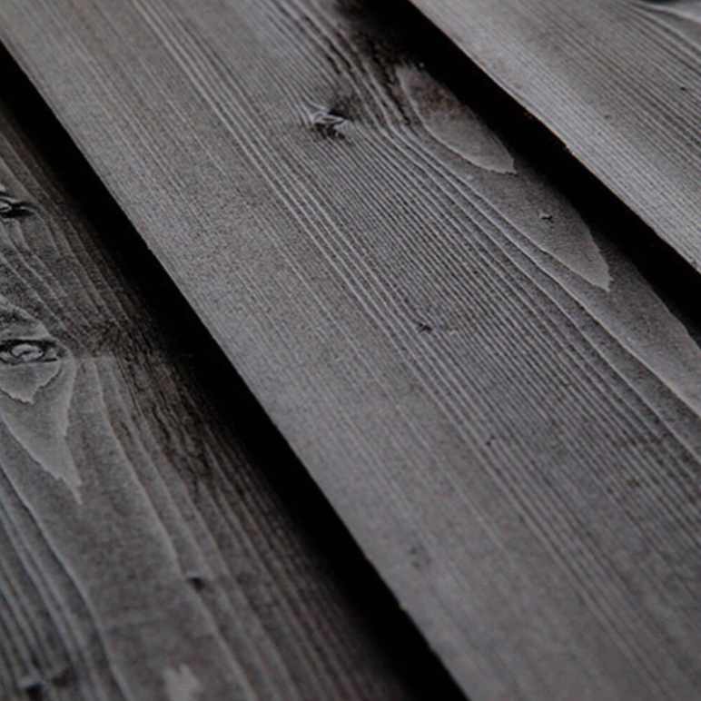

Roof

Roof – Slate Tiles
Roofing Superstore: Cwt Y Bugail County Grade Welsh Slate Roof Tile in Blue/Grey
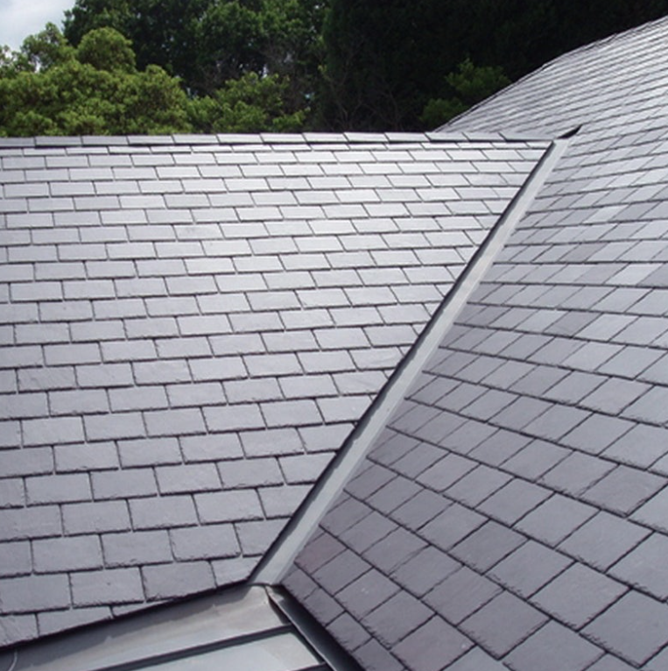

Windows and Doors – High Performance Aluminium
Windows and Doors

Windows and Doors – High Performance Aluminium
Norrsken – Aluminium windows and door colour

