DELEGATED HOUSEHOLDER APPLICATION REPORT

Ward: Katesgrove
App Ref: 220034/HOU
Address: 36 Home Farm Close, Reading, RG2 7TD
Proposals: Part first floor side extension and part two storey rear extension
Case Officer: Chukwudi Onwudinanti
Applicant: Mr Mek Gurung
Date received (valid from): 7 January 2022
Target Decision date: 28 March 2022

1. INTRODUCTION
The site is a semi-detached dwelling on the northern side of Home Farm close, among similarly styled and sized buildings, the existing building footprint covering approximately 60 square metres, on a plot of approximately 300 square metres.
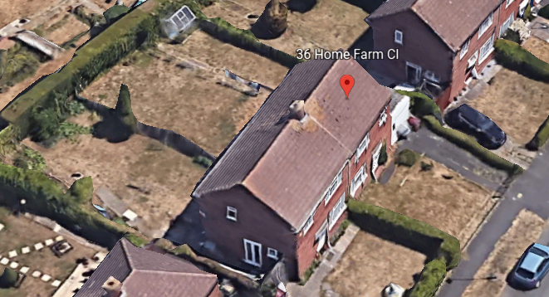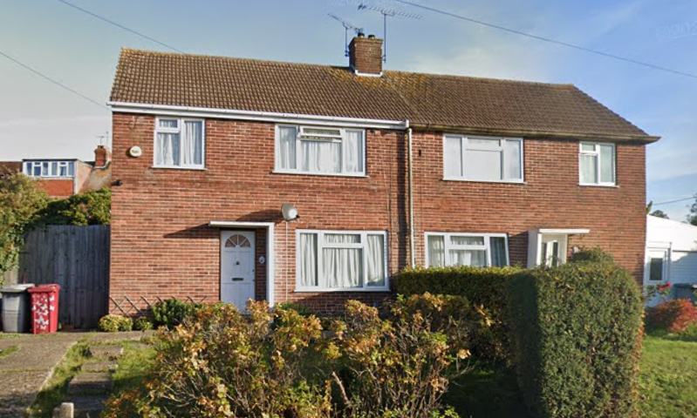

2. PROPOSAL AND SUPPORTING INFORMATION

The application consists of a first floor side extension, measuring approximately 3.2m by 3.4 m and first floor rear extension supported on pillars, open sided over a terrace, measuring approximately 2.4m by 5.1m, with pitched roof dormer window above, proposed at 2.6m wide

Plans considered
39/21 – Existing Plans/Elevations/Sections (Received 12th January 2022)
39/21/1 – Proposed Plans/Elevations/Sections (Received 12th January 2022)
SU72027155 - Block Plans (Received 11th January 2022)
SU72027155 - Location Plans (Received 11th January 2022)

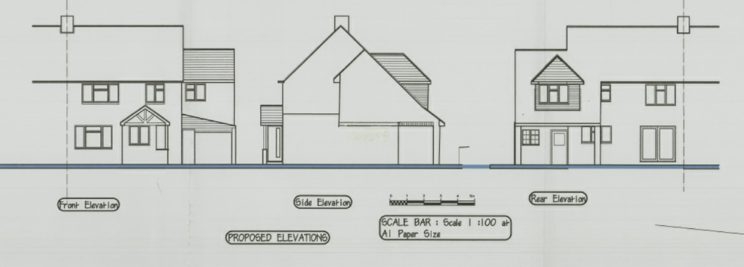

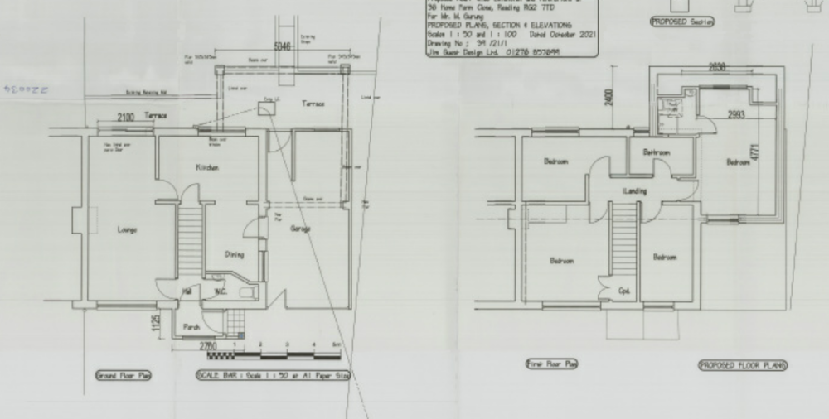

- RELEVANT PLANNING HISTORY

None

4. CONSULTATIONS

4.1 The following addresses were consulted by letter.

34 Home Farm Close, Reading, RG2 7TD
33 Lincoln Road, Reading, RG2 0EX
38 Home Farm Close, Reading, RG2 7TD

4.2 No letters of representation have been received.

Equality Act 2010:
In determining this application the Council is required to have regard to its obligations under the Equality Act 2010. However, there is no indication or evidence (including from consultation on the application) that the protected groups identified by the Act have or will have different needs, experiences, issues and priorities in relation to this particular planning application. Therefore in terms of the key equalities protected characteristics it is considered there would be no significant adverse impacts as a result of the development.

- LEGAL AND PLANNING POLICY CONTEXT

Section 38(6) of the Planning and Compulsory Purchase Act 2004 requires that proposals be determined in accordance with the development plan unless material considerations indicate otherwise. Material considerations include relevant policies in the National Planning Policy framework (NPPF) - among them the 'presumption in favour of sustainable development'. The following local and national planning policy and guidance is relevant to this application:

National Policy
National Planning Policy Framework
National Planning Practice Guidance

Reading Borough Local Plan (2019)
CC7 (Design and the Public Realm)
CC8 (Safeguarding Amenity)
H9 (House Extensions and Ancillary Accommodation)

SPD
- Design Guide to House Extensions (2021)

6. APPRAISAL

H9 states: An extension to a house will be acceptable where it:

- Respects the character of the house in terms of scale, location, materials and design;

To assess this, the following has been considered – would the proposal:
- detract from the appearance of the original building through the use of ill-matching materials and by not fitting in with the design, scale and proportions of the original building; NO - In terms of the view from the front the proposal is subservient, being set back and set down, and follows the design of the host dwelling. Although the remainder of the proposal is slightly unusual with its first floor form only, over a terrace at ground floor, its overall scale and proportions are considered to not detract from the original building and are deemed acceptable.
- reduce the amount of usable amenity space for the property to an unacceptable degree; NO
- require the loss of trees in the garden or put significant trees at risk; NO

- Respects the character and pattern of neighbouring properties and the street as a whole in terms of scale, location, materials and design, and any important existing building line; Respects neighbour’s amenities and does not present a large blank façade to public areas.

To assess this, the following has been considered – would the proposal:
- Significantly reduce the amount of daylight and sunlight enjoyed by neighbouring properties; NO, the neighbouring property is significantly away from the boundaries with the proposal site and the area of the extension, such that the 45 degree rule shows that the extension will not impact on the daylight and sunlight enjoyed by the property at No.34. There is a side facing window at no. 34, which is believed to serve a landing, but the combination of the splay, and scale of the proposed side extension element, and the orientation of dwellings, is considered to be such that no significant reduction to daylight and sunlight would occur.
- invade the privacy of neighbouring properties through overlooking from windows or balconies; NO, there are no windows proposed on the side of the extension.
- detract from the character of neighbouring properties through siting, excessive bulk, ill-matching materials or inconsistent design; NO
- detract from the appearance of the street or area by using ill-matched materials, glazing and detailing; NO

CC8: Safeguarding Amenity states an extension to a house will be acceptable where it will not cause a significant detrimental impact to the living environment of existing or new residential properties.

To assess this, the following has been considered – would the proposal cause a significant detrimental impact to the living environment of existing or new residential properties in terms of:

- Privacy and overlooking;
- Access to sunlight and daylight;
- Visual dominance and overbearing effects of a development;
- Noise and disturbance;
- Artificial lighting;
- Vibration;
- Dust and fumes;
- Smell;
- Crime and safety.

- CONCLUSION
The proposed development has been assessed and the proposed works are considered to be in accordance with the above relevant policies and planning permission can be granted.

8. RECOMMENDATION
Grant

