DELEGATED APPLICATION REPORT

Target Date: 28/01/2022
Application No: 211950/FUL
Address: Land adjacent to 5 Wilson Road
Proposal: Erection of a 2 bedroom house
Case Officer: Claire Ringwood
______________________________________________________________________

Site Description and Surrounding Area
The site is located on the eastern side of Wilson Road and is the side garden of no. 5 Wilson Road. The surrounding area is characterised by a mixture of two-storey semi-detached and terraced dwellings situated towards the front of plots. This part of Wilson Road includes some shallow plots, although this is generally not characteristic of the wider area.

There have been some redevelopments of former industrial/commercial sites for residential units: 3 no. units at former the Elgee Plastics site (rear of Grovelands church), 3 no. terraced houses at no 13. Wilson Road; and 5 no. terraced houses at 19-23 Wilson Road.

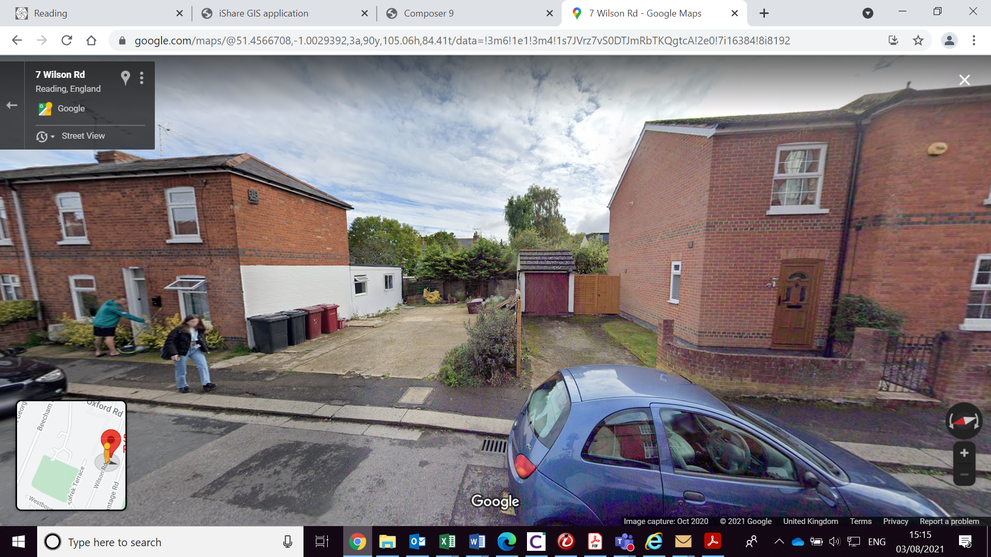

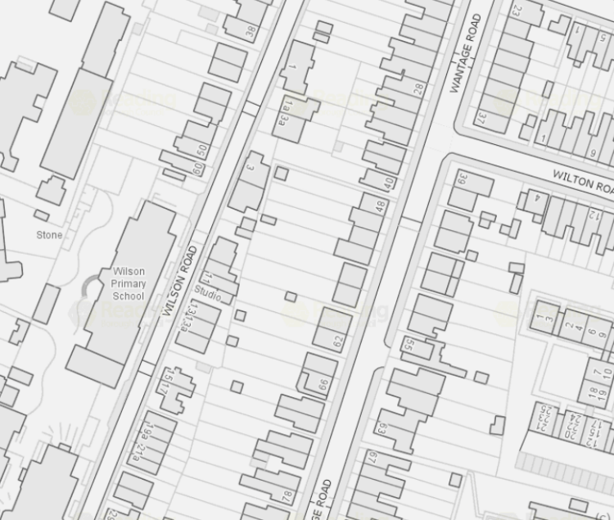

Application site

Proposal
The proposed development is:
- A detached 2-bedroom dwelling with a rear garden to serve the new dwelling;
- Bin and bicycle storage for the proposed dwelling; and
- Bicycle shelter to serve the retained no 5. Wilson Road.

- Originally Submitted Proposed Ground Floor Plan
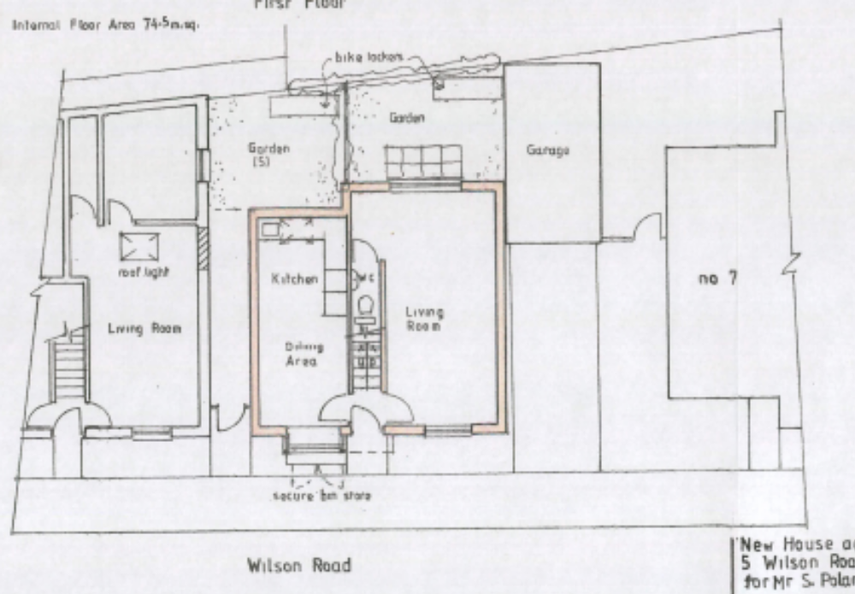

- Amended Proposed Ground Floor Plan received 3rd February 2022 (following 1st February 2022 email from the Planning Officer)
Amendments comprised:
- Removal of the garden for the retained no. 5 Wilson Road;
- Bike shelter and rear access to the retained no. 5 Wilson Road;
- Bin storage to the front of the property.
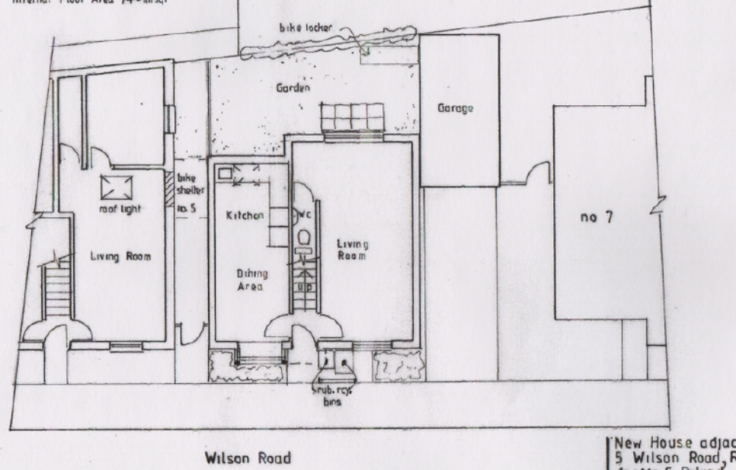

Discussion with the Agent/Applicant

Email from officer to agent 1st February 2022:
I note the application has attempted to address a number of matters that were raised in application 201307 and these are:

- Independent access to the 2 gardens for No5 and the new house;
- Larger ground floor, internal floor area now 74.5sqm; and
- Secure bin store added to the front of the house.

The proposal now has an internal floor area that meets the NDSS which is acceptable (previously reason for refusal 2). The independent access to the two gardens is an improvement although the size of the proposed amenity space was the main reason for refusal in the previous application and this concern still remains.

Although bin storage is now proposed to the front of the proposed dwelling this does not look big enough to accommodate two bins in terms of height or depth and the floor plan suggests the doors of the storage open onto the public footpath. This is not considered acceptable.

Unfortunately the matters raised in reasons for refusal 1, 3, 4, 5 and 6 of application 201307 still remain and the proposal cannot be supported by officers and will be recommended for refusal unless you wish to withdraw the application. The reasons for refusal will be the same as application 201307 other than the removal of reason for refusal 2 and amended wording for the bin storage based on the reasons above.

The details submitted with the application advises the applicant would be willing to enter into a legal agreement to secure affordable housing however as the application is not considered acceptable in other regards this matter will remain a reason for refusal although it is accepted that this matter could have been addressed had the application been acceptable.

An amended scheme was received 3rd February 2022 as detailed above.

Email from officer to agent 16th February 2022:
Thank you for your email and apologies for the delay responding. I have looked at the amendments and they do not change my previous concerns and officer opinion that the application be refused. I would therefore be grateful if you could advise whether you wish the application to be refused on the original plans submitted or the amended plans. I am not inviting any further amendments.

The agent advised on the 17th February 2022 to base the refusal on the amended plans.

Plans and Documents

The agent submitted the following plans and information, received on 3rd December 2021:

Drawing No: WN 11A – Proposed Street Elevation + Plan
Drawing No: WN 12 – Existing Street Elevation + Plan
Drawing No: WN 16A – Proposed Plans
Drawing No: WN 17A – Proposed Elevations
Design & Access Statement

The agent submitted the following amended plans, received on 3rd February 2022:

Drawing No: WN 11B – Proposed Street Elevation + Plan
Drawing No: WN 16B – Proposed Plans
Drawing No: WN 17B – Proposed Elevations

Internal Consultations

RBC Transport Development Control
Wilson Road is subject to No Entry from the south and therefore in the vicinity of the site the road is effectively one way working north to south. The carriageway is narrow and is reduced to single lane by on street parking.

The site is located within the Zone 2, the primary core area but on the periphery of the Zone 3, Secondary Core Area, of the Council’s adopted Parking Standards and Design SPD. In accordance with the adopted Parking Standards and Design SPD, the development would be required to provide a parking provision of 1.5 space per 2-bedroomed dwelling. A previous application (191775) included the provision of 1no. off-road parking space (which was supported by Transport DC), however, no parking is proposed as part of this application.

Policy TR5 of the Local Plan states that development should provide car parking and cycle parking that is appropriate to the accessibility of locations within the Borough to sustainable transport facilities, particularly public transport.

Whilst the site is located within 200m of bus stops to and from the town centre, Wilson Road is within a Residents Permit Parking Zone 07R where there is significant pressure for on-street parking. It should be noted that the new dwelling would not be entitled to Resident’s Parking Permits, and conditions would be applied to prevent the future residents from parking on Wilson Road or within the parking zone.

While residents may use sustainable modes to access workplaces or destinations without parking, it is reasonable to assume residents may require the use of a car to go to destinations not served by public transport or at times when they feel when they feel vulnerable such as at night. In view of this, the none provision of parking does not comply with policy TR5 of the Local Plan.

In respect of the existing property, no. 5 Wilson Road, the Council’s permit records confirm that the property is included within the Residents Permit Zone. Therefore, the property is entitled to apply for resident and visitor permits as per the scheme rules.

In accordance with the Council’s Parking Standards and Design SPD, secure cycle storage will be provided in the form of a brick built store which is acceptable.

Based on the proposed plans, the development does not comply with policy TR5 of the Local Plan. In view of this, I object to the application on parking grounds.

Refusal Reason

1. The proposed layout fails to demonstrate that it complies with the Local Planning Authority’s standards in respect of vehicle parking. This could result in on-street parking on Wilson Road and on the surrounding highway, adversely affecting road safety and the flow of traffic, and in conflict with Local Plan Policies TR3 and TR5.

Suggested conditions

The following conditions and informatives should be applied if the application is approved;

DC5 – Cycle Parking
DC8 - Bins
DE2 & DE3 – Parking permits

Informatives
IF3 - Highways
I13 – Parking permits
I29 – Access construction

Environmental Protection
Standing advice states that the following conditions would have been applied had the application been acceptable 1) The control of noise and dust, 2) Construction and demolition hours of work and 3) No bonfires.

External Consultees

Neighbours
Nos 3, 3A and 7 Wilson Road and 48-56 (even) Wantage Road were consulted and a site notice displayed. No responses were received.

Relevant Planning History
Application site:

201307/FUL - Erection of a 2 bedroom house – Refused 09/08/2021.

Refused plans
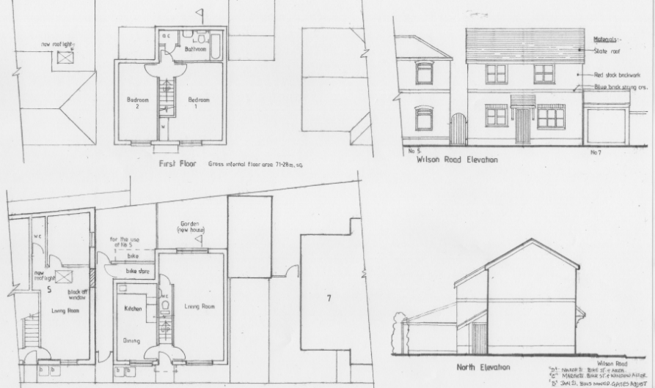

For the following reasons:

1. The proposed development, by reason of its overall scale relative to plot size, would be overly prominent within its context. It would result in the loss of spaces between buildings and the entire garden of no. 5 Wilson Road, and a cramped arrangement, which would be an overdevelopment of the site, harmful to the wider streetscene and the prevailing pattern of development. This would thereby fail to preserve or enhance the character and appearance of the area, contrary to Policies CC7, and H11 of the Reading Borough Local Plan (2019).

2. The proposed development, by reason of its internal size would fail to meet the relevant internal space standards for a 2 bed dwelling and would therefore, not provide an acceptable quality of living accommodation for future occupants, which would detract from their living conditions, contrary to policies CC8, H5 and H11 of the Reading Borough Local Plan (2019).

3. The proposed development would not only be developed on the entire existing garden of no. 5 Wilson Road, but through the provision of uncharacteristically and unacceptably small gardens, in comparison to the prevailing size in the surrounding area, would fail to provide an acceptable level of external amenity space for the existing residents of no. 5 Wilson Road and future occupants. This would detract from their living conditions, contrary to Policies CC8, H10 and H11 of the Reading Borough Local Plan (2019).

4. The proposed development would include no provision for secure bin storage and would lead to bins being stored to the front of no. 5 Wilson Road and the proposed dwelling, which would have a detrimental effect on the appearance of the streetscene and would therefore, be contrary to Policies CC5, CC7, CC8 and H11 of the Reading Borough Local Plan (2019).

5. The proposed layout fails to demonstrate that it complies with the Local Planning Authority’s standards in respect of vehicle parking. This could result in on-street parking on Wilson Road and on the surrounding highway, adversely affecting road safety and the flow of traffic, and in conflict with Policy TR3 and TR5 of the Reading Borough Local Plan (2019).

6. In the absence of a completed legal agreement to secure an acceptable contribution towards the provision of Affordable Housing, the proposal fails to contribute adequately to the housing needs of Reading Borough, contrary to Policy CC9 and H3 of the Reading Borough Local Plan (2019), and the Council’s Adopted Affordable Housing Supplementary Planning Document 2021.

191775/FUL - Erection of a 2 bedroom house with off road parking – Refused 10/6/2020.

Refused plans
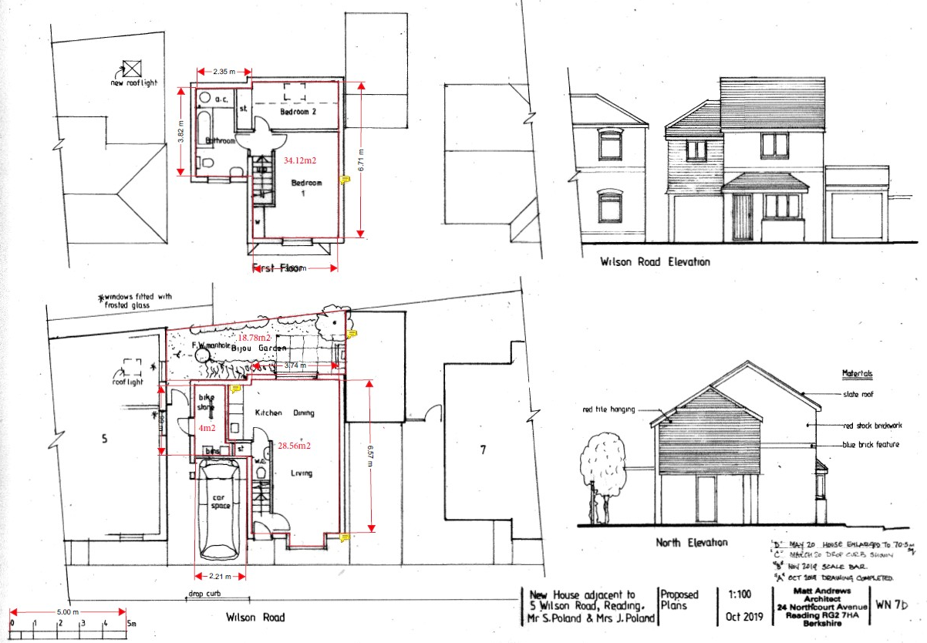

For the following reasons:

1. The proposed development, by reason of its overall scale relative to plot size, would be overly prominent within its context and result in a cramped arrangement of buildings and spaces and an overdevelopment of the site that would not respect the prevailing pattern of development and would fail to preserve or enhance the character and appearance of the street scene and wider area. The proposal is therefore contrary to Policies CC7, and H11 of the Reading Borough Local Plan (2019).

2. The design of the proposed development, by reason of its specific built form, roofscape, window and door positioning, front porch, bay window, and use of materials, would appear as an inappropriate and unsympathetic development that would not be of a sufficient high quality design that maintains and enhances the character and appearance of the area, contrary to Policies CC7 and H11 of the Reading Borough Local plan (2019).

3. The proposed development, by reason of its scale, siting, and number and close proximity of windows to No.5 Wilson Road, would result in a loss of light, loss of private amenity space, and impact on the amenity of internal living spaces to the occupiers of No.5 Wilson Road, therefore causing an overall significant detrimental impact to these occupiers residential amenity, contrary to Policies CC8, H10 and H11 of the Reading Borough Local Plan (2019).

4. The proposed development, by reason of its internal size and uncharacteristically small garden, in comparison to the prevailing size in the surrounding area, would fail to provide an acceptable quality of living accommodation, and external amenity space for future occupants, contrary to Policies CC8, H5 and H10 of the Reading Borough Local Plan (2019).

5. In the absence of a completed legal agreement to secure an acceptable contribution towards the provision of Affordable Housing, the proposal fails to contribute adequately to the housing needs of Reading Borough, contrary to policy CC9 (Securing Infrastructure) and H3 (Affordable Housing) of the Reading Borough Local Plan (2019), and the Council’s Adopted Affordable Housing Supplementary Planning Document 2013.

5 Wilson Road

191071/HOU - First floor rear extension (retrospective) – Approved - 27/9/2019

Former Elgee Plastics, Wilson Road
160180/FUL - Demolition of existing commercial premises and erection of 3 No. 2-bedroom terraced houses (Use Class C3) (amended description) – Approved 17/1/2017

13 Wilson Road
07/01455/FUL (071290) - Demolition of light industrial unit and garages and erection of 4 x 2 bedroom houses – Refused 25/1/2008 - Lack of off-street vehicle parking; does not comply with standards with respect to cycle storage; inadequate amenity space; unacceptable degree of overlooking for the private gardens to the rear of the site; absence of completed S106 legal agreement.

09/00472/FUL (090774) - Demolition of existing light industrial unit and garages and the erection of 3 x 3 bedroom terraced houses (re- submission of planning application 08/01622/FUL) - Approved 12/10/2009

10/01354/FUL (101364) – Erection of 4x 2 bed houses – Refused 15/10/2010. Appeal dismissed 24/5/2011 – APP E0345/A/11/2145320/NW

19-23 Wilson Road
05/00858/FUL (051303) - Demolition of existing workshops, erection of one two-bed house, two one-bed flats and change of use of ground floor no. 21 from associated business back to residential – Approved 21/9/2005

06/01222/FUL (060988) - Demolition of existing redundant workshops and associated buildings and construction of 5 no. terraced houses – Approved 2/1/2007

Equality Act 2010
In determining this application, the Council is required to have regard to its obligations under the Equality Act 2010. However, there is no indication or evidence (including from consultation on the application) that the protected groups identified by the Act have or will have different needs, experiences, issues and priorities in relation to this particular planning application. Therefore in terms of the key equalities protected characteristics it is considered there would be no significant adverse impacts as a result of the development.

Relevant Planning Policy and Guidance
Section 38(6) of the Planning and Compulsory Purchase Act 2004 requires that proposals be determined in accordance with the development plan unless material considerations indicate otherwise. The Development Plan for Reading relevant to the application site comprises the Reading Borough Local Plan (2019) (RBLP).

The ‘National Planning Policy framework’ (‘’NPPF’’) 2012 states clearly that its content is to be a material consideration in the determination of applications. The ‘NPPF’ states that due weight should be given to the adopted policies according to their degree of consistency with the ‘NPPF’ (the closer the policies in the plan to the policies in the ‘NPPF’, the greater the weight that may be given).

Relevant Policies
The application has been assessed against the following policies:

National
National Planning Policy Framework 2021
National Planning Policy Guidance

Reading Borough Local Plan (2019)
CC1 Presumption in Favour of Sustainable Development
CC2 Sustainable Design and Construction
CC3 Adaption to Climate Change
CC5 Waste Minimisation and Storage
CC6 Accessibility and the Intensity of Development
CC7 Design and the Public Realm
CC8 Safeguarding Amenity
CC9 Securing Infrastructure
EN12 Biodiversity and the Green Network
EN14 Trees, Hedges and Woodland
EN15 Air Quality
EN16 Pollution and Water Resources
H1 Provision of Housing
H2 Density and Mix
H3 Affordable Housing
H5 Standards for New Housing
H10 Private and Communal Outdoor Space
H11 Development of Private Residential Gardens
TR1 Achieving the Transport Strategy
TR3 Access, Traffic and Highway-Related Matters
TR5 Car and Cycle Parking and Electric Vehicle Charging

Supplementary Planning Documents
Revised Parking standards and design (2011)
Sustainable Design and Construction (2019)
Affordable Housing Supplementary Planning Document (2021)
Planning Obligations Under Section 106 (2015)

Appraisal

The main issues are considered to be as follows and the assessment is based on the amended plans as received 3rd February 2022:

- Principle of Development
- Design
- Impact on Amenity
- Transport Matters
- S106 and Community Infrastructure Levy (CIL)
- Other Matters: Sustainability; Bin Storage

Principle of Development

The NPPF (para.119) states that “Planning policies and decisions should promote an effective use of land in meeting the need for homes and other uses, while safeguarding and improving the environment and ensuring safe and healthy living conditions. Strategic policies should set out a clear strategy for accommodating objectively assessed needs, in a way that makes as much use as possible of previously-developed or ‘brownfield’ land”.

The NPPF definition of ‘previously developed land’ excludes private residential gardens.

Therefore, it is clear that the priority for development should be on previously developed land, in particular vacant and derelict sites and buildings. However, that does not mean that the development of private residential garden land is unacceptable in principle, rather that, previously developed land should be the first choice for housing development.

Therefore, the principle of the redevelopment of the site for further residential development could be acceptable subject to the above criteria and other material planning considerations.

It should be noted, however, that the examples of infill developments referred to under ‘Planning History’ above relate to previously developed land not garden land. Officers do not agree with the applicant’s contention that this is a vacant plot nor previously developed land (brownfield) and therefore, the following assessment has also been undertaken within the context of Policy H11 (Development of Private Residential Gardens).

Design

Policy CC7 (Design and the Public Realm) states that “All development must be of high design quality that maintains and enhances the character and appearance of the area of Reading in which it is located. The various components of development form, including: Layout: urban structure and urban grain; landscape; density and mix; Scale: height and massing; and Architectural detail and materials”.

The Council’s adopted Policy H11 requires that new residential development that involves land within the curtilage or the former curtilage of private residential gardens will be acceptable where:

- “The proposal makes a positive contribution to the character of the area in terms of:
  - The relationship of the existing built form and spaces around buildings within the surrounding area;
  - A layout which integrates with the surrounding area with regard to the built up coverage of each plot, building line(s), rhythm of plot frontages, parking areas, and existing pattern of openings and boundary treatments on the site frontage;
  - Providing appropriate hard and soft landscaping, particularly at site boundaries. This includes features such as the variety of trees, hardstanding/lawns and hedges, etc;
  - Compatibility with the general building height within the surrounding area;
  - The materials and elevational detail. These should be high quality, and where appropriate distinctive and/ or complementary;
  - The arrangement of doors, windows and other principal architectural features and their rhythm between buildings.
- The application site provides a site of adequate size and dimensions to accommodate the development proposed in terms of the setting and spacing around buildings, amenity space, landscaping and space for access roads and parking;
- The proposal includes access, which meets appropriate highway standards;
- The proposal does not lead to tandem development;
- The design and layout minimises exposure of existing private boundaries to public areas, and avoids the need for additional physical security measures;
- The proposal does not cause a significant detrimental impact to the amenity of adjacent and nearby occupants;
- The emphasis is on the provision of family-sized housing;
- The development provides biodiversity net gain wherever possible, and would not have an adverse impact on biodiversity in terms of the fragmentation of blocks of gardens, which as a unit or in association with adjacent green space are deemed to make an important contribution to biodiversity and contribute to the green network; and
- The proposal does not prejudice the satisfactory development of a wider area.”

Wilson Road is a narrow, mainly residential road with an informal mix of terraced and semi-detached houses. The houses vary in appearance and design, but generally are of traditional appearance, constructed of red brick and render with pitched slate-tiled roofs and decorative detailing around the windows.

The proposed development would be for a two-storey detached dwelling positioned to be in line with the building line along the eastern side of Wilson Road. The proposal would be built to the boundary of no.7 Wilson Road, and would be of a similar depth to no.7.

The overall eaves height would be similar to No. 5, but the overall height would be higher than no.5, but consistent with the height and roof form of the side extension of no. 7. It is different in design appearance to no. 5 with respect to the roofscape, slightly narrower, and with a different arrangement and scale of fenestration with a roof over the door and bay window at ground floor. There would be a gap of 1m between the no. 5 Wilson Road and the proposed dwelling. It is considered that in itself it would be acceptable in the context as a detached building with a more modern interpretation of design features but reflecting the prevailing appearance through the proposed use of traditional materials and brick detailing.
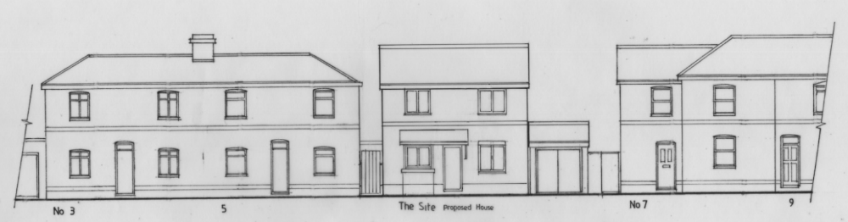

Although the overall appearance of the proposed dwelling is considered acceptable in itself, it would be developed on the entire garden area of no. 5 Wilson Road, which is considered to form a valuable contribution to the overall character of this section of Wilson Road, where spacing between groups of buildings is a particularly characteristic feature. Therefore, the proposed dwelling is considered to be harmful to the wider streetscene and the amenity of existing and future residents (the latter addressed further below). It would appear cramped within the plot and within the street and would be uncharacteristic of the wider area.

The originally submitted plans retained two small garden spaces for no. 5 Wilson Road and the proposed dwelling however, following the same concerns as previously raised by officers, the agent submitted amended plans which increased the amount of garden space for the proposed dwelling by removing the proposed garden space for no. 5 Wilson Road entirely. The amended garden area now measures approximately 20.4sqm but this still falls well below guidance in Policy H10 which states in paragraph 4.4.87 “the Council has sought the following minimum provisions for private or communal outdoor space…..and they provide a useful guide for proposals: (a) Houses: Useable private outdoor space should be no less than the gross floor area of the dwelling to which it relates (measured externally and including garage space)”.

Although some garden area is proposed it is considered that the proposal would fail to provide adequate provision for suitable on-site landscaping, or appropriate boundary treatments and the total loss of any garden space for the existing residents of no. 5 Wilson Road is also considered to be an indicator of a cramped site. The agent has stated that no. 5 Wilson Road has not had a garden since it was extended to the rear however, Google StreetView images clearly show the site on which the new dwelling is proposed was used as garden space including bin storage and a shed at least up to 2016.

Policy H11 has an emphasis on family housing and although the proposed dwelling now meets space standards (by removing the previously proposed bike store for no. 5 Wilson Road and incorporating this space into the proposed dwelling) the garden size would fall below relevant standards and would not be suitable for a family. The site would therefore fail to be of an adequate size to accommodate the proposed development. Further detail is set out under the ‘Amenity’ section below.

Therefore, the overall design, is not considered to be high quality design, which would maintain or enhance the character and appearance of the area in which it is located. The proposal is considered to be overdevelopment of the plot, including being developed on the garden space associated with the original dwelling (no.5 Wilson Road). The proposal would therefore be contrary to Policy CC7 and H11 of the RBLP, as well as Policy H10.

Impact on Amenity

Policy CC8 of the RBLP states that “Development will not cause a detrimental impact on the living environment of existing residential properties or unacceptable living conditions for new residential properties, in terms of:

- Privacy and overlooking;
- Access to sunlight and daylight;
- Visual dominance and overbearing effects of a development;
- Harm to outlook;
- Noise and disturbance;
- Artificial lighting;
- Vibration;
- Dust and fumes;
- Smell;
- Crime and safety; or
- Wind, where the proposals involve new development of more than 8 storeys.”

The existing dwelling at no.5 Wilson Road includes two side-facing windows. One window currently serves the living room (this also has a window to the front elevation), with the other being the primary window for a bedroom at no.5. The plans submitted (Drawing No: WN 16B) shows the side window to the living room blocked up and a rooflight inserted and this arrangement is considered acceptable. However, the ground floor bedroom window to no. 5 Wilson Road will be within 1m of the boundary with the proposed dwelling and although a sufficient level of privacy would be maintained, as a habitable room, Officers consider this would be harmful to outlook and daylight and sunlight for the residents of this bedroom and is an unacceptable arrangement.

For the proposed bathroom there is a rear facing obscure glazed window. Had the scheme been acceptable overall, a condition would have been included to ensure the retention of this window as obscure glazed and non- opening 1.7m above floor level to minimise overlooking and ensure privacy of the rear gardens of the properties on Wantage Road.

Policy H5 states that all new development in Reading should meet a number of standards. Specifically, the nationally described space standards (included in the supporting text of Policy H5) requires that a 2-bed 3-person (based on the size of the bedrooms in this case), over two-storeys, be a minimum of 70m². The plans and submitted Design & Access Statement show that the proposal would be 74.5m². The proposal would therefore just meet the requirements of Policy H5.

In addition, Policy H10 (Private and Communal Outdoor Space) states that “Dwellings will be provided with functional private or communal open space, including green space wherever possible, that allows for suitable sitting-out areas, children’s play areas, home food production, green waste composting, refuse storage, general outdoor storage and drying space. Houses will be provided with private outdoor space whereas flats may be provided with communal outdoor space, balconies and/or roof gardens … The design of outdoor areas will respect the size and character of other similar spaces in the vicinity”.

The supporting text within Policy H10 also states that in the past the Councils standards were that “useable private outdoor space should be no less than the gross floor area of the dwelling to which it relates (measures externally and including garage space)”. Although not a strict criteria, it is a useful guide. The applicant has proposed, through amended plans, a garden area measuring ca 20.4sqm for the proposed house and although they acknowledge this is small, they state that there are parks close by.

The proposed garden size is well below planning guidance and although larger than originally proposed it is not considered to contribute towards pleasant or useable garden space for the proposed dwelling and the non-provision of garden space for the existing dwelling at no.5 Wilson Road is considered unacceptable. Although there are a few examples of similar garden spaces the majority are at least double in size and larger or relate to smaller terrace properties.

It is not considered that any examples of surrounding shortfalls should form the basis for poor provision of garden space for new development and along with the loss of the existing garden space to the side of no. 5 Wilson Road Officers consider this has a detrimental effect on the overall prevailing character and pattern of development in the area. This issue was considered and accepted by the Inspector on an appeal at 13 Wilson Road (referenced above) for four two bed terraces. The Inspector stated (Paras 4 & 5) that:

“the proposed amenity space would be below the Council’s minimum standards. Whilst standards should be flexible, the proposed gardens.. would be very small and provide a limited area for outdoor living. The gardens would be cramped and restricted creating a poor external environment for the future occupiers detracting from the living conditions. There are recreation areas reasonably close to the appeal site. However, they are not private, nor are they part of people’s living space, and this would not compensate for the lack of gardens at the appeal site.

The houses to the north of the appeal site have very small, tapering gardens, but these are not typical, and would not set a precedent for garden sizes in Wilson Road.”

The amended plans now propose a separate side access for no. 5 Wilson Road with a bike shelter located in the middle. Access to the rear garden space of the proposed dwelling would be through the house itself and although a bike locker has been shown on the amended plans, bikes would need to be taken through the proposed dwelling. This is considered to be an indicator of a poor on-site arrangement with insufficient space to accommodate all the requirements for the existing and proposed dwelling.

Overall it is considered that the small garden size for the proposed dwelling and the loss of garden space for the existing no. 5 Wilson Road would result in an unacceptable level of amenity for the future and existing occupiers, detracting from their living conditions contrary to RBLP Policies CC7, CC8 and H10.

Transport Matters
The proposed development includes no on- site parking and the approved standards require 1.5 off road car parking spaces for a two bed dwelling. Although it is accepted that the site is located within close proximity to high frequency bus routes there is already pressure on the available on-street parking and this does not take into account ownership of cars and the need to park them even if other modes are being used and that some destinations may require the use of a car. The applicant has stated that they would accept a condition that does not allow any future occupiers of the proposed dwelling to be entitled to residents parking permits however this does not overcome Transports objection as there is no provision of parking, for both no. 5 and the proposed dwelling, which does not comply with policy TR5 of the Local Plan.

Other transport conditions to control construction phase management could be controlled by condition should the scheme have been found acceptable in other regards.

The cycle provision for the proposed dwelling would be within a secure bike store and would be deemed acceptable.

S106 and Community Infrastructure Levy (CIL)
Policy H3 (Affordable Housing) requires all developments to contribute appropriately toward affordable housing elsewhere in the Borough and this would equate to 10% of the Gross Development Value for 1-4 dwellings. No information has been submitted and therefore, the failure to complete a s106 agreement to secure this would form a reason for refusal, however an agreed contribution and completion of a s106 or unilateral undertaking could overcome this and had the application been acceptable in all other regards the applicant had agreed to enter into a legal agreement.

The proposal would have been CIL liable if recommended for approval.

Other Matters
Sustainability - The proposed development would be required to be constructed in accordance with the optional building regulations standards (Council’s opt-in) as outlined in Policy H5. Had the scheme been acceptable in other regards a condition would have been included to secure this.

Bin Storage – The amended scheme includes bins being stored to the front of the proposed dwelling although the amended plans do not show provision for bin storage for no. 5 Wilson Road. This does not meet the requirements for secure bin storage (Policy CC5) and would have an additional detrimental effect on the appearance of the streetscene, and is a further indicator of the cramped nature of the site. Policy CC5 states “….the promotion of layouts and designs that provide adequate, well-designed space to facilitate waste storage, reuse, recycling and composting”.

Conclusion
Having regard to the material considerations and all matters raised, the Local Planning Authority considers that the balance of considerations therefore, weigh against the granting of consent.

Recommendation
REFUSE

- The proposed development, by reason of its overall scale relative to plot size, would be overly prominent within its context. It would result in the loss of spaces between buildings and the entire garden of no. 5 Wilson Road, and a cramped arrangement, which would be an overdevelopment of the site, harmful to the wider streetscene and the prevailing pattern of development. This would thereby fail to preserve or enhance the character and appearance of the area, contrary to Policies CC7, and H11 of the Reading Borough Local Plan (2019).

- The proposed development, by reason of its close proximity to the ground floor side window at no. 5 Wilson Road would result in harm to outlook, loss of daylight and sunlight and impact on the amenity of the internal living space of this room therefore causing an overall significant detrimental impact to the residential amenity of existing and future occupiers of this room, contrary to Policies CC8, H10 and H11 of the Reading Borough Local Plan (2019).

- The proposed development would not only be developed on the entire existing garden of no. 5 Wilson Road, but through the provision of an uncharacteristically and unacceptably small garden, in comparison to the prevailing size in the surrounding area and the total loss of any provision of garden space for the existing residents of no. 5 Wilson Road, would fail to provide an acceptable level of external amenity space for the existing residents of no. 5 Wilson Road and future occupants of the proposed dwelling. This would detract from their living conditions, contrary to Policies CC8, H10 and H11 of the Reading Borough Local Plan (2019).

- The proposed development would include no provision for secure bin storage and would lead to bins being stored to the front of no. 5 Wilson Road and the proposed dwelling, which would have a detrimental effect on the appearance of the streetscene and would therefore, be contrary to Policies CC5, CC7, CC8 and H11 of the Reading Borough Local Plan (2019).

- The proposed layout fails to demonstrate that it complies with the Local Planning Authority’s standards in respect of vehicle parking. This could result in on-street parking on Wilson Road and on the surrounding highway, adversely affecting road safety and the flow of traffic, and in conflict with Policy TR3 and TR5 of the Reading Borough Local Plan (2019).

- In the absence of a completed legal agreement to secure an acceptable contribution towards the provision of Affordable Housing, the proposal fails to contribute adequately to the housing needs of Reading Borough, contrary to Policy CC9 and H3 of the Reading Borough Local Plan (2019), and the Council’s Adopted Affordable Housing Supplementary Planning Document 2021.

INFORMATIVES

1. The development hereby refused was assessed using the submitted drawings as follows:

Received on 3rd February 2022:
Drawing No: WN 11B – Proposed Street Elevation + Plan
Drawing No: WN 16B – Proposed Plans
Drawing No: WN 17B – Proposed Elevations
3
2. Reason for refusal No. 6 above could be overcome with the completion of a satisfactory s106 agreement or unilateral undertaking.
5
3. The Local Planning Authority has worked positively and proactively but it has not been possible to overcome the concerns raised and therefore the decision to refuse planning permission has been taken. 6

