DELEGATED HOUSEHOLDER APPLICATION REPORT

Ward: Southcote
App Ref: 212056/HOU
Address: 11 Haywood Way, Reading, RG30 4QP
Proposals: 2 storey side and rear extension
Case Officer: Chukwudi Onwudinanti
Applicant: Armand Lusha and Meme Brahimi
Date received (valid from): 20 December 2021
Target Decision date: 17th June 2022(EXT)

1. INTRODUCTION
The site is a semi-detached building on the Eastern side of Haywood Way, which is a cul-de-sac, running off Hogarth Avenue, in a predominantly residential area. The dwelling is among buildings of similar style and sizes, on both sides of Haywood way. The application site is at a higher ground level than no 10 to the north. No. 10 has an existing single storey side extension, which projects beyond the rear elevation, with a side facing door and window and a first floor side facing windows within the original house. There is an existing first floor side facing window at the application site and a garage set back from the rear line of the house.

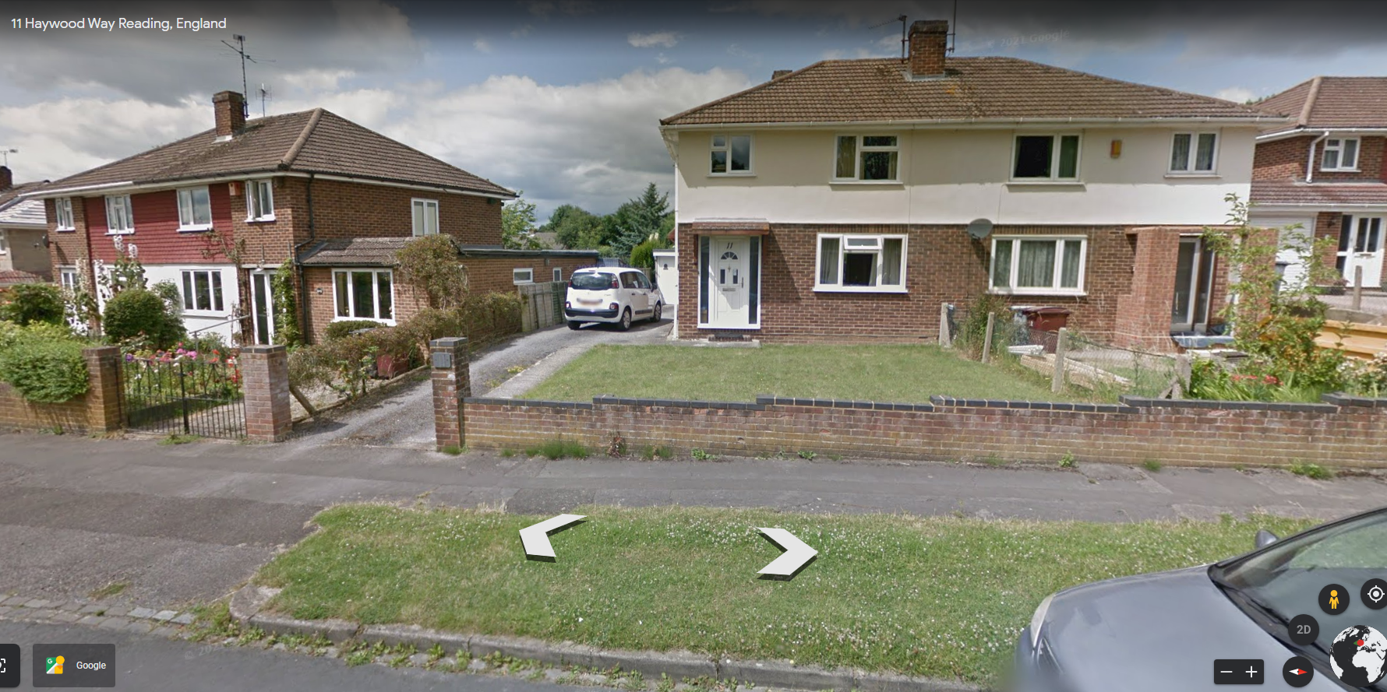

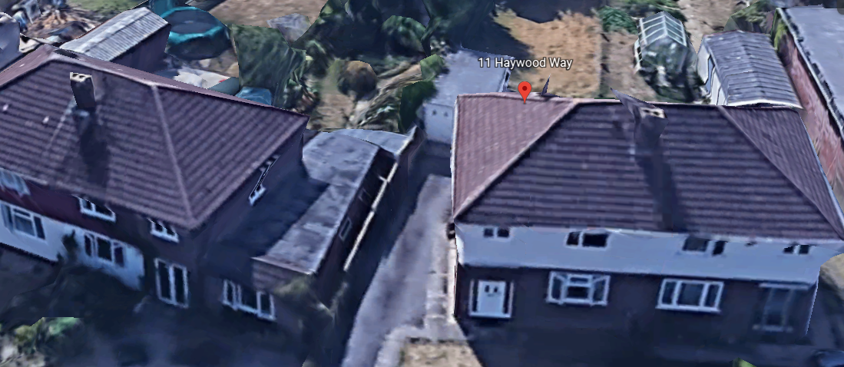

2. PROPOSAL AND SUPPORTING INFORMATION

The proposal is for a two storey side and rear extensions. The side extension would be approximately 2.25m wide set back and set down narrowing to approx. 1.08m wide, with a rear projection at ground floor of 3.2m deep with a staggered first floor extension, i.e. shallower closer to no.

Plans considered
Received 20th December 2021
Location Plan
Drawing No: 211001-2: Block Plan
Drawing No: 211001-6: Existing Floor Plans
Drawing No: 211001-7: Existing Elevations

Received 22nd March 2022
Drawing No: 211001-3: Site Plan/Roof Plan
Drawing No: 211001-4 : Proposed Floor Plans
Drawing No: 211001-5: Proposed Elevations
Drawing No : 21101-2A: Block Plan received 15th June 2022

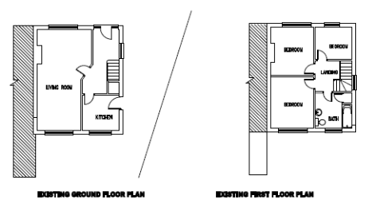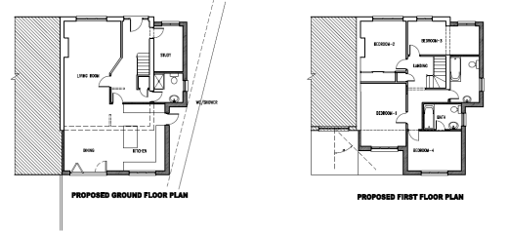

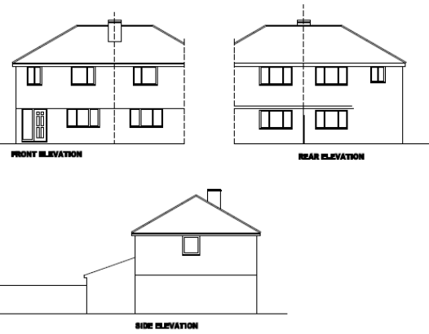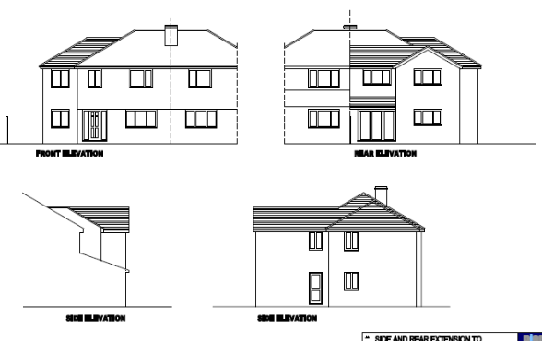

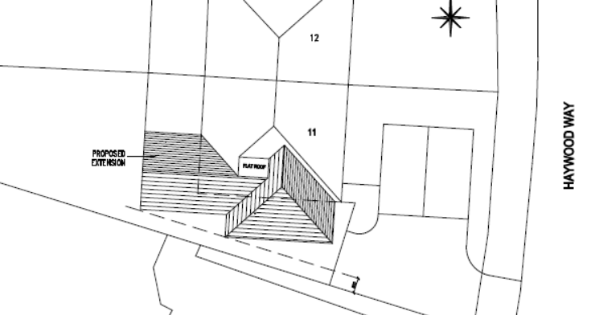

- RELEVANT PLANNING HISTORY

None

4. CONSULTATIONS

4.1 The following addresses were consulted by letter.

12 Haywood Way, Reading
25 Haywood Way, Reading, RG30 4QP
26 Haywood Way, Reading, RG30 4QP
24 Fontwell Drive, Reading, RG30 4QR
10 Haywood Way, Reading, RG30 4QP

4.2 Letter of representation have been received from the neighbour at 12 Haywood Way stating:

“Bedroom 1 extension - This extension is adjacent to my bedroom and extending this will cause shadows and block the daylight, as their house (No 11) is on the south side where the sunlight comes from”

“Bedroom 4 is not very clear if this is within the 45 degree angle and will not cause any further shadows or block sunlight to my property”.

Planning Officer notes that as shown “Drawing No: 211001-4: Proposed Floor Plans” the proposal is in line with the 45 degree stipulations..

Transport had no objections.

Equality Act 2010:
In determining this application the Council is required to have regard to its obligations under the Equality Act 2010. However, there is no indication or evidence (including from consultation on the application) that the protected groups identified by the Act have or will have different needs, experiences, issues and priorities in relation to this particular planning application. Therefore in terms of the key equalities protected characteristics it is considered there would be no significant adverse impacts as a result of the development.

- LEGAL AND PLANNING POLICY CONTEXT

Section 38(6) of the Planning and Compulsory Purchase Act 2004 requires that proposals be determined in accordance with the development plan unless material considerations indicate otherwise. Material considerations include relevant policies in the National Planning Policy framework (NPPF) - among them the 'presumption in favour of sustainable development'. The following local and national planning policy and guidance is relevant to this application:

National Policy
National Planning Policy Framework
National Planning Practice Guidance

Reading Borough Local Plan (2019)
CC7 (Design and the Public Realm)
CC8 (Safeguarding Amenity)
H9 (House Extensions and Ancillary Accommodation)

SPD
- Design Guide to House Extensions (2021)

6. APPRAISAL

H9 states: An extension to a house will be acceptable where it:

- Respects the character of the house in terms of scale, location, materials and design;

To assess this, the following has been considered – would the proposal:
- detract from the appearance of the original building through the use of ill-matching materials and by not fitting in with the design, scale and proportions of the original building; NO, the extension has been stepped back from the front line of the principal façade and the ridgeline stepped down from the line of the original building, in response to advice from the planning officer. The two storey aspect of the rear extension is stepped back, away from the boundary with the adjoining property.
- reduce the amount of usable amenity space for the property to an unacceptable degree; NO
- require the loss of trees in the garden or put significant trees at risk; NO

- Respects the character and pattern of neighbouring properties and the street as a whole in terms of scale, location, materials and design, and any important existing building line; Respects neighbour’s amenities and does not present a large blank façade to public areas.

To assess this, the following has been considered – would the proposal:
- significantly reduce the amount of daylight and sunlight enjoyed by neighbouring properties; NO, the element of the proposed second storey extension at first floor closest to no. 12 has been stepped back, such that the 45 degree line drawn from the closest neighbouring living space is not affected by shadows or loss of sunlight. It is the opinion of the Planning Officer, having conducted a site visit, that this proposal will not have any significant additional impact on the obscured windows on the side of no. 11 existing side extension
- invade the privacy of neighbouring properties through overlooking from windows or balconies; NO – the proposed side facing windows would serve bathrooms and would be obscure glazed secured through condition.
- detract from the character of neighbouring properties through siting, excessive bulk, ill-matching materials or inconsistent design; NO
- detract from the appearance of the street or area by using ill-matched materials, glazing and detailing; NO

CC8: Safeguarding Amenity states an extension to a house will be acceptable where it will not cause a significant detrimental impact to the living environment of existing or new residential properties.

To assess this, the following has been considered – would the proposal cause a significant detrimental impact to the living environment of existing or new residential properties in terms of:

- Privacy and overlooking; See above comments
- Access to sunlight and daylight; See above comments
- Visual dominance and overbearing effects of a development; No
- Noise and disturbance; N/A
- Artificial lighting; N/A
- Vibration; N/A
- Dust and fumes; N/A
- Smell; N/A
- Crime and safety. N/A

- CONCLUSION
The proposed development has been assessed and the proposed works are considered to be in accordance with the above relevant policies and planning permission can be granted.

8. RECOMMENDATION
Grant

