DELEGATED HOUSEHOLDER APPLICATION REPORT

Ward: Thames
App Ref: 220388/HOU
Address: 3 Grove Hill, Emmer Green, Reading, RG4 8PN
Proposals: Proposed extension of existing front porch.
Case Officer: Chukwudi Onwudinanti
Applicant: Mr Billy Chan
Date received (valid from): 21 March 2022
Target Decision date: 29th June 2022 (Ext)

1. INTRODUCTION
The site is a semi–detached two storey dwelling unit on the western side of Grove Hill between the junction of Hemdean Road and the road leading to Eliot Close. It is among buildings of similar style as well as varied styles and sizes.
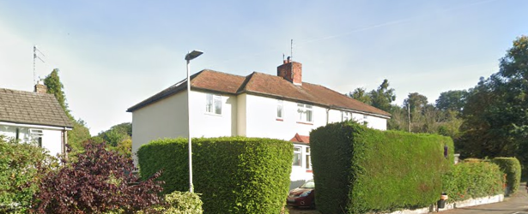

2. PROPOSAL AND SUPPORTING INFORMATION

The proposal is for the extension of existing front in depth and width. All materials are to match existing.

Plans considered (Received 21st March 2022)
CHAN-0322-01-Proposed Ground Floor Plan
CHAN-0322-02-Proposed Elevations
CHAN-0322-03-Existing Plan and Elevations
CHAN-0322-04-Section A-A
CHAN-0322-05-Location Plan
CHAN-0322-06-Block Plan

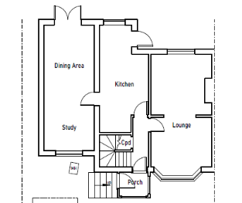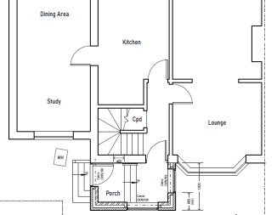

Existing Plan Proposed Plan

- RELEVANT PLANNING HISTORY
None

4. CONSULTATIONS

4.1 The following addresses were consulted by letter.

flat 1, 5 Grove Hill Close, Grove Hill, Emmer Green, Reading, RG4 8EJ
flat 2, 5 Grove Hill Close, Grove Hill, Emmer Green, Reading, RG4 8EJ
flat 3, 5 Grove Hill Close, Grove Hill, Emmer Green, Reading, RG4 8EJ
1 Grove Hill, Caversham, Reading

4.2 No letters of representation have been received.

Equality Act 2010:
In determining this application the Council is required to have regard to its obligations under the Equality Act 2010. However, there is no indication or evidence (including from consultation on the application) that the protected groups identified by the Act have or will have different needs, experiences, issues and priorities in relation to this particular planning application. Therefore in terms of the key equalities protected characteristics it is considered there would be no significant adverse impacts as a result of the development.

- LEGAL AND PLANNING POLICY CONTEXT

Section 38(6) of the Planning and Compulsory Purchase Act 2004 requires that proposals be determined in accordance with the development plan unless material considerations indicate otherwise. Material considerations include relevant policies in the National Planning Policy framework (NPPF) - among them the 'presumption in favour of sustainable development'. The following local and national planning policy and guidance is relevant to this application:

National Policy
National Planning Policy Framework
National Planning Practice Guidance

Reading Borough Local Plan (2019)
CC7 (Design and the Public Realm)
CC8 (Safeguarding Amenity)
H9 (House Extensions and Ancillary Accommodation)

SPD
- Design Guide to House Extensions (2021)

6. APPRAISAL

H9 states: An extension to a house will be acceptable where it:

- Respects the character of the house in terms of scale, location, materials and design;

To assess this, the following has been considered – would the proposal:
- detract from the appearance of the original building through the use of ill-matching materials and by not fitting in with the design, scale and proportions of the original building; NO, the added width and depth to the porch does not significantly impact on the scale of the porch in proportion to the original building.
- reduce the amount of usable amenity space for the property to an unacceptable degree; NO
- require the loss of trees in the garden or put significant trees at risk; NO

- Respects the character and pattern of neighbouring properties and the street as a whole in terms of scale, location, materials and design, and any important existing building line; Respects neighbour’s amenities and does not present a large blank façade to public areas.

To assess this, the following has been considered – would the proposal:
- significantly reduce the amount of daylight and sunlight enjoyed by neighbouring properties; NO
- invade the privacy of neighbouring properties through overlooking from windows or balconies; NO
- detract from the character of neighbouring properties through siting, excessive bulk, ill-matching materials or inconsistent design; NO, while the depth and width of the porch will be increased, it will be relatively limited in scale and will not have a significant impact on the character of the street scene.
- detract from the appearance of the street or area by using ill-matched materials, glazing and detailing; NO, the extended porch will be constructed in matching materials of the original porch.

CC8: Safeguarding Amenity states an extension to a house will be acceptable where it will not cause a significant detrimental impact to the living environment of existing or new residential properties. NO - there will be no impact on the amenity of existing residential properties.

- CONCLUSION
The proposed development has been assessed and the proposed works are considered to be in accordance with the above relevant policies and planning permission can be granted.

8. RECOMMENDATION
Grant

