DELEGATED HOUSEHOLDER APPLICATION REPORT

Ward: Kentwood
App Ref: 220008/HOU
Address: 4 Armour Road, Tilehurst, Reading, RG31 6HT
Proposals: Proposed single storey rear extension.
Case Officer: Chukwudi Onwudinanti
Applicant: Mr A Gaynor
Date received (valid from): 5 January 2022
Target Decision date: 18 March 2022

1. INTRODUCTION
The site is a semi-detached dwelling on the northern side of Armour road, close to the intersection with Polsted Road. The area is predominantly residential, with a mix of buildings of varied styles and sizes.

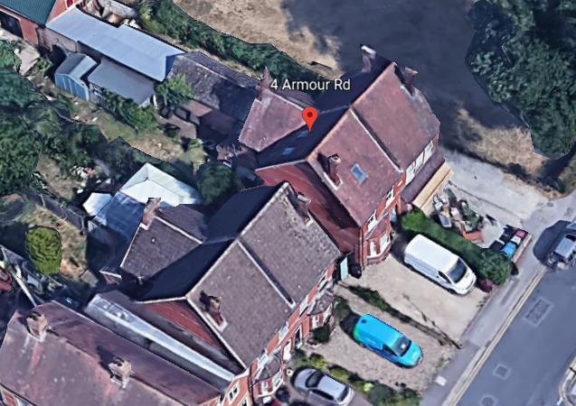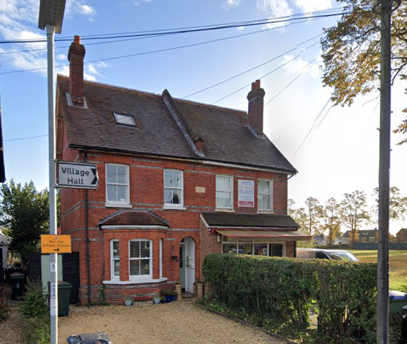

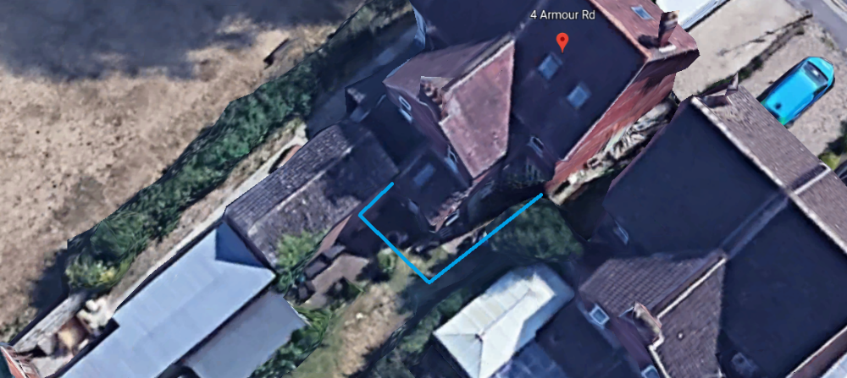

2. PROPOSAL AND SUPPORTING INFORMATION

The proposed single storey rear extension measures 2.3m wide and 6.2m deep, with a height of 2.2m to the eaves, completing an infill to an existing projection on the original dwelling.

Plans considered (Received 6th January 2022)
01 : Existing Ground Floor and Roof plan
01 : Proposed Ground Floor and Roof plan
02 : Existing Elevations
02: Proposed Elevations
03 : Existing Block Plans
03 : Proposed Block Plans

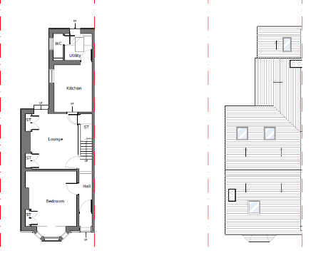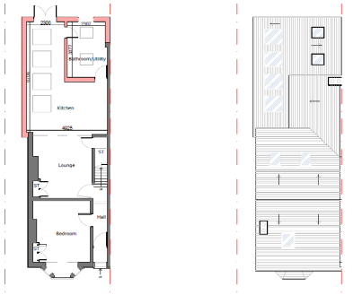

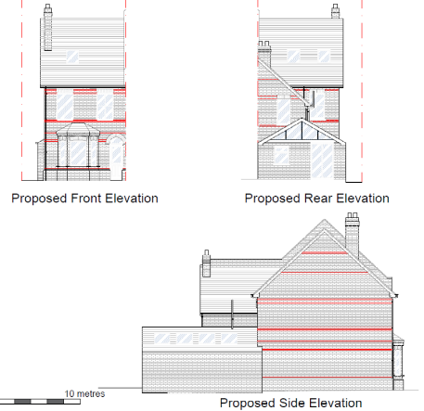

- RELEVANT PLANNING HISTORY

None

4. CONSULTATIONS

4.1 The following addresses were consulted by letter.

2A Armour Road, Reading, RG31 6HT
2 Polsted Road, Tilehurst, Reading
2b Armour Road, Tilehurst, Reading, RG31 6HT
6 Armour Road, Tilehurst, Reading, RG31 6HS
2 Armour Road, Tilehurst, Reading, RG31 6HT

4.2 No letters of representation have been received.

Equality Act 2010:
In determining this application the Council is required to have regard to its obligations under the Equality Act 2010. However, there is no indication or evidence (including from consultation on the application) that the protected groups identified by the Act have or will have different needs, experiences, issues and priorities in relation to this particular planning application. Therefore in terms of the key equalities protected characteristics it is considered there would be no significant adverse impacts as a result of the development.

- LEGAL AND PLANNING POLICY CONTEXT

Section 38(6) of the Planning and Compulsory Purchase Act 2004 requires that proposals be determined in accordance with the development plan unless material considerations indicate otherwise. Material considerations include relevant policies in the National Planning Policy framework (NPPF) - among them the 'presumption in favour of sustainable development'. The following local and national planning policy and guidance is relevant to this application:

National Policy
National Planning Policy Framework
National Planning Practice Guidance

Reading Borough Local Plan (2019)
CC7 (Design and the Public Realm)
CC8 (Safeguarding Amenity)
H9 (House Extensions and Ancillary Accommodation)

SPG/SPD
- A Design Guide to House Extensions SPG

6. APPRAISAL

H9 states: An extension to a house will be acceptable where it:

- Respects the character of the house in terms of scale, location, materials and design;

To assess this, the following has been considered – would the proposal:
- detract from the appearance of the original building through the use of ill-matching materials and by not fitting in with the design, scale and proportions of the original building; NO, the extension fits in the existing envelope of the original dwelling.
- reduce the amount of usable amenity space for the property to an unacceptable degree; NO, the impact on the usable amenity space is not significant.
- require the loss of trees in the garden or put significant trees at risk; NO

- Respects the character and pattern of neighbouring properties and the street as a whole in terms of scale, location, materials and design, and any important existing building line; Respects neighbour’s amenities and does not present a large blank façade to public areas.

To assess this, the following has been considered – would the proposal:
- significantly reduce the amount of daylight and sunlight enjoyed by neighbouring properties; NO, the height of the extension is proposed to be 2.26m and there is a ca 0.93m separation to the boundary. There will not be a significant reduction in the impact on daylight and sunlight to the adjacent property at no. 6 Armour Road.
- invade the privacy of neighbouring properties through overlooking from windows or balconies; NO
- detract from the character of neighbouring properties through siting, excessive bulk, ill-matching materials or inconsistent design; NO
- detract from the appearance of the street or area by using ill-matched materials, glazing and detailing; NO

CC8: Safeguarding Amenity states an extension to a house will be acceptable where it will not cause a significant detrimental impact to the living environment of existing or new residential properties.

To assess this, the following has been considered – would the proposal cause a significant detrimental impact to the living environment of existing or new residential properties in terms of:

- Privacy and overlooking;
- Access to sunlight and daylight;
- Visual dominance and overbearing effects of a development;
- Noise and disturbance;
- Artificial lighting;
- Vibration;
- Dust and fumes;
- Smell;
- Crime and safety.

- CONCLUSION
The proposed development has been assessed and the proposed works are considered to be in accordance with the above relevant policies and planning permission can be granted.

8. RECOMMENDATION
Grant

