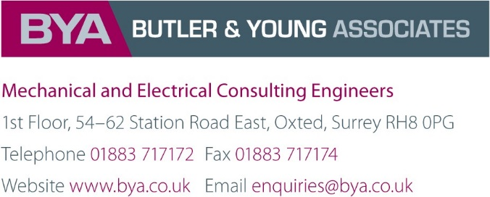

External Lighting Calculations. Date 07-10-2022

University of Reading New Art Building. External Lighting Report.
The building will be provided with IP66 rated wall mounted LED type luminaires with a colour temp of 2700K and the image below shows the proposed luminaire.
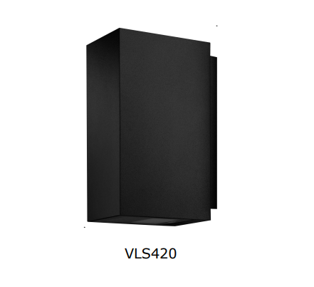
The luminaires will be wall mounted around the perimeter of the building @ 2m above finished ground level to underside of the luminaire.
In areas where emergency exit doors are located, the luminaires shall be emergency version type and will be mounted above the doorway.
The lighting layout, prepared by BYA (Ref: W310-1956132-BYA-ZZ-GF-DR-E-7080-82000 Rev 7), shows the positions where the proposed luminaires around the building will be installed.
The luminaire type M/ME indicated on drawing will utilise the Up and Down lights and will be used in the West/East and North façades as these are the main visible facades.
The luminaire type M1/M1E indicated on drawing will utilise down lights only will be used in the Southern side of the building in order to limit the light level to the ecological zone areas
The lighting controls are compatible with the DALI protocol installed throughout the building and the general lux levels shall be commissioned between 3 to lux 5 lux in accordance with CIBSE the CCTV recommendations ecology requirements. The lighting can be increased or dimmed to the desired lux level at commissioning stage using a lux meter.
Lux levels will be set as low as possible on the woodland line. The attached calculations indicate the lux levels at 0 lux.
The specified colour temperature of the luminaires will be in line with the CCTV requirements and will also accommodate wildlife within the vicinity.
For External lighting calculations, please refer to the Art School Drawing Rev 5 and 5A dated -07.10.22 below.
The lighting shall be controlled via strategically located movement and daylight sensors.
The unit shall be commissioned so the lighting remains off during day light hours and operational between dusk and dawn.

Rev 5
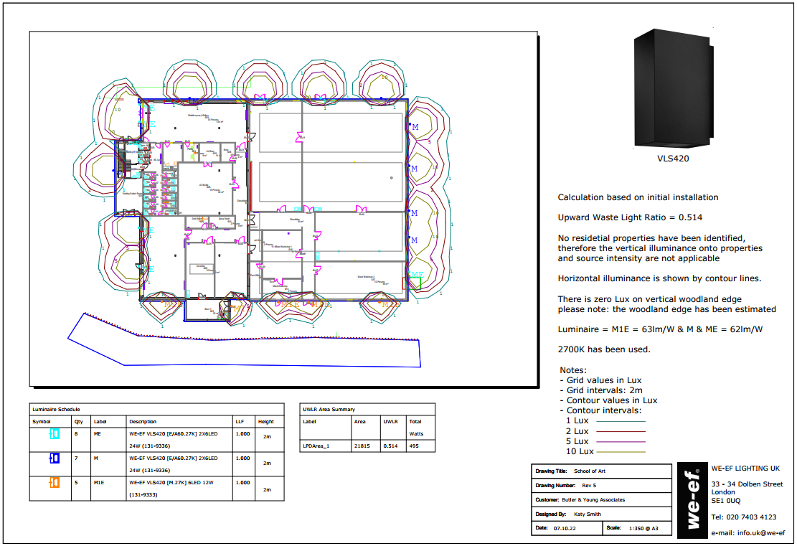

Rev 5A
