DELEGATED HOUSEHOLDER APPLICATION REPORT

Ward: Tilehurst
App Ref: 220260/HOU
Address: 64 Mayfair, Reading, RG30 4RD
Proposals: Removal of grass verge from path to road and lay tarmac access including drop kerb
Case Officer: Chukwudi Onwudinanti
Applicant: Mrs Lydia Hicks
Date received (valid from): 22 February 2022
Target Decision date: 27th June 2022 (Ext)

1. INTRODUCTION
The proposed site is on the eastern side of Mayfair Road, a classified C road, and two green verges separate the road from the pedestrian walkways, one closer to the road, the second closer to the dwelling unit that is No 64. There are a number of similar dropped kerb arrangements adjacent to the site.

2. PROPOSAL AND SUPPORTING INFORMATION

The application proposes to remove the grass verge separating the paths from the road and to lay tarmac access into No 64, including provision of a drop kerb.

Plans considered
01A Site & Location Plan received 18th May 2022
01C Tree Protection Plan received 4th July 2022

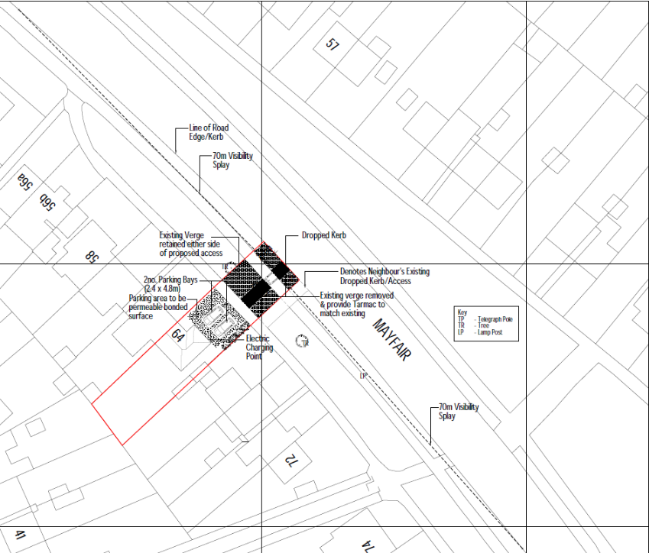
Site Location Plan

- RELEVANT PLANNING HISTORY

None

4. CONSULTATIONS

4.1 The following addresses were consulted by letter.

66 Mayfair, Tilehurst, Reading, RG30 4RD
62 Mayfair, Tilehurst, Reading, RG30 4RD

Internal consultees:
Natural Environment
Transport

4.2 No letters of representation have been received from the neighbours consulted.

Transport and Natural Environment advised that revised plans should be submitted to allay concerns raised about protection of the trees during development and to ensure that all the verges removed are replaced by tarmac.

Plans were submitted and confirmed as satisfactory by Transport and Natural Environment, subject to certain conditions being attached.
These conditions have been attached to the decision.

Equality Act 2010:
In determining this application the Council is required to have regard to its obligations under the Equality Act 2010. However, there is no indication or evidence (including from consultation on the application) that the protected groups identified by the Act have or will have different needs, experiences, issues and priorities in relation to this particular planning application. Therefore in terms of the key equalities protected characteristics it is considered there would be no significant adverse impacts as a result of the development.

- LEGAL AND PLANNING POLICY CONTEXT

Section 38(6) of the Planning and Compulsory Purchase Act 2004 requires that proposals be determined in accordance with the development plan unless material considerations indicate otherwise. Material considerations include relevant policies in the National Planning Policy framework (NPPF) - among them the 'presumption in favour of sustainable development'. The following local and national planning policy and guidance is relevant to this application:

National Policy
National Planning Policy Framework
National Planning Practice Guidance

Reading Borough Local Plan (2019)
EN14: Trees, hedges and woodlands
TR3: Access, traffic and highway-related matters

SPD
- Design Guide to House Extensions (2021)

6. APPRAISAL

Policy EN14 requires: “Individual trees, groups of trees, hedges and woodlands will be protected from damage or removal where they are of importance
Policy TR3 states that “In determining proposals involving a new or altered access onto the transport network, improvement works to the transport network, the creation of new transport infrastructure or the generation of additional trips on the transport network, consideration will be given to the effect on safety, congestion and the environment.

Development will only be permitted where:-
i) Accesses and works to the highway comply with the adopted standards of the
Transport Authority;

ii) The development would not have a material detrimental impact on the functioning of the transport network;
iii) The proposals would not be detrimental to the safety of users of the transport network, including pedestrians and cyclists;
iv) The proposal would not generate regular movement of heavy goods vehicles (HGVs) on unsuitable roads, or on roads without easy access to the Classified Highway
Network; and
v) For non-residential uses, or new dwellings on classified roads, off-street servicing would be provided.
Proposals involving either the construction of a new site access, or a material increase in the use of an existing site access, directly onto the Classified Highway Network will not be acceptable if they would be likely to result in the encouragement of the use of the network for short local trips or compromise the safe movement and free flow of traffic on the network or the safe use of the road.”

The road includes a number of similar arrangements of dropped kerbs and therefore, subject to addressing the requirements in terms of protecting the existing tree and highway safety requirements, the proposal is deemed acceptable in principle. Relevant conditions are included.

- CONCLUSION
The proposed development has been assessed and the proposed works are considered to be in accordance with the above relevant policies and planning permission can be granted.

8.0 RECOMMENDATION
Grant

