DELEGATED HOUSEHOLDER APPLICATION REPORT

Ward: Whitley
App Ref: 220063/HOU
Address: 6 Kingsbridge Road, Reading, RG2 7RE
Proposals: Erection of Two srorey side and Single storey rear extension with a porch to the front
Case Officer: Chukwudi Onwudinanti
Applicant: Mr Job Dasayyan
Date received (valid from): 17 January 2022
Target Decision date: 14 March 2022

1. INTRODUCTION
The site is a semi-detached dwelling on the Southern side of Knightsbridge Road, among buildings of similar style and sizes. It is on the intersection with the road leading into Chudleigh gardens.

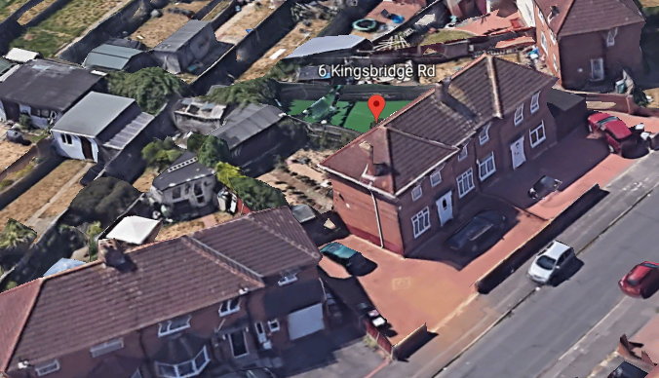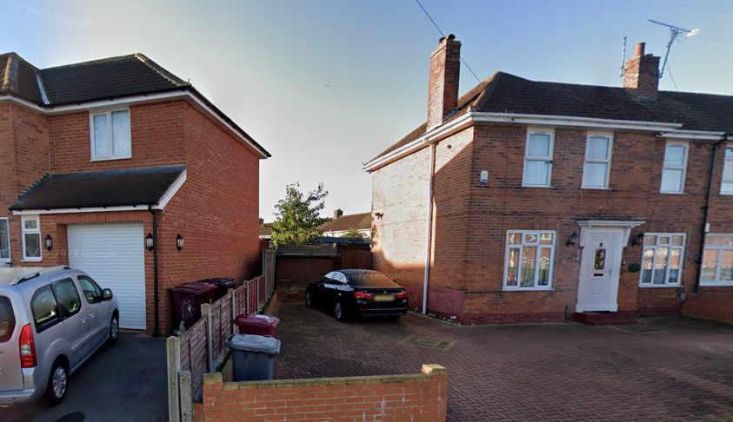

2. PROPOSAL AND SUPPORTING INFORMATION

The proposal is the erection of two storey side extension, measuring 3.2m wide and 5.2m high, with a single storey rear extension aspect measuring 3.5m deep and a porch to the front. The first floor extension is limited to the side extension aspect of the proposal.

Plans considered (Received 17th January 2022)
Drawing NO 110: Existing Floor Plans and Elevations
Drawing NO 120: Proposed Floor Plans and Elevations

Amended Plans (Received 28th March 2022)
Drawing NO 120 Rev B: Proposed Floor Plans and Elevations
Drawing NO 101: Block Plan Rev C (Received 15th May 2022)

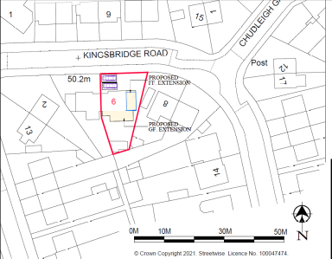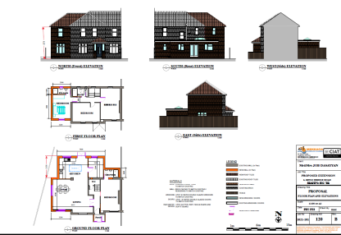
Block Plan Proposed Floor Plans

- RELEVANT PLANNING HISTORY

None

4. CONSULTATIONS

4.1 The following addresses were consulted by letter.

17 Brixham Road, Reading, Berkshire, RG2 7RA
8 Kingsbridge Road, Reading, Berkshire, RG2 7RE
4 Kingsbridge Road, Reading, RG2 7RE
10 Kingsbridge Road, Reading, RG2 7RE

Transport – parking would be required for a minimum of 2 vehicles following the loss of the parking area to the side.

Planning Officer Note: The amended block plan shows 2 spaces to the front.

4.2 No letters of representation have been received from neighbours consulted.

Equality Act 2010:
In determining this application the Council is required to have regard to its obligations under the Equality Act 2010. However, there is no indication or evidence (including from consultation on the application) that the protected groups identified by the Act have or will have different needs, experiences, issues and priorities in relation to this particular planning application. Therefore in terms of the key equalities protected characteristics it is considered there would be no significant adverse impacts as a result of the development.

- LEGAL AND PLANNING POLICY CONTEXT

Section 38(6) of the Planning and Compulsory Purchase Act 2004 requires that proposals be determined in accordance with the development plan unless material considerations indicate otherwise. Material considerations include relevant policies in the National Planning Policy framework (NPPF) - among them the 'presumption in favour of sustainable development'. The following local and national planning policy and guidance is relevant to this application:

National Policy
National Planning Policy Framework
National Planning Practice Guidance

Reading Borough Local Plan (2019)
CC7 (Design and the Public Realm)
CC8 (Safeguarding Amenity)
H9 (House Extensions and Ancillary Accommodation)

SPD
- Design Guide to House Extensions (2021)

6. APPRAISAL

H9 states: An extension to a house will be acceptable where it:

- Respects the character of the house in terms of scale, location, materials and design;

To assess this, the following has been considered – would the proposal:
- detract from the appearance of the original building through the use of ill-matching materials and by not fitting in with the design, scale and proportions of the original building; NO, the original proposal submitted has been amended by the agent, on the advice of the officer, to step back the side extension from the line of the principal elevation and stepping down the ridgeline from the top ridgeline of the original roof.
- reduce the amount of usable amenity space for the property to an unacceptable degree; NO
- require the loss of trees in the garden or put significant trees at risk; NO

- Respects the character and pattern of neighbouring properties and the street as a whole in terms of scale, location, materials and design, and any important existing building line; Respects neighbour’s amenities and does not present a large blank façade to public areas.

To assess this, the following has been considered – would the proposal:
- significantly reduce the amount of daylight and sunlight enjoyed by neighbouring properties; NO
- invade the privacy of neighbouring properties through overlooking from windows or balconies; NO
- detract from the character of neighbouring properties through siting, excessive bulk, ill-matching materials or inconsistent design; NO
- detract from the appearance of the street or area by using ill-matched materials, glazing and detailing; NO

CC8: Safeguarding Amenity states an extension to a house will be acceptable where it will not cause a significant detrimental impact to the living environment of existing or new residential properties.

To assess this, the following has been considered – would the proposal cause a significant detrimental impact to the living environment of existing or new residential properties in terms of:

- Privacy and overlooking;
- Access to sunlight and daylight;
- Visual dominance and overbearing effects of a development;
- Noise and disturbance;
- Artificial lighting;
- Vibration;
- Dust and fumes;
- Smell;
- Crime and safety.

NO

- CONCLUSION
The proposed development has been assessed and the proposed works are considered to be in accordance with the above relevant policies and planning permission can be granted.

8. RECOMMENDATION
Grant

