

DELEGATED HOUSEHOLDER APPLICATION REPORT

Ward: Whitley
App Ref: 221047/HOU
Address: 165 Whitley Wood Road, Reading, RG2 8LB
Proposals: Single storey side extension
Case Officer: Chukwudi Onwudinanti
Applicant: Mr Harvir Singh
Date received (valid from): 17 July 2022
Target Decision date: 7 November 2022 (EXT)

1. SITE DESCRIPTION
The site is a semi-detached Victorian dwelling on the southern side of Whitley Wood Road, among dwellings of similar as well as varied styles in a predominantly residential area. It is close to the intersection with Woodside Way. The property is adjacent to a private driveway to a bank of garages which are sited to the rear of nos 157-163 Whitley Wood Road. There is an existing single storey side extension roughly the full depth of the house and a single storey flat roofed rear extension the full width of the original house.

No 163, on the other side of the drive, has a number of side facing windows at ground and first floor levels.

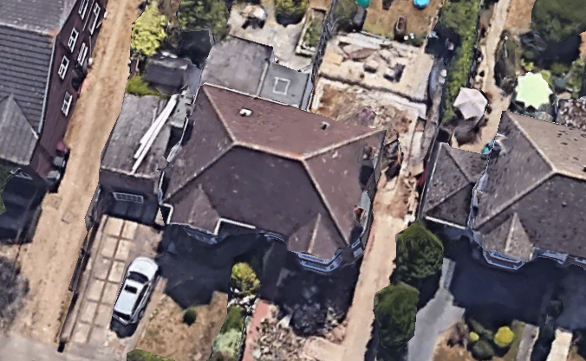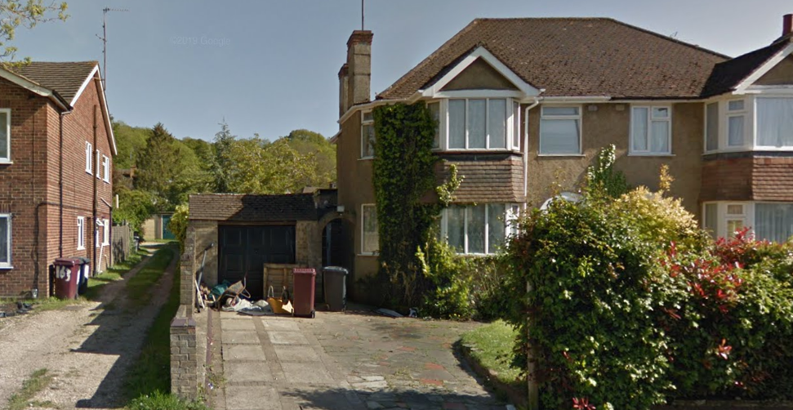

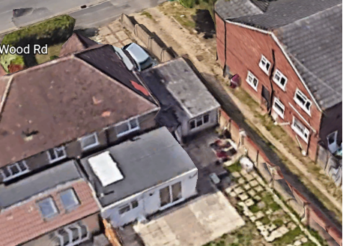

2. PROPOSAL AND SUPPORTING INFORMATION
The proposal is for a single storey side extension measuring approximately 5.8m deep and 3.5m wide replacing an existing side extension. It would have a mono-pitched roof to the front with flat roof to the remainder and it would extend slightly beyond the rear wall of the existing single storey extension. The height would be the same as the existing rear extension. It would be set off the side boundary by 0.85m.

Plans considered received 18th July 2022
Location Plan
2221-ex-01: Existing Elevations
2221-pl-01: Proposed Plans and Elevations
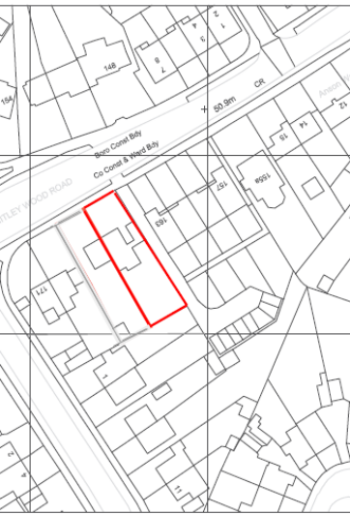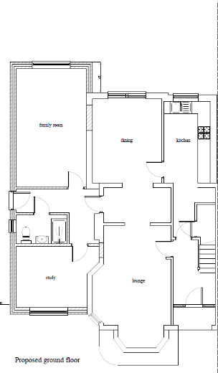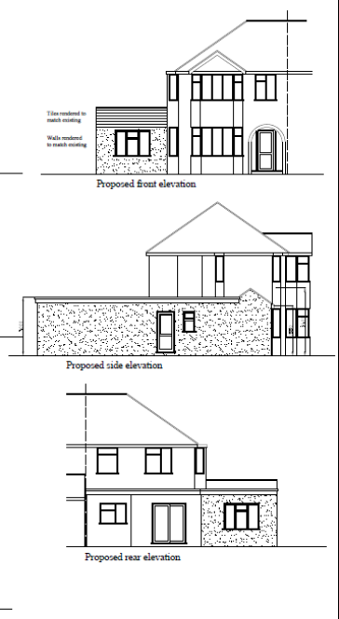

Location Plan Proposed Plan Proposed Elevations

- RELEVANT PLANNING HISTORY
None

4. CONSULTATIONS
The following addresses were consulted by letter.

1 Woodside Way, Reading, RG2 8SY
163 Whitley Wood Road, Reading, RG2 8LB
163a Whitley Wood Road, Reading, RG2 8LB
167 Whitley Wood Road, Reading, RG2 8LB

No letters of representation have been received as follows:

Equality Act 2010:
In determining this application the Council is required to have regard to its obligations under the Equality Act 2010. However, there is no indication or evidence (including from consultation on the application) that the protected groups identified by the Act have or will have different needs, experiences, issues and priorities in relation to this particular planning application. Therefore in terms of the key equalities protected characteristics it is considered there would be no significant adverse impacts as a result of the development.

- LEGAL AND PLANNING POLICY CONTEXT

Section 38(6) of the Planning and Compulsory Purchase Act 2004 requires that proposals be determined in accordance with the development plan unless material considerations indicate otherwise. Material considerations include relevant policies in the National Planning Policy framework (NPPF) - among them the 'presumption in favour of sustainable development'. The following local and national planning policy and guidance is relevant to this application:

National Policy
National Planning Policy Framework
National Planning Practice Guidance

Reading Borough Local Plan (2019)
CC7 (Design and the Public Realm)
CC8 (Safeguarding Amenity)
H9 (House Extensions and Ancillary Accommodation)

SPD
Design Guide to House Extensions (2021)

6. APPRAISAL
Character and Appearance
Policy H9 states that an extension to a house will be acceptable where it respects the character of the house in terms of scale, location, materials and design and respects the character and pattern of neighbouring properties and the street as a whole in terms of scale, location, materials and design, and any important existing building line. Policy CC7 also sets out relevant considerations for design.

All aspects of this application are at a single storey level, restricted to the side that is facing a private drive way and to the rear of the property. All materials to be used externally are also to match the existing materials.

It is therefore considered that no aspect of this proposal will impact negatively on the existing dwelling or the neighbours in terms of scale, location, materials and design.

Residential Amenity
Policy H9 states that an extension will be acceptable where it does not result in an overbearing impact on neighbours. Policy H10 seeks to ensure that the amenity of gardens and other outdoor areas are not compromised. Policy CC8 states an extension to a house will be acceptable where it will not cause a significant detrimental impact to the living environment of existing or new residential properties.

- Privacy and overlooking: The extension presented by this proposal will be on the side adjoining a private drive way which is at least 3m in width, separating the potential extension from the next property. Therefore a combination of this factor and the limited height of the extension to a single storey ensures that there is no perceived impact on the privacy of the adjoining property.
- Overbearing effects: As stated above, the extension is on a scale and position that presents no overbearing effect on any property in close proximity.
- Sunlight and daylight; There is no issue of this occurring as there is ample separation from the next property at No 163.
- Amenity Space: there would be sufficient amenity space remaining

- CONCLUSION
The proposed development has been assessed as set out above and is considered to be acceptable on that basis, subject to the following conditions.

8. RECOMMENDATION: Grant
Recommended Conditions:
AP1 : Approved Plans
M1: Materials to Match Existing
TL1: Time Limit Standards

