DELEGATED HOUSEHOLDER APPLICATION REPORT

Ward: Minster
App Ref: 220026/HOU
Address: 16 Ashley Road, Reading, RG1 6HT
Proposals: Proposed single storey rear and front extension and loft conversion
Case Officer: Chukwudi Onwudinanti
Applicant: Maciej Nicewicz
Date received (valid from): 8 January 2022
Target Decision date: 2 April 2022 Extension agreed to 17/6/2022

1. INTRODUCTION
The proposal site is a detached bungalow, on the end of Ashley Road, off Kimberley Close. It is among varied sizes of bungalows and two storey buildings in a predominantly residential neighbourhood.

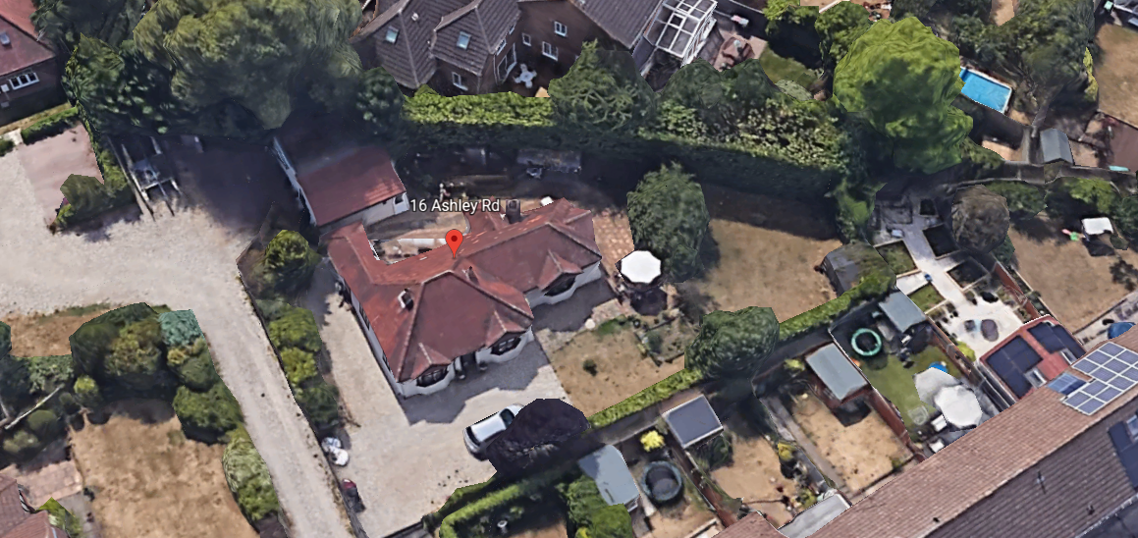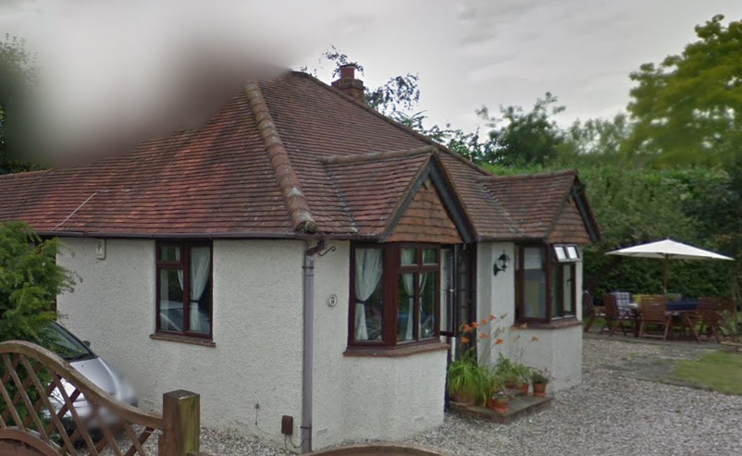

2. PROPOSAL AND SUPPORTING INFORMATION

The application proposes a single storey rear and front extension measuring 4.7m by 4.5m and 5m by 6m respectively and a loft conversion.

Plans considered (received 11th January 2022):
AR-01 – Location and Block Plan
AR-02 – Existing Floor Plans
AR-03 – Existing Elevations
AR-04 – Proposed Plans
AR-05 – Proposed Loft Conversion Plans
AR-06 – Proposed Elevations

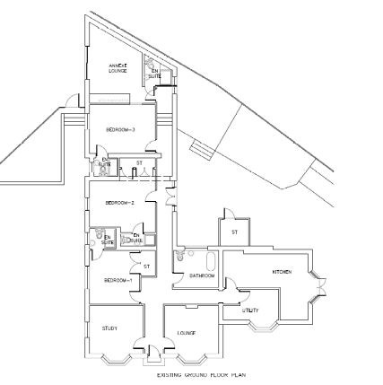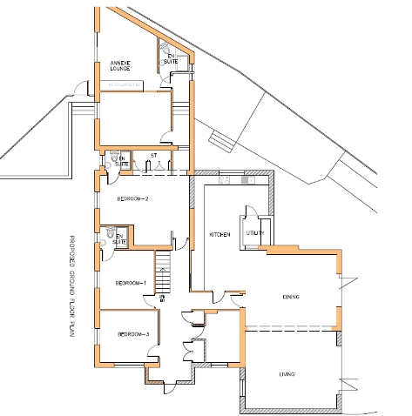
Existing Proposed
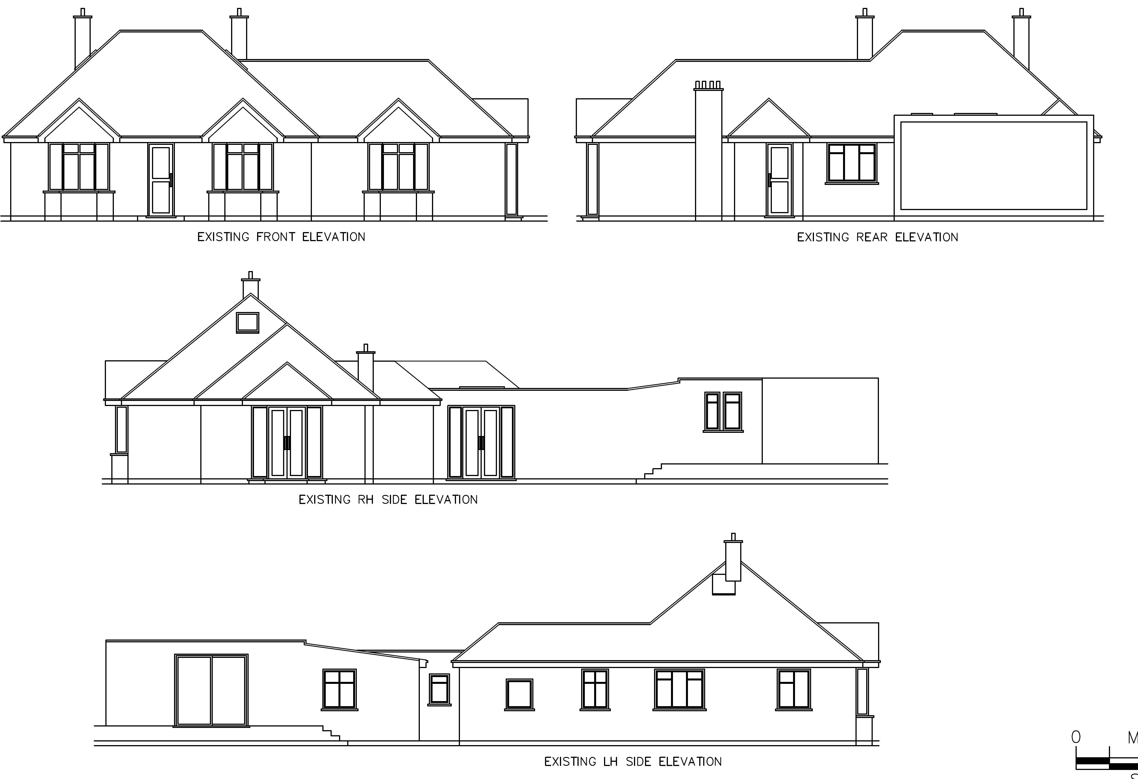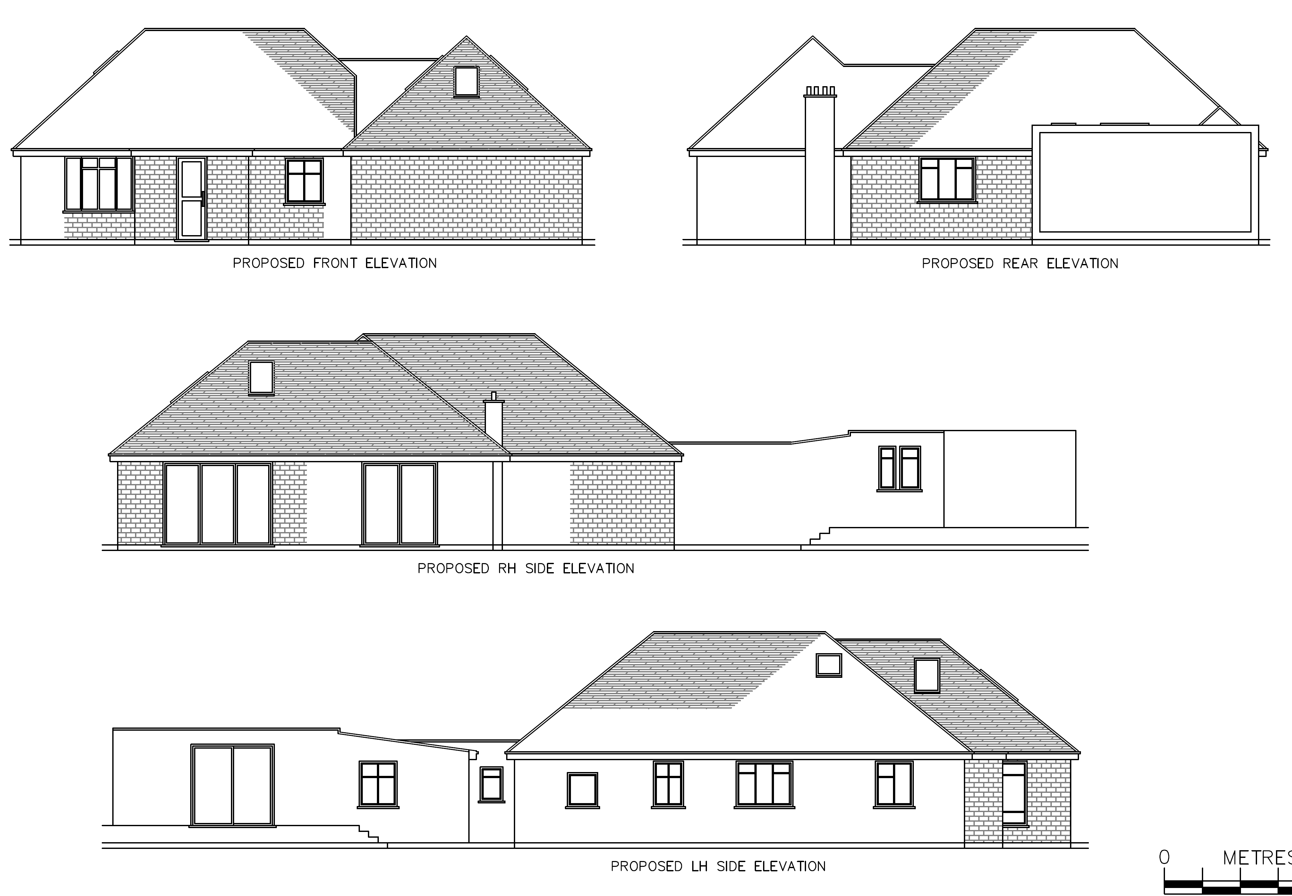
Existing Elevations Proposed Elevations

- RELEVANT PLANNING HISTORY

Application Number: 160204
Proposal: Change of use of the existing dwelling and outbuilding, including the
erection of front and rear extensions, to an 8 bedroom Sui Generis HMO
Decision: Application Withdrawn (The applicant chose to withdraw the application after being informed it would be recommended for refusal).
Date of Decision: 4/5/2016

Application Number: 161106
Proposal: Single Storey Front and Rear Extensions
Decision: Granted
Date of Decision: 23/8/2016

4. CONSULTATIONS

4.1 The following addresses were consulted by letter.

21 Ashley Road, Reading, Berkshire, RG1 6HT
16 Barrington Way, Reading, RG1 6EG
12 Kimberley Close, Reading, RG1 6LA
2 Kimberley Close, Reading, RG1 6LA
10 Kimberley Close, Reading, RG1 6LA
8 Kimberley Close, Reading, RG1 6LA
6 Kimberley Close, Reading, RG1 6LA
17 Ashley Road, Reading, RG1 6HT
20 Ashley Road, Reading, RG1 6HT
18 Ashley Road, Reading, RG1 6HT

4.2 Letters of representation have been received as follows:

Objection letters from 17 Ashley Road, 18 Ashley Road, 20 Ashley Road, 21 Ashley Road, 2 Kimberley Close, and 6 Kimberley Close.

The main objections from these representations were:

Concerns that the extension would be to create an HMO.

Planning Officer note: There is no evidence submitted or seen by the PO that suggests that this proposal is for an HMO. In any case, a conversion from C3 to C4 for 3-6 persons would be Permitted Development and in the case of a large Sui Generis HMO, a permission in its own right would be needed.

Discrepancies with plans
Planning Officer note: Site visit undertaken and all existing plans checked and clarified.

Impact on access from construction vehicles
Planning Officer note: The Planning Officer requested a construction and access statement, which has been submitted by the agent and deemed by Transport to satisfactorily allay any concerns.

Equality Act 2010:
In determining this application the Council is required to have regard to its obligations under the Equality Act 2010. However, there is no indication or evidence (including from consultation on the application) that the protected groups identified by the Act have or will have different needs, experiences, issues and priorities in relation to this particular planning application. Therefore in terms of the key equalities protected characteristics it is considered there would be no significant adverse impacts as a result of the development.

- LEGAL AND PLANNING POLICY CONTEXT

Section 38(6) of the Planning and Compulsory Purchase Act 2004 requires that proposals be determined in accordance with the development plan unless material considerations indicate otherwise. Material considerations include relevant policies in the National Planning Policy framework (NPPF) - among them the 'presumption in favour of sustainable development'. The following local and national planning policy and guidance is relevant to this application:

National Policy
National Planning Policy Framework
National Planning Practice Guidance

Reading Borough Local Plan (2019)
CC7 (Design and the Public Realm)
CC8 (Safeguarding Amenity)
H9 (House Extensions and Ancillary Accommodation)

SPG/SPD
- A Design Guide to House Extensions SPG

6. APPRAISAL

H9 states: An extension to a house will be acceptable where it:

- Respects the character of the house in terms of scale, location, materials and design;

To assess this, the following has been considered – would the proposal:
- detract from the appearance of the original building through the use of ill-matching materials and by not fitting in with the design, scale and proportions of the original building; NO
- reduce the amount of usable amenity space for the property to an unacceptable degree; NO, sufficient amenity space would be retained.
- require the loss of trees in the garden or put significant trees at risk; NO

- Respects the character and pattern of neighbouring properties and the street as a whole in terms of scale, location, materials and design, and any important existing building line; Respects neighbour’s amenities and does not present a large blank façade to public areas.

To assess this, the following has been considered – would the proposal:
- significantly reduce the amount of daylight and sunlight enjoyed by neighbouring properties; NO, all aspects of this extension are at a single storey level and no part of the extension is at the boundary with any adjoining properties.
- invade the privacy of neighbouring properties through overlooking from windows or balconies; NO, there are no close adjoining properties as this site is a bungalow on a large plot.
- detract from the character of neighbouring properties through siting, excessive bulk, ill-matching materials or inconsistent design; NO
- detract from the appearance of the street or area by using ill-matched materials, glazing and detailing; NO

CC8: Safeguarding Amenity states an extension to a house will be acceptable where it will not cause a significant detrimental impact to the living environment of existing or new residential properties.

To assess this, the following has been considered – would the proposal cause a significant detrimental impact to the living environment of existing or new residential properties in terms of:

- Privacy and overlooking;
- Access to sunlight and daylight;
- Visual dominance and overbearing effects of a development;
- Noise and disturbance;
- Artificial lighting;
- Vibration;
- Dust and fumes;
- Smell;
- Crime and safety.

- CONCLUSION
The proposed development has been assessed and the proposed works are considered to be in accordance with the above relevant policies and planning permission can be granted.

8. RECOMMENDATION
Grant

