DELEGATED ADVERT CONSENT APPLICATION REPORT
Ward: Redlands
App Ref: 211277/ADV
Address: Granby Tavern Ph, 120 London Road, Reading, RG1 5AY
Proposals: 2 No. internally illuminated fascia sign on rails, 2 No. internally illuminated on fascia, 2 No. internally hung sign, 1 No. Vinyl sign externally illuminated on the totem – Amended
Case Officer: James Schofield

Date received (valid from): 5 August 2021 Target Decision date: 30 September 2021 Extended to 7 Jan 2022

- SITE DECSRIPTION AND CONTEXT
The proposal site is a locally listed building on the southern side of London Road. It has been on the Council’s list of locally listed buildings since 20th November 2013.
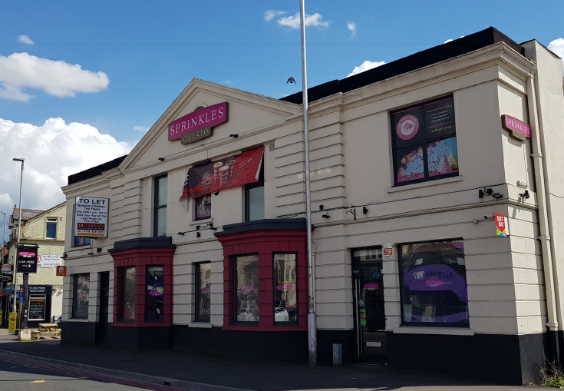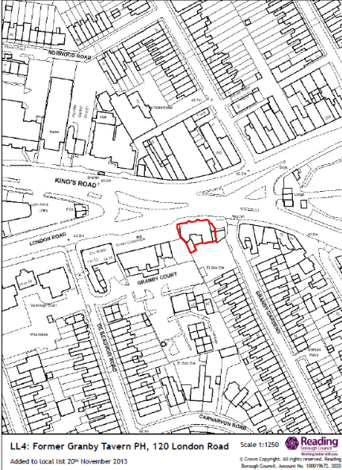
Existing appearance Location Plan
The development site appears to be a mid-twentieth century former pub in a neo-classical architectural style. The front elevation includes a significant amount of advertisements for a gelato shop.
- PROPOSALS
The application originally sought permission for 10 advertisements – all to be illuminated to 200 cd/m2.

Signs 1 & 2 are individual letters above the feature bays on the main frontage
Signs 3 & 4 are high level signs in the gabled pediment.
Sign 5 is an illuminated car park direction sign on west facing elevation
Sign 6 & 7 are similar signs to the high level ones but on east facing elevation
Signs 8 & 9 are internal illuminated signs in the bay windows
Sign 10 is a replica pub sign located on the forecourt area.

Plans considered;
Drawing No: 171.02/02.1 Site Location Plan
Drawing No: 171.02/A.1.6 Existing External Elevations
Drawing No: 171.02/A.1.7 Proposed External Elevations
Received on 5th of August 2021

Further to assessment by officer and discussion with agent it was agreed to delete signs 3, 4 & 5 and amended plan for 171.02/A1.7 was provided on 5th Jan 2022.
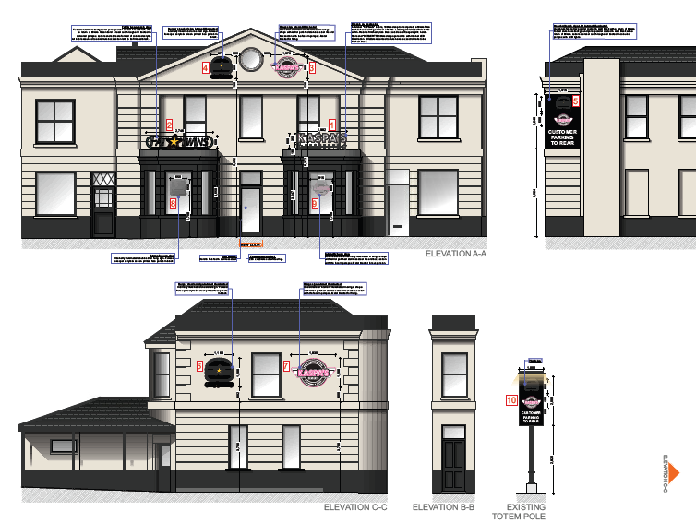 Original Plan
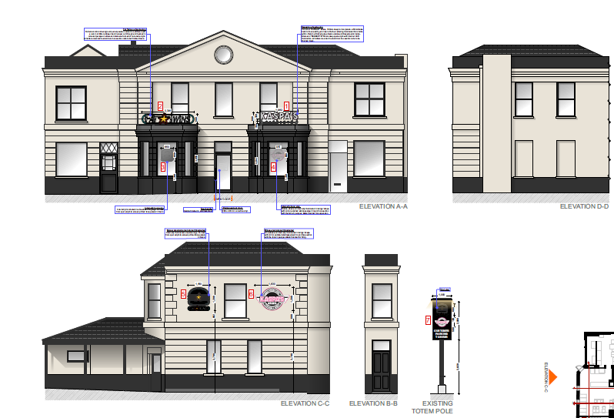 Amended Plan
- CONSULTEES
Neighbours
The planning officer erected the site notice on the 23rd of September 2021. No comments have been received.
Heritage
The Heritage Officer was consulted however, no response was received prior to the application being determined.
Transport
The Transport Officer was consulted who raised no objections provided any approval includes a condition to limit the level of lighting to 600/cd/m2. (Officer note – the applicant is proposing 200 cd/m2 so is acceptable).

- RELEVANT PLANNING HISTORY
211509/FUL - New entrance door (replacement of window). Granted 22.11.2021

Previous record of advert permission dates from 1996. No record of the existing signs being approved.

5. LEGAL AND PLANNING POLICY CONTEXT

In determining this application, the Council is required to have regard to its obligations under the Equality Act 2010. However, there is no indication or evidence (including from consultation on the application) that the protected groups identified by the Act have or will have different needs, experiences, issues and priorities in relation to this particular planning application. Therefore, in terms of the key equalities protected characteristics it is considered there would be no significant adverse impacts as a result of the development.

Section 38(6) of the Planning and Compulsory Purchase Act 2004 requires that proposals be determined in accordance with the development plan unless material considerations indicate otherwise. The Development Plan for Reading relevant to the application site comprises the Reading Borough Local Plan (2019).

Accordingly, the ‘NPPF’ and the following development plan policies and supplementary planning guidance are relevant. Regulation 3 of the Town and Country Planning (Control of Advertisements) (England) Regulations 2007 requires the Local Planning Authority to exercise its powers under these regulations in the interests of amenity and public safety taking into account the provisions of the development plan, so far as they are material; and any other relevant factors. Regulation 3 states that factors relevant to amenity include the general characteristics of the locality, including the presence of any feature of historic, architectural, cultural, or similar interest. Factors relevant to public safety include highway safety and whether the advert would hinder security or surveillance devices, including speed cameras.

National Planning Policy
National Planning Policy Framework (2019)
National Planning Practice Guidance

Reading Borough Local Plan (adopted 2019):
CC7: Design and the Public Realm
TR3: Access, Traffic and Highway-Related Matters
OU4: Advertisements
EN1: Protection and Enhancement of the Historic Environment
EN4: Locally Important Heritage Assets

6. APPRAISAL

Principle of development

The proposal is for the replacement of the existing signs and to distinguish that two operators will be in the building. While no record for when the existing signs were installed can be found there is also no record of enforcement action taken against them and given the previous commercial use and the location within a designated shopping area the principal of replacing the signage is acceptable. The rest of this assessment considers the merits of the new signs against adopted policies.

Amenity and Historic Character

Policy EN1 states: All proposals will be expected to protect and where possible enhance the significance of heritage assets and their settings, the historic character and local distinctiveness of the area in which they are located. Proposals should seek to avoid harm in the first instance. Any harm to or loss of a heritage asset should require clear and convincing justification, usually in the form of public benefits.

Policy EN4 states: Development proposals that affect locally important heritage assets will demonstrate that development conserves architectural, archaeological or historical significance which may include the appearance, character and setting of the asset.

Policy CC7 requires development to be of a high design quality that maintains and enhances the character and appearance of the area in Reading in which it is located.
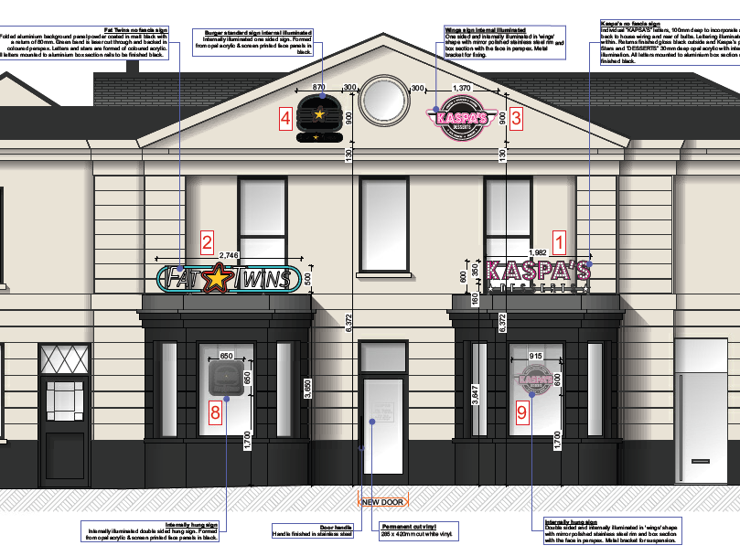
The proposal was considered to introduce too much clutter to the locally listed building and the setting of the adjacent listed Cemetery Arch. The agent was advised that a split decision would be issued unless amended plans to delete signs 3, 4 & 5 were provided to reduce this harm. The amended plans received (see above) do this and illustrate how much better the building will appear as a result.

All signs are to be illuminated but as the proposed level is 200cd/m2 this should be subdued enough to limit glare distracting from the appearance of the building and the nearby listed Cemetery Arch. No harm is considered likely to result to residential amenity as a consequence of the proposal. As such, the amended proposal is considered to comply with Policies CC7, OU4, EN1 and EN3 of the Local Plan 2019.

Public Safety

No works considered by this application could cause a physical obstruction to the public using a public highway. The proposal does include illumination but at a level that is well below the limit suggested by the transport advisor. The car park direction sign (5) has also been removed as officers considered that its size and location facing west was a distraction and clutter given the same guidance is provided on the totem sign. The amended proposal is acceptable in terms of Policy TR3 of the Reading Borough Local Plan (2019).

7. CONCLUSION
In light of the above assessment the amended proposal is considered to accord with the requirements of the development plan and is therefore recommended for approval subject to conditions.

8. RECOMMENDATION
GRANT subject to conditions:
- A1 Standard Advert Condition
- Standard Advert Time Limit
- AD2 Approved Plans
- Luminance limit of 200 cd/m2

