DELEGATED HOUSEHOLDER APPLICATION REPORT

Ward: Abbey
App Ref: 220534/FUL
Address: 200-202 Broad Street, Reading, RG1 7QJ
Proposals: Infill of brickwork to match existing and new windows to the rear at first, second and third floors.
Case Officer: Chukwudi Onwudinanti
Applicant: Thackeray Estates
Date received (valid from): 16 May 2022
Target Decision date: 9/9/2022 (Ext)

1. Site Description and Surrounding Area
The proposal site is a Victorian corner building at the intersection of Broad Street, West Street and Oxford Road, in the commercial centre of Reading Town. There are buildings of varied styles and uses in the predominantly commercial area. The building lies to the western side of the intersection. It is not listed nor in a Conservation Area.

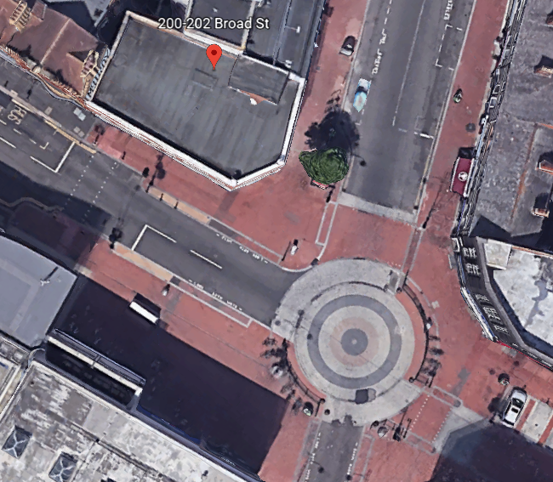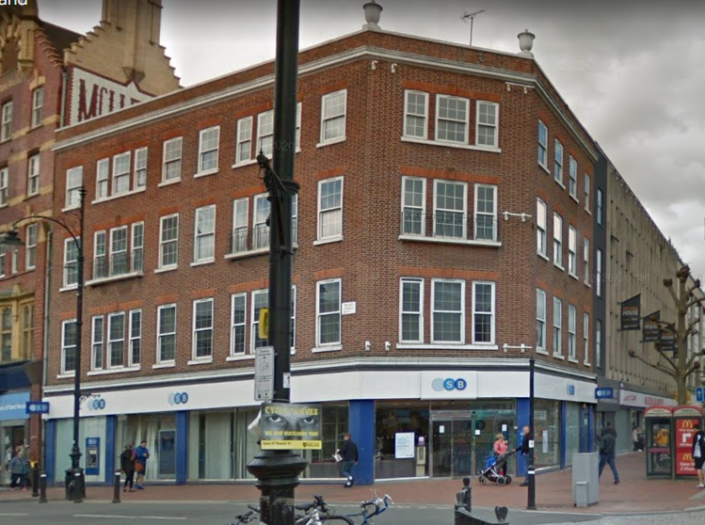

2. The Proposal
The application proposes to install new windows to the rear, infilling brickwork to match existing and the installation of new windows within the first, second and third floors. These external works are in association with the prior approval to convert the upper office floors to residential (220970 – not yet determined).

3. Consultations
The following were consulted.

Environmental Protection: No objection but notes that in the vent of future conversion to residential units, new windows will have to be taken into account in making Noise Assessments.

Transport: No objections as the “the proposal does not have an impact on the highway”.

4. Plans and Documents Considered (received 8th April 2022)
Drawing No 20033/P(--)202 : Existing Elevations C & D Service Yard
Drawing No 20033/P(--)202 : Proposed Elevations C & D Service Yard
Drawing No 20033/P(--)001: Location Plan

5. RELEVANT PLANNING HISTORY
220970: Change of use of 1st, 2nd and 3rd floors from Class E (offices) to C3 (dwelling houses) to comprise 9 self-contained flats. Prior Notification under Class MA, Part 3 of Schedule 2 of the Town and Country Planning (General Permitted Development) Order 2015. Not yet determined.

6. Legal and policy context
Section 38(6) of the Planning and Compulsory Purchase Act 2004 requires that proposals be determined in accordance with the development plan unless material considerations indicate otherwise. Material considerations include relevant policies in the National Planning Policy framework (NPPF) - among them the 'presumption in favour of sustainable development'. The following local and national planning policy and guidance is relevant to this application:

National Policy
National Planning Policy Framework
National Planning Practice Guidance

Reading Borough Local Plan (2019)
CC7 (Design and the Public Realm)
CR2: (Design in Central Reading)

7. Appraisal
CC7 (Design and the Public Realm)
All development must be of high design quality that maintains and enhances the character and appearance of the area of Reading in which it is located.

CR2: (Design in Central Reading)
Applications for development within Central Reading should demonstrate the following
attributes:
d. The architectural details and materials used in the central area should be high quality
and respect the form and quality of the detailing and materials in areas local to the development site.

The proposal is to the rear of the property and is not visible to the street scene, however, the proposal includes for the design of windows, which seek to respect the scale, form and design of the existing building features. The materials would be to match existing.

CR7: (Primary Frontages in Central Reading)
Uses on the ground floor along the designated primary frontages as shown on the Proposals Map will be within one of the following use classes: A1, A2, A3, A4, A5, C1, D1, D2 or related sui generis uses, unless it would be an entrance to upper floors. New developments (or alterations to existing uses) that front onto any of the designated primary frontages will provide an active building frontage with a display window or glazed frontage at ground floor level, in order to contribute to the vibrancy of the town centre, and provide visual interest.

The proposal does not present any significant change of use on the ground floor level, nor presents any new features that will have detrimental impacts on the display and frontage functions of the building, in keeping with Central Reading Frontages.

8. Conclusion
The proposed development has been assessed and the proposed works are considered to be in accordance with the above relevant policies and planning permission can be granted.

9. Recommendation
Grant

