DELEGATED HOUSEHOLDER APPLICATION REPORT

Ward: Thames
App Ref: 220238/CLP
Address: 268 Hemdean Road, Reading, RG4 7QT
Proposals: Certificate of Lawfulness for Proposed Hip to gable loft conversion including the installation of two roof windows into the pitched roof of the front elevation and the addition of a dormer at the rear.
Case Officer: Chukwudi Onwudinanti
Applicant: Mr Steven Gaulier
Date received (valid from): 18 February 2022
Target Decision date: 15 April 2022

INTRODUCTION
The site is a semi-detached dwelling unit on the western side of Hemdean Road, among dwellings of similar styles and sizes. The area is predominantly residential.

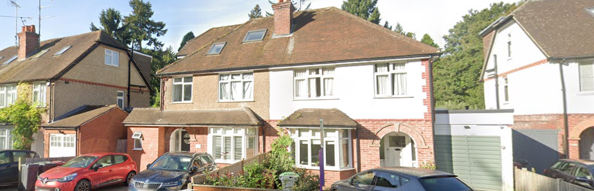

PROPOSAL AND SUPPORTING INFORMATION
The proposal is for the conversion of the hip roof to a gable roof, conversion of the roof space into a loft and installation of two roof windows into the pitched roof on the front elevation, as well as the introduction of a dormer to the rear of the dwelling.

Plans considered
Drawing 1 A : Existing Ground Floor Plan
Drawing 2 A : Proposed Ground Floor Plan
Drawing 3 A : Existing First Floor Plan
Drawing 4 A : Proposed First Floor Plan
Drawing 5 A : Proposed Loft Plan
Drawing 6 A : Existing Roof Plan
Drawing 7 A : Proposed Roof Plan
Drawing 8 A : Existing Elevations
Drawing 9 A : Proposed Elevations
Drawing 10 A : Existing Section A-A
Drawing 11 A : Proposed Section A-A
Drawing 14 A : Location Plan
Drawing 15 A : Block Plan

RELEVANT PLANNING HISTORY

None

CONSULTATIONS
No consultations were undertaken as it is not required for an application of this type.
Equality Act 2010:
In determining this application the Council is required to have regard to its obligations under the Equality Act 2010. However, there is no indication or evidence (including from consultation on the application) that the protected groups identified by the Act have or will have different needs, experiences, issues and priorities in relation to this particular planning application. Therefore in terms of the key equalities protected characteristics it is considered there would be no significant adverse impacts as a result of the development.

Relevant Planning Policy and Guidance
National Planning Practice Guidance
The Town and Country Planning (General Permitted Development) (England) Order 2015 (GPDO)
Permitted development rights for householders – Technical Guidance September 2019

Assessment
A Certificate of Lawfulness for a proposed development has been submitted as the applicant considers the proposal falls within the permitted development rights of the property.
The proposed loft conversion with rear dormer and front rooflights must be assessed to ensure that it complies with the conditions of Class B and Class C, Part 1, Schedule 2 of the Town and Country Planning (General Permitted Development) (England) Order 2015 (as amended), which relates to ‘additions etc to the roof of a dwellinghouse’ and ‘other alterations to the roof of a dwellinghouse’ respectively.
The relevant conditions of the GPDO for a loft conversion with rear dormer which is not listed or in a conservation area, are as follows:
B.1 Development is not permitted by Class B if:
B.1 (a) permission to use the dwellinghouse as a dwellinghouse has been granted only by virtue of Class M, N, P or Q of Part 3 of this Schedule (changes of use); complies
B.1 (b) any part of the dwellinghouse would, as a result of the works, exceed the height of the highest part of the existing roof; complies
B.1 (c) any part of the dwellinghouse would, as a result of the works, extend beyond the plane of any existing roof slope which forms the principal elevation of the dwellinghouse and fronts a highway; complies
B.1 (d) the cubic content of the resulting roof space would exceed the cubic content of the original roof space by more than (i) 40 cubic metres in the case of a terrace house; Not Applicable, or (ii) 50 cubic metres in any other case ;complies, the cubic content of the resulting roof space would exceed the cubic content of the original roof space by 46.43m cubic metres.(19.4m for the dormer to the rear and 27.03m for the new gable space)
B.1 (e) it would consist of or include (i) the construction or provision of a veranda, balcony or raised platform, complies or (ii) the installation, alteration or replacement of a chimney, flue or soil and vent pipe; complies or
B.1 (f) the dwellinghouse is on article 2(3) land. complies
Conditions
B.2 Development is permitted by Class B subject to the following conditions:
B.2 (a) the materials used in any exterior work must be of a similar appearance to those used in the construction of the exterior of the existing dwellinghouse; complies
B.2 (b) the enlargement must be constructed so that (i) other than in the case of a hip-to-gable enlargement or an enlargement which joins the original roof to the roof of a rear or side extension (aa) the eaves of the original roof are maintained or reinstated; complies and (bb) the edge of the enlargement closest to the eaves of the original roof is, so far as practicable, not less than 0.2 metres from the eaves, measured along the roof slope from the outside edge of the eaves; complies and (ii) other than in the case of an enlargement which joins the original roof to the roof of a rear or side extension, no part of the enlargement extends beyond the outside face of any external wall of the original dwellinghouse; complies and
B.2 (c) any window inserted on a wall or roof slope forming a side elevation of the dwellinghouse must be (i) obscure-glazed, complies and (ii) non-opening unless the parts of the window which can be opened are more than 1.7 metres above the floor of the room in which the window is installed, complies
Interpretation of Class B
B.3 For the purposes of Class B, “resulting roof space” means the roof space as enlarged, taking into account any enlargement to the original roof space, whether permitted by this Class or not.
B.4 For the purposes of paragraph B.2(b)(ii), roof tiles, guttering, fascias, barge boards, and other minor roof details overhanging the external wall of the original dwellinghouse are not to be considered part of the enlargement.
C.1 Development is not permitted by Class C if:
C.1 (a) permission to use the dwellinghouse as a dwellinghouse has been granted only by virtue of Class M, N, P or Q of Part 3 of this Schedule (changes of use); complies
C.1 (b) the alteration would protrude more than 0.15 metres beyond the plane of the slope of the original roof when measured from the perpendicular with the external surface of the original roof; complies
C.1 (c) it would result in the highest part of the alteration being higher than the highest part of the original roof; complies or
C.1 (d) it would consist of or include (i) the installation, alteration, or replacement of a chimney, flue or soil and vent pipe, N/A or (ii) the installation, alteration or replacement of solar photovoltaics or solar thermal equipment, N/A
Conditions
C.2 Development is permitted by Class C subject to the condition that any window located on a roof slope forming a side elevation of the dwellinghouse must be:
C.2 (a) obscure-glazed; complies and
C.2 (b) non-opening unless the parts of the window which can be opened are more than 1.7 metres above the floor of the room in which the window is installed, complies
Recommendation
Sufficient evidence has been provided to demonstrate that a Certificate of Lawfulness should be granted for the proposed hip to gable loft conversion including the installation of two roof windows into the pitched roof of the front elevation and the addition of a dormer at the rear.
The proposal has been assessed against the Town and Country Planning Act 1990 (as amended) and Class B and Class C, Part 1, Schedule 2 of the Town and Country Planning (General Permitted Development) (England) Order 2015 (as amended). It can be confirmed that the proposed operation would be lawful for planning purposes on the basis of the following received on 22nd February 2022:
Drawing 2 A : Proposed Ground Floor Plan
Drawing 4 A : Proposed First Floor Plan
Drawing 5 A : Proposed Loft Plan
Drawing 9 A : Proposed Elevations
Drawing 11 A : Proposed Section A-A
Drawing 15 A : Block Plan

Therefore the Local Planning Authority can issue the applicant with a Certificate of Lawfulness for the proposed development.
Informatives:

Building Regulations
Construction and demolition
Positive and proactive Working

