Material Schedule

For

New dwelling

at

190 Henley Road
Caversham
Reading
RG4 5LN

Project Number – 3490
Prepared By – GH
Revision | Description |  |  | Date | By

Walls:
Facing brickwork- Old Carrow Blend – TBS Specialist Products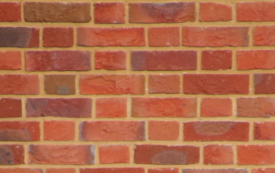
Window Heads- Ferro – TBS Specialist Products
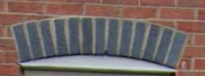
Brickwork Below DPC Orange Engineering Brick
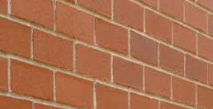
Mortar Colour- Natural Mortar
Tile Hanging- Imerys/Edilians tiles – Phalempin Val de Seine Sandfaced Plain & Club Clay Tile
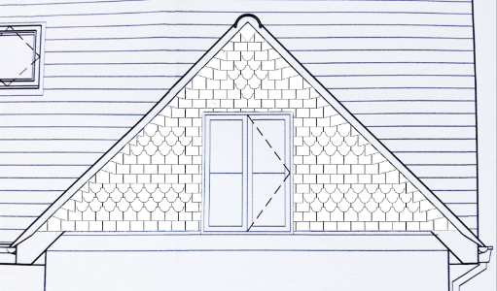
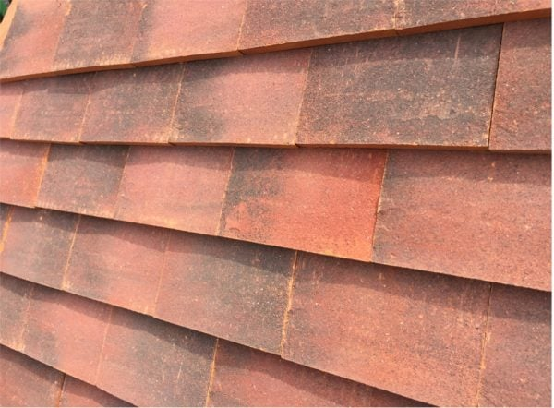
Special Bricks- Manthrope RSPB, Bird Brick House & Habibat. Installed at high level on side elevations.
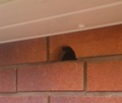
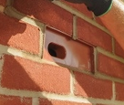
Windows:
Window- White UPVC
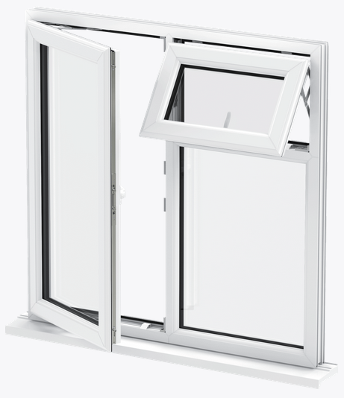
Roof Lights- Velux
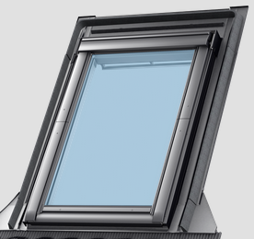
Cill- 150mm deep stone cill
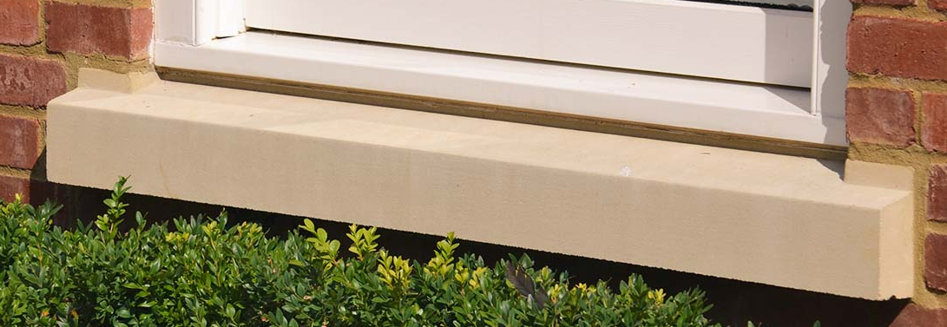

Doors:
Main Entrance- Composite door
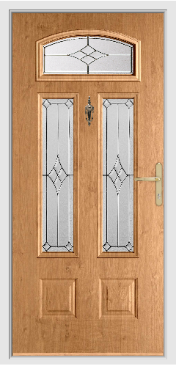
Bifold Door- Powder Coated Aluminium in anthracite grey from Origin
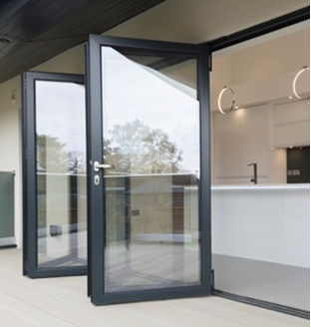
Rear Door- Powder coated aluminium in anthracite grey from Origin

Roof:
Porch, Bay & single storey rear- Imerys/Edilians – Beauvoise Graphite Tile (interlocking tiles)
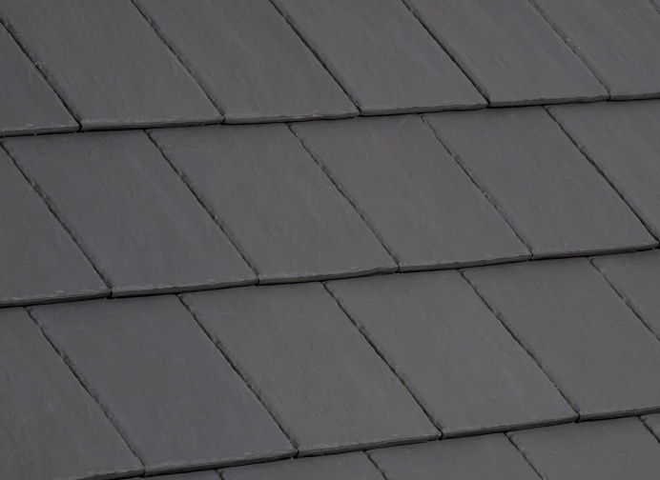

Majority of the main roof will be Sandtoft New Cassius Interlocking Clay Roof Tile – Antique Slate with Ergosun Solar Roof tiles fitted above for solar power.
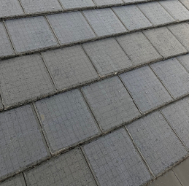

Finial Tile to front gable- See image below
