DELEGATED HOUSEHOLDER APPLICATION REPORT

Ward: Kentwood
App Ref: 211644/HOU
Address: 208 Kentwood Hill, Tilehurst, Reading, RG31 6DP
Proposals: Single storey rear/side extension with new feature lantern rooflight and garage conversion
Case Officer: Chukwudi Onwudinanti
Applicant: Miss Elizabeth Haworth
Date received (valid from): 5 October 2021
Target Decision date: 21 December 2021

1. INTRODUCTION
The proposed site is a semi-detached dwelling house on the western side of Kentwood Hill, among similarly styled and sized buildings on the one side of the street.

2. PROPOSAL AND SUPPORTING INFORMATION

Single storey rear/side extension with new feature lantern rooflight and garage conversion

Plans considered
(Received 5th November 2021)
EH10 – Site/Block Plan
EH13 C – Proposed Ground Floor Layout
EH14 A – Proposed Elevations
EH11 – Existing Ground Floor Layout
EH14 E – Proposed Elevations

(Received 11th November 2021)
EH10 A – Site/Block Plan
EH14 C – Proposed Elevations
EH13 E – Proposed Ground Floor Layout

(Received 23rd November 2021)
EH13 F – Proposed Ground Floor Layout

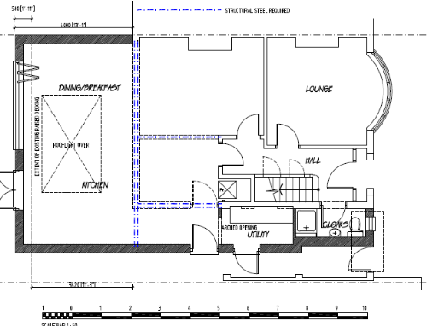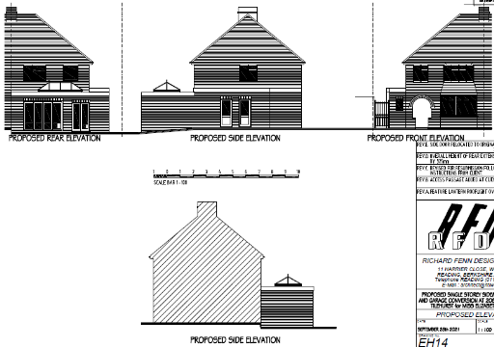

- RELEVANT PLANNING HISTORY

None

4. CONSULTATIONS

4.1 The following addresses were consulted by letter.

210 Kentwood Hill, Tilehurst, Reading, Berkshire, RG31 6DP
106 Rodway Road, Tilehurst, Reading, RG30 6DT
108 Rodway Road, Tilehurst, Reading, RG30 6DT
206 Kentwood Hill, Tilehurst, Reading, RG31 6DP

4.2 Letters of representation have been received as follows:
The neighbours at 210 Kentwood Hill, RG31 6DP raised objections, stating that the proposed development would cast shadows over their property and also cause overlooking into their property. These concerns have been addressed by the applicant and amended plans re-consulted on.

Equality Act 2010:
In determining this application the Council is required to have regard to its obligations under the Equality Act 2010. However, there is no indication or evidence (including from consultation on the application) that the protected groups identified by the Act have or will have different needs, experiences, issues and priorities in relation to this particular planning application. Therefore in terms of the key equalities protected characteristics it is considered there would be no significant adverse impacts as a result of the development.

- LEGAL AND PLANNING POLICY CONTEXT

Section 38(6) of the Planning and Compulsory Purchase Act 2004 requires that proposals be determined in accordance with the development plan unless material considerations indicate otherwise. Material considerations include relevant policies in the National Planning Policy framework (NPPF) - among them the 'presumption in favour of sustainable development'. The following local and national planning policy and guidance is relevant to this application:

National Policy
National Planning Policy Framework
National Planning Practice Guidance

Reading Borough Local Plan (2019)
CC7 (Design and the Public Realm)
CC8 (Safeguarding Amenity)
H9 (House Extensions and Ancillary Accommodation)

SPD
- Design Guide to House Extensions (2021)

6. APPRAISAL

H9 states: An extension to a house will be acceptable where it:

- Respects the character of the house in terms of scale, location, materials and design;

To assess this, the following has been considered – would the proposal:
- detract from the appearance of the original building through the use of ill-matching materials and by not fitting in with the design, scale and proportions of the original building; NO
- reduce the amount of usable amenity space for the property to an unacceptable degree; NO
- require the loss of trees in the garden or put significant trees at risk; NO

- Respects the character and pattern of neighbouring properties and the street as a whole in terms of scale, location, materials and design, and any important existing building line; Respects neighbour’s amenities and does not present a large blank façade to public areas.

To assess this, the following has been considered – would the proposal:
significantly reduce the amount of daylight and sunlight enjoyed by neighbouring properties; NO, the agent has reduced the height of the extension thereby reducing the impact of reduced sunlight to the adjoining dwelling house. This is shown in the amended plans submitted by the agent, after engagement with the planning officer and the neighbours who raised objections.
- invade the privacy of neighbouring properties through overlooking from windows or balconies; NO, as stated above, the concerns from the original drawings submitted have been resolved with the amended plans which has now repositioned the doors to the side of the extension, away from the adjoining property.
- detract from the character of neighbouring properties through siting, excessive bulk, ill-matching materials or inconsistent design; NO
- detract from the appearance of the street or area by using ill-matched materials, glazing and detailing; NO

CC8: Safeguarding Amenity states an extension to a house will be acceptable where it will not cause a significant detrimental impact to the living environment of existing or new residential properties.

To assess this, the following has been considered – would the proposal cause a significant detrimental impact to the living environment of existing or new residential properties in terms of:

- Privacy and overlooking;
- Access to sunlight and daylight;
- Visual dominance and overbearing effects of a development;
- Noise and disturbance;
- Artificial lighting;
- Vibration;
- Dust and fumes;
- Smell;
- Crime and safety.

- CONCLUSION
The proposed development has been assessed and the proposed works are considered to be in accordance with the above relevant policies and planning permission can be granted.

8. RECOMMENDATION
Grant

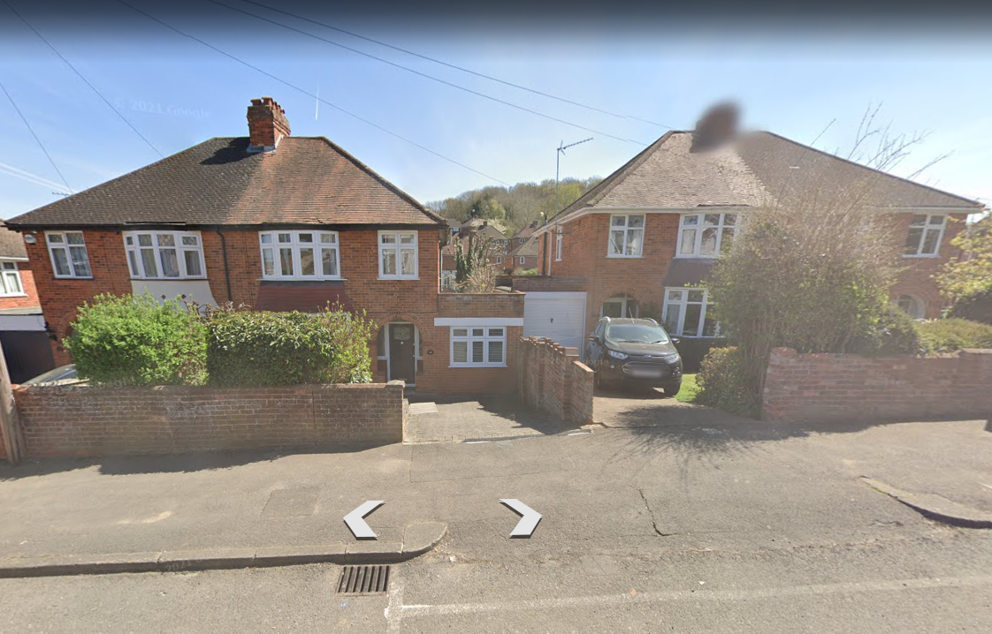

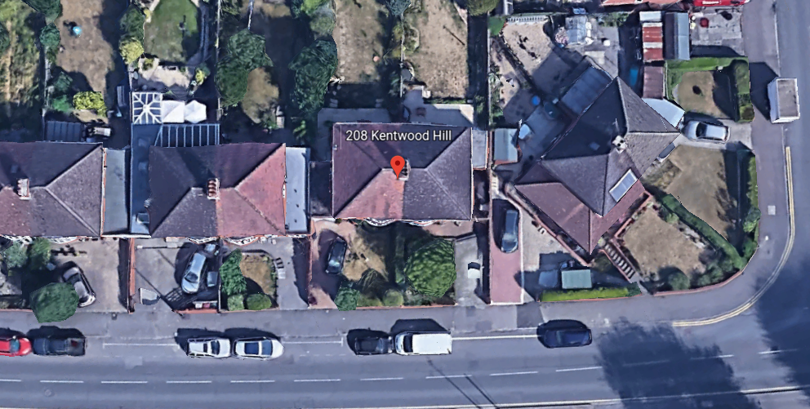

Google Earth Photos

