DELEGATED HOUSEHOLDER APPLICATION REPORT

Ward: Kentwood
App Ref: 220398/HOU
Address: 3 Delft Close, Reading, RG30 6EU
Proposals: Single storey side / rear extension
Case Officer: Chukwudi Onwudinanti
Applicant: Ms Joanne Conroy
Date received (valid from): 22 March 2022
Target Decision date: 30th June 2022 (Ext)

1. INTRODUCTION
The proposal site is a semi-detached linked two storey dwelling on the eastern side of Delft close, among buildings of similar style and size. It has an attached one storey level garage which links it to the garage of the adjoining building.

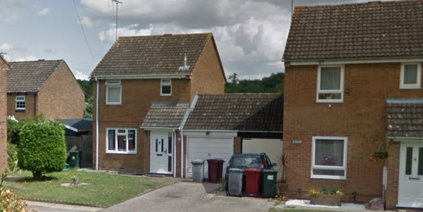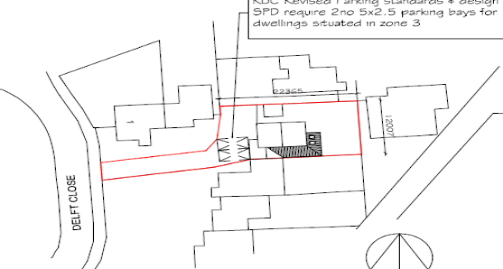

2. PROPOSAL AND SUPPORTING INFORMATION

The application is for a single storey side extension which wraps around the rear, extending to the side by approximately 2.4m (the width of the existing garage) and 2.3m to the rear. The height of the extension will be 2.1m to the eaves and have an overall height of 3.5m to the ridgeline, just below the ridgeline of the existing garage. A new window will be installed to the front wall of the existing garage which is being converted to a study and bathroom.

Plans considered (Received 22nd March 2022)
Drawing No 1: Existing Plans
Drawing No 2: Existing Elevations
Drawing No 3: Proposed Plans
Drawing No 4: Proposed Elevations
Drawing No 5: Existing and Proposed Plans plus Location and Block Plans

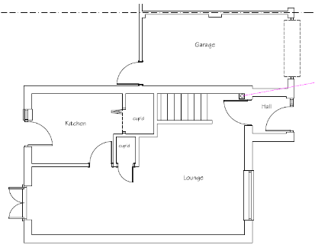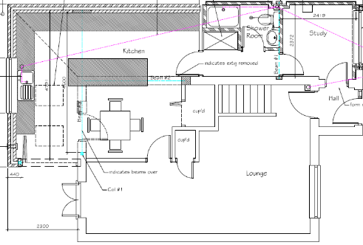
Existing Floor Plan Proposed Floor Plan

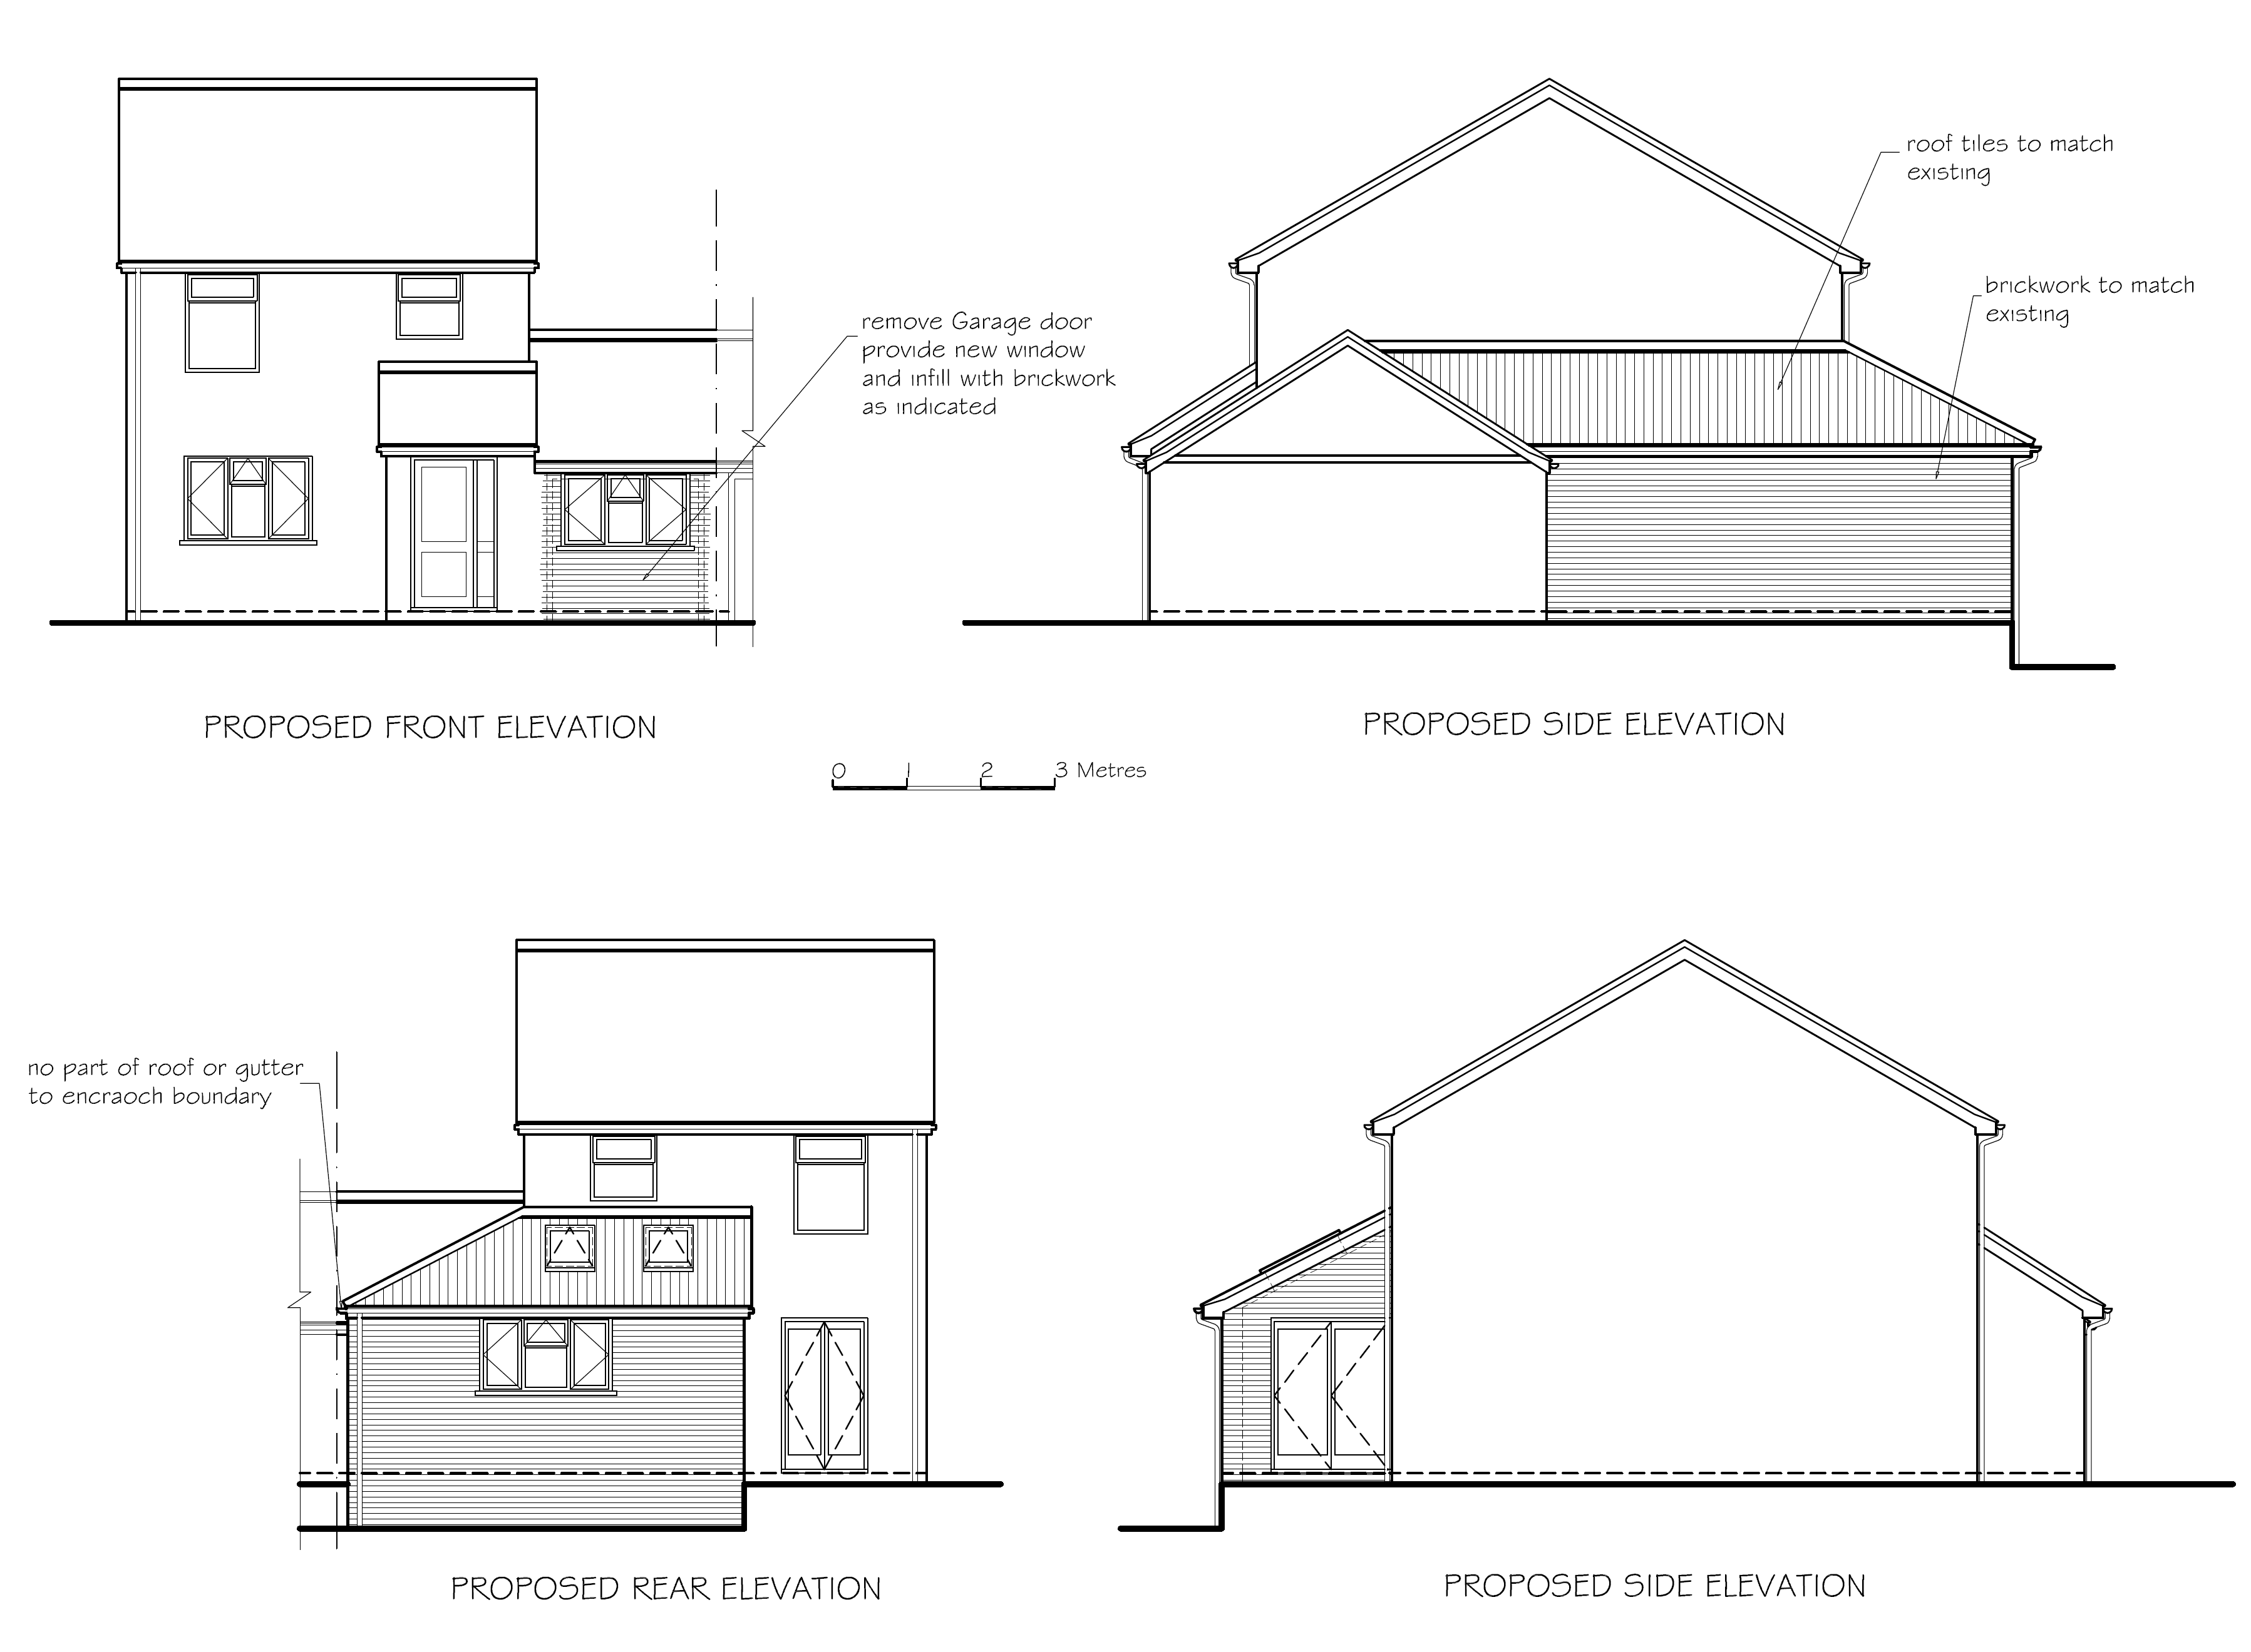
Proposed elevations

- RELEVANT PLANNING HISTORY

Application Ref: 170393 - Single storey side and rear extension and conversion of garage - Permitted, 11/5/2017

Planning Officer note: this was identical to the proposed scheme.

4. CONSULTATIONS

4.1 The following addresses were consulted by letter.

43 Wealden Way, Tilehurst, Reading, RG30 6DA
41 Wealden Way, Tilehurst, Reading, RG30 6DA
2 Delft Close, Tilehurst, Reading, RG30 6EU
1 Delft Close, Tilehurst, Reading, RG30 6EU
4 Delft Close, Tilehurst, Reading, RG30 6EU

4.2 No letters of representation have been received.

Equality Act 2010:
In determining this application the Council is required to have regard to its obligations under the Equality Act 2010. However, there is no indication or evidence (including from consultation on the application) that the protected groups identified by the Act have or will have different needs, experiences, issues and priorities in relation to this particular planning application. Therefore in terms of the key equalities protected characteristics it is considered there would be no significant adverse impacts as a result of the development.

- LEGAL AND PLANNING POLICY CONTEXT

Section 38(6) of the Planning and Compulsory Purchase Act 2004 requires that proposals be determined in accordance with the development plan unless material considerations indicate otherwise. Material considerations include relevant policies in the National Planning Policy framework (NPPF) - among them the 'presumption in favour of sustainable development'. The following local and national planning policy and guidance is relevant to this application:

National Policy
National Planning Policy Framework
National Planning Practice Guidance

Reading Borough Local Plan (2019)
CC7 (Design and the Public Realm)
CC8 (Safeguarding Amenity)
H9 (House Extensions and Ancillary Accommodation)

SPD
- Design Guide to House Extensions (2021)

6. APPRAISAL

H9 states: An extension to a house will be acceptable where it:

- Respects the character of the house in terms of scale, location, materials and design;

To assess this, the following has been considered – would the proposal:
- detract from the appearance of the original building through the use of ill-matching materials and by not fitting in with the design, scale and proportions of the original building; NO, while the side extension runs the whole length of the existing building as well as halfway at the rear, it does not significantly add to the size as viewed from the street, as the width of the side extension is masked by the existing garage which is being converted. The new window also matches the existing window to the front façade.
- reduce the amount of usable amenity space for the property to an unacceptable degree; NO, the extension does not increase the footprint of the existing dwelling to the extent of significantly reducing the amount of usable amenity to the rear of the building.
- require the loss of trees in the garden or put significant trees at risk; NO

- Respects the character and pattern of neighbouring properties and the street as a whole in terms of scale, location, materials and design, and any important existing building line; Respects neighbour’s amenities and does not present a large blank façade to public areas.

To assess this, the following has been considered – would the proposal:
- significantly reduce the amount of daylight and sunlight enjoyed by neighbouring properties; NO, the height of the extension is only 2.1m to the eaves, barely above the height of the existing fence and the roof is mono-pitch which adds nothing to the height of the extension at the line of boundary with adjoining neighbours.
- invade the privacy of neighbouring properties through overlooking from windows or balconies; NO, there are no windows to the side of the extension.
- detract from the character of neighbouring properties through siting, excessive bulk, ill-matching materials or inconsistent design; NO
- detract from the appearance of the street or area by using ill-matched materials, glazing and detailing; NO, the window added to the front façade matches the existing.

CC8: Safeguarding Amenity states an extension to a house will be acceptable where it will not cause a significant detrimental impact to the living environment of existing or new residential properties.

To assess this, the following has been considered – would the proposal cause a significant detrimental impact to the living environment of existing or new residential properties in terms of: NO

- Privacy and overlooking;
- Access to sunlight and daylight;
- Visual dominance and overbearing effects of a development;
- Noise and disturbance;
- Artificial lighting;
- Vibration;
- Dust and fumes;
- Smell;
- Crime and safety.

- CONCLUSION
The proposed development has been assessed and the proposed works are considered to be in accordance with the above relevant policies and planning permission can be granted. It is an identical scheme to that approved in 2017 and there are no material issues which have led to a different recommendation to that in 2017.

8. RECOMMENDATION
Grant

