DELEGATED HOUSEHOLDER APPLICATION REPORT

Ward: Abbey
App Ref: 220276/ADV
Address: Land Between Weldale Street, Chatham Street, Reading
Proposals: Erection of 1no. internally illuminated fascia sign, 3no. internally illuminated totem signs and 2no. fingerpost signs.
Case Officer: Chukwudi Onwudinanti
Applicant: Ropemaker Properties Ltd
Date received (valid from): 24 February 2022
Target Decision date: 21 April 2022

- INTRODUCTION
The site is located in Reading centre boundary, on land between Chatham Street and Weldale Street. The character of the site and surrounding area is generally of high-rise and high density development primarily in residential or commercial use. Chatham Place is located to the south of the site, on the junction of Weldale Street and Caversham Road, and consists of a 19 storey block of high rise residential apartments.
Greyfriars Church (Grade 1 Listed) is situated approx. 90m to the east of the site but is separated from the site by the existing roundabout off Chatham Street. To the north of the site lies Weldale Street, with an existing industrial estate consisting of primary two storey buildings located opposite the site and to the west lies existing residential development at Stratheden Place which consists of two and three storey dwellings.

2. PROPOSAL AND SUPPORTING INFORMATION

Erection of 1no. internally illuminated fascia sign, 3no. internally illuminated totem signs and 2no. fingerpost signs.

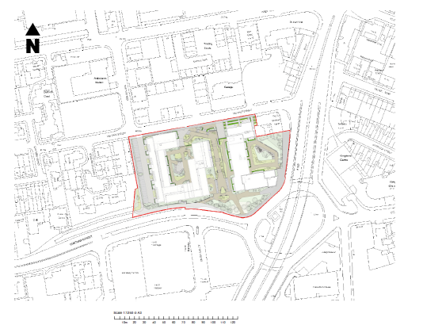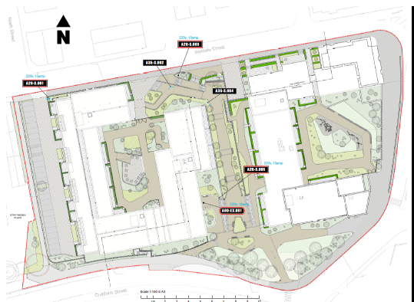
Site Location Plan Detailed Site Layout

Plans considered (Received 24th February 2022)

Illuminated fascia sign
DI – A00.00 : Design Intent 004
DI – A00.01: Design Intent 005
DI – A00.02: Design Intent 006

Totem
DI – A20.00: Design Intent 007
DI – A20.01: Design Intent 008
DI – A20.02: Design Intent 009

Fingerpost
DI – A35.00: Design Intent 010
DI – A35.01: Design Intent 011

Location Plans
LP – 000.00 : Site Wayfinding Location Plan
LP – S.00: Site Wayfinding Location Plan
LP – S.01: Site Wayfinding Location Plan

- RELEVANT PLANNING HISTORY
Application ref: 170326
Description : demolition of all existing buildings (including 3 retail units) and structures, and erection of new buildings ranging between lower ground & 4 storeys to lower ground & 11 storeys in height, providing 427 (233x1, 182x2 & 12x3-bed) residential units (Class C3) and 1 flexible ground floor retail shop (Class A1) or restaurant and cafe (Class A3) unit, together with new public realm, landscaping, accesses, parking and associated works.
Decision: Permitted
Decision Date: March 2018

Permission has now been implemented with blocks A1 and A2 under construction currently. This application relates to the proposed signage for the development.

4. CONSULTATIONS

4.1 The following addresses were consulted by letter.

6-14 Weldale Street, Reading, RG1 7BX
6 Weldale Street, Reading, RG1 7BX
4 Weldale Street, Reading
Transport
Environment

Transport has been consulted and have no objections but have advised to include condition AD1 in the Decision Notice.
Environment has expressed no concerns/objections.

4.2 No letters of representation have been received.

Equality Act 2010:
In determining this application the Council is required to have regard to its obligations under the Equality Act 2010. However, there is no indication or evidence (including from consultation on the application) that the protected groups identified by the Act have or will have different needs, experiences, issues and priorities in relation to this particular planning application. Therefore in terms of the key equalities protected characteristics it is considered there would be no significant adverse impacts as a result of the development.

- LEGAL AND PLANNING POLICY CONTEXT

Section 38(6) of the Planning and Compulsory Purchase Act 2004 requires that proposals be determined in accordance with the development plan unless material considerations indicate otherwise. Material considerations include relevant policies in the National Planning Policy framework (NPPF) - among them the 'presumption in favour of sustainable development'. The following local and national planning policy and guidance is relevant to this application:

National Policy
National Planning Policy Framework
National Planning Practice Guidance

Reading Borough Local Plan (2019)
CC7 (Design and the Public Realm)
OU4 (Advertisements)

6. APPRAISAL

CC7 (Design and the Public Realm)
All the advertisement signs in this proposal are not of the size that will cause any impact to the perception of the public realm and the street scene.

OU4 (Advertisements)
Advertisements will respect the building or structure on which they are located and/or
their surroundings and setting in terms of size, location, design, materials, colour, noise,
lettering, amount and type of text, illumination and luminance, and will not have a
detrimental effect on public safety. The cumulative impact of adverts will be taken into
account, and a proliferation of advertisements that detrimentally affects visual or aural
amenity or public safety will not be acceptable. All adverts shall comply with the
following criteria:

a) Advertisements will not obstruct windows, any other sign already located on the
building, or cut across significant architectural features such as historic fascias,
windows, pilasters, cornices or scrolls; Complies
b) Where a shop or business occupies more than one adjacent unit, the advertisement will not run between the shopfronts; N/A
c) Advertisements on listed buildings or in Conservation Areas will respect or enhance the
building or area, and will respect the key features of the special historic interest; N/A
d) Advertisements will not reduce visibility for users of the highway or accesses onto the
highway; Complies ( As advised by Transport)
e) Illumination should not detract from the amenity of the area or pose a safety hazard
to users of the highway; Complies ( As advised by Transport) and
f) Advertisements should not obscure the sight lines of cameras installed for public
safety. Complies ( As is stated in the Application Statement/Letter)

- CONCLUSION
The proposed development has been assessed and the proposed works are considered to be in accordance with the above relevant policies and planning permission can be granted.

8. RECOMMENDATION
Grant

