BIODIVERSITY ENHANCEMENTS
CONDITION 9

DEVELOPMENT AT

Land Adjacent to
114 – 116 School Road
Tilehurst
Reading
RG31 5AX

DEVELOPER

Chesters Place Limited

PREPARED By

C Thorpe

Date

6th July 2022

V2

The site will incorporate 4 integral bird & bat boxes, as shown in the attached image

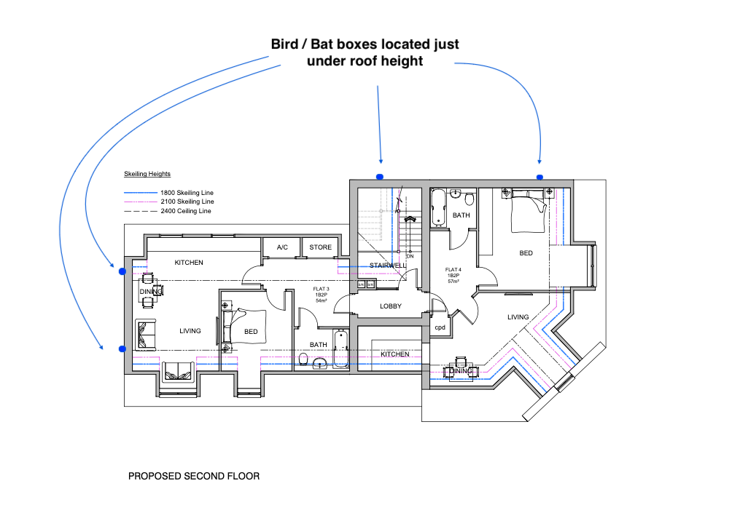

Proposed integrated bat box unit

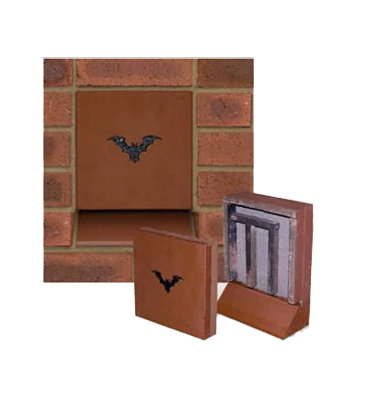

Proposed integrated bird box unit
Manthorpe swift bird box

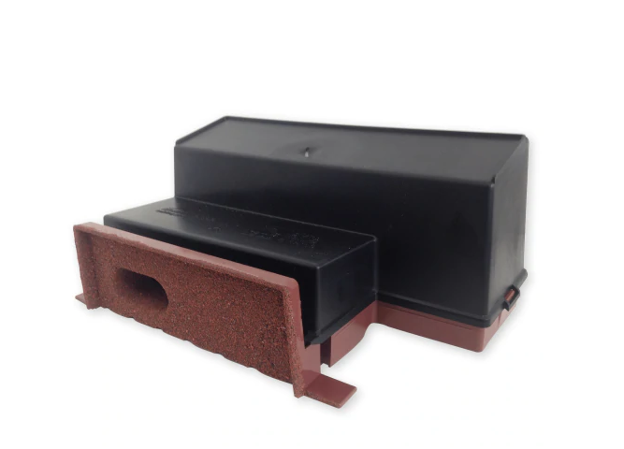

Portuguese Laurel Planting

