DELEGATED HOUSEHOLDER APPLICATION REPORT

Ward: Mapledurham
App Ref: 220315/VAR
Address: 179 Kidmore Road, Reading, RG4 7NW
Proposals: Application for removal or variation of a condition following grant of planning permission 201024 - Changes to materials and the inclusion of solar panels
Case Officer: Chukwudi Onwudinanti
Applicant: Big Tots
Date received (valid from): 6 April 2022
Target Decision date: 5 August 2022 (Ext)

INTRODUCTION
The site is a detached part two storey, part one storey dwelling unit, with two principal elevations facing Kidmore and Sancroft Roads, among buildings of different styles and sizes. The buildings on the same side of the road are similar to the proposal site but buildings on the opposite side of the road are of a different style, all making up a predominantly residential area.

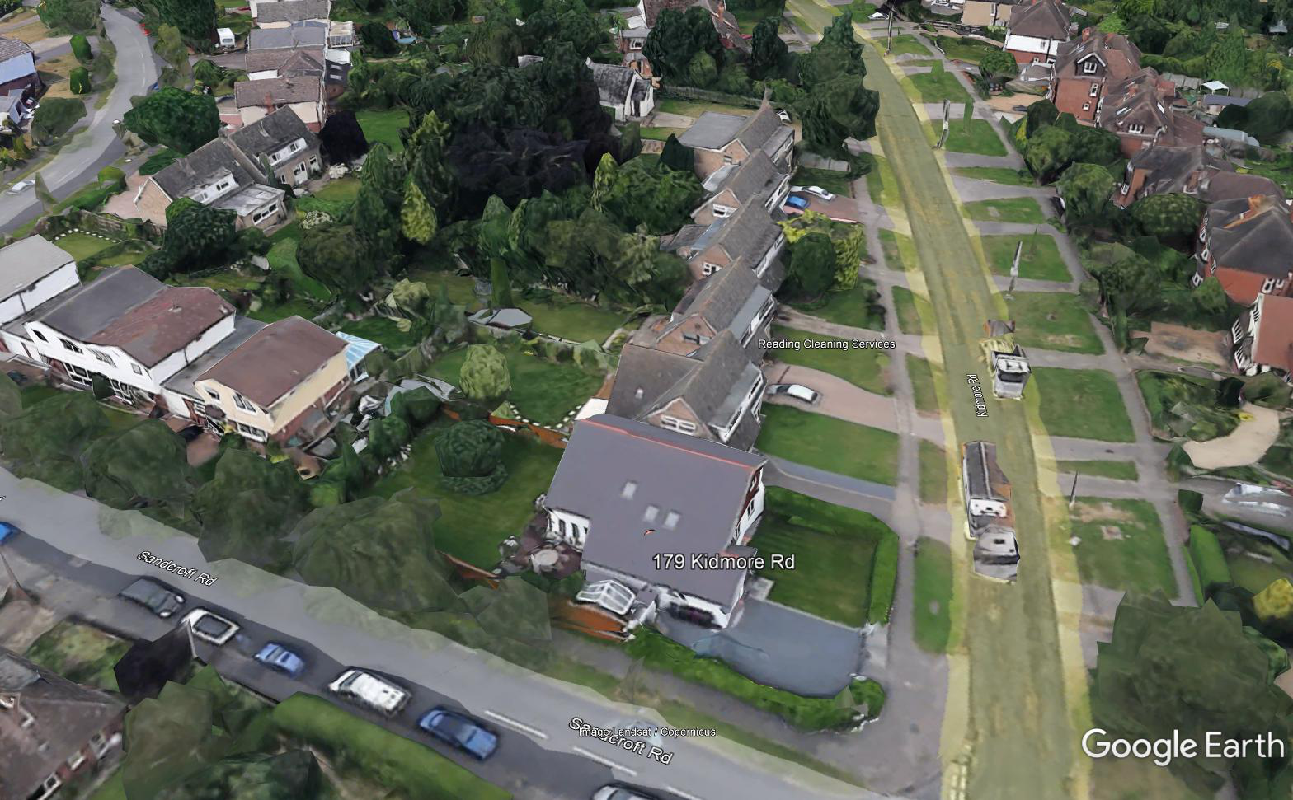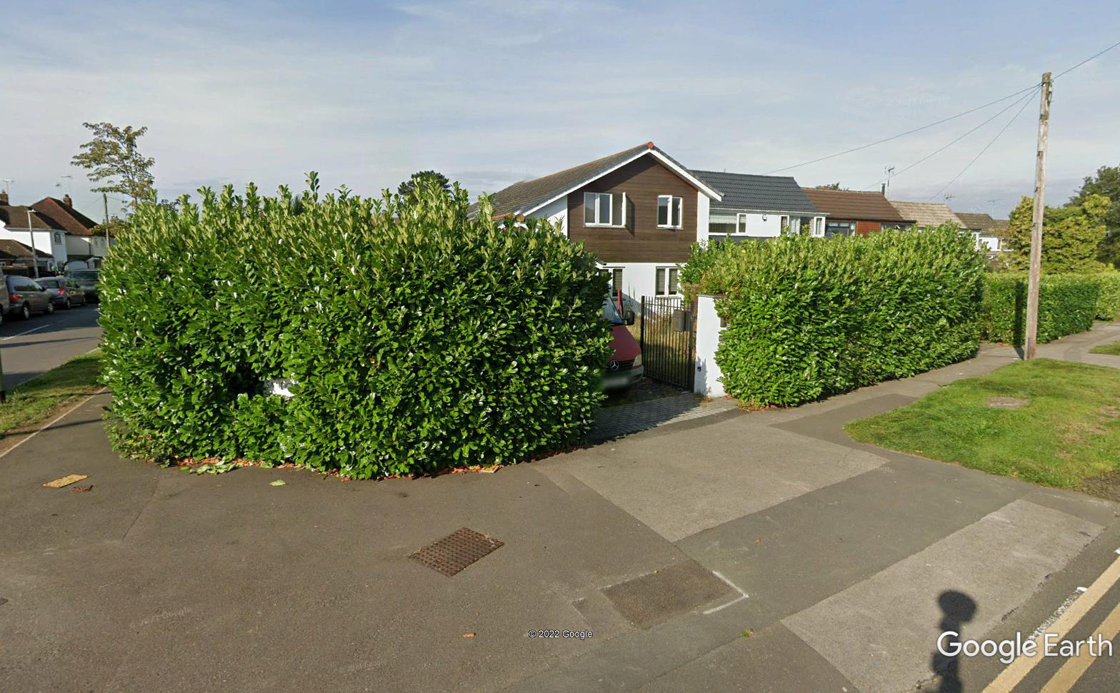

PROPOSAL AND SUPPORTING INFORMATION

- Application for removal or variation of a condition following grant of planning permission 201024
- Changes to materials and the
- Inclusion of solar panels

Plans considered
3678/200 Rev A: Block and Location Plan
3678/201 Rev D: Proposed Floor Plans
3678/202 Rev C: Proposed Elevations

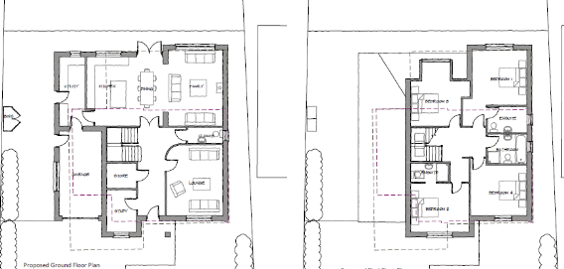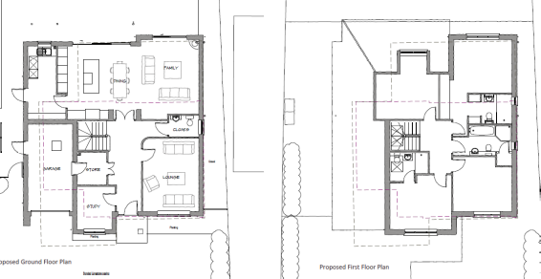
Previously Permitted Plans VAR Plans
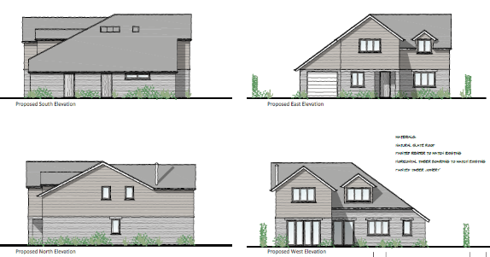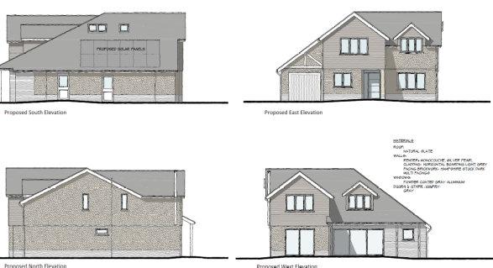
Previously Permitted Elevations VAR Elevations

RELEVANT PLANNING HISTORY
Application Ref: 201024
Description: Demolition of existing dwelling and erection of replacement detached
Dwelling
Decision : Permitted
Decision Date : 15th October 2020

CONDITIONS TO VARY
3. The development hereby permitted shall ONLY be carried out in accordance with the following approved plans:
Drawing No: 3678/202 Rev A – Proposed Elevations received on 22nd July 2020
Drawing No: 3678/201 Rev C – Proposed Floor Plans
Drawing No: 3678/203 Rev A – Proposed Site Plan
Drawing No: 3678/205 – Bike and Bin Store
Construction Method Statement
All received on 15th September 2020
Drawing No: 3678/204 Rev A – Construction Method Plan received on 5th October 2020
REASON: For the avoidance of doubt and to ensure that the development is carried out and adhered to in accordance with the application form and associated details hereby approved.

REVISED CONDITION
3. The development hereby permitted shall ONLY be carried out in accordance with the following approved plans received 8th March 2022:
Drawing No: 3678/200 Rev A: Block and Location Plan
Drawing No: 3678/201 Rev D: Proposed Floor Plans
Drawing No: 3678/202 Rev C: Proposed Elevations
Drawing No: 3678/205 – Bike and Bin Store received 15th September 2020
Drawing No: 3678/204 Rev A – Construction Method Plan received on 5th October 2020
Construction Method Statement received 15th September 2020
REASON: For the avoidance of doubt and to ensure that the development is carried out and adhered to in accordance with the application form and associated details hereby approved.

Equality Act 2010:
In determining this application the Council is required to have regard to its obligations under the Equality Act 2010. However, there is no indication or evidence (including from consultation on the application) that the protected groups identified by the Act have or will have different needs, experiences, issues and priorities in relation to this particular planning application. Therefore in terms of the key equalities protected characteristics it is considered there would be no significant adverse impacts as a result of the development.

LEGAL AND PLANNING POLICY CONTEXT

Section 38(6) of the Planning and Compulsory Purchase Act 2004 requires that proposals be determined in accordance with the development plan unless material considerations indicate otherwise. Material considerations include relevant policies in the National Planning Policy framework (NPPF) - among them the 'presumption in favour of sustainable development'. The following local and national planning policy and guidance is relevant to this application:

National Policy
National Planning Policy Framework
National Planning Practice Guidance

Reading Borough Local Plan (2019)
CC7 (Design and the Public Realm)
CC8 (Safeguarding Amenity)

6. APPRAISAL

In line with NPPG, this proposal has been considered to be ‘minor material amendments’, as both individually and collectively (by virtue of scale and/or nature considerations) they are considered to result in a development which is not substantially different from the one which was originally approved.
- CONCLUSION
The proposed development has been assessed and the proposed works are considered to be in accordance with the above relevant policies and planning permission can be granted.

8. RECOMMENDATION
Grant

